Summer Internship 2018

**ChatBot**

Chat with Experts

horizontal line

# 

# Introduction

We know the idea of chatbots can be a little intimidating.But the truth is, robots aren’t here to take over the world. They’re here to make life easier.Taking on the burden of time-consuming tasks, and allowing you to better serve your customers in ways that matter most.

## 

## What Are Chatbots?

Chatbots are programs built to automatically engage with received messages. Chatbots can be programmed to respond the same way each time, to respond differently to messages containing certain keywords and even to use machine learning to adapt their responses to fit the situation.

**ADVANTAGES**

1. Save Time & Money

2. Generate Leads & Revenue

3. Guide Users to Better Outcomes

4. Provide ‘After Hours’ Support

5. Engage Users in a Unique Way

### **FEATURES PROVIDED**

The ***key things***of chatbots are:

* To get a quick answer to questions
* To resolve a complaint or problem
* To get a more detailed answer to a query
* Finding a human customer service agent

### **PLATFORM USED**

* Dialogflow

### LANGUAGES USED

* Python
* node.js

## What is Dialogflow?

Dialog Flow is a Google-owned developer of human–computer interaction technologies based on natural language conversations.

Main working of this platform is with the api called ***api.ai***. It uses node.js as an inbuilt language in it. It is very user-friendly so it is easy to make chatbot application through this platfrom.

### Technical Architecture

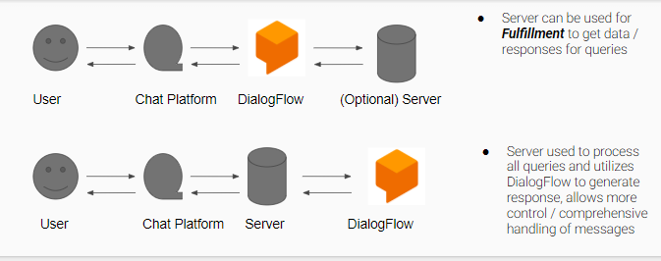

### Main components of Dialogflow

* Intents
* Contexts
* Entities

### Flow Chart for Dialogflow

## 

## Workings

### Create Dialogflow Account

Sign up for free to Dialogflow account from<https://dialogflow.com>

### Create Agent

It is essentially the container or project and it contains [intents](https://dialogflow.com/docs/intents), [entities](https://dialogflow.com/docs/entities), and the responses you want to deliver to your user. It represents the conversational interface of your application, device, or bot.

* So in this chatbot I created an agent and named it as *“****Welcome to tasklance****”*. Now inside this agent we need to give the functionalities to the chatbot for inputs given by the user and their responses , so for this we need to create intents. Dialog flow matches user input to a specific intent.

### Create Intents

An intent represents a mapping between what a user says and what action should be taken by your software.

There are some sections in the intent namely:

**Contexts**-

*used to structure non-linear conversations*

**Training phrase-**

*To make sure your agent matches user input as often as possible, it’s important to provide your agent with enough data. This user expressions are the inputs given by user in the chat window,so we need to provide enough sentences that user may use .*

**Action and parameter-**

*If you mark parameters extracted from a user's request as required, Dialogflow will prompt the user if their values were not extracted from their initial request. Here we can also create custom entities so that any important data you want to get from a user's request can be extracted. There are 3 types of entities:*

* + - * + [*System*](https://dialogflow.com/docs/entities#system_entities) *entities (defined by Dialogflow)*
        + [*Developer*](https://dialogflow.com/docs/entities#developer_entities) *entities (defined by a developer)*
        + [*User*](https://dialogflow.com/docs/entities#user_entities) *entities (built for each individual end-user in every request).*

**Responses**

*Respond to the inputs of the users with its respective simple message, or build custom rich messages for the integrations you support.*

* The intent I used here is the ***follow up intent*** *(Yes/No)* or *directional intents* as it solves the queries of the users by providing solution in a branching way and is used in business related chatbot. This intent automatically sets the contexts information and action. Training inputs are also given for the sentences that matches with Yes/No word. I added a few sets for my responses.

### Training Tool

* Training tool that allows you to analyze conversation logs with your agent and add annotated examples to relevant intents in bulk.
* Whenever a user provides input, that input is recorded in the conversation logs along with the number of times that input was successfully or unsuccessfully matched to an intent. These logs can help us discover gaps in our conversation setup.
* The Unmatched number means the conversation contains the displayed number of interactions in which the user said something that wasn't matched to an intent.

### History

It keeps record of the conversation between agent and user o the respective chatbot agent.

* I also added a feature “**SMALL TALK**” so that the common conversational questions can be responded without creating any intents for that. The agent can learn how to support small talk without any extra development. By default, it will respond with predefined phrases. Small talk already has some inbuilt intents to respond to the routine conversation.

### 

### 

### Flow Chart for Follow-up intent

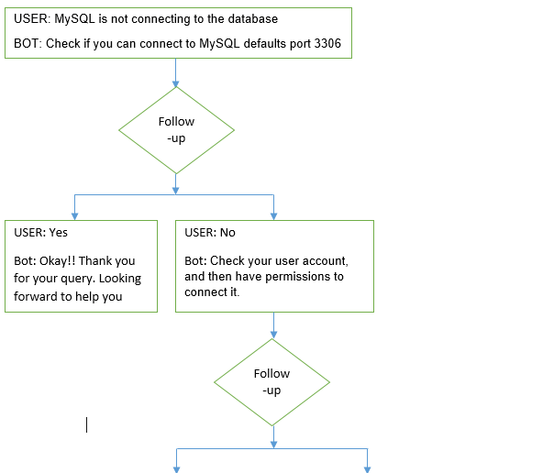

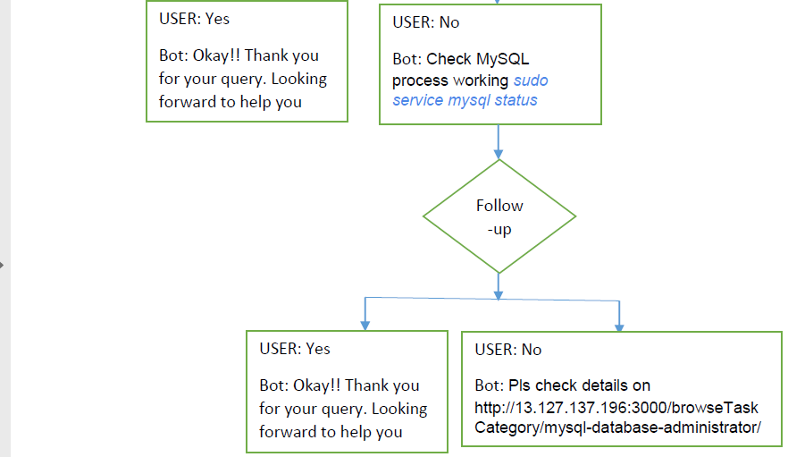

## Integration

## There are many integrations to deploy chatbot on the websites.

Common integrations are Web Demo, Google Assistant, Facebook Messenger, Slack, Line, Viber, kick, Microsoft Cortana, Skype, Twitter etc.

* I used a **Web Demo integration** which allows us to publicly share your agent through a generated page or by embedding it in your existing website. It gives a small **code** of our created chatbot agent shown below which we need to add to our website .
  + <iframe  
     width="350"  
     height="430"  
     src="https://console.dialogflow.com/api-client/demo/embedded/10493df2-b0dd-4fee-a88d-c9a05c39fc8a">  
    </iframe>

## RESEARCH

1. Why was I unable to put clickable hyperlink or a clickable button response inside the chatbot window ?

* I used Web Demo integration of Dialogflow in my chatbot. As this existing web demo integration in Dialogflow is quite limited in terms of capabilities, so I cannot display clickable hyperlinks inside the chat window. For this to happen, I cannot use the built-in integration, which means I need to use Dialogflow’s REST API to communicate with your agent. To use this REST API, I need to build it. So building this API was a difficult task.
  + Reference: <https://miningbusinessdata.com/rich-webchat-dialogflow/>

1. If there is other way to give input and output responses not using Dialogflow platform ?

* Dialogflow doesn't "compile" to anything else, so it needs to be run on the Dialogflow servers. We can, however, export the project and some other person can create their own project and import it.
* Other way to give responses is to write the script for chatbot intents with python programming.
  + Reference: <https://www.youtube.com/watch?v=FVNyUehBU2I>

1. Can the conversation be stored in some mysql database other than storing in the history of Dialogflow application ?

* If I will use webhook fulfillment, then i can log anything i wish using the fulfillment's code. If i am just using the responses entered in Dialogflow, then no, i can't do any outside logging.

1. How to intoduce a line break?

* I found on internet that we can make multi-line responses by clicking ADD MESSAGE CONTENT in the Response section.The bot will send a message for each content, making it look like a human message response. But it doesn’t seem to work. I only get first message.
* \n and shift +enter didn’t work and after researching I found that it wasnt possible.So another solution was Basically , add a line filled with invisible characters

if you are on windows , type Alt+255 a couple of times ,copy those invisible characters ,And repeatedly paste them until you have enough characters to cover a line ! But this too does not work !!

1. Why CSV file format was not used ?

* Sometime around May 2017, Dialog-flow (which was then API.AI) introduced the follow-up intents feature. These allowed you to have a hierarchy of intents, Since the number of hierarchical levels is (theoretically) unlimited, you can imagine that it is not possible to capture this very complex structure in the CSV format at all.
  + Reference: <https://miningbusinessdata.com/how-to-bulk-upload-intents-from-a-csv-file-in-dialogflow/>

1. How can a bot initiate the conversation first?

* References :
* <https://stackoverflow.com/questions/51184134/in-a-chatbot-conversation-using-dialogflow-is-there-a-way-to-make-the-bot-speak>
* [https://stackoverflow.com/questions/51245608/welcome-intent-creating-error-in-dialogflow](https://stackoverflow.com/questions/51184134/in-a-chatbot-conversation-using-dialogflow-is-there-a-way-to-make-the-bot-speak)

## Connection to the company website server

I was given a duplicate tasklance server to deploy my chatbot for checking purpose. For this i needed to download Putty,WinScp and a key file.

**PuTTY** is a [free and open-source](https://en.wikipedia.org/wiki/Free_and_open-source) [terminal emulator](https://en.wikipedia.org/wiki/Terminal_emulator), [serial console](https://en.wikipedia.org/wiki/Serial_console) and network file transfer application.

**WinScp ’s** main function is secure file transfer between a local and a [remote computer](https://en.wikipedia.org/wiki/Remote_computer). Beyond this, WinSCP offers basic [file manager](https://en.wikipedia.org/wiki/File_manager) and [file synchronization](https://en.wikipedia.org/wiki/File_synchronization) functionality. For secure transfers, it uses Secure Shell ([SSH](https://en.wikipedia.org/wiki/Secure_shell)) and supports the SCP protocol in addition to SFTP.

## References:

<https://www.youtube.com/watch?v=DkZmVLHoCLo>

<https://www.youtube.com/watch?v=Yjji510scI0&list=PLj-LOoBjYq6d3yZwhY6BJBtufuFYpJpu-&index=1>

<https://dialogflow.com/docs/getting-started/basics>

<https://www.youtube.com/watch?v=gWNUg_v25dw&t=5s>