PAISAPILOT
Personal Finance Advisor Bot
Track. Plan. Save. Grow.

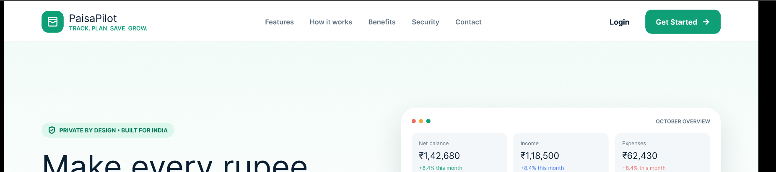
Project Documentation
A web-based personal finance management and AI-assisted budgeting platform

1. Project Overview
PaisaPilot is a personal finance advisor platform designed to help users understand, organize, and improve their everyday financial activities. It provides a centralized environment for recording income, tracking expenses, creating budgets, setting savings goals, and viewing financial insights.
The interface shown in the project emphasizes simplicity, clarity, privacy, and India-focused financial usage. The dashboard presents balances, income, expenses, cash-flow information, and budget progress in an easy-to-understand format.

2. Abstract
PaisaPilot is an AI-powered personal finance advisor that converts everyday money data into understandable financial information. Users can record monthly income and daily or weekly expenses, categorize spending, create budgets, monitor savings goals, and receive personalized financial insights. The system is intended to reduce the difficulty of manual financial tracking by presenting important information through a simple dashboard and actionable recommendations. The project combines a modern web interface with backend data management and AI-assisted analysis to support better budgeting and financial awareness.

3. Problem Statement
Many users record expenses irregularly or do not have a clear view of how much they earn, spend, and save. Manual calculations can be time-consuming and may make it difficult to identify spending patterns. PaisaPilot addresses this problem by bringing income, expenses, budgets, savings goals, and financial insights into one digital platform.

4. Objectives
- Provide a simple platform for recording and monitoring personal income and expenses.
- Organize spending into meaningful categories for better analysis.
- Help users create and monitor monthly budgets.
- Track savings goals and progress over time.
- Generate understandable financial insights from user-provided data.
- Present financial information through a clean and responsive dashboard.
- Follow privacy and security principles suitable for personal financial information.

5. Scope of the Project
The project covers personal finance tracking and decision support. Its scope includes income entry, expense management, budget planning, savings goals, dashboard reporting, financial insights, and secure user access. The system can be extended in the future with bank integrations, notifications, advanced analytics, and additional AI capabilities.

6. Major Features
Feature | Description
Dashboard | Shows total balance, income, expenses, budget status, and financial overview.
Income Tracking | Allows users to record and monitor sources of income.
Expense Tracking | Records expenses and organizes them into categories.
Budget Management | Helps users set a monthly spending limit and monitor usage.
Savings Goals | Allows users to define goals and track progress.
Cash Flow | Provides a visual representation of financial movement over time.
AI Financial Insights | Uses financial data to provide understandable suggestions and observations.
Security | Designed with privacy-focused access and secure data-handling principles.

7. System Workflow
- User creates an account and logs in securely.
- User enters income and expense information.
- Transactions are categorized and stored in the system.
- The system calculates balances, spending, budget usage, and savings progress.
- The dashboard presents the processed information visually.
- The AI advisor analyzes available financial patterns and generates useful insights.
- The user reviews the insights and adjusts spending or saving plans.

8. System Modules
User Authentication Module: Handles account access, login, and user-specific data.
Income Module: Stores income entries and supports monthly financial calculations.
Expense Module: Stores categorized expenses and supports spending analysis.
Budget Module: Creates budgets and calculates the amount spent and remaining.
Savings Goal Module: Tracks target amounts and progress toward savings goals.
Dashboard Module: Combines important financial values into a single view.
AI Advisor Module: Converts financial data into personalized insights and suggestions.
Security Module: Protects user data through authentication, authorization, and secure handling.

9. Technologies and Tools
- Frontend: HTML, CSS, JavaScript and/or a modern frontend framework.
- Backend: Server-side application for authentication, APIs, business logic, and data processing.
- Database: Structured storage for users, transactions, budgets, and goals.
- AI Layer: AI-assisted analysis for financial insights and recommendations.
- UI/UX: Responsive dashboard design for desktop and mobile screens.
- Version Control: Git and GitHub for source-code management and project collaboration.

10. User Interface Screenshots
The following screenshots show the main visual design and dashboard experience of PaisaPilot.

Figure 1: PaisaPilot landing page and financial dashboard preview.

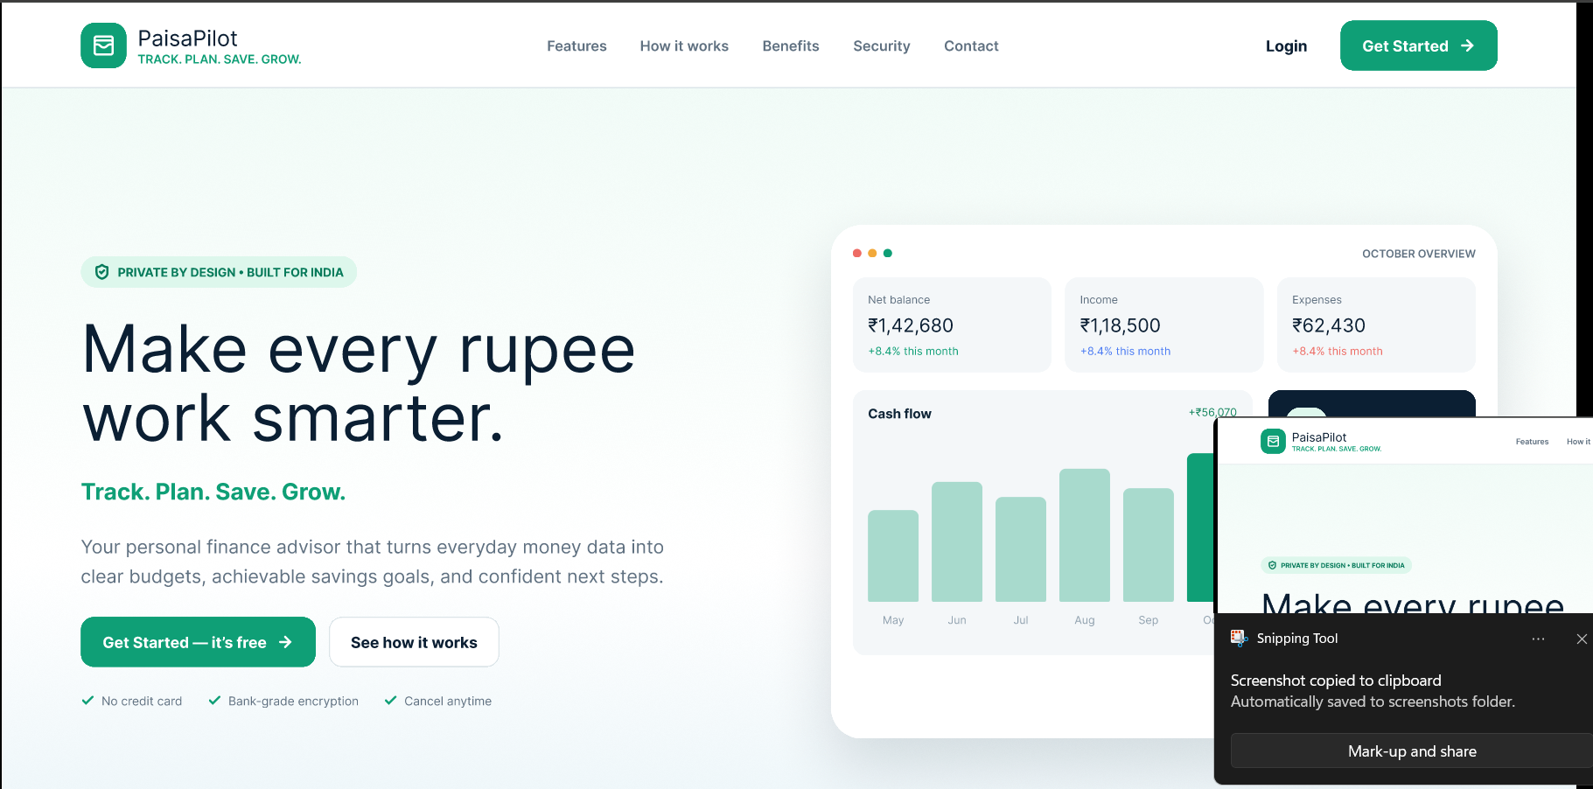
Figure 2: Responsive web dashboard showing balance, income, expenses and cash flow.

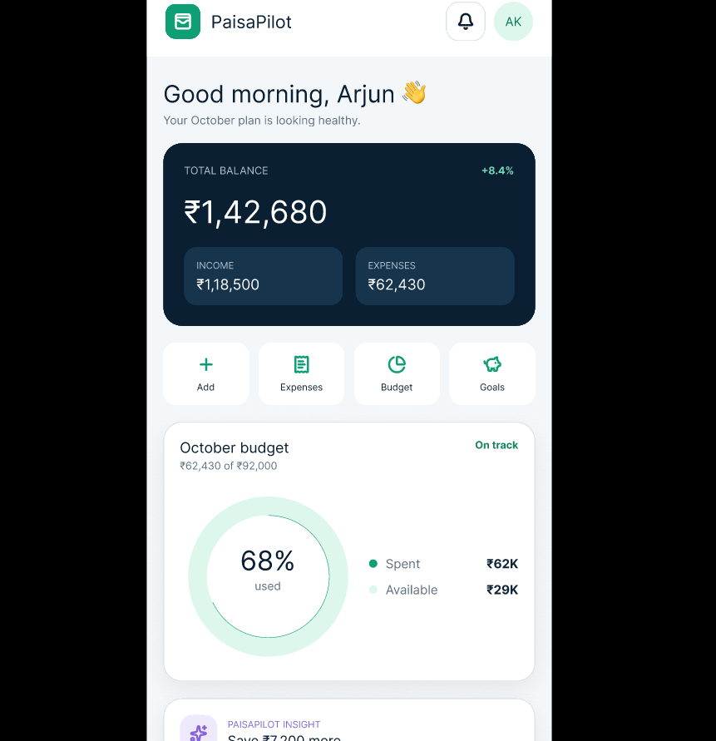
Figure 3: Mobile dashboard with budget usage and quick-access modules.

11. Dashboard Explanation
- Total Balance: Displays the current overall balance available to the user.
- Income: Shows the recorded income for the selected period.
- Expenses: Shows total recorded spending for the selected period.
- Cash Flow: Visualizes changes in financial activity across months.
- Budget Progress: Shows how much of the planned budget has been used and how much remains.
- Quick Actions: Provides shortcuts for adding transactions, viewing expenses, managing budgets, and tracking goals.
- AI Insight: Presents an automated financial observation or suggestion based on the user's data.

12. Security and Privacy
Because personal finance information is sensitive, the application should follow secure software-development practices. Recommended controls include secure authentication, password hashing, authorization checks, encrypted communication using HTTPS, input validation, protection against common web attacks, secure session handling, and restricted access to user-specific financial records. The interface also communicates a privacy-first design approach.

13. Advantages
- Simple and user-friendly financial dashboard.
- Centralized management of income, expenses, budgets, and goals.
- Visual representation of financial data.
- Supports regular budgeting and savings habits.
- AI-assisted insights can make financial information easier to understand.
- Responsive design supports desktop and mobile usage.
- Can be expanded with additional financial services in the future.

14. Limitations
- Financial insights depend on the accuracy and completeness of user-entered data.
- AI-generated suggestions should be treated as general financial guidance, not professional financial advice.
- Advanced bank synchronization may require external financial APIs and additional security controls.
- The quality of recommendations depends on the amount and quality of historical data available.

15. Future Scope
- Secure bank-account and payment-data integrations.
- Automatic transaction categorization.
- Bill and subscription reminders.
- AI-based spending forecasts and personalized saving plans.
- Notification system for budget limits and goal milestones.
- Advanced reports and downloadable monthly statements.
- Multi-language support, including Indian regional languages.
- Enhanced analytics for long-term financial trends.

16. Testing Plan
Test Case | Expected Result
Login Test | Valid and invalid login details are handled correctly.
Income Entry Test | Income records are stored and reflected in dashboard totals.
Expense Entry Test | Expense records update category totals and overall spending.
Budget Test | Budget usage and remaining amount are calculated correctly.
Goal Test | Savings progress changes correctly after updates.
Responsive UI Test | The interface remains usable on desktop and mobile screen sizes.
Security Test | Unauthorized users cannot access another user's financial records.

17. Conclusion
PaisaPilot demonstrates how a modern web application can simplify personal finance management by combining transaction tracking, budgeting, savings goals, dashboard visualization, and AI-assisted financial insights. The project focuses on making financial information clear and actionable while maintaining a privacy-first design. With additional integrations and analytics, the platform can be extended into a more comprehensive personal financial management solution.

18. References
- MDN Web Docs – HTML, CSS and JavaScript documentation.
- Git documentation – version control and repository management.
- OWASP Web Security resources – secure web application development practices.
- Project design and implementation materials for PaisaPilot.

