Tab 1
Pizza sales sql queries

A. KPI’S

1. Total Revenue

SELECT ROUND(SUM(total_price), 0) AS Total_Revenue FROM pizza_sales;
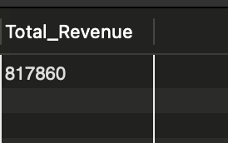

2. Average Order Value

SELECT SUM(total_price) / COUNT(DISTINCT order_id) AS avg_order_value From pizza_sales;
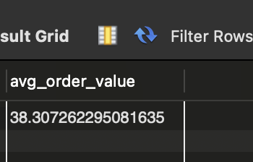

3. Total pizza sold

SELECT SUM(quantity) AS total_pizza_sold FROM pizza_sales;


4. Total orders

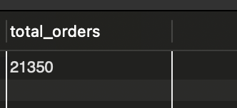
SELECT COUNT(DISTINCT order_id) AS total_orders FROM pizza_sales;

Tab 2
5. Average pizzas per order

SELECT SUM(quantity) / COUNT(DISTINCT order_id) AS avg_pizzas_per_order FROM pizza_sales;

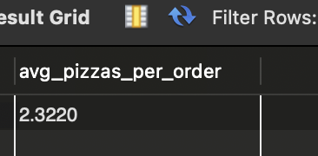

6. Daily trend by total orders

SELECT order_day, total_orders
FROM (
SELECT
DAYNAME(order_date) AS order_day,
COUNT(DISTINCT order_id) AS total_orders
FROM pizza_sales
GROUP BY order_day
) t
ORDER BY FIELD(order_day,
'Monday','Tuesday','Wednesday','Thursday','Friday','Saturday','Sunday'
);

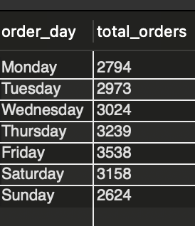

7. Hourly trend by total pizza sold

SELECT HOUR(order_time) AS order_hour SUM(quantity) AS total_pizzas_sold FROM pizza_sales
GROUP BY HOUR(order_time)
ORDER BY HOUR(order_time);

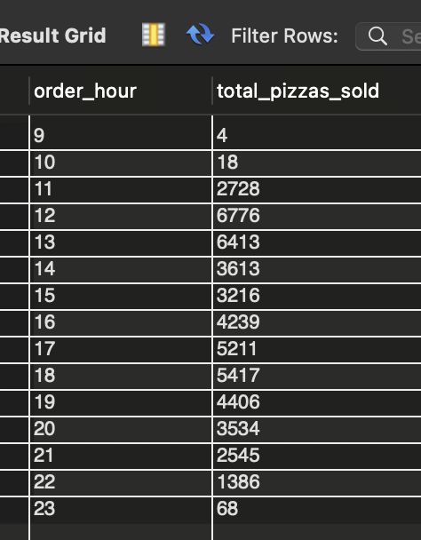

8.Weekly Trend for Total Order

SELECT
YEAR(order_date) AS order_year,
WEEK(order_date) AS order_week,
COUNT(DISTINCT order_id) AS total_orders
FROM pizza_sales
GROUP BY
YEAR(order_date),
WEEK(order_date) ORDER BY order_year,order_week;

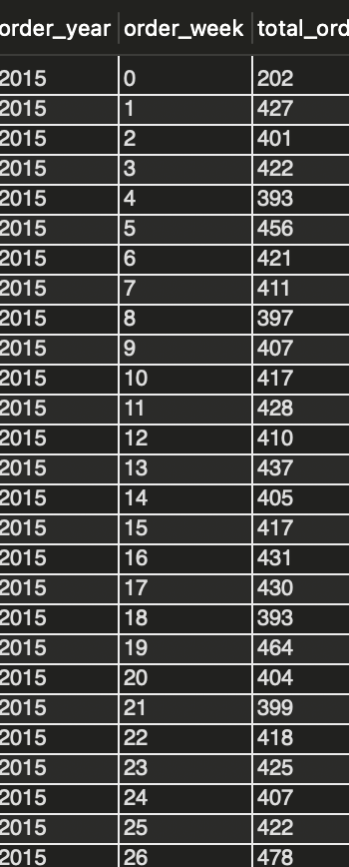
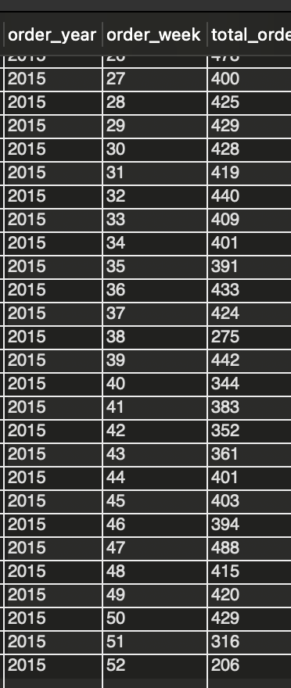

9. Percentage of sales by pizza category

select pizza_category, sum(total_price)*100 /(select sum(total_price) from pizza_sales) as sales_percentage
from pizza_sales
group by pizza_category;
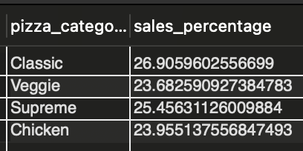

10. Percentage of sales by pizza size

SELECT
pizza_size,
ROUND(SUM(total_price) * 100 / (SELECT
SUM(total_price)
FROM
pizza_sales),
2) AS sales_percentage
FROM
pizza_sales
GROUP BY pizza_size
ORDER BY sales_percentage DESC;

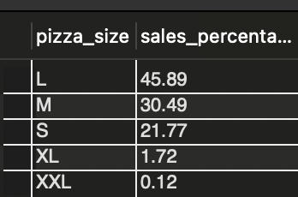

11. Top 5 best seller by revenue

SELECT
pizza_name, SUM(total_price) AS total_revenue
FROM
pizza_sales
GROUP BY pizza_name
ORDER BY total_revenue DESC
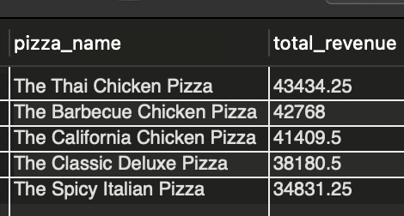
LIMIT 5;

12. Bottom 5 best seller by revenue
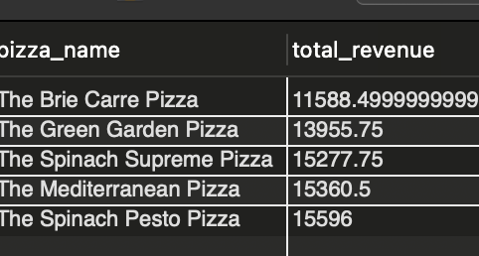
SELECT
pizza_name, SUM(total_price) AS total_revenue
FROM
pizza_sales
GROUP BY pizza_name
ORDER BY total_revenue
LIMIT 5;

13. Top 5 best seller by total quantity
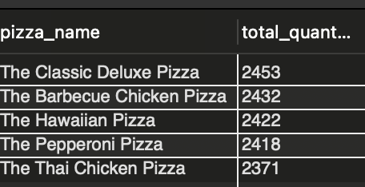

SELECT
pizza_name, SUM(quantity) AS total_quantity
FROM
pizza_sales
GROUP BY pizza_name
ORDER BY total_quantity desc
LIMIT 5;

13. Bottom 5 best seller by total quantity

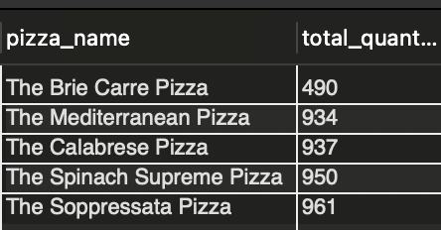
SELECT
pizza_name, SUM(quantity) AS total_quantity
FROM
pizza_sales
GROUP BY pizza_name
ORDER BY total_quantity
LIMIT 5;

14.Top 5 best seller by total order

SELECT pizza_name, count(distinct order_id) AS total_order
FROM
pizza_sales
GROUP BY pizza_name
ORDER BY total_order desc
LIMIT 5;

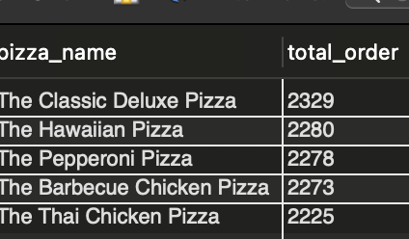
16.Bottom 5 best seller by total order

SELECT
pizza_name, count(distinct order_id) AS total_order
FROM
pizza_sales
GROUP BY pizza_name
ORDER BY total_order
LIMIT 5;

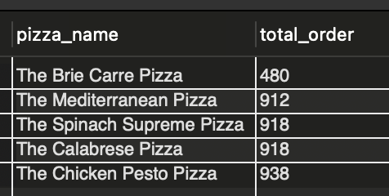

Tab 3

