

Using PyCharm

Author: Scholl, Justin

Document Number: [Asset ID]

Revision: [Version]

|  |  |
| --- | --- |
| XALT Energy - XTC  750 S Blvd E  Pontiac, MI 48341 | XALT Energy - MBP  2700 S Saginaw Road  Midland, MI 48640 |

Table of Contents

1 Introduction 3

1.1 Forward 3

1.1.1 Purpose 3

1.2 Language 3

1.2.1 Definitions and Acronyms 3

2 Creating Projects 3

2.1 Project Interpreter 3

2.2 Adding Library’s 4

3 Code Style Settings 5

# Introduction

## Forward

This Software Work Instruction (SWWI) is intended to review the process of adding the XALT Energy Python Scheme to the PyCharm editor.

### Purpose

## Language

### Definitions and Acronyms

# Creating Projects

## Project Interpreter

PyCharm is a Python editor but requires Python to already be installed and linked to the editor. To link your current version of Python with PyCharm you must create a new project and also setup a Prokect Interpreter. This can be done by selecting File>New Project… Here you can select a file location to store your new project and then selecting the “Project Interpreter:” drop down to add a new interpreter.

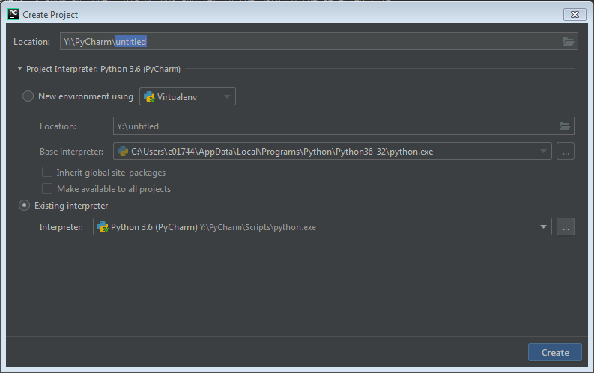

Figure 2‑1: New Project:

Here select “Existing interpreter:” and in the next window select “System Interpreter” and select the path to the python executable (python.exe) Figure 2‑2

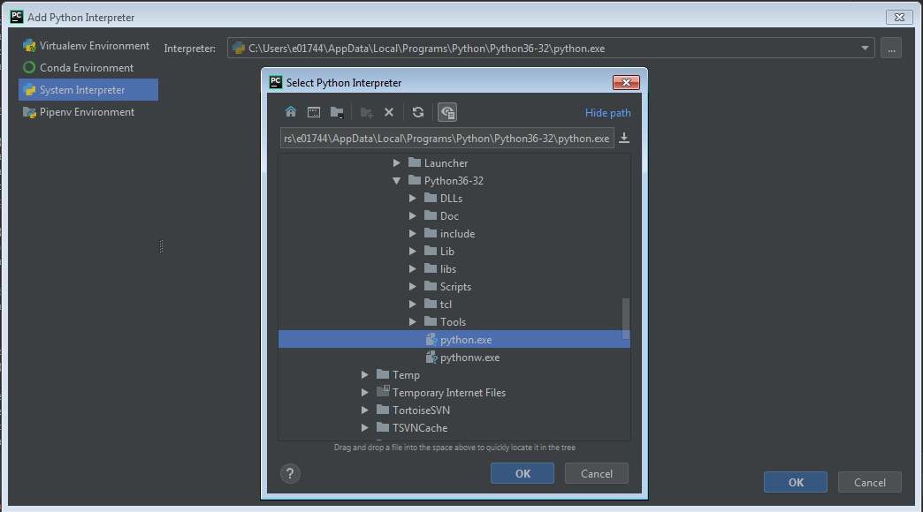

Figure 2‑2: System Interpreter settings

## Adding Library’s

With Python there are many open source Libraries that you can use. Using PyCharm you can easily search and add libraries. This can be done within the settings window under “Project” tab in “Project Interpreter”. Here you will see a list of all current available libraries. To add a new library select the “+”.

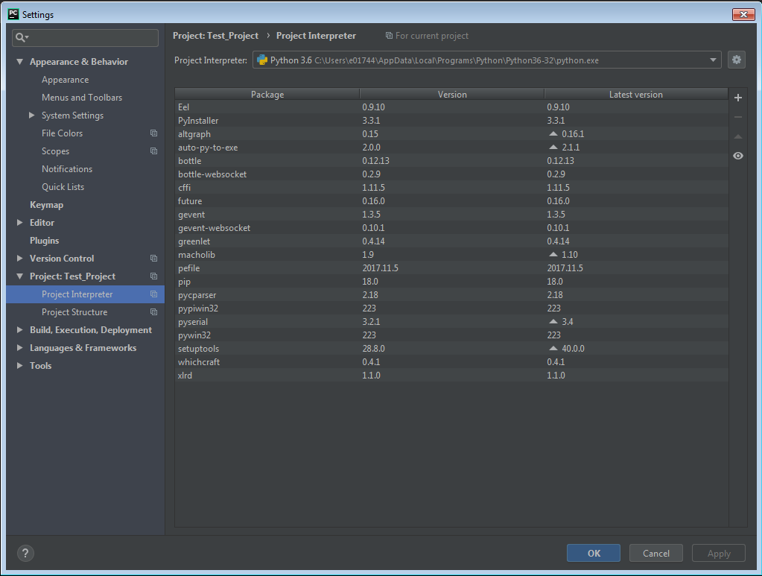

Figure 2‑3: Library Settings

When adding new libraries PyCharm automatically links to pypi.org and generates a list of available packages, these are all the available libraries. To install a library simply select it on the left hand side and select “Install Package”.

*If you run into any errors dealing with trusted sources you must select the “Options” check box and enter “--trusted-host pypi.python.org --trusted-host files.pythonhosted.org --trusted-host pypi.org”

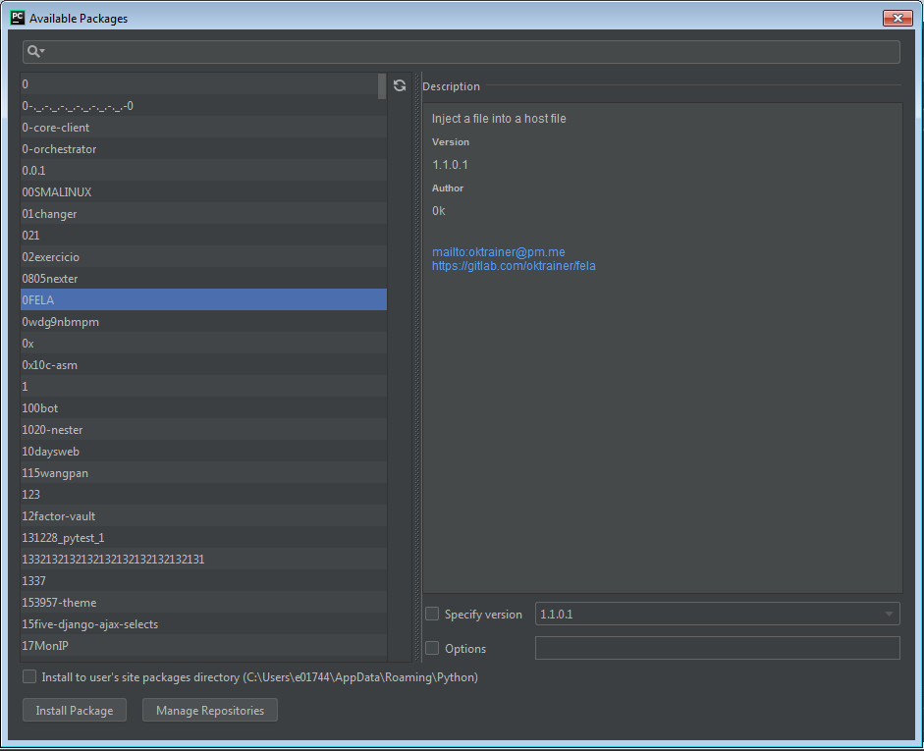

# Code Style Settings

The PyCharm editor has the ability to select various Code Styles based on the source code type. XALT has created a custom Scheme for Python code that follows many of the C coding standards. The custom Python scheme can be located in TeamForge in docf1350 under the Python folder

The scheme can then be imported into the PyCharm environment by performing the following steps. First open the settings dialog (Figure 2‑1) by navigating to File>Settings (Ctrl+Alt+S).

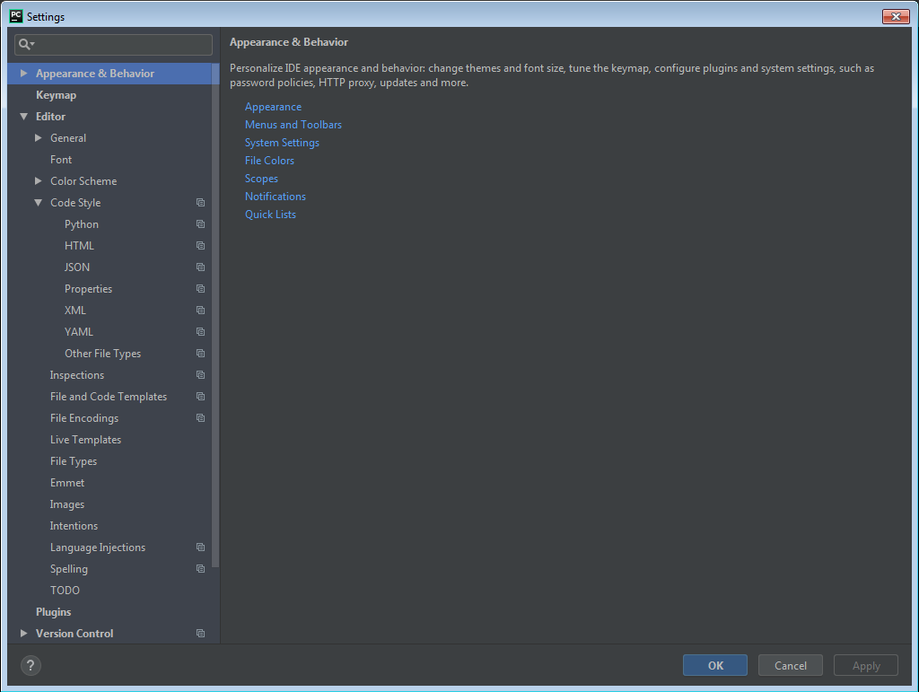

Figure 3‑1: Settings Window

In the “Code Style” Drop down on the left select “Python”. In the upper left you will then see an option for “Scheme:” select the gear icon and select “Import Scheme” Figure 2‑2.

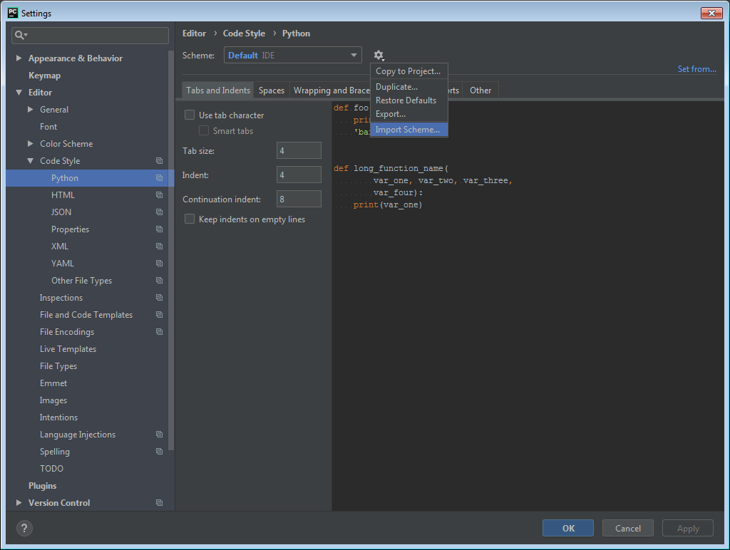

Figure 3‑2: Import settings

From the Windows dialog box select the XALT_PyCharm_Code_Style.xml file and select ok.