1. Project Overview
This project analyzes employee performance and attrition patterns to identify key factors driving workforce turnover. Using Python for data cleaning, SQL for analytical queries, and Power BI for visualization, the project provides actionable insights to reduce attrition and improve retention strategies.
2. Dataset Summary
• Rows: 1,470
• Columns: 35
• Key Features:
- Demographics: Age, Gender, Education, Marital Status
- Work Details: Department, Job Role, YearsAtCompany, Overtime
- Compensation: MonthlyIncome, JobLevel, SalaryRange
- Performance & Satisfaction: PerformanceRating, JobSatisfaction, EnvironmentSatisfaction
• Missing Values: None
• Primary Key: Added a unique column Employee_ID using Python.
3. Exploratory Data Analysis using Python
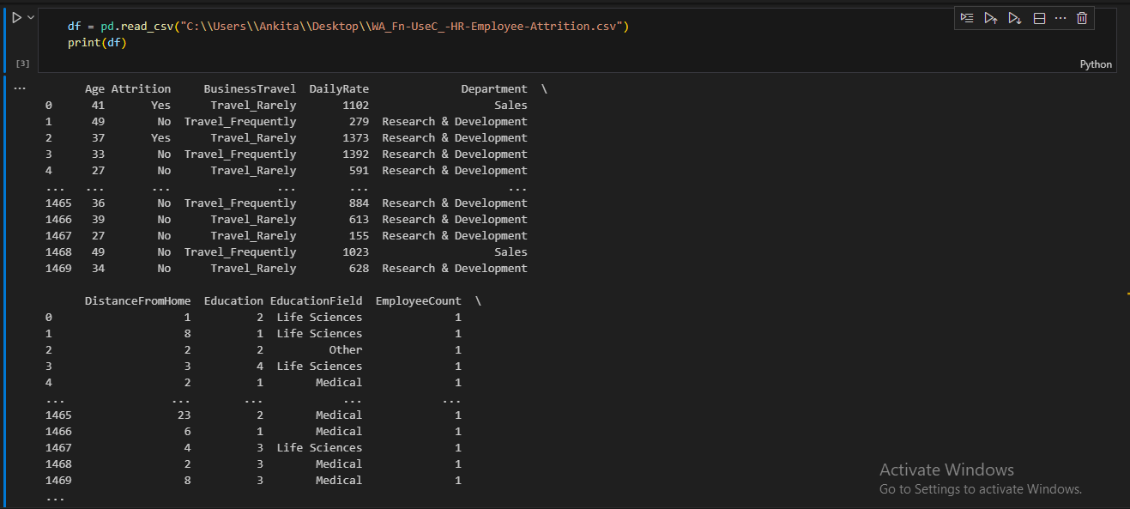
Data loaded and inspected using pandas with 1,470 records verified.
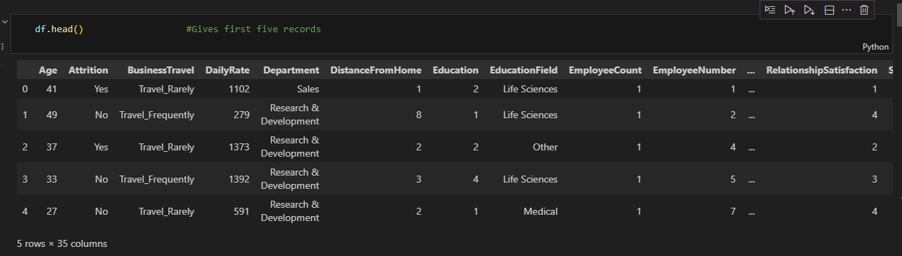
Initial data summary and type inspection to ensure consistency.
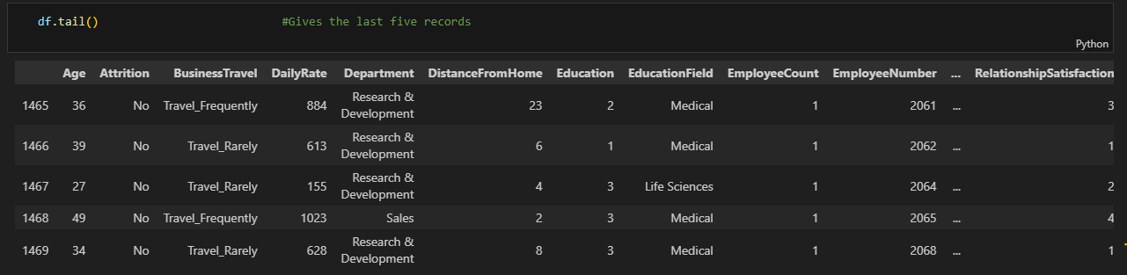
Data quality check confirming no missing or duplicate values.
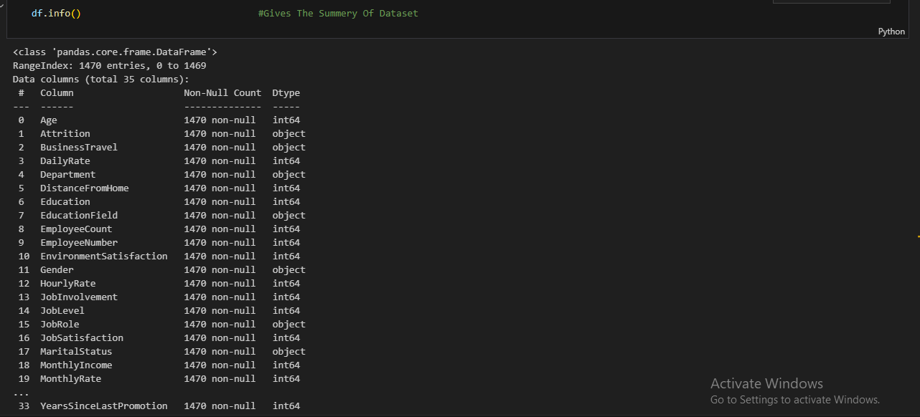
Renamed columns and standardized naming for clarity.
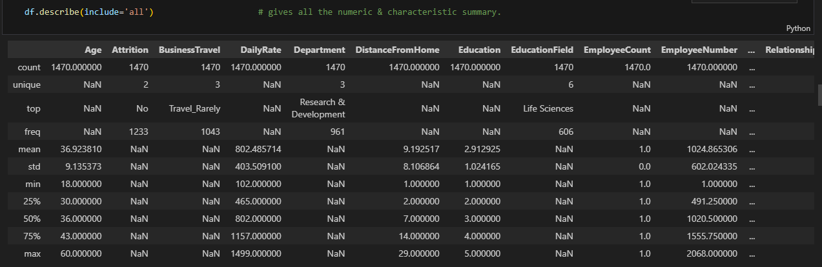
Created unique Employee_ID column to act as a primary key.
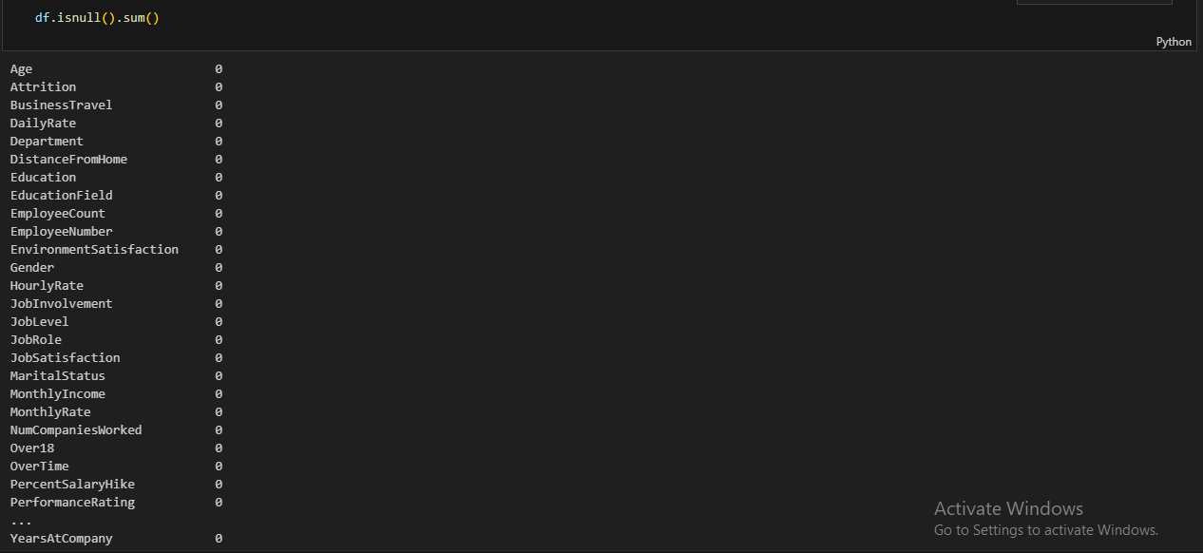
Cleaned dataset successfully integrated into MySQL database.
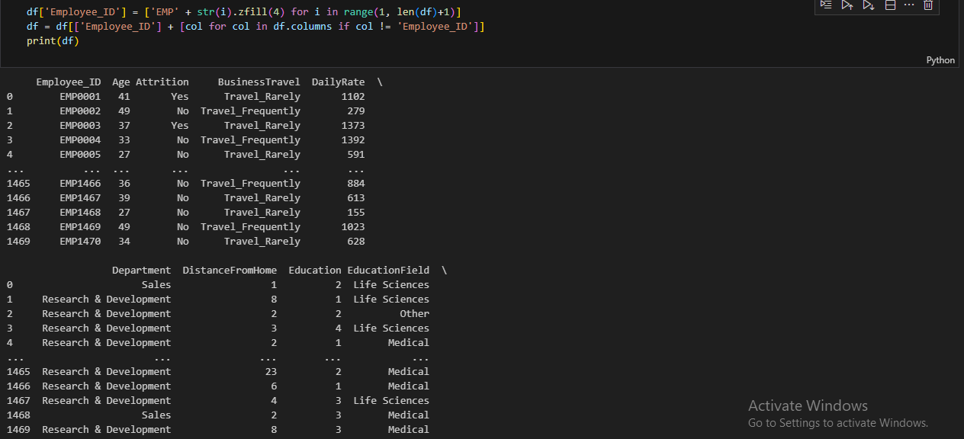
Exploratory visualizations prepared using matplotlib.
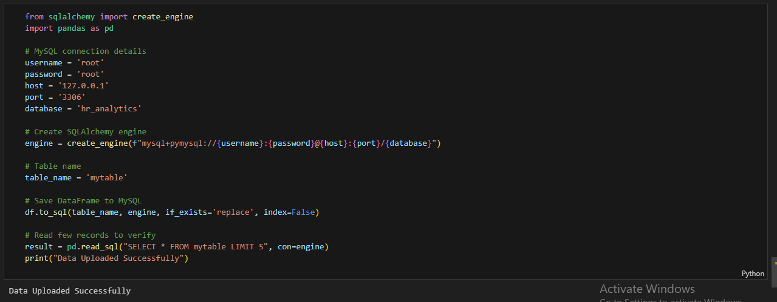
EDA summary confirms data is clean and ready for SQL analysis.
4. Data Analysis using SQL
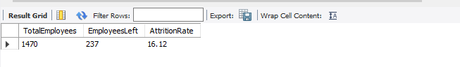
Calculated overall attrition rate (16.12%) from total employees.
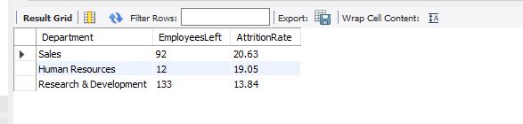
Grouped data by department showing Sales with highest attrition.
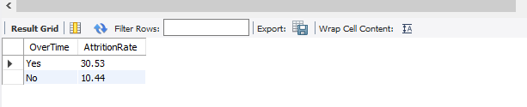
Analyzed attrition by overtime work — employees doing overtime show higher attrition.
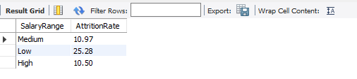
Examined attrition by salary range — lower salaries correlate with higher attrition.
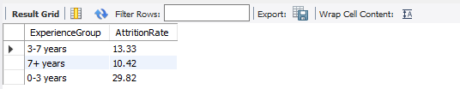
Attrition by experience — early tenure employees (0–3 years) leave most frequently.
5. Power BI Dashboard
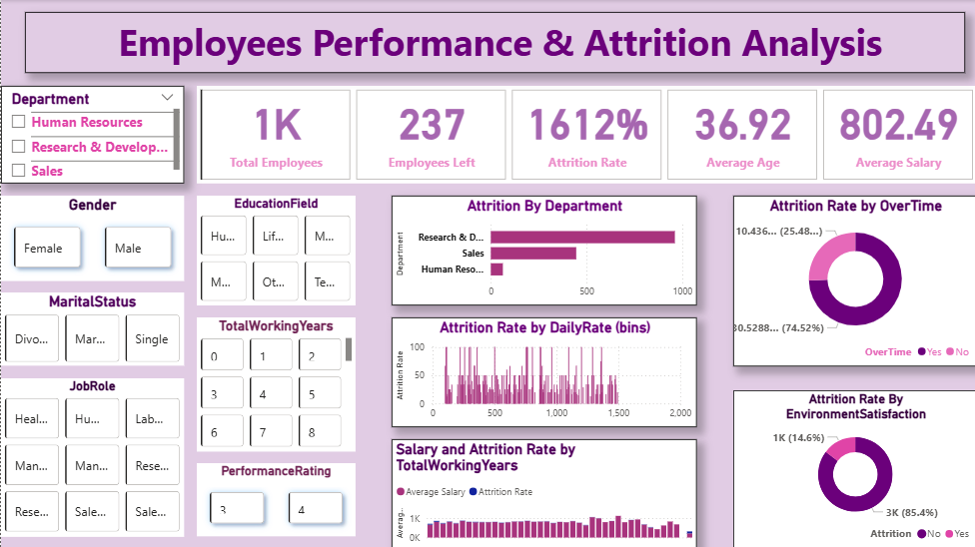
The Power BI dashboard visualizes key metrics like Total Employees (1,470), Employees Left (237), and Attrition Rate (16%). Insights show that Sales department, overtime workload, and low-salary employees contribute most to attrition.
8. Business Recommendations
• Focus on Early Tenure Retention: Develop mentorship or engagement programs for new hires (<3 years).
• Manage Overtime: Balance workloads and monitor burnout risks.
• Improve Compensation: Raise lower salary bands to reduce financial-driven attrition.
• Enhance Work Environment: Invest in satisfaction surveys and well-being initiatives.
• Recognize Performance: Reward consistent performers to improve engagement.

