

Version: 21.0

DesignSpecification Document

**Disclaimer:** This document is intended to outline our general product direction and is intended for information purposes only. The information provided in this document is confidential and SumTotal Internal. The development and release timing of the features and functionality detailed in this document are at the sole discretion of Sumtotal and are subject to change without notice.

**Edwards Update Version Properties through TMU requirement**

|  |  |
| --- | --- |
| Document Title: | Design specification for Edwards Update Version Properties through TMU requirement |
| Document Creation Date: | 22 Dec 2015 |
| Last Updated: | 23 Dec 2015 |
| Document Location: |  |
| Description: | Design specification for Charged Oraganization (Association of Learner’s organization at Time of Training) |
| Current Owners: | Anil Kumar |
| Status (Draft, In Review, Stable): | Draft |

Document Approval

|  |  |  |  |
| --- | --- | --- | --- |
| Date | Approver Name | Role | Approval Status |
|  |  |  |  |
|  |  |  |  |
|  |  |  |  |
|  |  |  |  |
|  |  |  |  |

**Document Revision History**

| Version | Date | Revised By | Remarks |
| --- | --- | --- | --- |
| 1.0 | 11\13\2015 | Anil Kumar | Created the document |
|  |  |  |  |

**Related Documents**

|  |  |  |
| --- | --- | --- |
| Document Name | Type of reference | Document location |
| ST_FS_BCBSSC_ChargedOrg_v1_6 | Functional Specification |  |
|  |  |  |
|  |  |  |
|  |  |  |
|  |  |  |

Contents

Version: 1.0 1

**Mobile Access Notification** 1

1. Introduction 6

1.1. Goals 6

1.2. Non-goals 6

1.3. Assumptions 6

1.4. Glossary 6

2. References 7

*3.* Solution *Overview* 8

3.1. Mobile Access Enabled Notification 8

3.2. Mobile Access Disabled Notification 8

4. Design Overview 9

4.1. Changes to Existing Notification 9

4.2. New Notification 9

4.3. UX Change 11

4.4. Scheduling 11

5. Database Layer 12

5.1. Schema 12

5.2. ETL Design 12

5.3. Dataset Design 12

5.4. TI Interface Design 12

5.5. Common Data Cache 12

5.6. Database Triggers 12

5.7. Workflow Events 12

5.8. Common Libraries\APIs 12

5.9. Dependencies on other Products 12

5.10. Compliance to Industry Standards 13

6. Presentation Layer 14

7. Service Layer 15

7.1. Services Contract 15

7.2. Web Services Design 15

7.3. Data Transfer Objects 15

7.4. Scheduled Jobs 15

7.5. Cache 15

7.6. Common Libraries 15

8. Data Access Layer 16

8.1. ORM 16

8.2. Stored Procedure Added 16

9. Integrations 17

9.2 Transaction Scope\Management 17

10. Impact of Existing Process 18

10.1. Notifications 18

10.2. Upgrade 18

11. Design Foundation 19

11.1. Performance and Scalability 19

11.2. Security 19

11.3. Globalization 19

11.4. Diagnosis and Supportability 19

11.5. Setup and Deployment 19

11.6. 508 Support 19

11.7. Hosting Update 19

11.8. Backward Compatibility 20

11.9. Third party 20

11.10. Monitoring 20

11.11. Licensing 20

11.12. Hardware\Topology 20

11.13. Archiving 20

11.14. Tool Versions 20

12. Unit Test Plan 21

13. APPENDIX 23

13.1. Products and tools Used 23

13.2. Future Enhancements 23

13.3. Design Issues 23

14. Traceability Matrix 24

# Introduction

This document provides design specification details for implementing BCBSSC Charged Organization feature on core product as productization.

## Goals

Capturing learner association to organization for all training activities.

## Non-goals

Charged organization rollup in roster is out of scope

## Assumptions

NA

## Glossary

| Term | Definition |
| --- | --- |
|  |  |
|  |  |
|  |  |
|  |  |
|  |  |
|  |  |
|  |  |
|  |  |

# References

| Document File Name | Document Title |
| --- | --- |
|  |  |
|  |  |
|  |  |
|  |  |
|  |  |
|  |  |
|  |  |
|  |  |

# Solution *Overview*

This feature is for associating an organization with a learner registration. This feature includes :

* Provide a domain level setting to enable/disable the charged organization feature
* A New role permission will be introduced.
* When enabled, the charged organization column will be shown in the roster page.
* If the domain level setting is enabled and the user has the role permission, the user will be able to update the charged org of the selected records from the roster.
* A button will be provided to browse for the organizations for the administrator in the roster.
* Validation will be performed while deleting for the organization.
* The above functions should be applicable for admin as well as instructor roster.

# Design Overview

## Domain level setting (enable/disable the charged organization feature)

### Overview of Design

Create a domain level setting that will be used to enable / disable the charged organization feature. This setting should be accessible by an administrator under System 🡪 Domain Settings 🡪 Basic Settings

If the setting is enabled at a domain:

* Charged Organization field will be shown in the roster if admin/instructor has role permissions.
* Charged Organization will be stored during learner registration for learners in the domain.

### UI design

enterprise/ui/virtual_dir/App_GlobalResources/L_MNT_BasicSettings.resx

enterprise/ui/virtual_dir/app/maintenance/MNT_BasicSettings.aspx.js

### DB design

None

### Impact on other areas of product

None

### UX Mockup

## New role permission bit (Can edit Charged Organization)

### Overview of Design

A new role permission bit “Can edit charged organization” will be added under “Can Manage Others registration” permission. When enabled the charged organization column will be shown in the roster page. If the domain level setting is enabled and the user has the role permission, the user will be able to view and update the charged organization of the selected records from the roster.

### UI design

enterprise/ui/lib/Ent.Legacy.Util/ObjConstants.js

enterprise/ui/virtual_dir/app/administration/Security/Roles/ADM_EditPermissions.aspx.js

enterprise/ui/virtual_dir/custom/App_GlobalResources/L_ADM_EditPermissions.resx

### DB design

enterprise/db/Stored_Procedures/LMS/LMS_CNT.aml

enterprise/db/Stored_Procedures/LMS/LMS_Roster.aml

enterprise/db/Stored_Procedures/LMS/LMS_RosterAdv.aml

enterprise/db/Stored_Procedures/Obj/OBJ_Reg.aml

### Impact on other areas of product

None

### UX Mockup

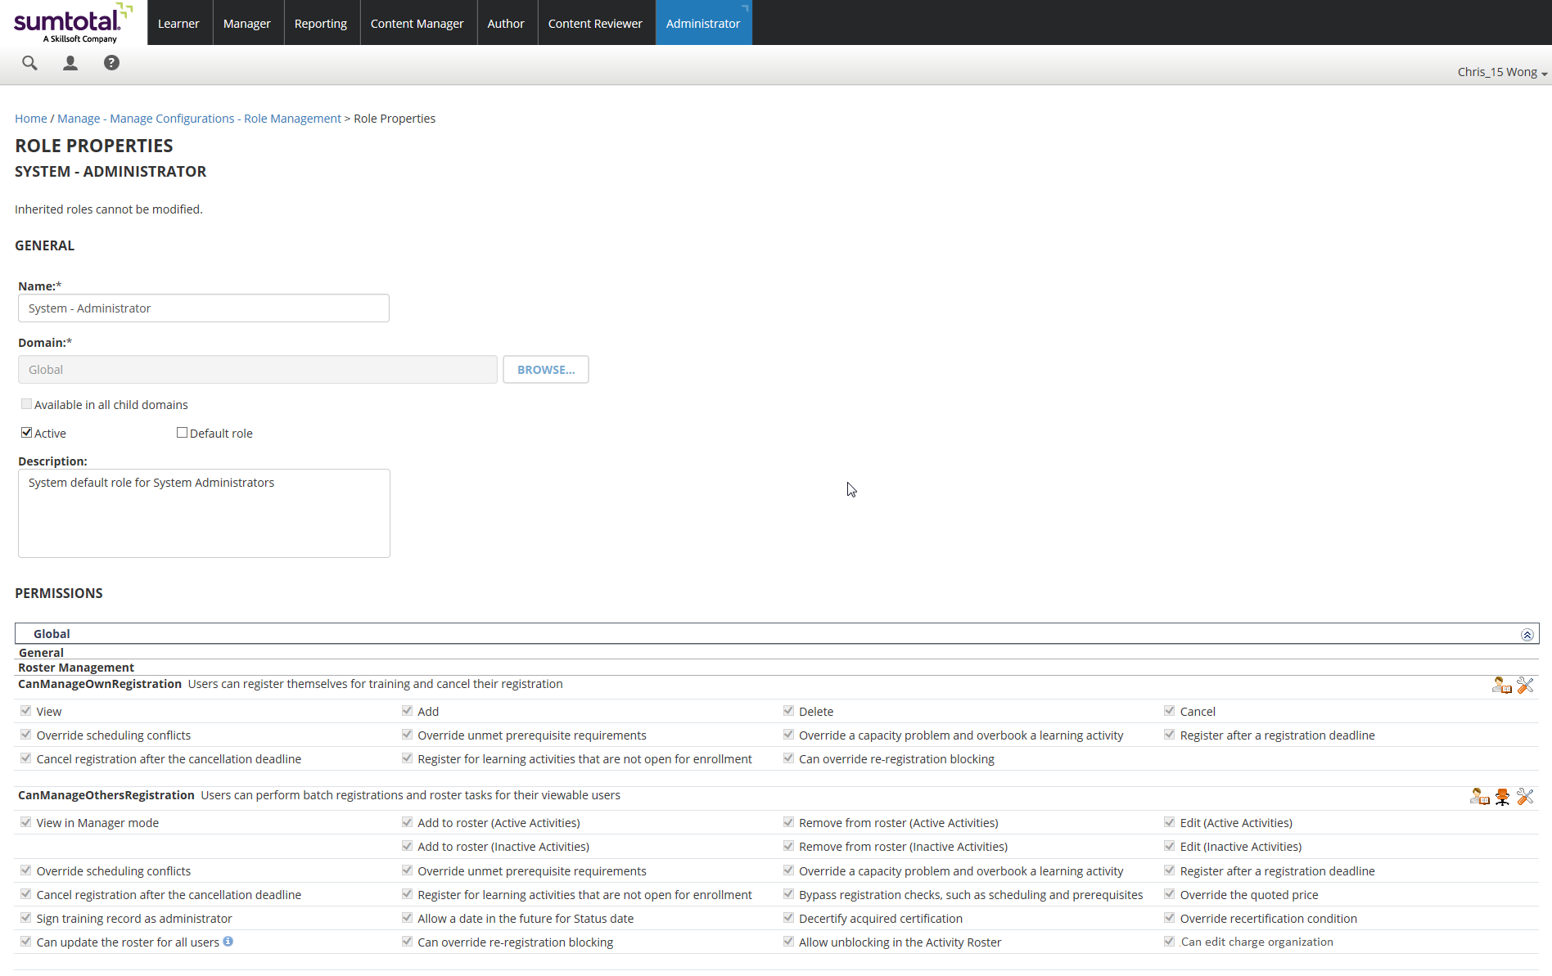

## Roster – Edit Charged Organization field

### Overview of Design

If the domain level setting is enabled and the administrator or instructor has the role permission, charged organization field will be shown in ‘Other notes’ view of roster and the admin/instructor will be able to update the charged organization of selected records from the roster. A Browse button will be shown against the Charged Organization field for admin to update the existing charged organization.

Charged Organization can be changed to any existing organization (not just the organizations the user is currently associated with), if needed. This is because a person may be transferring to another department before the actual training date but may not yet be affiliated with that new department in the LMS. This column needs to be open for editing post registration as well. However, it should NOT be necessary for the administrator to confirm if the primary organization is the correct association. This should populate and the administrator will have to choose to edit the organization if they wish to use another. Whether they are registering one or doing mass roster registrations, there will be no need to confirm the organization. The learner’s primary organization is always used and the administrator has the option of changing if they need to.

### UI design

enterprise/ui/lib/Ent.Legacy.Web.Roster/ObjRosterNotesView.js

enterprise/ui/lib/Ent.Legacy.Web.Roster/ObjRosterState.js

enterprise/ui/lib/Ent.Legacy.Web.Roster/ObjRosterView.js

enterprise/ui/virtual_dir/app/administration/user/organization/LMS_ListViewChargedOrganizations.aspx

enterprise/ui/virtual_dir/app/administration/user/organization/LMS_ListViewChargedOrganizations.aspx.js

enterprise/ui/virtual_dir/app/management/LMS_ActRoster.aspx

enterprise/ui/virtual_dir/app/management/LMS_ActRoster.aspx.js

enterprise/ui/virtual_dir/client/js/core/management/LMS_ActRoster.js

### DB design

Charged Organization field will be saved in TBL_TMX_RegistrationTrack.ChargdOrgFK field

### Impact on other areas of product

If any learning Activity with no registration required enabled launched directly by learner then no record inserted in TBL_TMX_RegistrationTrack table, but charged organization needs to be saved in TBL_TMX_RegistrationTrack table. So here we need to insert record in TBL_TMX_RegistrationTrack table for laearning activities with no registration required also.

### UX Mockup

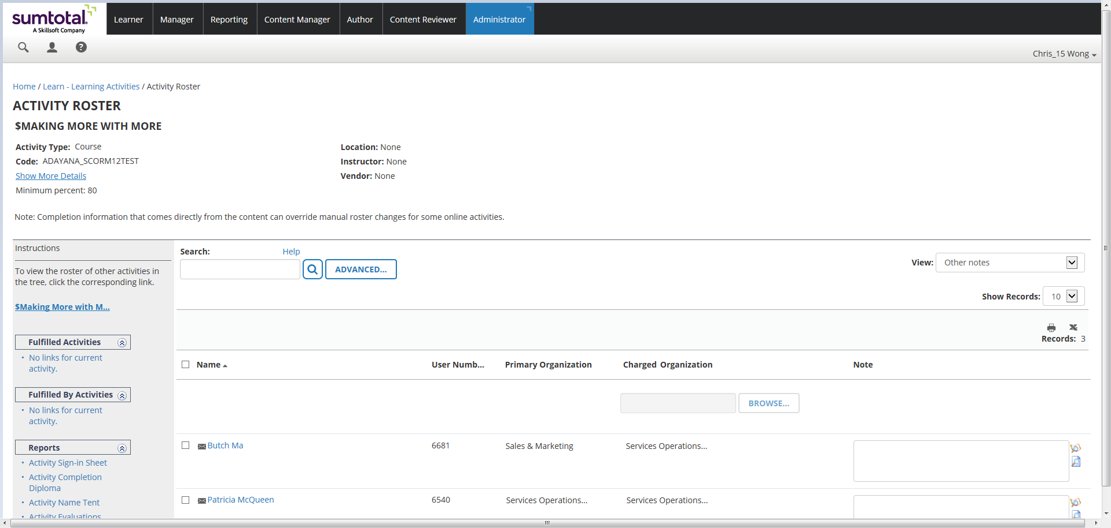

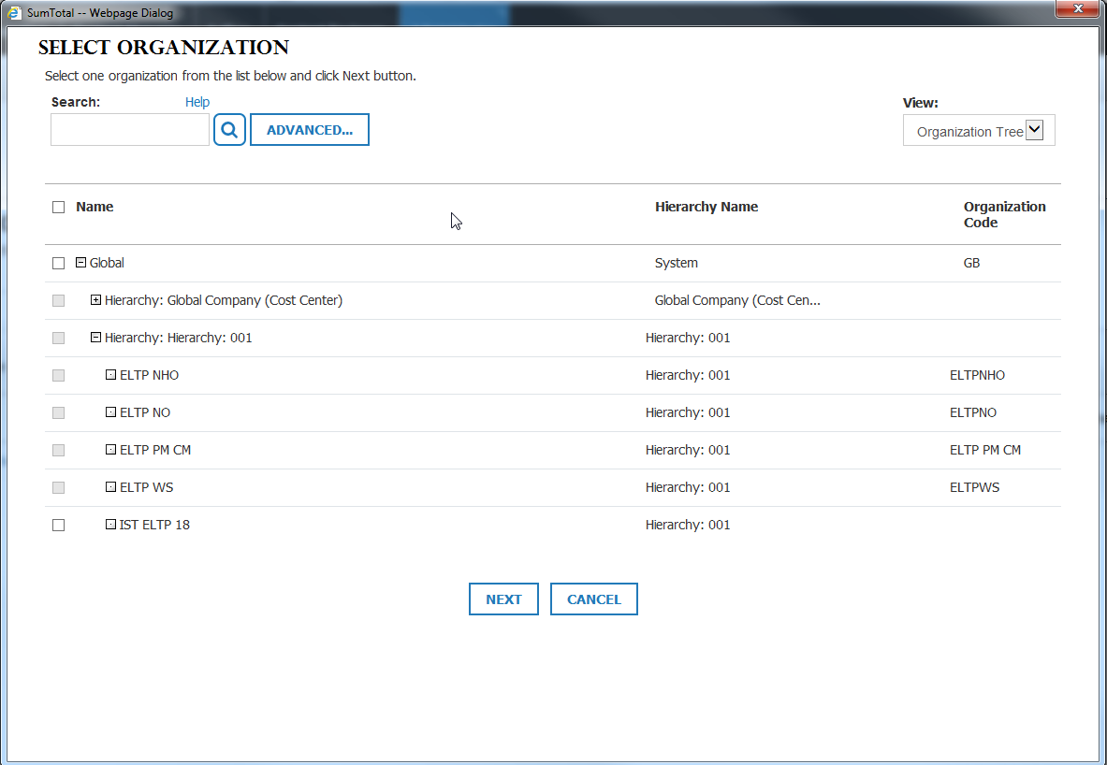

# Database Layer

## Schema

## ETL Design

Not required for this feature

## Dataset Design

## TI Interface Design

Not required for this feature

## Common Data Cache

Not required for this feature

## Database Triggers

## Workflow Events

Not required for this feature

## Common Libraries\APIs

## Dependencies on other Products

| Dependency# | Product name | Description | Severity |
| --- | --- | --- | --- |
|  |  |  |  |
|  |  |  |  |
|  |  |  |  |

## Compliance to Industry Standards

<Are there any standards that we need to be compliant with>

| Dependency# | Product name | Description | Severity |
| --- | --- | --- | --- |
|  |  |  |  |
|  |  |  |  |
|  |  |  |  |

# Presentation Layer

# Service Layer

Not required for this feature

## Services Contract

Not required for this feature

## Web Services Design

Not required for this feature

## Data Transfer Objects

Not required for this feature

## Scheduled Jobs

Not required for this feature

## Cache

Not required for this feature

## Common Libraries

Not required for this feature

# Data Access Layer

## ORM

Not required for this feature

## Stored Procedure Added

Core_NTF_MessageLogic.MobileAccessDisabledNotif

# Integrations

NA

## Transaction Scope\Management

How will transaction management happen (from within the Stored proc, in the Web Tier)

# Impact of Existing Process

## Notifications

## Upgrade

NA

# Design Foundation

The following sections describe the concepts that support the design, or the system foundation. These sections include concepts such as performance, security, and globalization. Detail should be included in these sections to show that they were considered during the design process and considerations for them are accounted for.

## Performance and Scalability

Explain how performance and scalability issues are addressed in the design. Identify possible bottlenecks in the design and ways to address them. If possible, state the scalability goal for this design, such as 1000 concurrent-users per web server.

* How will the design scale as the number of concurrent users increase
* How will the database design scale as the number of records increase
* How does the design scale in a web farm environment
* Does the design use any asynchronous processes to reduce the immediate load on web server

## Security

Enter security related changes

## Globalization

Enter globalization related changes

## Diagnosis and Supportability

Enter diagnosis and supportability

## Setup and Deployment

No special step required

## 508 Support

Enter 508 relates changes

## Hosting Update

Enter changes which impacts hosting environment

## Backward Compatibility

Enter backward compatibility

## Third party

## Monitoring

## Licensing

## Hardware\Topology

## Archiving

## Tool Versions

# Unit Test Plan

# APPENDIX

## Products and tools Used

*Enter tools used for the developing the feature*

## Future Enhancements

*Enter future enhancements*

## Design Issues

Identify any problems that exist with the current design, so that they can be tracked and resolved. All design issues should be resolved before the design is approved

| Open Date | Issue description | Resolution Status |
| --- | --- | --- |
|  |  |  |
|  |  |  |
|  |  |  |

# Traceability Matrix

| RD # | **FS Section** | **DS Section** |
| --- | --- | --- |
| 1 | 2 | 4 |
|  |  |  |
|  |  |  |
|  |  |  |
|  |  |  |