DAY-4
FIREWALL BASICS
TASKS
1. Open Windows Defender Firewall settings on your computer and create a new outbound rule to block all traffic from the Spotify desktop app.
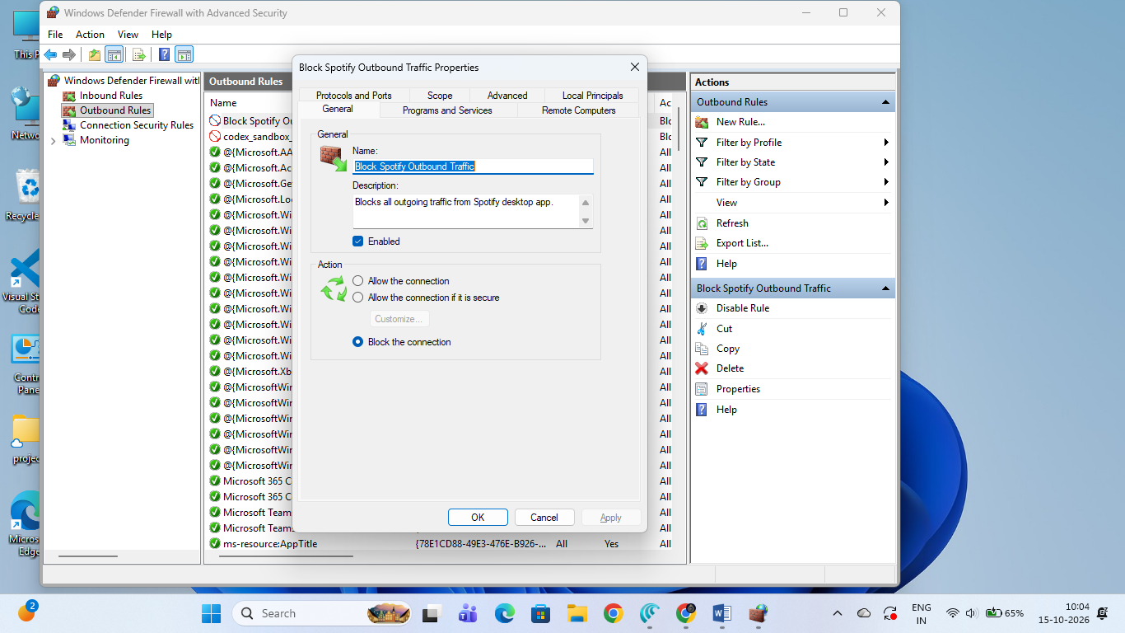

Windows Defender Firewall - Block Spotify Outbound Traffic

1. Configuration Summary:
- Tool Used: Windows Defender Firewall with Advanced Security (wf.msc)
- Rule Type: Outbound Rule
- Rule Name: Block Spotify Outbound Traffic
- Program Executable Path: %LocalAppData%\Microsoft\WindowsApps\Spotify.exe (or %AppData%\Spotify\Spotify.exe)
- Action: Block the connection
- Profiles Applied: Domain, Private, and Public
- Status: Active & Enabled

2. Step-by-Step Implementation Procedure:
- Opened Windows Defender Firewall with Advanced Security by running wf.msc.
- Navigated to Outbound Rules and clicked New Rule... under the Actions menu.
- Selected Program as the Rule Type and specified the application path for the Spotify desktop app executable (Spotify.exe).
- Set the Action to Block the connection.
- Applied the rule across all network profiles (Domain, Private, Public).
- Named the rule Block Spotify Outbound Traffic and saved it.

3. Network Security Analysis (Outcome & Behavior):
- Network Behavior: Blocked all outgoing network packets initiated by the Spotify client towards remote streaming servers.
- Application Impact: When Spotify is opened, it fails to fetch online media content, showing an offline error message despite active internet connectivity on the system.
- Security Purpose: Demonstrates application-level traffic filtering to prevent unauthorized data transmission, background telemetry, or potential data leaks from specific desktop software.
2. Set up an inbound rule in Windows Defender Firewall to allow incoming connections only for Google Chrome on port 443 (HTTPS).
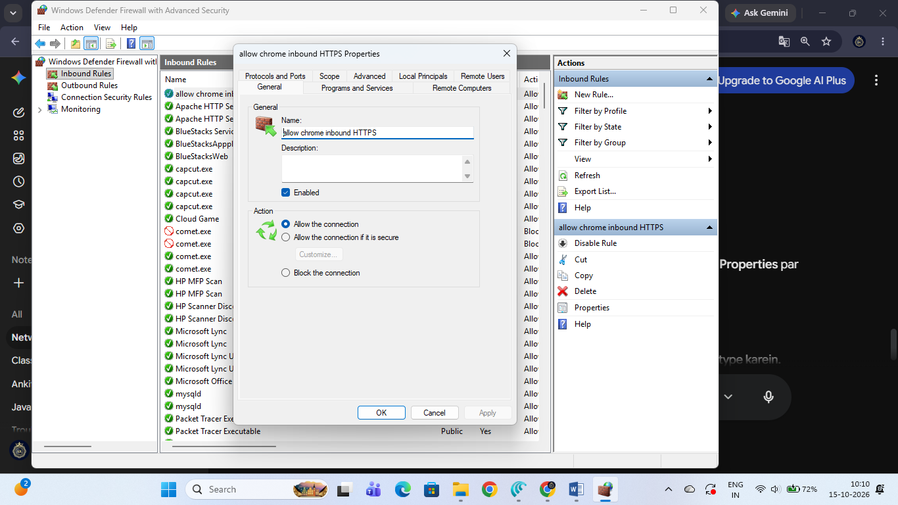

Windows Defender Firewall - Allow Inbound HTTPS Traffic for Google Chrome

1. Configuration Summary:
- Tool Used: Windows Defender Firewall with Advanced Security (wf.msc)
- Rule Type: Inbound Rule
- Rule Name: allow chrome inbound HTTPS
- Target Application: Google Chrome (%ProgramFiles%\Google\Chrome\Application\chrome.exe or %ProgramFiles(x86)%\Google\Chrome\Application\chrome.exe)
- Protocol: TCP
- Local Port: 443 (HTTPS)
- Action: Allow the connection
- Profiles Applied: Domain, Private, and Public
- Status: Active & Enabled

2. Step-by-Step Implementation Procedure:
- Opened Windows Defender Firewall with Advanced Security using wf.msc.
- Selected Inbound Rules from the left navigation tree and clicked New Rule... under the Actions pane.
- Chose Program as the Rule Type and provided the file path for chrome.exe.
- Configured the Action to Allow the connection.
- Applied the rule across all network profiles (Domain, Private, Public).
- Named the rule allow chrome inbound HTTPS and completed the wizard.
- Opened the rule's Properties, navigated to the Protocols and Ports tab, selected TCP as the protocol, set the Local Port to Specific Ports, and specified port 443.

3. Network Security Analysis (Outcome & Purpose):
- Network Behavior: Permits incoming TCP traffic over port 443 specifically targeted at the Google Chrome application.
- Security Purpose: Demonstrates the application of the Principle of Least Privilege by restricting inbound connections strictly to necessary transport layer protocols (TCP) and standard secure communication ports (Port 443/HTTPS) for a designated executable.
- Impact: Prevents unsolicited incoming connections on non-standard ports while granting explicit ingress access for secure HTTPS network traffic.
3. Document, step-by-step, how you would block all traffic from a specific IP address (for example, 123.45.67.89) using Windows Defender Firewall.Use the 'Scope' tab when creating a new rule to specify the IP address.
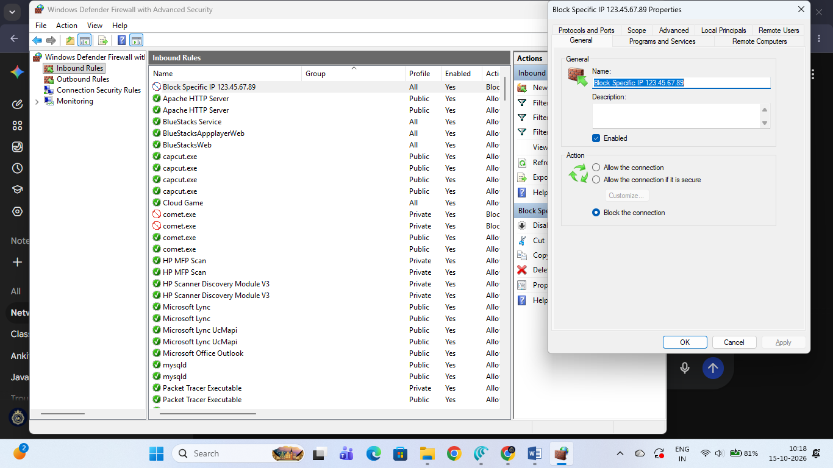

Block All Traffic from a Specific IP Address Using Windows Defender Firewall

1. Configuration Summary:
- Tool Used: Windows Defender Firewall with Advanced Security (wf.msc)
- Rule Type: Custom Rule (Inbound/Outbound)
- Target IP Address: 123.45.67.89 (Remote IP Address via Scope tab)
- Action: Block the connection
- Profiles Applied: Domain, Private, and Public
- Rule Name: Block Specific IP 123.45.67.89

2. Step-by-Step Implementation Procedure:
- Opened Windows Defender Firewall with Advanced Security by running the command wf.msc via the Run dialog.
- Selected Inbound Rules from the left navigation tree and clicked New Rule... in the Actions pane.
- Chose Custom as the rule type and clicked Next.
- Set the program selection to All programs and proceeded.
- Left the Protocol type as Any.
- Configured the Scope tab:
  - Under "Which remote IP addresses does this rule apply to?", selected These IP addresses.
  - Clicked Add and specified the target IP address: 123.45.67.89.
  - Clicked OK and then Next.
- Selected Block the connection as the required action.
- Applied the rule across all network profiles (Domain, Private, Public).
- Named the rule Block Specific IP 123.45.67.89 and clicked Finish.

3. Network Security Analysis (Outcome & Purpose):
- Network Behavior: The firewall immediately drops all incoming network packets originating from or communicating with the specified remote IP address (123.45.67.89).
- Security Purpose: Utilizes the Scope feature to enforce IP-based filtering, which is vital in cybersecurity for isolating malicious hosts, blocking unauthorized scanners, or mitigating targeted network attacks.

4. Compare hardware firewalls (like those used in large offices) and software firewalls (like Windows Defender) by listing 3 key differences and a use case for each.

Comparison Between Hardware Firewalls and Software Firewalls

1. Three Key Differences:
- Deployment & Placement:
  - Hardware Firewall: Acts as a physical network gateway (often placed between the local network/router and the internet) to protect an entire organization or network segment.
  - Software Firewall: Installed and run locally as an application/service directly on an individual operating system (e.g., Windows Defender Firewall) to protect that specific host device.
- Resource Utilization & Performance:
  - Hardware Firewall: Features dedicated processors and memory (ASICs), ensuring high-speed packet filtering without consuming host CPU or RAM resources.
  - Software Firewall: Relies on the host computer's processor and system memory to inspect incoming and outgoing traffic packets.
- Scope of Protection:
  - Hardware Firewall: Protects multiple connected devices simultaneously across the entire local area network (LAN).
  - Software Firewall: Granularly protects a single device/host, making it effective even when the device moves across different external networks (e.g., public Wi-Fi).

2. Practical Use Cases:
- Hardware Firewall Use Case:
  - Large Corporate Offices / Enterprise Networks: Used at the network perimeter (edge) of an enterprise to screen all inbound and outbound traffic for hundreds or thousands of employee workstations connected to the corporate LAN.
- Software Firewall Use Case:
  - Remote Workers / Standalone Host Protection: Used on an individual laptop (such as Windows Defender Firewall on Windows 10/11) to control application-level traffic (e.g., blocking specific apps or opening port 443 for Chrome) while traveling or working on unsecured public networks.

