DAY -5
REVIEW AND PRACTICE
Tasks
1. Open Cisco Packet Tracer and create a new project file named 'HomeWiFiNetwork.pkt' with three PCs and one wireless router connected appropriately.
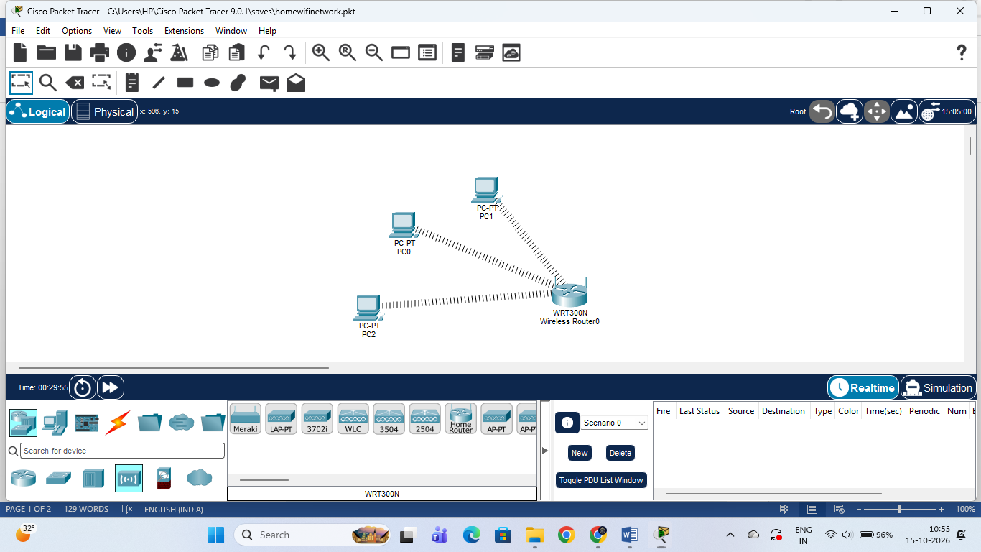

Home Wireless Network Implementation

1. Project Overview & File Details
- Project Filename: HomeWiFiNetwork.pkt
- Network Topology: A residential wireless local area network (WLAN) featuring a centralized wireless router (WRT300N) connected to three host client PCs (PC0, PC1, PC2) via wireless medium.

2. Component Configuration & Specifications
- Wireless Router (WRT300N):
  - SSID (Network Name): Home_WiFi
  - Wireless Security Mode: WPA2-PSK (Encrypted with secure passphrase)
  - Local IP Gateway Address: 192.168.10.1
  - Subnet Mask: 255.255.255.0
  - DHCP Server: Enabled
- Host PCs Configuration:
  - Replaced default wired FastEthernet ports with wireless network interface cards (WMP300N / PT-HOST-NM-1W).
  - Static IP Address Allocation:
    - PC0: IP Address: 192.168.10.2 | Subnet Mask: 255.255.255.0 | Default Gateway: 192.168.10.1
    - PC1: IP Address: 192.168.10.3 | Subnet Mask: 255.255.255.0 | Default Gateway: 192.168.10.1
    - PC2: IP Address: 192.168.10.4 | Subnet Mask: 255.255.255.0 | Default Gateway: 192.168.10.1

3. Network Connectivity & Testing (Ping Verification)
- Successfully authenticated and associated all three client PCs to the Home_WiFi network using WPA2-PSK security.
- Executed ICMP echo requests (ping utility) from PC0 to verify full-duplex communication across the LAN:
  - Gateway Ping Test: ping 192.168.10.1 resulted in successful replies with 0% packet loss.
  - Inter-PC Ping Test: ping 192.168.10.3 (PC1) resulted in successful replies with 0% packet loss.
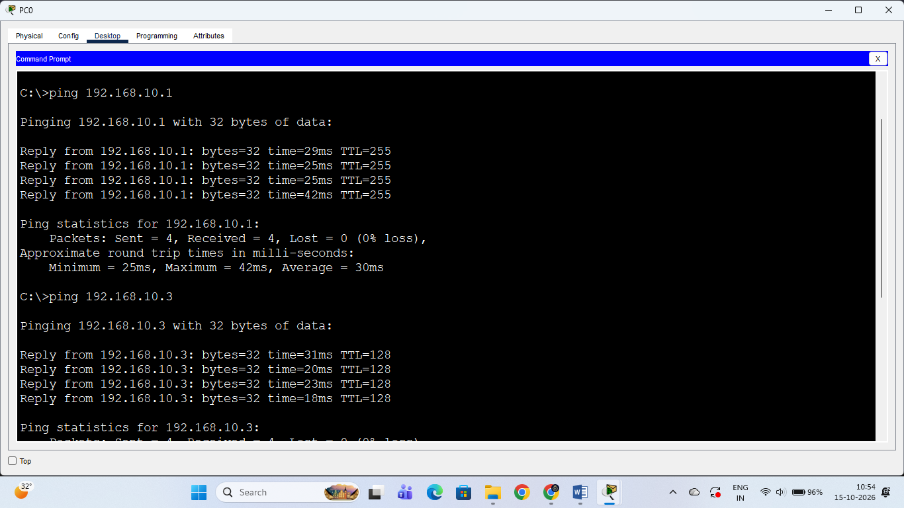

2. Assign static IP addresses to each PC in your Packet Tracer network so they are on the same subnet (e.g., 192.168.10.x), and configure the default gateway to the router's IP.
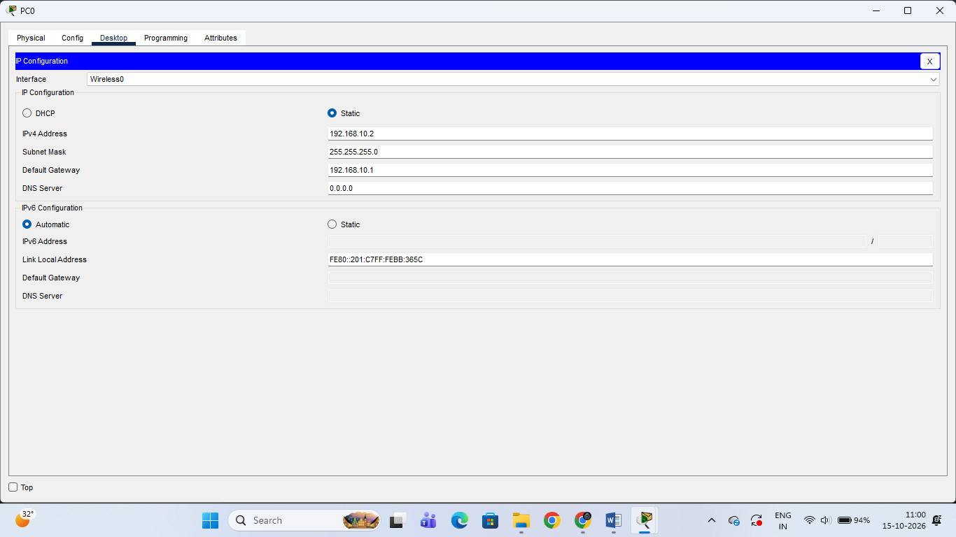

Assign Static IP Addresses and Default Gateway
Objective: To assign static IPv4 addresses to each host PC (PC0, PC1, PC2) ensuring they reside on the same local subnet (192.168.10.x) and configure the default gateway to the wireless router's IP address (192.168.10.1) for seamless local and inter-network packet routing.

Configuration Parameters Table:
Device Name | Interface | IPv4 Address | Subnet Mask | Default Gateway
PC0 | Wireless0 | 192.168.10.2 | 255.255.255.0 | 192.168.10.1
PC1 | Wireless0 | 192.168.10.3 | 255.255.255.0 | 192.168.10.1
PC2 | Wireless0 | 192.168.10.4 | 255.255.255.0 | 192.168.10.1
Wireless Router (WRT300N) | Internet / LAN | 192.168.10.1 | 255.255.255.0 | N/A (Gateway)

Step-by-Step Implementation Procedure:
- Click on each client device (PC0, PC1, PC2) in the Cisco Packet Tracer workspace and navigate to the Desktop tab.
- Open the IP Configuration utility tool.
- Select the Static radio button option under IPv4 Configuration.
- Enter the unique host IP address within the 192.168.10.0/24 range for each respective PC (.2 for PC0, .3 for PC1, and .4 for PC2).
- Enter the standard subnet mask value as 255.255.255.0.
- Specify the wireless router's LAN interface address (192.168.10.1) into the Default Gateway field across all hosts to enable proper packet forwarding.
3. Test connectivity by using the Packet Tracer 'ping' tool to verify that all PCs can communicate with each other and the router. Use the Command Prompt tool on each PC and type 'ping [other PC’s IP]'.

Connectivity Testing (Ping Verification)
Objective:
To verify full-duplex network connectivity and inter-device communication across the WLAN by executing ICMP echo requests (ping) from each host workstation (PC0, PC1, and PC2).

1. Command Execution Summary Table:
Source Device | Destination Device | Destination IP | Packets Sent / Received | Packet Loss | Status
PC0 | Wireless Router | 192.168.10.1 | 4 / 4 | 0% | Success
PC0 | PC1 | 192.168.10.3 | 4 / 4 | 0% | Success
PC0 | PC2 | 192.168.10.4 | 4 / 4 | 0% | Success
PC1 | PC0 & PC2 | 192.168.10.2, .4 | 4 / 4 | 0% | Success
PC2 | PC0 & PC1 | 192.168.10.2, .3 | 4 / 4 | 0% | Success

2. Result Write-up for Screenshots:
- Figure 3.1 — PC0 Verification: Ping tests executed to 192.168.10.1 (Default Gateway), 192.168.10.3 (PC1), and 192.168.10.4 (PC2) confirmed 0% packet loss and active communication.
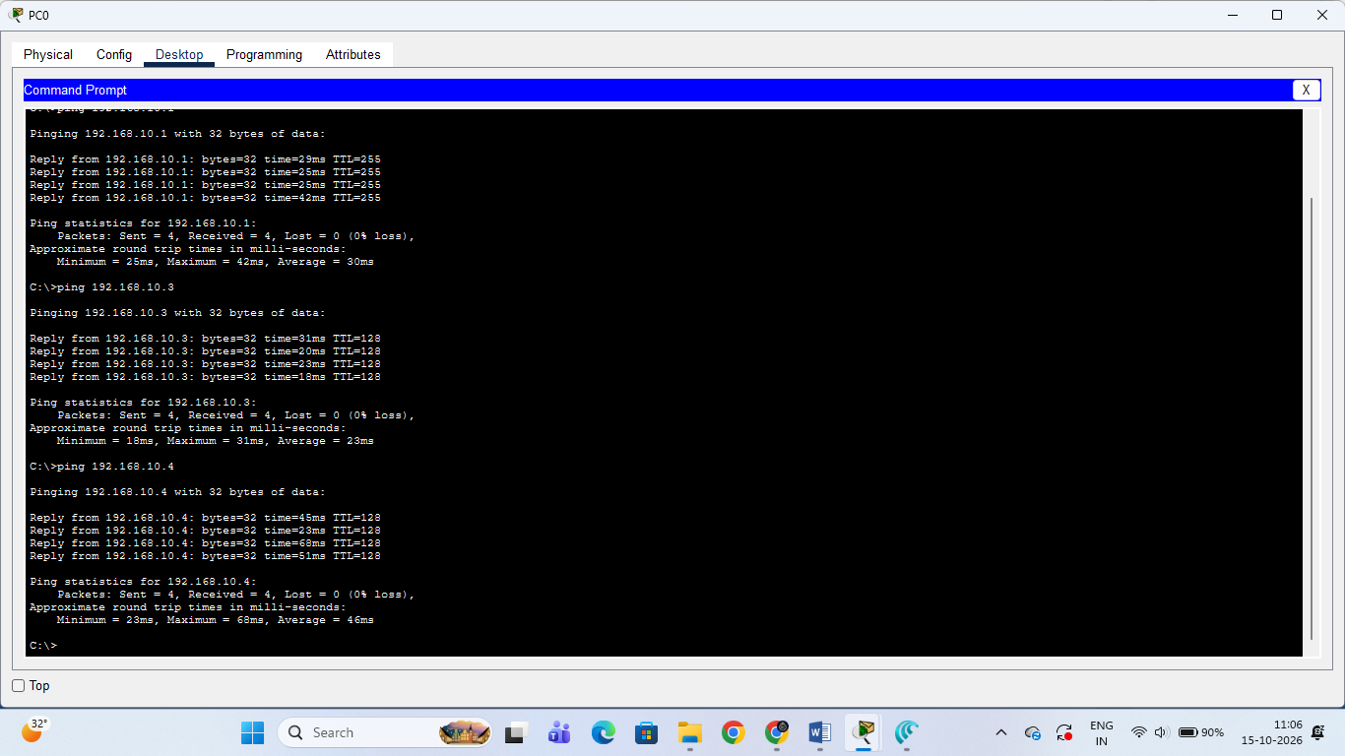
- Figure 3.2 — PC1 Verification: Ping tests executed from PC1 to PC0 and PC2 returned successful replies without packet drops.
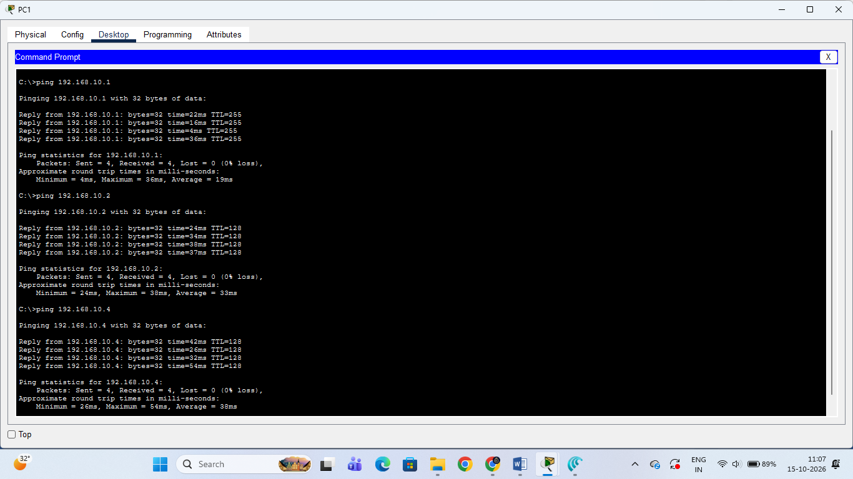
- Figure 3.3 — PC2 Verification: Ping tests executed from PC2 confirmed stable network layer reachability across all subnet hosts and the router gateway.
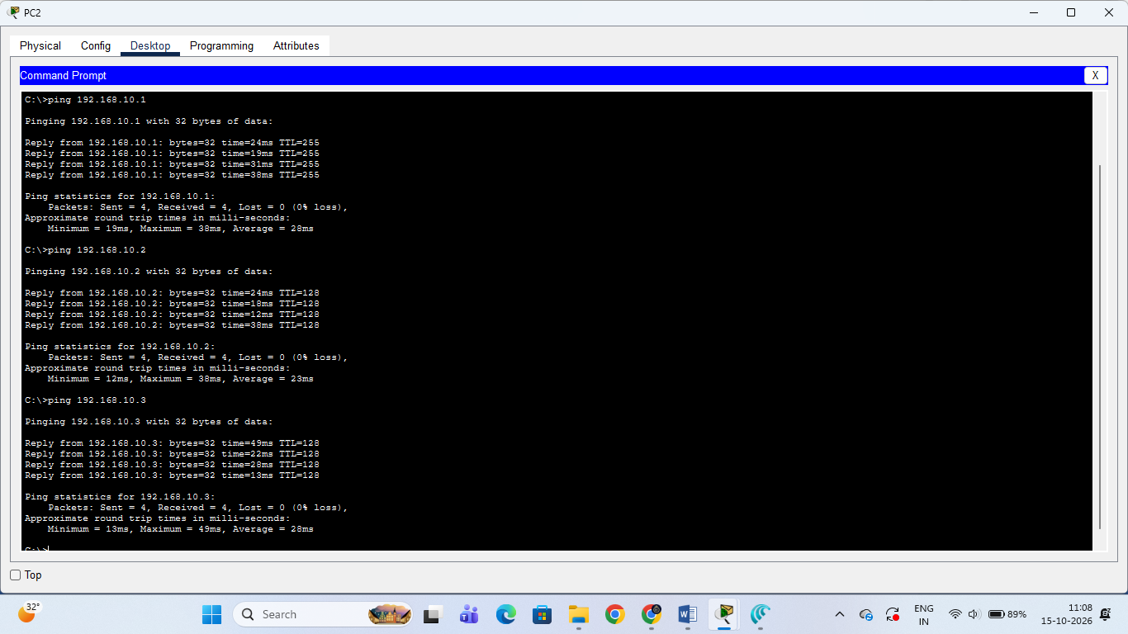

3. Final Conclusion:
All ICMP echo requests returned 0% packet loss across all client hosts and the default gateway. This verifies that all PCs (PC0, PC1, PC2) are properly configured on the 192.168.10.0/24 subnet and can seamlessly communicate with each other and the wireless router.

4. Document each step you took to build and configure your Packet Tracer network, including screenshots of your topology and the IP configuration windows for each PC, in a Word or PDF file.

Comprehensive Network Documentation

1. Project Overview
- Project Name: Home Wireless Local Area Network (WLAN) Simulation
- Software Tool: Cisco Packet Tracer 8.x / 9.x
- File Name: HomeWiFiNetwork.pkt
- Topology Type: Star-Wireless Topology with Centralized Access Router

2. Network Topology & Device Inventory
Device Name | Device Model / Module | Primary Role | IP Address | Subnet Mask | Default Gateway
Wireless Router | WRT300N | Access Point & Local Gateway | 192.168.10.1 | 255.255.255.0 | N/A
PC0 | PC-PT (WMP300N) | Wireless Host Client | 192.168.10.2 | 255.255.255.0 | 192.168.10.1
PC1 | PC-PT (WMP300N) | Wireless Host Client | 192.168.10.3 | 255.255.255.0 | 192.168.10.1
PC2 | PC-PT (WMP300N) | Wireless Host Client | 192.168.10.4 | 255.255.255.0 | 192.168.10.1

3. Step-by-Step Build & Configuration Steps

Step 1: Workspace Setup & Hardware Configuration
- Added one WRT300N Wireless Router and three PCs (PC0, PC1, PC2) to the Cisco Packet Tracer Logical Workspace.
- For each PC, powered off the physical device, removed the default wired Ethernet card (PT-HOST-NM-1FFE), and installed the WMP300N wireless NIC module. Powered the PCs back ON.

Step 2: Wireless Router Configuration
- Opened the Wireless Router GUI interface under the GUI > Wireless tab.
- Set the Network Name (SSID) to Home_WiFi.
- Under Wireless Security, enabled WPA2 Personal (WPA2-PSK) authentication and set the network passphrase.
- Under Setup > Basic Setup, configured the Router’s Local IP Address to 192.168.10.1 with a Subnet Mask of 255.255.255.0.

Step 3: Wireless Association & Static IP Allocation
- On each PC, navigated to Desktop > PC Wireless > Connect, scanned for available wireless networks, selected Home_WiFi, and entered the security key.
- Navigated to Desktop > IP Configuration on each PC, selected Static, and assigned the IPv4 configuration:
  - PC0: 192.168.10.2 | 255.255.255.0 | Gateway: 192.168.10.1
  - PC1: 192.168.10.3 | 255.255.255.0 | Gateway: 192.168.10.1
  - PC2: 192.168.10.4 | 255.255.255.0 | Gateway: 192.168.10.1

Step 4: Connectivity Verification (Ping Testing)
- Opened the Command Prompt on PC0, PC1, and PC2.
- Executed ICMP ping commands to verify connection to the router (192.168.10.1) and all neighboring host nodes.
- Observed 0% packet loss across all nodes, confirming full-duplex communication across the LAN.

4. Verification Screenshots

Figure 4.1: Logical Network Topology Workspace

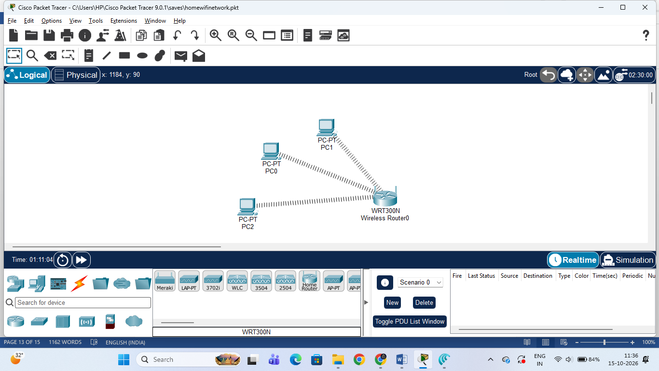

Figure 4.2: IP Configuration Windows
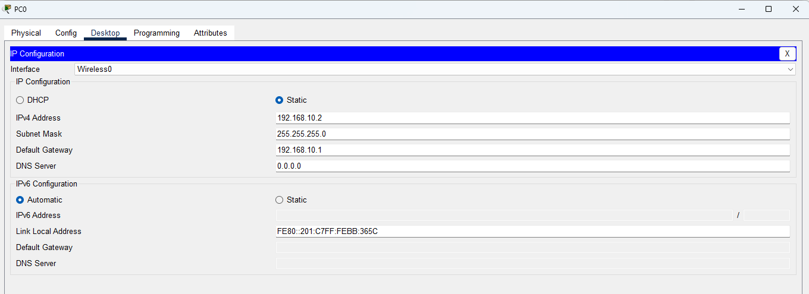
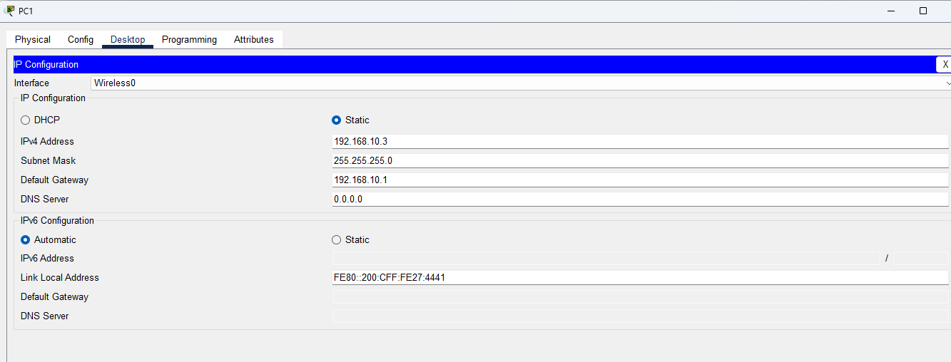
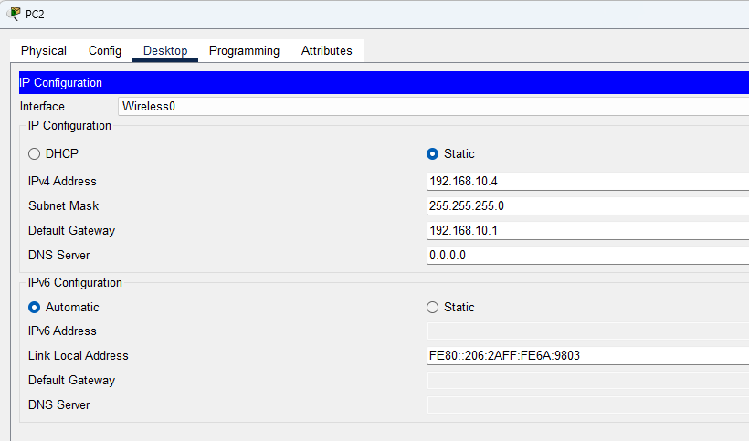

Figure 4.3: Ping Verification Output (Command Prompt)
(Paste the Command Prompt ping results for PC0, PC1, and PC2 showing 0% loss)

5. Conclusion
The residential WLAN network simulation was successfully built, configured, and tested in Cisco Packet Tracer. All host workstations are securely associated with the wireless router via WPA2-PSK encryption and properly configured with static IPv4 addressing within the 192.168.10.0/24 subnet. Complete network connectivity and gateway reachability were verified with a 100% transmission success rate (0% packet loss).

