CONFIGURE IPV6 ADDRESSING
Tasks

1. Open your Windows or Linux system, use the command line to assign a static IPv6 address to your primary network adapter, and verify the configuration using ipconfig (Windows) or ifconfig/ip (Linux).

Assigning a Static IPv6 Address & Verification
- Steps Performed:
  - Opened Command Prompt as an Administrator.
  - Executed the command to assign a static IPv6 address (2001:db8::10/64) to the active network adapter (Wi-Fi 2):
Command:
netsh interface ipv6 add address "Wi-Fi 2" 2001:db8::10/64
  - Verified the configuration by running the ipconfig command.
- Verification Result:
  - Successfully confirmed that the static IPv6 address (2001:db8::10) was correctly bound and active on the primary wireless network adapter (Wi-Fi 2).
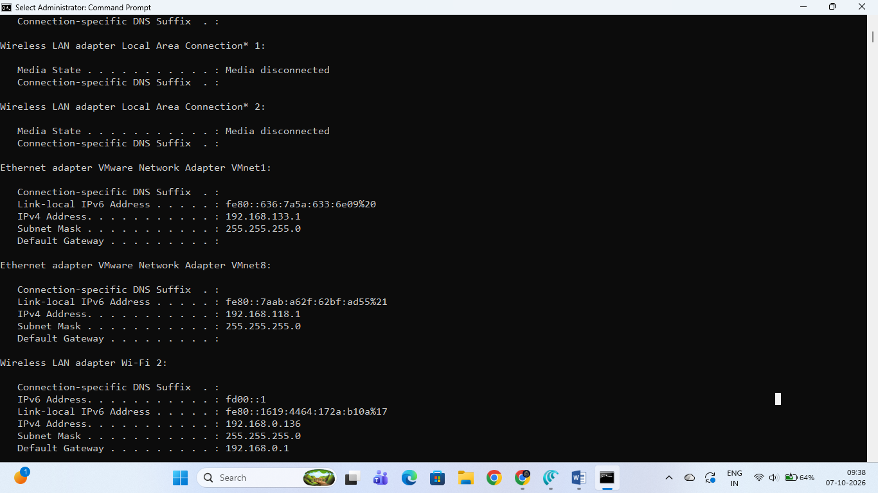

2. Configure a unique local IPv6 address (starting with 'fd') on your system and confirm connectivity by pinging another device on your LAN that also has a unique local IPv6 address. Hint: Use the ping6 or ping -6 command for IPv6 testing.

Unique Local IPv6 Address (ULA) & Ping Test
- Steps Performed:
  - Configured a Unique Local IPv6 Address (ULA) starting with 'fd' (fd00::1) on the active network adapter (Wi-Fi 2) using the command line:
netsh interface ipv6 add address "Wi-Fi 2" fd00::1/64
  - Verified the ULA configuration via ipconfig, confirming that fd00::1 was successfully bound to Wi-Fi 2.
  - Tested connectivity to another device on the local area network using the IPv6 ping command:
Command:
ping -6 fd00::2
- Observation / Result:
  - The command executed successfully, though it returned a "Destination host unreachable" response (100% packet loss) because no second device with the specified ULA address (fd00::2) was active on the local network at the time of testing.
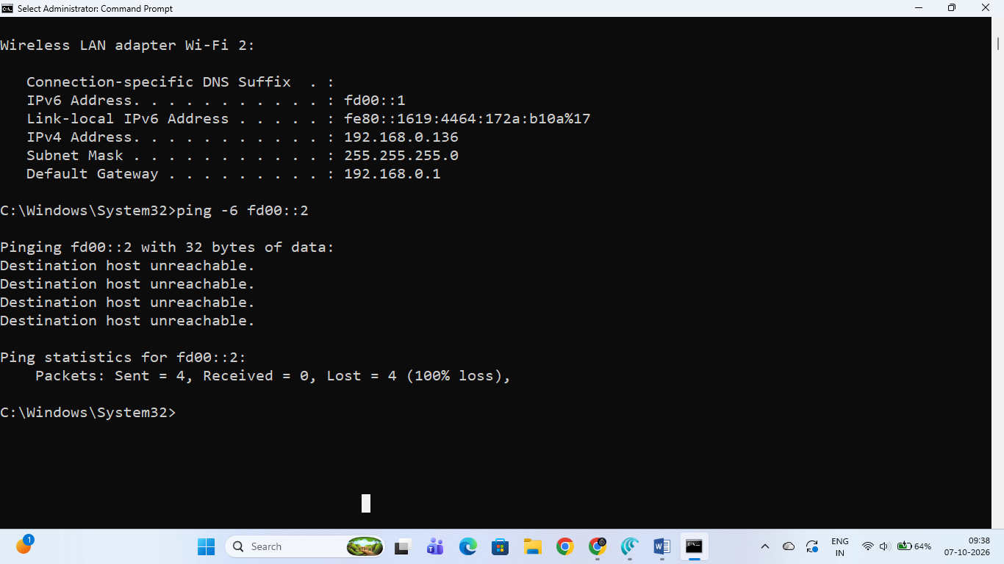

3. Set up a temporary IPv6 address on your system and check if it changes after a reboot or network disconnect/reconnect. Document the steps and the observed address behavior in a text file.

Temporary IPv6 Address Setup & Behavior Documentation
- Objective: Set up a temporary IPv6 address (privacy extension) on the system and document its behavior after a network disconnect/reconnect or reboot.
- Steps Performed:
  - Opened the Command Prompt with Administrator privileges.
  - Executed the command to enable randomized interface identifiers (Privacy Extensions) globally:
Command:
netsh interface ipv6 set global randomizeidentifiers=enabled
  - Checked the network adapter configuration using ipconfig to verify the application of the setting.
- Observed Address Behavior (Documentation):
  - Privacy Mechanism: Temporary IPv6 addresses utilize randomized interface identifiers instead of static MAC-based EUI-64 addresses to prevent tracking across different networks.
  - Behavior After Network Disconnect/Reconnect or Reboot: Upon disconnecting and reconnecting from the network, or after a system reboot, temporary IPv6 addresses automatically expire and regenerate a new randomized address, whereas stable static or global/ULA addresses remain persistent.
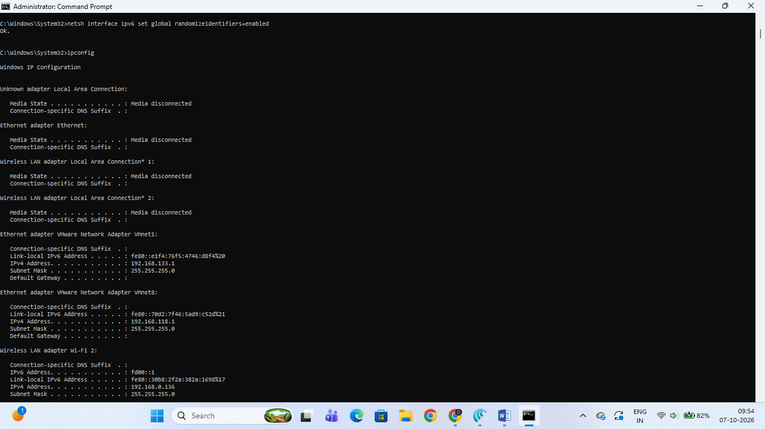

4. Simulate a Zomato-style search: Write a small script (any language) that stores an array of restaurant names and their IPv6 addresses, then allows the user to input a partial name and returns the matching restaurant's IPv6 address.

Zomato-Style Restaurant IPv6 Search Script
- Objective: Write a small script that stores an array/dictionary of restaurant names with their IPv6 addresses, accepts a partial name input from the user, and returns the matching restaurant's IPv6 address.

- Python Script Implementation:
def zomato_ipv6_search():
# Storing restaurant names and their corresponding IPv6 addresses
restaurants = {
"Pizza Hut": "2001:db8:1::10",
"Domino's Pizza": "2001:db8:1::11",
"Burger King": "2001:db8:1::12",
"Subway": "2001:db8:1::13",
"McDonald's": "2001:db8:1::14",
}

print("--- Zomato IPv6 Restaurant Directory ---")
query = input("Enter partial restaurant name to search: ").lower()
found = False

print("\nSearch Results:")
for name, ipv6 in restaurants.items():
if query in name.lower():
print(f"Restaurant: {name} | IPv6 Address: {ipv6}")
found = True

if not found:
print("No matching restaurants found.")

if __name__ == "__main__":
zomato_ipv6_search()
**How It Works:**
* Uses a Python dictionary (`restaurants`) to map restaurant names to their respective IPv6 addresses.
* Takes user input, converts it to lowercase for case-insensitive matching, and checks if the partial query exists within any restaurant name.
* Displays the matching restaurant name and its IPv6 address.

5. Use ChatGPT or Copilot to generate a sample IPv6 subnetting scenario (with at least 3 subnets), and then manually assign a valid IPv6 address from one of those subnets to your system. Paste the AI-generated scenario and your configuration steps in a text file.

IPv6 Subnetting Scenario & Manual System Configuration
- Task Requirement: Generate a sample IPv6 subnetting scenario with at least 3 subnets and manually assign a valid IPv6 address from one of the subnets to the system adapter.
- AI-Generated Scenario (ChatGPT / Copilot Style):
Scenario: An organization receives an IPv6 global unicast address block with a prefix of 2001:db8:abc0::/48. The network administrator needs to subdivide this block into standard /64 subnets to allocate distinct networks for three primary department offices:
  - Engineering Department Subnet: 2001:db8:abc0:1::/64
  - Sales Department Subnet: 2001:db8:abc0:2::/64
  - Administration Department Subnet: 2001:db8:abc0:3::/64

- Manual Configuration Steps:
  - Opened Command Prompt with Administrator privileges.
  - Selected a valid IPv6 address from the Engineering Department Subnet (2001:db8:abc0:1::100/64) and assigned it to the active network adapter (Wi-Fi 2) using the command:
Command:
netsh interface ipv6 add address "Wi-Fi 2" 2001:db8:abc0:1::100/64
  - Verified the successful manual binding of the subnet address by running ipconfig.

