NETWORK TOPOLOGIES
Tasks

1. Draw and label diagrams of star, bus, and mesh network topologies on paper or using any drawing tool. For each, write one real-world app or service (like WhatsApp, Flipkart, or IPL streaming) that could use that topology and explain why in 1-2 lines.

- Star Topology

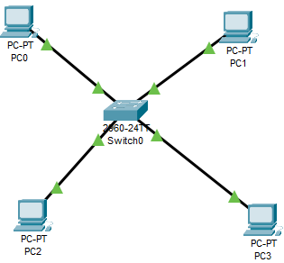

Real-world example: WhatsApp
WhatsApp uses centralized servers through which users send and receive messages and media. This is conceptually similar to a star arrangement because communication is coordinated through a central point.

- Bus Topology

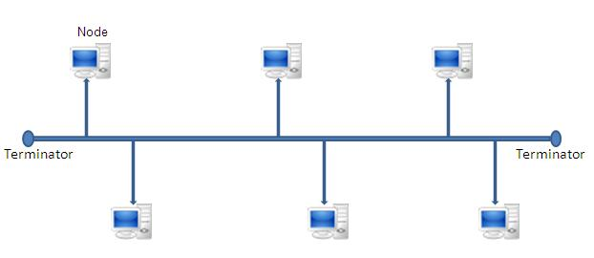
Real-world example: Cable TV Network
A cable TV network can use a shared main cable to distribute signals to multiple connections. This is similar to a bus topology where devices share one main communication line.

( C ) Mesh Topology

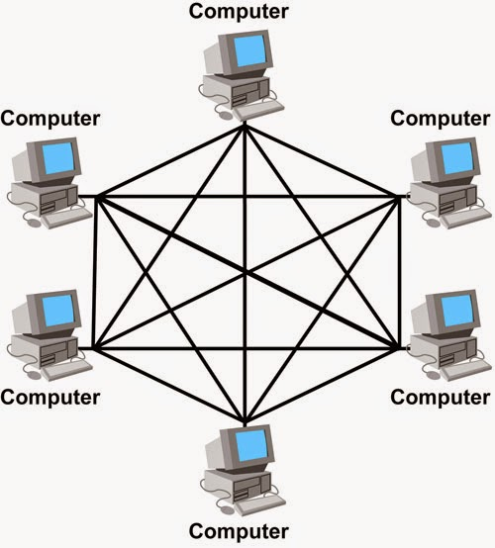
Real-world example: Internet
The Internet has many interconnected paths between networks. Multiple paths can allow data to reach its destination even when one path is unavailable.

2. Create a comparison table listing at least four pros and four cons for each of these topologies: star, bus, ring, mesh. Include a column for 'Best Use Case' and give an example from apps you use (e.g., Instagram, Zomato, Paytm).

Comparison Table for Network Topologies
Topology | Pros (4 Advantages) | Cons (4 Disadvantages) | Best Use Case | Real-World Example
Star | 1) Easy to add/remove devices  2) Failure of one cable doesn't affect others  3) Easy troubleshooting  4) High performance under normal load | 1) Central hub failure brings down the entire network  2) Requires more cable than bus  3) Hub/Switch cost  4) Setup complexity for large scales | Local Area Networkks (LAN), offices, and smart homes. | Home Wi-Fi network connected to a router.
Bus | 1) Requires minimal cable  2) Easy to set up for small networks  3) Cost-effective  4) Simple linear layout | 1) Single cable break disables the entire network  2) Difficult troubleshooting  3) Performance degrades with more devices  4) No centralized management | Small, temporary, or legacy networks. | Early office computer networks.
Ring | 1) Data travels in one direction (no collisions)  2) Equal access for all devices  3) Predictable performance  4) Good for high-load systems | 1) Single device/cable failure breaks the whole ring  2) Difficult to reconfigure while active  3) Slower data transfer in large rings  4) Complex setup | Closed loops or specific telecom systems. | Fiber optic ring networks in telecommunications.
Mesh | 1) High redundancy and reliability  2)Secure (dedicated lines)  3) If one path fails, data takes another route  4) Handles high traffic well | 1) Extremely expensive  2) Complex installation  3) Heavy cabling required  4) Difficult maintenance | Critical systems requiring high fault tolerance and security. | Internet backbone routing / Military communication.

3. Imagine you are designing a new multiplayer mobile game like PUBG or Free Fire. Choose a suitable network topology for the game servers and justify your choice in 3-4 lines, mentioning how it would impact speed, reliability, and cost.

Multiplayer Mobile Game Topology (PUBG / Free Fire)
- Selected Topology: Star Topology (with Regional Cloud Servers)

- Justification: For a game like PUBG or Free Fire, Star Topology ensures high speed with low latency as players connect directly to the nearest regional server hub rather than routing through each other. It provides high reliability because if one player's connection drops, it only affects that single user without disrupting the match for others. Additionally, it is cost-effective because developers can easily scale up server capacity centrally as the player base grows worldwide.

4. Given this scenario: A small Flipkart-style warehouse wants to connect 8 computers for order processing and inventory updates. Recommend a network topology, sketch a quick diagram, and explain your reasoning in 2-3 lines. Consider factors like cost, ease of troubleshooting, and future expansion.

Warehouse Network Topology Solution
- Recommended Topology: Star Topology
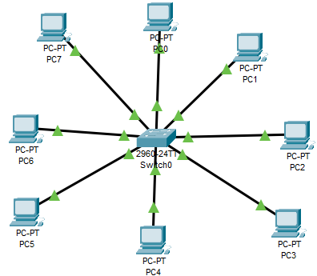
Reasoning: Star topology is cost-effective to set up and allows easy future expansion by plugging new computers or scanners into the central switch without disrupting warehouse operations. It also ensures high reliability and ease of troubleshooting, as the failure of a single cable or computer will only affect that specific terminal.

