OSI LAYER
Tasks

1. Draw a diagram of the OSI 7-layer model and label each layer with its correct name and a real-world example of a device or protocol that operates at that layer (e.g., Switch at Data Link, HTTP at Application).

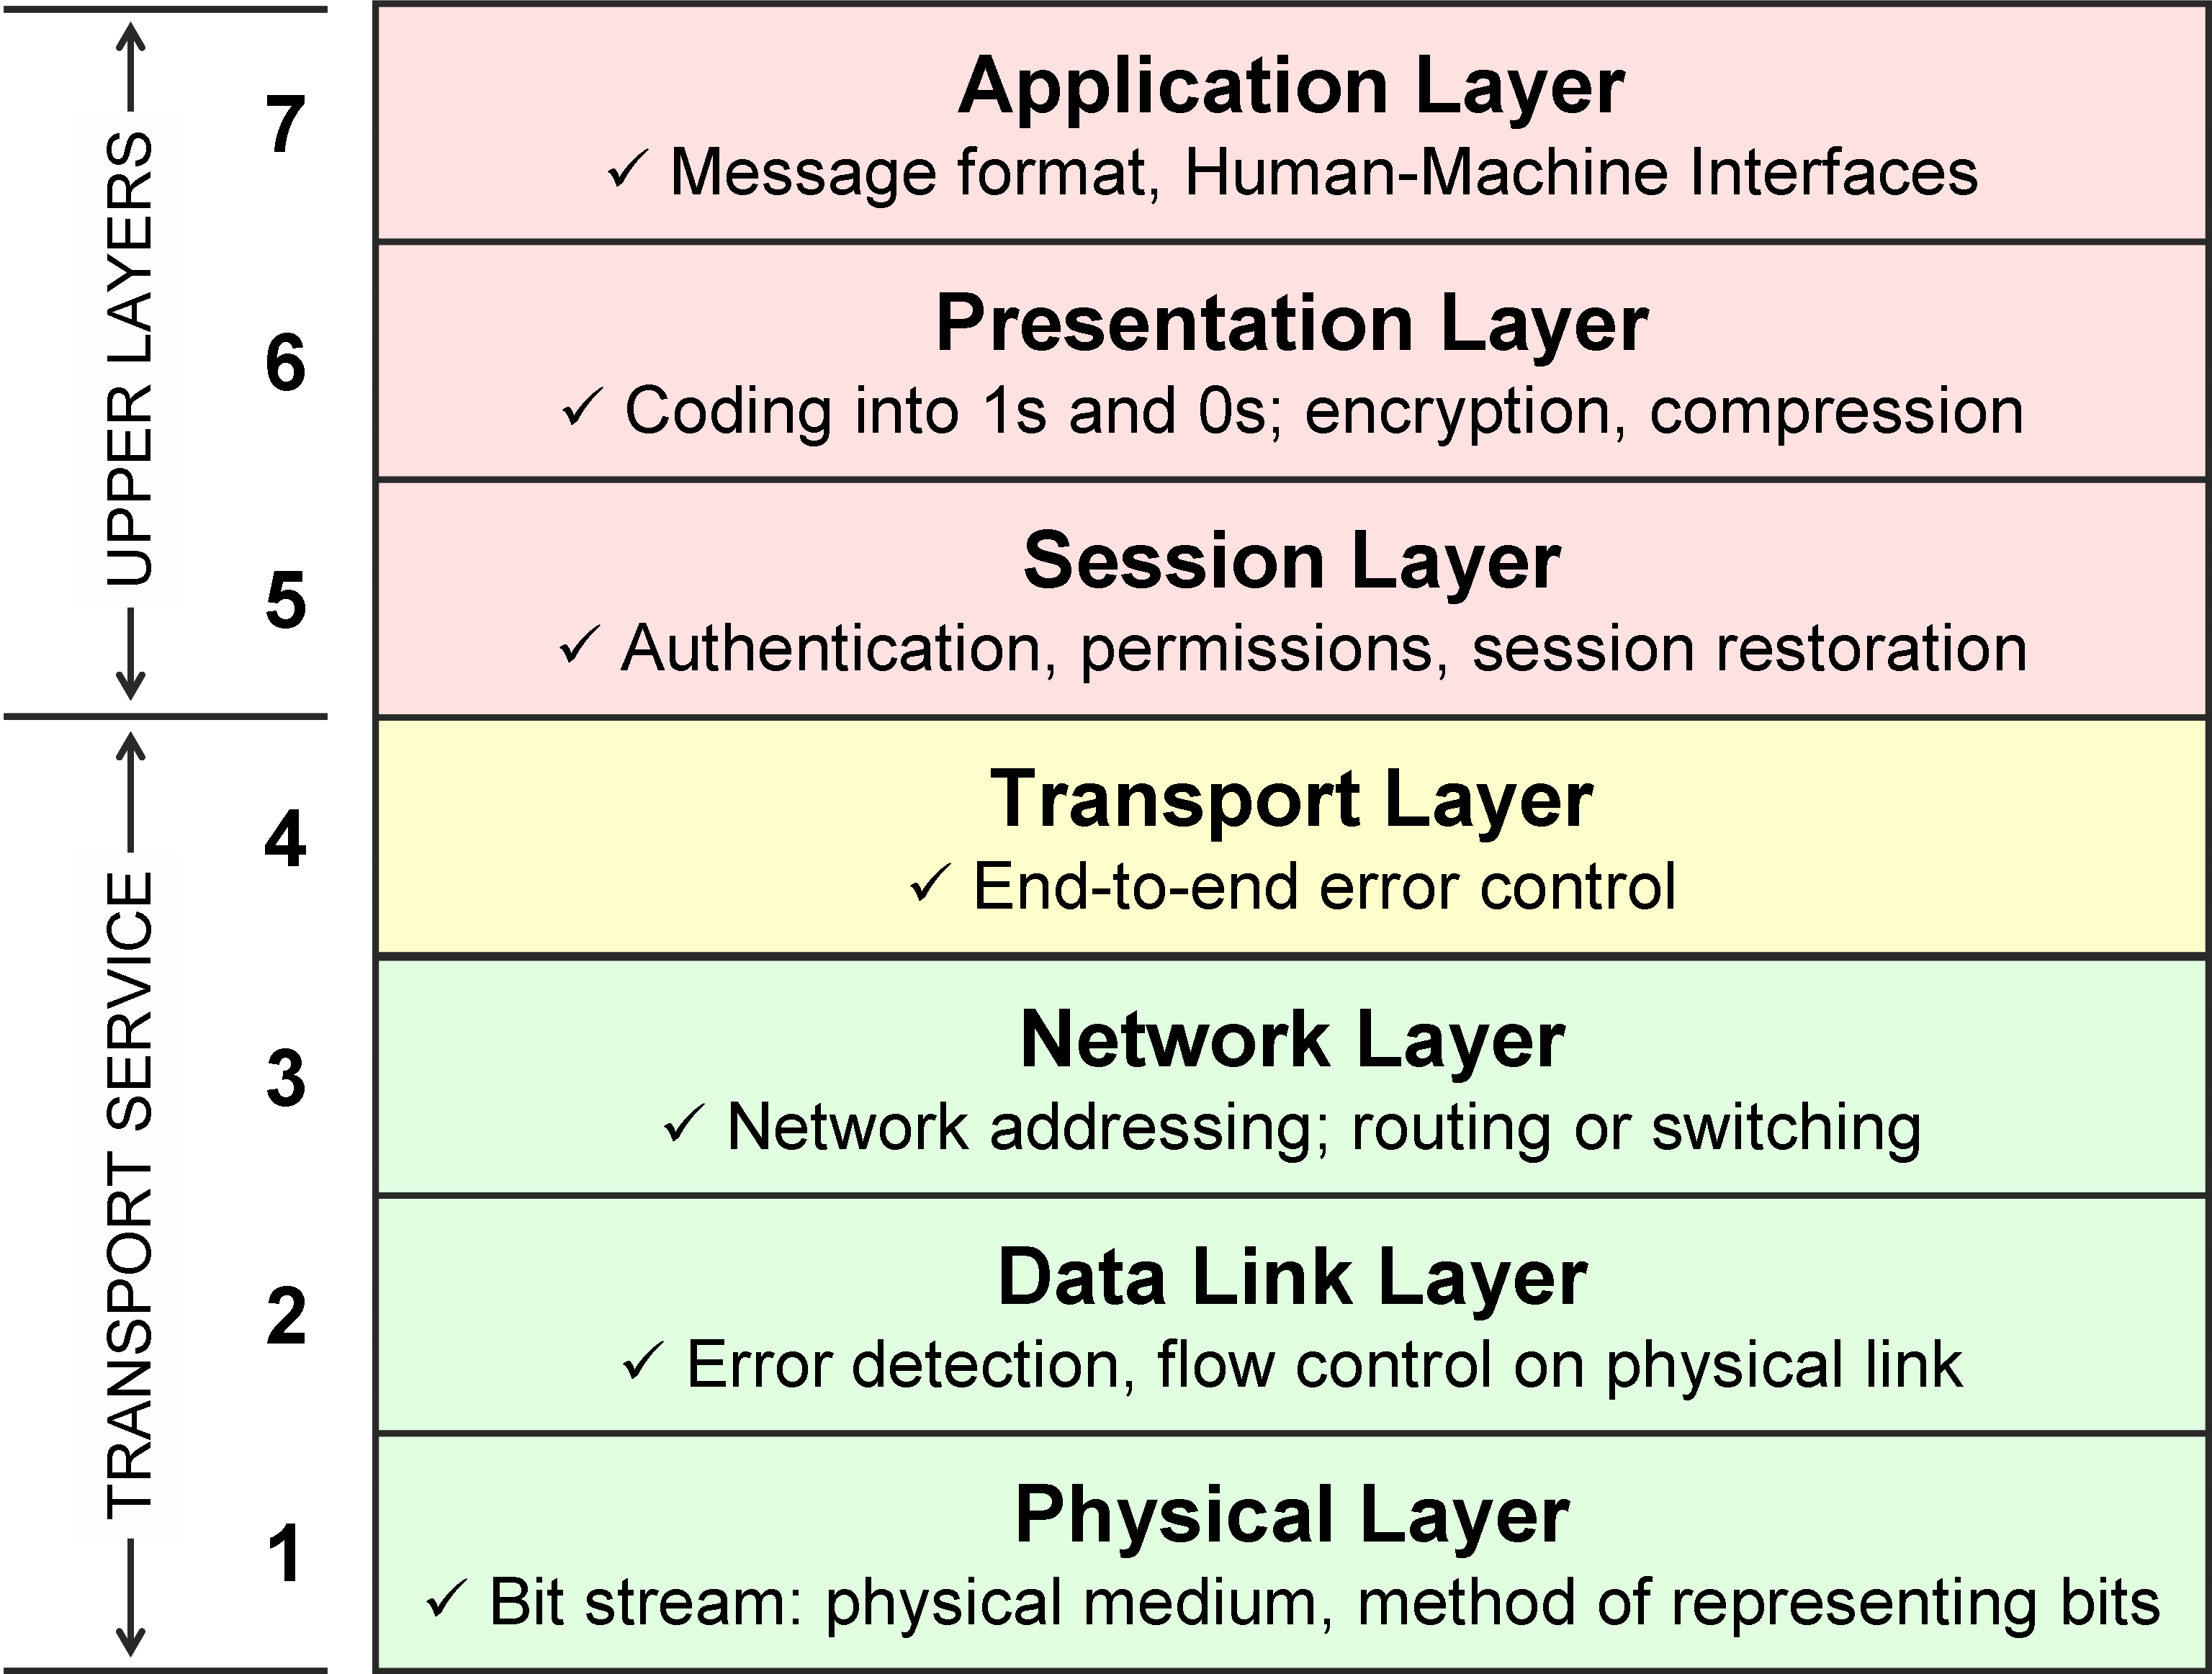

Labels & Real-World Examples:
- Physical Layer (Layer 1): Deals with physical cables, hardware signals, and bit transmission. Example: Network Hub, Ethernet Cables.
- Data Link Layer (Layer 2): Handles node-to-node data transfer, frame creation, and error detection. Example: Network Switch, MAC Addresses.
- Network Layer (Layer 3): Handles packet routing, logical addressing, and path determination across multiple networks. Example: Router, IP (Internet Protocol).
- Transport Layer (Layer 4): Ensures reliable end-to-end data delivery, segmentation, and flow control. Example: TCP (Transmission Control Protocol), UDP.
- Session Layer (Layer 5): Manages and maintains communication sessions between different applications. Example: APIs, NetBIOS.
- Presentation Layer (Layer 6): Translates, encrypts, and compresses data so that applications can read it. Example: SSL/TLS encryption, JPEG/ASCII formatting.
- Application Layer (Layer 7): Provides network services directly to user applications and browsers. Example: HTTP/HTTPS browsers, WhatsApp, Instagram.

2. Match the following networking scenarios to the correct OSI layer:
a) Encrypting data before sending, b) Routing packets across networks, c) Converting data to electrical signals,
d) Opening a web page in your browser,e) Detecting and correcting errors in frames.Write your answers as 'Scenario: Layer Name (Layer Number)'.

Matching Networking Scenarios to OSI Layers
- a) Encrypting data before sending: Presentation Layer (Layer 6)
- b) Routing packets across networks: Network Layer (Layer 3)
- c) Converting data to electrical signals: Physical Layer (Layer 1)
- d) Opening a web page in your browser: Application Layer (Layer 7)
- e) Detecting and correcting errors in frames: Data Link Layer (Layer 2)

3. Pick any app you use daily (like WhatsApp, Instagram, or Zomato) and describe how at least three different OSI layers are involved when you send or receive data in that app.

OSI Layers in Daily App Usage (WhatsApp)
When I send or receive a message on WhatsApp, multiple OSI layers work together behind the scenes:
- Application Layer (Layer 7): This is the topmost layer where you interact with the app. When you type and hit send on a message, the WhatsApp interface uses application-level protocols to package your chat request.
- Transport Layer (Layer 4): Once the message is ready, the Transport Layer (using protocols like TCP) breaks the message into smaller segments, ensures reliable and error-free delivery, and handles flow control between your phone and WhatsApp's servers.
- Network Layer (Layer 3): This layer adds logical IP addresses to the data packets. Routers use these IP addresses to find the best and fastest route across the global internet to deliver the message to the recipient's device.

4. Given this scenario: You are unable to access a website, but you can successfully ping its IP address. Identify which OSI layer(s) might be causing the problem and explain your reasoning.

Troubleshooting OSI Layers Scenario
- Identified Problematic Layer: Application Layer (Layer 7) (along with possible Presentation/Session Layers 5 & 6).
- Reasoning:
  - Since I can successfully ping the IP address, it proves that the lower layers (Physical Layer 1, Data Link Layer 2, and Network Layer 3) are functioning perfectly, meaning your device has an active physical connection and correct routing path to the destination server.
  - The inability to access the website using its web address typically points to a DNS (Domain Name System) resolution failure at the Application Layer (where the browser fails to map the domain name to that IP address), an invalid or expired SSL/TLS certificate (Presentation Layer 6), or the web server application itself being down.

