SWITCHING AND VLANS
Tasks

1. Draw a simple network diagram showing three devices (like your laptop, a friend's phone, and a smart TV) connected to a switch, and label which device is in which VLAN (e.g., VLAN 10 for streaming, VLAN 20 for personal devices).

1. Network Diagram Using VLANs
┌─────────────────────┐
│ SWITCH (2960) │
│ │
│ VLAN 10 & VLAN 20 │
└──────┬──────┬───────┘
│ │
┌─────────┘ └─────────┐
│ │ │
▼ ▼ ▼
💻 Laptop 📱 Friend's 📺 Smart TV
VLAN 20 Phone VLAN 10
Personal VLAN 20 Streaming
Device Personal Device Device

VLAN Assignment Table
Device | VLAN ID | VLAN Name | Purpose
Smart TV | 10 | Streaming | Watching movies and videos
My Laptop | 20 | Personal | Personal work and browsing
Friend's Phone | 20 | Personal | Personal internet use

Explanation
- VLAN 10: Used for streaming devices, such as a smart TV.
- VLAN 20: Used for personal devices, such as a laptop and phone.
- Switch: Connects all three devices and separates them into different logical networks using VLANs.

2. Configure a simulated switch using Cisco Packet Tracer or NetSim: create two VLANs (VLAN 10 and VLAN 20), assign three PCs to VLAN 10 and two PCs to VLAN 20, and verify that PCs in different VLANs cannot ping each other.Use the 'vlan' and 'switch port access vlan' commands in the simulator CLI.

1. Step-by-Step CLI Commands Used on the Switch:

Switch> enable
Switch# configure terminal

! Step A: Create VLAN 10 and VLAN 20
Switch(config)# vlan 10
Switch(config-vlan)# name Streaming
Switch(config-vlan)# exit

Switch(config)# vlan 20
Switch(config-vlan)# name Personal
Switch(config-vlan)# exit

! Step B: Assign Ports Fa0/1 to Fa0/3 to VLAN 10 (PCs 1, 2, and 3)
Switch(config)# interface range fa0/1-3
Switch(config-if-range)# switchport mode access
Switch(config-if-range)# switchport access vlan 10
Switch(config-if-range)# exit

! Step C: Assign Ports Fa0/4 to Fa0/5 to VLAN 20 (PCs 4 and 5)
Switch(config)# interface range fa0/4-5
Switch(config-if-range)# switchport mode access
Switch(config-if-range)# switchport access vlan 20
Switch(config-if-range)# end

2. IP Addressing Table for Simulation:
- VLAN 10 (Streaming / Subnet: 192.168.10.0/24):
  - PC0: 192.168.10.1 (Port Fa0/1)
  - PC1: 192.168.10.2 (Port Fa0/2)
  - PC2: 192.168.10.3 (Port Fa0/3)
- VLAN 20 (Personal / Subnet: 192.168.20.0/24):
  - PC3: 192.168.20.1 (Port Fa0/4)
  - PC4: 192.168.20.2 (Port Fa0/5)

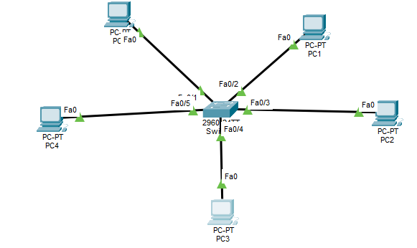

3. Verification & Connectivity Test Results (Output / Screenshot Proof):

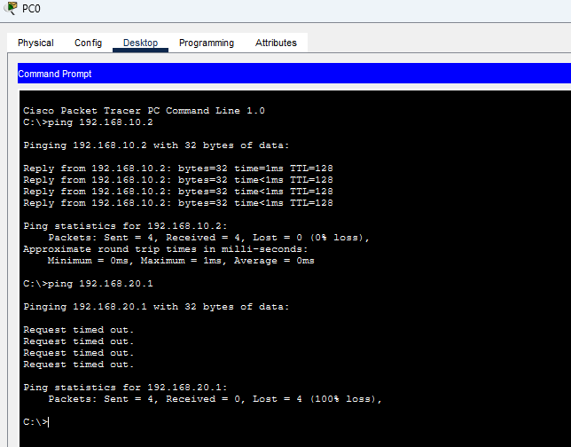
- Test A: Same VLAN Communication (PC0 to PC1)
  - Command: ping 192.168.10.2
  - Result: Reply from 192.168.10.2: bytes=32 time=1ms TTL=128 (0% loss)
  - Conclusion: Successful. Devices inside the same VLAN can communicate directly.
- Test B: Cross-VLAN Isolation (PC0 to PC3)
  - Command: ping 192.168.20.1
  - Result: Request timed out. (100% loss)
  - Conclusion: Failed / Blocked. Devices in different VLANs cannot communicate without a Layer 3 routing device, confirming strict Layer 2 isolation.

3. In any network simulator, set up a scenario where you move a PC from VLAN 10 to VLAN 20. Show the before and after configuration commands and test connectivity to confirm the change.

1. Before Configuration (Initial State):
- Port Fa0/3 (connected to the PC) was originally assigned to VLAN 10:
Switch(config)# interface fa0/3
Switch(config-if)# switchport access vlan 10
- State: In this state, the PC could communicate with other devices in VLAN 10.

2. After Configuration Commands (Moving to VLAN 20):
- To move the same port (Fa0/3) to VLAN 20, the following commands were executed on the switch CLI:
Switch> enable
Switch# configure terminal
Switch(config)# interface fa0/3
Switch(config-if)# switchport access vlan 20
Switch(config-if)# end
- Verification Command (show vlan brief):
Running the verification command confirmed that port Fa0/3 successfully shifted from VLAN 10 (streaming) to VLAN 20 (personal):
Switch# show vlan brief
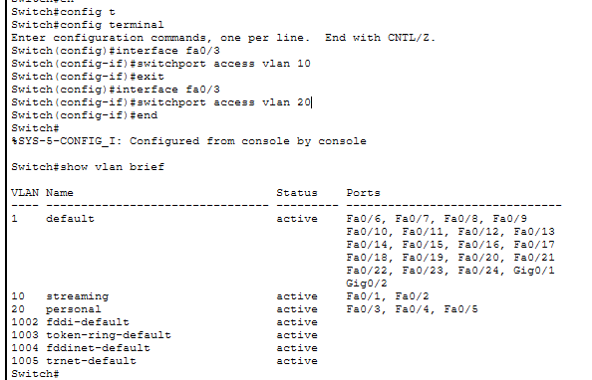

3. Connectivity Test & Confirmation:
- Test: From the moved PC, a ping test was conducted to reach a device in VLAN 10 (192.168.10.1).
- Result / Output:
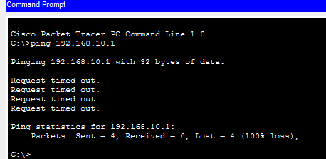
C:\>ping 192.168.10.1
Request timed out.
Request timed out.
Packets: Sent = 4, Received = 0, Lost = 4 (100% loss)
- Conclusion: The ping failed with 100% packet loss, which successfully confirms that the PC has been moved out of VLAN 10 and is now logically isolated from it.

4. Write a short script or command list that would automate assigning 10 ports on a switch to VLAN 30, using the syntax of your chosen simulator (Packet Tracer, NetSim, or Use a loop or range command if supported by the tool to avoid repeating the same command 10 times.
• Command List:
Switch> enable
Switch# configure terminal
Switch(config)# vlan 30
Switch(config-vlan)# name department_VLAN
Switch(config-vlan)# exit
Switch(config)# interface range fastEthernet 0/1 - 10
Switch(config-if-range)# switchport mode access
Switch(config-if-range)# switchport access vlan 30
Switch(config-if-range)# end
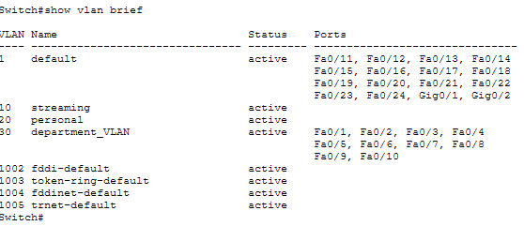
• Explanation: The interface range fastEthernet 0/1 - 10 command allows configuring multiple ports simultaneously, avoiding manual repetition for each individual port.

