DAY-2
NETWORK TOPOLOGIES
Tasks

1. Draw a diagram of a bus topology and label all key components, then write one real-world example where this topology might be used.

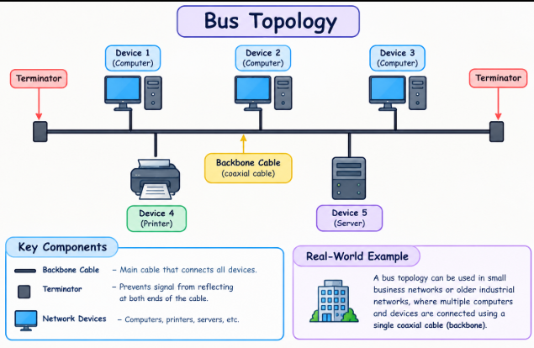
Explanation: Bus topology connects multiple devices through a single main cable called the backbone cable. Terminators are placed at both ends to prevent signal reflection. If the main cable fails, the entire network may stop working.
Real-World Example: Bus topology was used in older office networks where multiple computers shared a single coaxial cable.
2. In Cisco Packet Tracer, create a simple star topology with one switch and four PCs connected to it; name each PC after a popular app (e.g., WhatsApp, Zomato, Spotify, Flipkart) and take a screenshot of your topology.

Star Topology in Cisco Packet Tracer

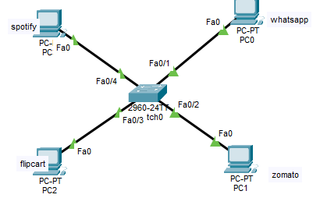
- Topology Type: Star Topology
- Central Device: 1 Network Switch (Cisco 2960-24TT)
- Connected End Devices: 4 PCs named whatsapp, zomato, flipcart, and spotify
- Cabling & Interface Connections:
  - whatsapp: Switch Port Fa0/1 $\leftrightarrow$ PC Port Fa0
  - zomato: Switch Port Fa0/2 $\leftrightarrow$ PC Port Fa0
  - flipcart: Switch Port Fa0/3 $\leftrightarrow$ PC Port Fa0
  - spotify: Switch Port Fa0/4 $\leftrightarrow$ PC Port Fa0
- Link Status: Active (All connection indicators are Green)

3. Draw a ring topology diagram and explain in 2-3 sentences how data travels between devices in this setup. Use arrows to show the direction of data flow.
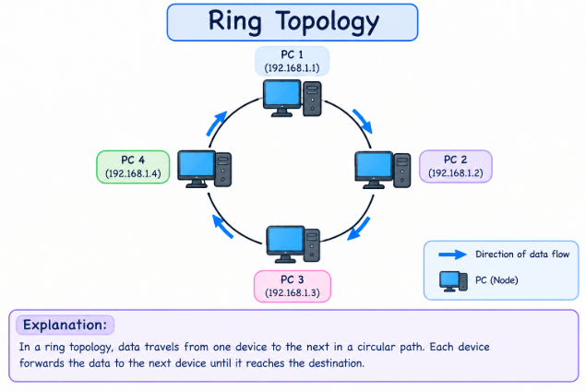
Explanation: In a ring topology, each device is connected to two neighboring devices, forming a circular network. Data travels from one device to the next in the direction shown by the arrows until it reaches its destination. Each device forwards the data to the next device in the ring.

4. Compare mesh and star topologies by listing 2 advantages and 2 disadvantages of each in a table format.

Mesh vs. Star Topologies Comparison
Topology Type | Advantages | Disadvantages
Mesh Topology | 1. Provides redundant paths, ensuring high reliability and fault tolerance if a single link fails.  2. High data security and privacy because dedicated point-to-point links prevent interference. | 1. Extremely high installation, cabling, and hardware maintenance cost.  2. Complex physical setup and configuration due to a large number of interconnecting cables.
Star Topology | 1. Easy to install, configure, and isolate faults (failure of one cable only affects that specific device).  2. High overall performance and scalability via the central switch or hub. | 1. Single point of failure: if the central switch fails, the entire network goes down.  2. Requires more cable length running from each device to the central hub compared to bus or ring topologies.

