DAY-6
INTRODUCTION TO NETWORK DEVICES
Tasks
1. Create a table listing the main functions and typical ports used by switches, routers, hubs, firewalls, and access points in a home WiFi setup.

Network Devices Comparison Table
Network Device | Main Function in a Home WiFi Setup | Typical Ports Used
Router | Connects your home network to the Internet (WAN) and routes data packets between different local subnets. | WAN Port (Ethernet/RJ45), LAN Ports (RJ45), Power Port, USB Port
Switch | Connects multiple devices (PCs, smart TVs, printers) within the same local network (LAN) using wired Ethernet. | Multiple LAN/Ethernet Ports (RJ45), Uplink Port, Power Port
Access Point (AP) | Extends wireless network coverage by converting wired network signals into wireless Wi-Fi signals for mobile devices and laptops. | Ethernet Port (RJ45 with PoE support), Power Port, External Antennas
Hub | A legacy networking device that broadcasts incoming data packets to all connected ports indiscriminately (largely obsolete in modern home setups). | Multiple RJ45 Ethernet Ports, Power Port
Firewall | Inspects incoming and external network traffic, filtering out malicious data, malware, and unauthorized access based on configured security rules. | WAN/Internet Port, LAN/Internal Ports, Console Port, Power Port

2. Given images or diagrams of network devices, label each device and mark the ports (Ethernet, console, power, antenna) for at least three devices.

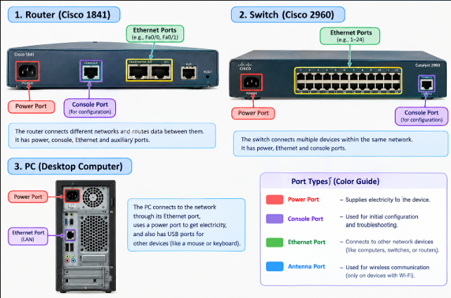
Explanation: A router connects different networks, a switch connects multiple devices within the same network, and a PC is used to access network services. Ethernet ports connect devices to a network, console ports are used to configure network devices, and power ports supply electricity. Antennas are used for wireless communication on Wi-Fi devices.

3. Pick a popular app you use daily (like Instagram, Zomato, or Paytm) and describe in 3-4 lines how at least two different network devices (from switches, routers, firewalls, access points) play a role when you use that app.

Role of Network Devices in Daily Apps (Instagram)
- Access Point: When you open Instagram on your phone via Wi-Fi, the wireless access point receives radio frequency signals from your device and translates them into wired Ethernet data packets to transmit over the local network.
- Router & Firewall: The home router then takes those data packets, directs them across the internet (WAN) to Instagram's cloud servers, while the firewall inspects the incoming and outgoing traffic to block malicious threats and ensure secure data transmission.

4. Suppose your college WiFi is slow and sometimes disconnects. Based on the features of access points, switches, and routers, suggest one possible reason for the issue and how upgrading one device could help. Hint: Think about device capacity, coverage, and traffic handling.

Troubleshooting College Wi-Fi Performance Issues
- Possible Reason: The existing Wireless Access Point (AP) is likely overwhelmed due to exceeding user and device capacity. Since hundreds of students connect simultaneously, the older AP struggles with heavy traffic handling, resulting in channel congestion, high latency, and frequent disconnections.
- How Upgrading Helps: Upgrading to a modern, enterprise-grade Wireless Access Point (supporting Wi-Fi 6 and MU-MIMO technology) will significantly increase concurrent device capacity, efficiently manage heavy data traffic across multiple users, expand coverage, and ensure a stable, high-speed connection.

