DAY 1
INTRODUCTION TO NETWORKING AND THE OSI MODEL
Tasks

1. Install Wireshark on your laptop, start a capture on your main network interface, and visit any website (like instagram.com). Stop the capture and note down the protocol names you see in the packet list.

Wireshark Network Capture & Protocol Observation
- Objective: Install Wireshark, start a capture on the active network interface, visit a website (instagram.com), stop the capture, and note down the observed protocol names from the packet list.

Execution Steps:
- Launched Wireshark and started a live packet capture on the active Wi-Fi network interface (Wi-Fi 2).
- Opened a web browser and navigated to instagram.com to generate live HTTP, DNS, and secure web traffic.
- Allowed the traffic to flow and then stopped the packet capture in Wireshark.

Observed Protocols in the Packet List:
- ARP (Address Resolution Protocol): Resolves local IP addresses to physical MAC addresses.
- UDP (User Datagram Protocol): Used for connectionless, fast data transfer.
- mDNS (Multicast DNS): Handles local network device discovery.
- TCP (Transmission Control Protocol): Manages reliable, connection-oriented communication sessions.
- ICMPv6 (Internet Control Message Protocol for IPv6): Used for network diagnostics, router solicitations, and neighbor discovery.
- TLS (Transport Layer Security): Provides secure, encrypted communication for web browsing and application traffic.
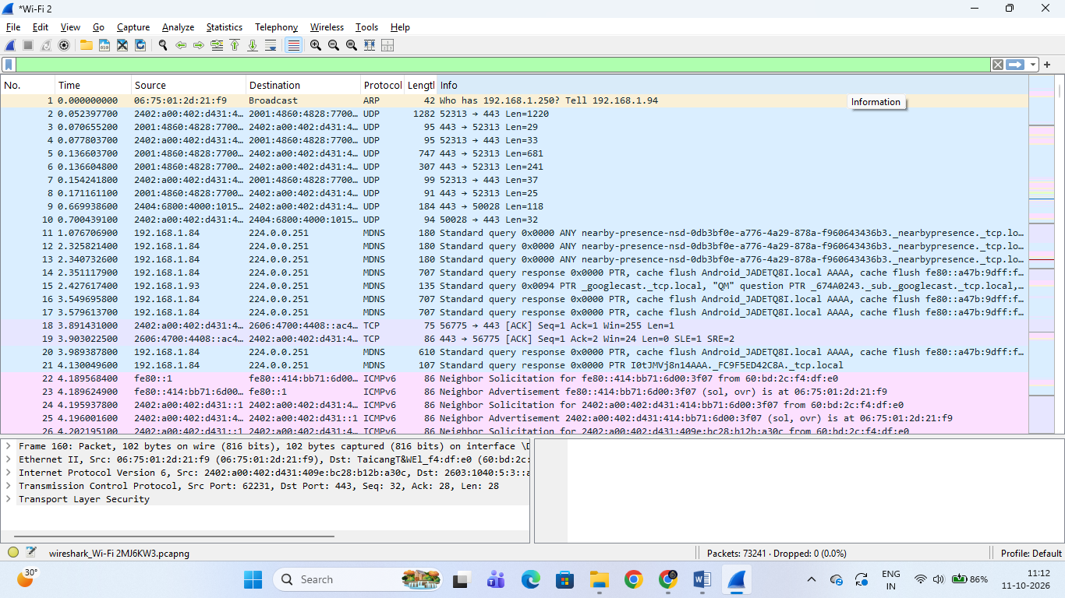

2. Pick any 3 packets from your Wireshark capture and identify which OSI layer each packet mainly represents (for example, HTTP for Application layer, TCP for Transport layer, etc.).Hint: Use the Protocol column and Info details in Wireshark to help you map protocols to OSI layers.

Mapping Wireshark Packets to OSI Model Layers
Based on the live packet capture from Wireshark, here are three specific packets mapped to their respective OSI layers using the Protocol column and Info details:
- Packet 1 (Protocol: TLS / Transport Layer Security)
  - OSI Layer: Application Layer (Layer 7)
  - Reason: TLS operates at the application/upper layers to provide secure, encrypted communication and data privacy for web browsing and application traffic.
- Packet 2 (Protocol: TCP / Transmission Control Protocol)
  - OSI Layer: Transport Layer (Layer 4)
  - Reason: TCP manages reliable, connection-oriented end-to-end communication, segment sequencing, and flow control between source and destination ports.
- Packet 3 (Protocol: ARP / ICMPv6)
  - OSI Layer: Network Layer (Layer 3) (or Data Link Layer for ARP)
  - Reason: ARP resolves local IP addresses to physical MAC addresses, while ICMPv6 handles neighbor discovery and network diagnostics across logical addresses.

3. Create a colorful diagram of the OSI Model using any drawing tool (MS Paint, Canva, or even paper and upload a photo). For each layer, add a real-world example from apps you use daily (e.g., WhatsApp uses the Application layer, Instagram images use the Presentation layer, etc.).
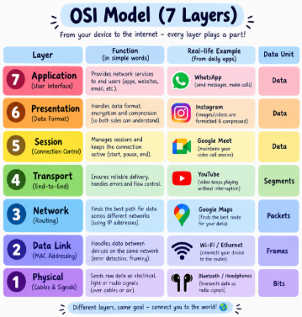

OSI Model Layers with Real-World App Examples
Here is the structured mapping of the 7 layers of the OSI model with daily app examples:
- Layer 7 - Application Layer: Provides network services directly to users (Example: WhatsApp for messaging and calls).
- Layer 6 - Presentation Layer: Handles data formatting, encryption, and compression (Example: Instagram for compressing and rendering images/videos).
- Layer 5 - Session Layer: Manages and maintains communication sessions (Example: Google Meet for keeping an active video call session).
- Layer 4 - Transport Layer: Ensures reliable end-to-end data delivery and flow control (Example: YouTube for continuous buffer-free video streaming).
- Layer 3 - Network Layer: Handles routing and logical IP addressing across networks (Example: Google Maps / IP Routing for finding the best path for data).
- Layer 2 - Data Link Layer: Manages node-to-node communication and MAC addressing on local networks (Example: Wi-Fi / Ethernet connecting to the router).
- Layer 1 - Physical Layer: Transmits raw binary bits over physical media or wireless signals (Example: Bluetooth / Radio waves transmitting physical signals).
4. Explain how sending a message on WhatsApp travels through at least 4 layers of the OSI Model, describing what happens at each layer in your own words. Think about how your message is typed, packaged, sent over the internet, and received.

How a WhatsApp Message Travels Through the OSI Model
When I send a message on WhatsApp, it passes through different layers of the OSI Model before reaching the receiver. Each layer performs a specific task.

7. Application Layer
I open WhatsApp and type a message, such as “Hello, how are you?” This layer provides the interface I use to send the message.

6. Presentation Layer
The message data is represented in a suitable format. Encryption helps protect the message's contents, and compression may be used where appropriate.

5. Session Layer
This layer represents the management of communication between devices, helping maintain the exchange of data during the conversation.

4.Transport Layer
The message data is divided into manageable pieces when needed. Transport protocols help deliver data between the devices and manage communication.

3. Network Layer
IP addresses help route the data across different networks toward the destination.

2. Data Link Layer
The data is placed into frames for transmission over the local network, such as Wi-Fi, between my phone and the router.

1. Physical Layer
The bits travel as radio signals over Wi-Fi or as electrical or optical signals through network connections.

How the message reaches the receiver
The data travels through the network to the recipient's device. The receiving device processes it through the corresponding layers, and WhatsApp displays the message on the screen.
Conclusion: The OSI Model helps explain how a simple WhatsApp message is prepared, transmitted across networks, and received by another person. 📱🌐

