DAY 2
TCP/IP SUITE
Tasks
1. Open Wireshark, capture network traffic while you refresh the Flipkart homepage, and identify one packet each belonging to the Application, Transport, Internet, and Network Access layers by examining their headers.
• Application Layer Packet:
- Protocol: DNS (Domain Name System) / HTTPS (as seen in Packet 90 query for [www.google.com](https://www.google.com)).
- Header/Details: Expandable Domain Name System (query) section showing application-layer web queries.
• Transport Layer Packet:
- Protocol: UDP (User Datagram Protocol)
- Header/Details: In Packet 90 details, see User Datagram Protocol showing Source Port: 50033 and Destination Port: 53.
• Internet Layer Packet:
- Protocol: IPv6 (Internet Protocol version 6)
- Header/Details: See Internet Protocol Version 6 showing Source IP (fe80::c8a4:2a37:586f:1010) and Destination IP (fe80::1).

• Network Access Layer Packet:
- Protocol: Ethernet II / ARP
- Header/Details: See the topmost Ethernet II section showing Source MAC (16:cb:ec:45:a7:ab) and Destination MAC (TaicangT&WEl_f4:df:e0) for local hardware delivery.
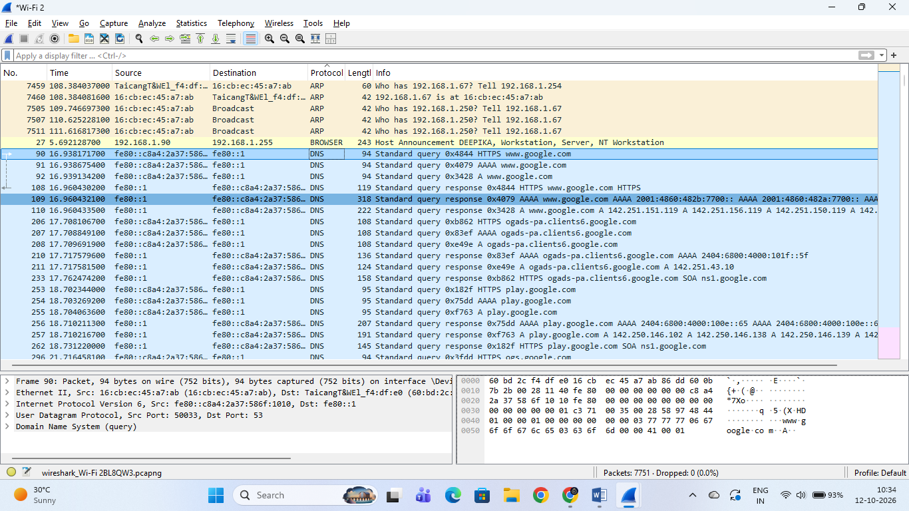

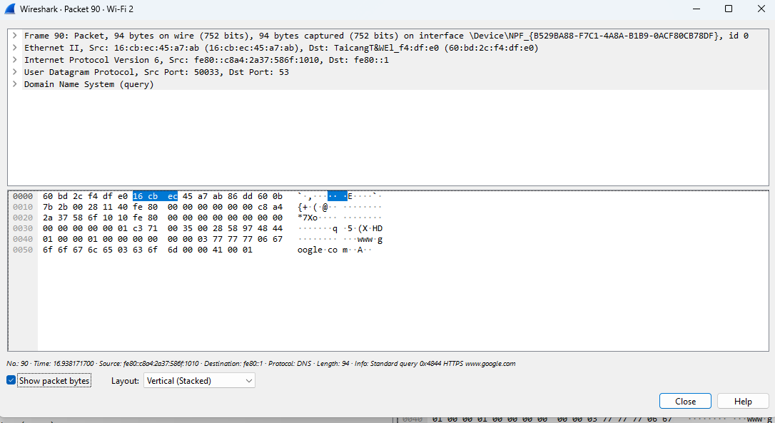

2. Create a table comparing the OSI and TCP/IP models, listing all layers side-by-side, and for each layer, give a real-world example from any app you use (e.g., WhatsApp message, Zomato order).

Comparison of OSI Model and TCP/IP Model with Real-World App Examples
OSI Model Layers (7 Layers) | TCP/IP Model Layers (4 Layers) | Real-World App Example
7. Application Layer | 4. Application Layer | WhatsApp / Instagram: Typing a text message or browsing a social feed.
6. Presentation Layer | (Included in Application Layer) | Instagram / Gallery App: Compressing, formatting, and encrypting images/videos (JPEG/PNG).
5. Session Layer | (Included in Application Layer) | Google Meet / Zoom: Maintaining an active, continuous live video call session login state.
4. Transport Layer | 3. Transport Layer | YouTube / Netflix: Using TCP/UDP to stream continuous video chunks without interruption.
3. Network Layer | 2. Internet Layer | Google Maps / IP Routing: Finding the best route and forwarding data packets across networks using IP addresses.
2. Data Link Layer | 1. Network Access Layer | Wi-Fi / Ethernet: Connecting your device locally to your home/college router using MAC addresses.
1. Physical Layer | 1. Network Access Layer | Bluetooth / Wi-Fi Radio Waves: Transmitting raw binary bits physically through the air.

3. Given a screenshot of a TCP segment header (provided by your trainer), label the fields that belong to the Transport layer and explain what each field does in 1-2 lines. Hint: Look for fields like Source Port, Destination Port, Sequence Number, etc.

TCP Segment Header Fields (Transport Layer)
In the Transport layer, the TCP (Transmission Control Protocol) header contains essential fields that manage reliable, connection-oriented data transfer. Based on the captured TCP segment header:
- Source Port:
  - Function: Identifies the sending application's port number on the source device (e.g., port 61522) so the receiving server knows where to send the response.
- Destination Port:
  - Function: Identifies the receiving application or service port on the destination server (e.g., port 443 for secure HTTPS web traffic).
- Sequence Number:
  - Function: Tracks the order of data bytes sent in the stream (e.g., Seq=0), ensuring that the receiver can reassemble them correctly even if they arrive out of order.
- Acknowledgment Number:
  - Function: Confirms receipt of expected data bytes by notifying the sender up to which byte has been successfully received (Ack=1).

- Window Size:
  - Function: Manages flow control and congestion by telling the sender how much incoming data buffer space the receiver currently has available.
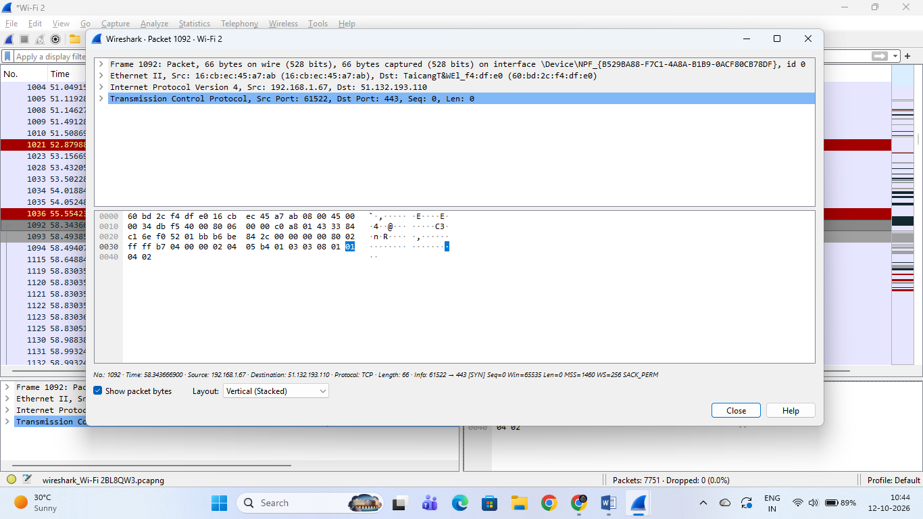

4. Draw a diagram showing how a message sent from your device to Instagram's server passes through each TCP/IP layer, and annotate what happens at each step using simple app-related terms (e.g., 'message split into packets', 'IP address added', etc.).

Journey of an Instagram Message Through TCP/IP Layers
When you send a message from your device to Instagram’s server, the data travels down through the 4 layers of the TCP/IP model. Here is the step-by-step breakdown of what happens at each layer:
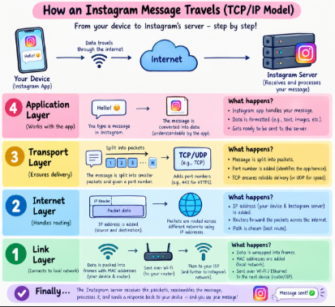
- Application Layer:
  - What happens: You open Instagram, type your message, and hit send. The application creates the user data and formats it using high-level communication protocols (such as HTTP/HTTPS/TLS) so the app can understand it.
- Transport Layer:
  - What happens: The message is split into smaller packets/segments, and port numbers (such as port 443 for HTTPS) are added to ensure reliable delivery and track the connection using protocols like TCP.
- Internet Layer:
  - What happens: The packets are wrapped with an IP address (source and destination IP addresses added), allowing routers to forward and find the best path for your data across different networks over the internet.
- Link / Network Access Layer:
  - What happens: The data is packed into frames with MAC addresses, and sent over Wi-Fi or Ethernet from your device to your local router, which then forwards it further to Instagram's network.
- Finally: Instagram's server receives the packets, reassembles the message, processes it, and confirms delivery!
5. Pick any one packet you captured in Wireshark and write which TCP/IP layer it belongs to, how you identified it, and what real-world action in an app (like sending a WhatsApp message or booking a ticket on BookMyShow) it represents.

Wireshark Packet Analysis & Real-World Application Mapping
- Chosen Packet: Packet 4479 (TLSv1.3 Application Data).
- TCP/IP Layer: Application Layer (running over Transport Layer via TCP).
- How it was identified:
  - In Wireshark, the Protocol column clearly shows TLSv1.3 with info Application Data.
  - Packet details show Source IP (192.168.1.67) connecting to Destination IP (162.247.243.29) via Destination Port 443 (standard port for secure web/app data).
- Real-World App Action:
  - This packet represents an encrypted data exchange during a real-world app activity—such as refreshing a feed or sending a message on Instagram / WhatsApp, or loading content securely on Flipkart without exposing private user data over Wi-Fi.
