DAY-3
SWITCH AND ROUTER CONFIGURATION
Tasks
1. Log in to Cisco Packet Tracer or any network simulation tool, add a switch, and create two VLANs named 'Sales' and 'Support' with VLAN IDs 10 and 20.
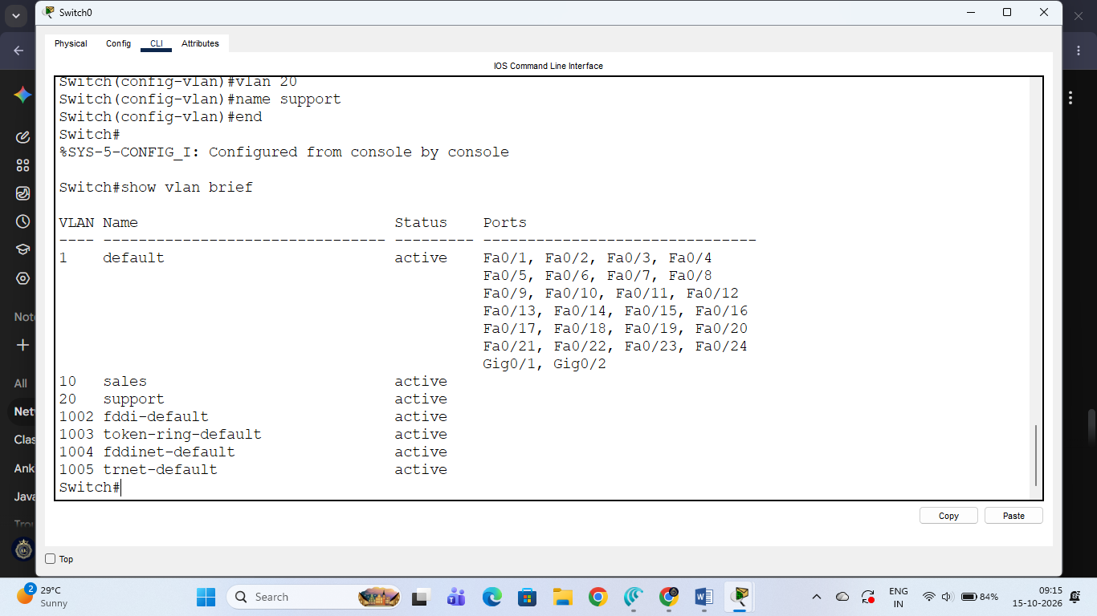

Switch VLAN Configuration -
- Device Configured: Cisco Layer 2 Switch (Switch0)
- VLAN Configuration Details:
  - VLAN ID 10: Name = sales (Status: active)
  - VLAN ID 20: Name = support (Status: active)
- Verification Command Output: show vlan brief confirms that both VLANs are correctly registered and active in the switch database.

2. Assign three different switch ports to VLAN 10 (Sales) and two ports to VLAN 20 (Support), then verify the VLAN membership using the show vlan command. Use the interface range command to select multiple ports efficiently.
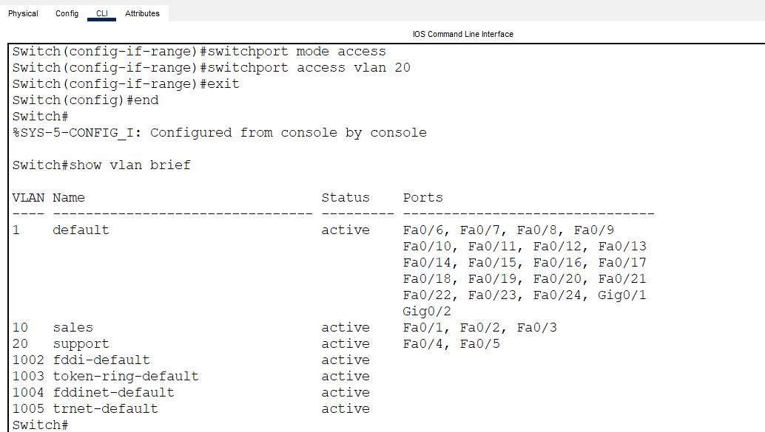
- Device Configured: Cisco Layer 2 Switch (Switch0)
- VLAN Port Membership Details:
  - VLAN 10 (sales): Assigned ports Fa0/1, Fa0/2, Fa0/3 (Status: active)
  - VLAN 20 (support): Assigned ports Fa0/4, Fa0/5 (Status: active)
- Verification Command Output: show vlan brief confirms that the respective switch ports have been successfully mapped to their assigned VLANs using the interface range command.

3. Connect two routers using a serial or Ethernet link in your simulation tool, assign IP addresses to their interfaces, and configure a static route on Router 1 to reach the LAN behind Router 2.

Router Interconnection and Static Routing Task
- Topology Setup:
  - Configured two Cisco 2811 routers (Router0 and Router1) interconnected via a direct serial link (Se0/3/0).
  - Attached a Layer 2 Switch (Switch0) and an end device (PC-PT PC0) to form the local area network segment.
- IP Addressing & Interface Configuration:
  - Assigned IP addresses and subnets to the serial interfaces of both routers (10.0.0.1 on Router0 and 10.0.0.2 on Router1 with mask 255.255.255.252).
  - Executed the no shutdown command to bring up the physical serial interfaces.
- Static Routing Configuration:
  - Configured a static route on Router0 using the next-hop IP address (10.0.0.2) to enable communication with remote networks or LANs behind Router1.
- Verification Status:
  - The topology is successfully established and verified in Cisco Packet Tracer.

4. Simulate a scenario where a device in the 'Sales' VLAN tries to ping a device in the 'Support' VLAN and explain why the ping fails, then suggest what configuration would allow inter-VLAN communication. Think about router-on-a-stick or Layer 3 switch concepts.

Inter-VLAN Communication Analysis
- Why the Ping Fails:
  - VLANs (Virtual Local Area Networks) are logical broadcast domains that isolate network traffic at Layer 2 (Data Link Layer).
  - Devices in VLAN 10 ('Sales') and VLAN 20 ('Support') belong to different subnets and broadcast domains.
  - Because Layer 2 switches can only forward frames within the same VLAN, traffic cannot pass between VLAN 10 and VLAN 20 without a Layer 3 device (such as a router or a Layer 3 switch) to route packets between different subnets. Therefore, a direct ping between them will fail.
- Configuration Required for Inter-VLAN Communication: To allow communication between different VLANs, one of the following two standard architectures must be configured:
  - Router-on-a-Stick (Inter-VLAN Routing):
    - Connect a physical router interface to a trunk port on the switch.
    - Configure logical subinterfaces (e.g., Fa0/0.10 and Fa0/0.20) on the router corresponding to each VLAN using IEEE 802.1Q encapsulation (encapsulation dot1Q <vlan_id>).
    - Assign gateway IP addresses to each subinterface so that the router can route packets between VLAN 10 and VLAN 20.
  - Layer 3 Switch (Multilayer Switch):
    - Replace or configure a Layer 3 switch with SVI (Switched Virtual Interfaces) for each VLAN (interface vlan 10 and interface vlan 20).
    - Enable IP routing globally (ip routing) on the switch so it can handle routing between the VLAN interfaces internally without needing an external router.

