DAY-5
NETWORK TESTING TOOLS
Tasks
1. Use the ping command to test connectivity from your computer to www.youtube.com and note the average response time.

Testing Connectivity to YouTube Using the Ping Command

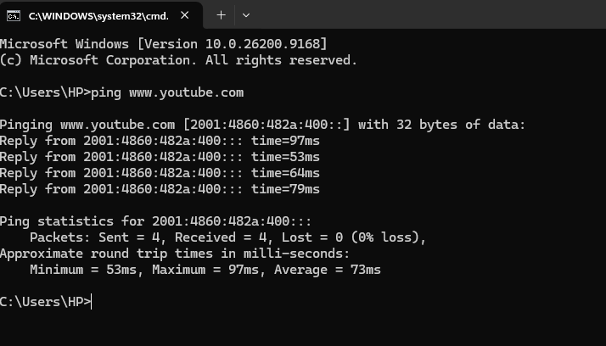
- Command Executed: ping [www.youtube.com](https://www.youtube.com)
- Target Resolved Address (IPv6): 2001:4860:482a:400::
- Packet Statistics:
  - Packets Sent: 4
  - Packets Received: 4
  - Packets Lost: 0 (0% loss)
- Round Trip Times (RTT):
  - Minimum: 53ms
  - Maximum: 97ms
  - Average Response Time: 73ms
2. Run the traceroute (tracert on Windows) command to www.flipkart.com and list all the intermediate hops shown in the output. Hint: Each hop represents a network device your data passes through to reach the destination.

Traceroute toFlipkart(tracert[www.flipkart.com])
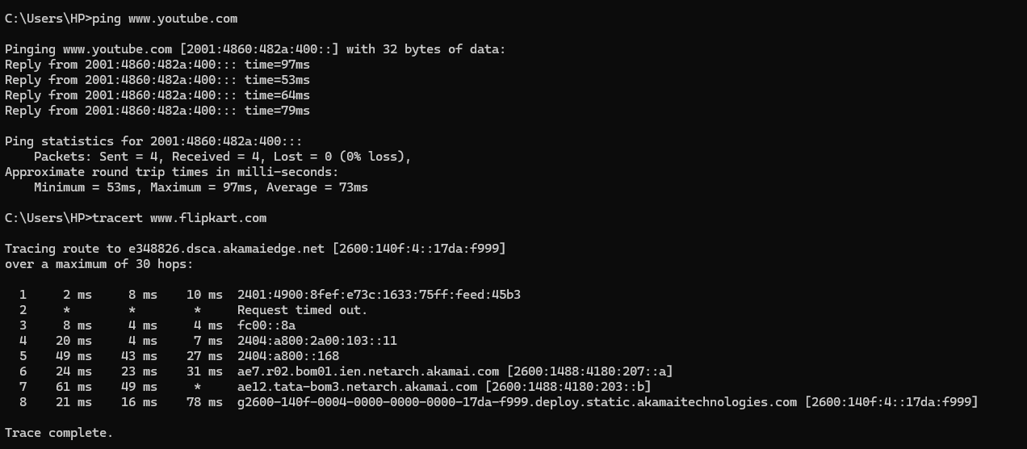
- Command Executed: tracert [www.flipkart.com](https://www.flipkart.com)
- Target Destination: e348826.dsca.akamaiedge.net (2600:140f:4::17da:f999)
- Total Hops Traced: 8 Hops
- Intermediate Hops List:
  - Hop 1: 2401:4900:8fef:e73c:1633:75ff:feed:45b3 (Response times: 2 ms, 8 ms, 10 ms)
  - Hop 2: Request timed out (* * *)
  - Hop 3: fc00::8a (Response times: 8 ms, 4 ms, 4 ms)
  - Hop 4: 2404:a800:2a00:103::11 (Response times: 20 ms, 4 ms, 7 ms)
  - Hop 5: 2404:a800::168 (Response times: 49 ms, 43 ms, 27 ms)
  - Hop 6: ae7.r02.bom01.ien.netarch.akamai.com (2600:1488:4180:207::a) (Response times: 24 ms, 23 ms, 31 ms)
  - Hop 7: ae12.tata-bom3.netarch.akamai.com (2600:1488:4180:203::b) (Response times: 61 ms, 49 ms, *)
  - Hop 8 (Final Destination): g2600-140f-0004-0000-0000-0000-17da-f999.deploy.static.akamaiedge.net (2600:140f:4::17da:f999) (Response times: 21 ms, 16 ms, 78 ms)

3. Use the nslookup tool to find the IP address of www.zomato.com and record the result.

Finding IP Address of Zomato Using nslookup
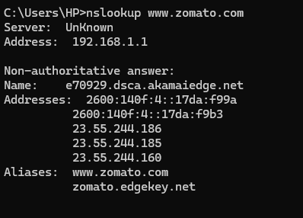
- Command Executed: nslookup [www.zomato.com](https://www.zomato.com)
- DNS Server Address: 192.168.1.1
- Resolved Canonical Name (CDN Node): e70929.dsca.akamaiedge.net
- Retrieved IP Addresses (IPv6 and IPv4):
  - 2600:140f:4::17da:f99a
  - 2600:140f:4::17da:f9b3
  - 23.55.244.186
  - 23.55.244.185
  - 23.55.244.160
- Aliases:
  - [www.zomato.com](https://www.zomato.com)
  - zomato.edgekey.net
4. Test connectivity to another device on your local network (such as your friend's laptop or your phone) using the ping command and describe what happens if the device is offline.

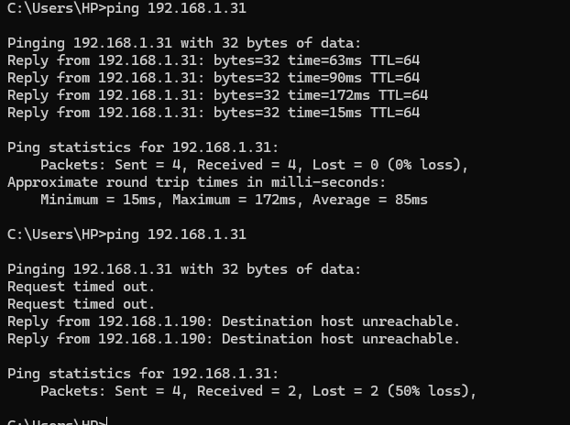

Testing Local Network Connectivity and Offline Device Behavior
- Target Local IP Address Tested: 192.168.1.31
- Scenario A: When the Device is ONLINE
  - Command Executed: ping 192.168.1.31
  - Observations:
    - Received continuous successful replies (bytes=32 time=... TTL=64).
    - Packet Statistics: Sent = 4, Received = 4, Lost = 0 (0% loss).
    - Round Trip Times: Minimum = 15ms, Maximum = 172ms, Average = 85ms.
- Scenario B: When the Device is OFFLINE / DISCONNECTED
  - Command Executed: ping 192.168.1.31 (when the target device was turned off or disconnected from the network)
  - Observations:
    - Initial packets resulted in Request timed out.
    - Subsequent probes triggered Destination host unreachable responses routed via the local gateway (192.168.1.190).
    - Packet Statistics: Sent = 4, Received = 2, Lost = 2 (50% packet loss due to partial response timeout/unreachability).

5. Create a short report (5-7 lines) summarizing which tool (ping, traceroute, nslookup) is most useful for diagnosing each of these problems: (a) Website not loading, (b) Slow connection, (c) Suspecting DNS issues.Constraint: Give a specific example for each tool based on your own test results above.

Network Diagnostics Tool Utility Report
- Basic Reachability & Websites Not Loading (Ping): Best for checking end-to-end device or server availability. Example: Our ping 192.168.1.31 test accurately identified device disconnection through 50% packet loss and unreachable errors.
- Slow Connections & Routing Delays (Traceroute): Best for pinpointing where latency or bottlenecks occur along the network path. Example: Our tracert [www.flipkart.com](https://www.flipkart.com) test mapped 8 distinct hops through Akamai and Tata infrastructure to locate routing latency up to the final destination.
- Suspected DNS Failures (Nslookup): Best for verifying whether domain names are successfully translating into valid IP addresses. Example: Our nslookup [www.zomato.com](https://www.zomato.com) query successfully fetched multiple server IPs and CDN aliases via local DNS 192.168.1.1.

