DAY-3
INTRODUCTION TO IP ADDRESSING
Tasks

1. List the key differences between IPv4 and IPv6 addressing by creating a two-column table with at least 4 points for each.

Differences Between IPv4 and IPv6 Addressing
Feature / Aspect | IPv4 Addressing | IPv6 Addressing
Address Length | 32-bit numeric address | 128-bit alphanumeric address
Notation / Format | Written in dotted-decimal notation (e.g., 192.168.1.1) | Written in colon-hexadecimal notation (e.g., 2001:db8::1)
Address Space | Provides approximately $4.3 \times 10^9$ unique addresses (limited capacity) | Provides a virtually limitless pool of addresses ($3.4 \times 10^{38}$)
Configuration | Requires manual configuration, DHCP, or DHCPv6 for IP assignment | Supports Stateless Address Autoconfiguration (SLAAC) and DHCPv6 natively
Security Support | IPsec is optional and must be configured separately | IPsec is built-in and mandatory as a core feature
Packet Header | Contains options fields making headers variable in length | Uses a fixed-length header with extension headers for efficiency

2. Given the following scenario: You have 4 devices (laptop, phone, smart TV, and printer) connected to your home WiFi. Assign a unique static IPv4 address to each device using the 192.168.10.0/24 network, and write down the IP, subnet mask, and default gateway for each device.

Static IPv4 Address
For the home Wi-Fi network 192.168.10.0/24, I will assign a unique static IPv4 address to each device.
Device | IP Address | Subnet Mask | Default Gateway
Laptop | 192.168.10.2 | 255.255.255.0 | 192.168.10.1
Phone | 192.168.10.3 | 255.255.255.0 | 192.168.10.1
Smart TV | 192.168.10.4 | 255.255.255.0 | 192.168.10.1
Printer | 192.168.10.5 | 255.255.255.0 | 192.168.10.1

Explanation:
- IP Address: A unique address assigned to each device.
- Subnet Mask: 255.255.255.0 identifies the network portion of the IP address.
- Default Gateway: 192.168.10.1 is the home router's IP address, used to communicate with other networks.
The router uses 192.168.10.1, and all four devices have different IP addresses within the same /24 network. These addresses should be reserved or excluded from the router's DHCP pool to avoid conflicts.
3. Calculate the number of valid subnets and hosts per subnet if you use a /27 CIDR subnet mask on a 192.168.1.0 network. List the first three valid subnet address ranges (network address to broadcast address) and the usable host IPs in each.

Subnetting Calculations for a /27 CIDR on 192.168.1.0

1. Subnet & Host Calculations:
- Original Network: 192.168.1.0/24 (Subnet Mask: 255.255.255.0)
- New Subnet Mask: /27 (Subnet Mask in decimal: 255.255.255.224)
- Bits borrowed for subnets: 27 - 24 = 3 bits
- Total Valid Subnets: 2^3 = 8 subnets
- Host bits remaining: 32 - 27 = 5 bits
- Total Hosts per Subnet: 2^5 = 32 total IP addresses
- Usable Hosts per Subnet: 32 - 2 = 30 usable host IPs (excluding Network and Broadcast addresses)

2. First Three Valid Subnet Ranges:
- Subnet 1:
  - Network Address: 192.168.1.0
  - Usable Host IP Range: 192.168.1.1 to 192.168.1.30
  - Broadcast Address: 192.168.1.31
- Subnet 2:
  - Network Address: 192.168.1.32
  - Usable Host IP Range: 192.168.1.33 to 192.168.1.62
  - Broadcast Address: 192.168.1.63
- Subnet 3:
  - Network Address: 192.168.1.64
  - Usable Host IP Range: 192.168.1.65 to 192.168.1.94
  - Broadcast Address: 192.168.1.95
4. You are given the IP address 10.0.5.17 with subnet mask 255.255.255.0. Determine the network address, broadcast address, and the range of valid host addresses for this subnet. Hint: Convert the subnet mask to CIDR notation and use bitwise AND for network address calculation.

Subnet Calculations for IP 10.0.5.17 with Subnet Mask 255.255.255.0

1. Step-by-Step Calculation:
- Given IP Address: 10.0.5.17
- Given Subnet Mask: 255.255.255.0
- CIDR Notation: /24 (since 255.255.255.0 has 24 network bits)
- Network Address Calculation (Bitwise AND):
  - Converting the IP and Subnet Mask to binary and performing a bitwise AND operation keeps the network portion (10.0.5) and zeroes out the host portion.
  - Network Address: 10.0.5.0
- Broadcast Address:
  - With all host bits set to 1, the broadcast address for this /24 network is 10.0.5.255.
- Valid Host Address Range:
  - Ranges from the first usable IP after the network address up to the IP right before the broadcast address.
  - Host IP Range: 10.0.5.1 to 10.0.5.254

2. Final Answers Summary:
- Network Address: 10.0.5.0
- Broadcast Address: 10.0.5.255
- Range of Valid Host Addresses: 10.0.5.1 to 10.0.5.254

5. Use an online subnet calculator tool (such as https://www.subnet-calculator.com/) to verify your answer for the previous task. Take a screenshot of your calculation and write one line explaining if your manual answer matched the tool's output.
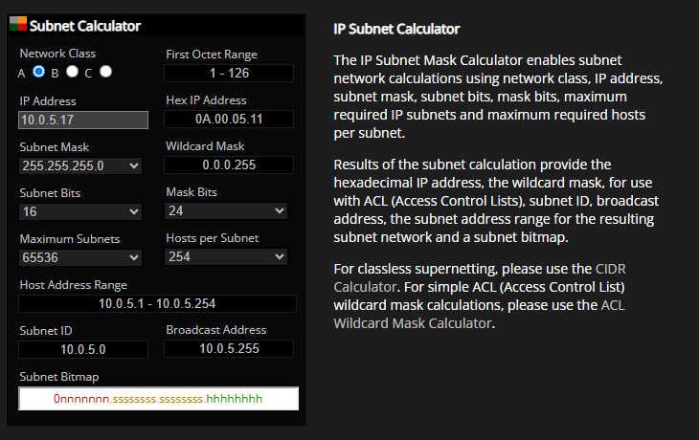
My manual calculation matched the subnet calculator's output. The network address is 10.0.5.0, the broadcast address is 10.0.5.255, and the valid host range is 10.0.5.1 to 10.0.5.254.

