HANDS-ON SUBNETTING
Tasks

1. Given a network address of 192.168.10.0/24, divide it into 4 equal subnets and write down the subnet mask, network address, and broadcast address for each subnet.

Dividing 192.168.10.0/24 into 4 Equal Subnets
- Subnetting Calculations:
  - Original Network: 192.168.10.0/24
  - Target Subnets: 4 equal subnets
  - Bits Borrowed: 2 bits (since $2^2 = 4$)
  - New CIDR Notation: /26
  - New Subnet Mask: 255.255.255.192
  - Block Size / Increment: 64 addresses per subnet
- Subnet 1:
  - Network Address: 192.168.10.0
  - Subnet Mask: 255.255.255.192
  - Usable Host IP Range: 192.168.10.1 to 192.168.10.62
  - Broadcast Address: 192.168.10.63
- Subnet 2:
  - Network Address: 192.168.10.64
  - Subnet Mask: 255.255.255.192
  - Usable Host IP Range: 192.168.10.65 to 192.168.10.126
  - Broadcast Address: 192.168.10.127

- Subnet 3:
  - Network Address: 192.168.10.128
  - Subnet Mask: 255.255.255.192
  - Usable Host IP Range: 192.168.10.129 to 192.168.10.190
  - Broadcast Address: 192.168.10.191
- Subnet 4:
  - Network Address: 192.168.10.192
  - Subnet Mask: 255.255.255.192
  - Usable Host IP Range: 192.168.10.193 to 192.168.10.254
  - Broadcast Address: 192.168.10.255
2. For one of the subnets you created, assign valid IP addresses to 5 devices (such as a router, two laptops, a printer, and a mobile) and list which IP goes to which device. Make sure not to use the network or broadcast address for any device.

Device IP Assignment for Subnet 1
- Selected Subnet: Subnet 1 (192.168.10.0/26)
- Subnet Mask: 255.255.255.192
- Network Address: 192.168.10.0 (Reserved, cannot be used for devices)
- Broadcast Address: 192.168.10.63 (Reserved, cannot be used for devices)
- Usable Host IP Range: 192.168.10.1 to 192.168.10.62
- Assigned Device IPs:
  - Router (Default Gateway): 192.168.10.1
  - Laptop 1: 192.168.10.2
  - Laptop 2: 192.168.10.3
  - Printer: 192.168.10.4
  - Mobile: 192.168.10.5
3. Draw a simple diagram (hand-drawn or digital) showing your subnet plan: label each subnet, the range of IPs, and where each device is connected.

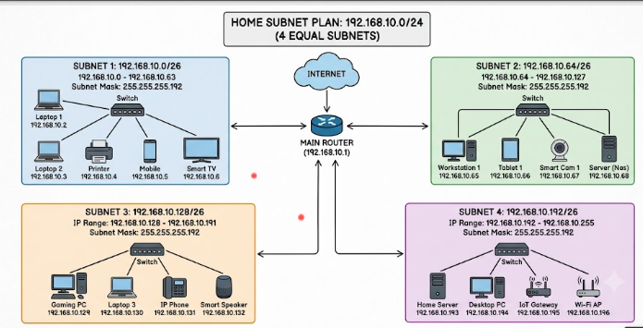
Explanation: The network 192.168.10.0/24 is divided into four equal subnets using the /26 subnet mask (255.255.255.192). Each subnet contains 64 IP addresses, including 62 usable host addresses. Each subnet is connected to the router through a separate interface, allowing devices to communicate within their subnet.

4. Document step-by-step how you calculated the subnet mask, number of hosts per subnet, and assigned IP addresses for your plan, as if you are explaining it to a friend who is new to subnetting.

Step-by-Step Subnetting Calculation

Step 1: Understand the given network
My original network address is 192.168.10.0/24. I need to divide this network into four equal subnets.

Step 2: Calculate the new subnet mask
To create 4 subnets, I borrow 2 bits from the host portion because (2^2 = 4).
New CIDR prefix = /24 + 2 = /26
Therefore, the new subnet mask is 255.255.255.192.

Step 3: Calculate the number of hosts per subnet
The number of host bits is (32 - 26 = 6).
- Total IP addresses per subnet = (2^6 = 64)
- Usable host addresses = (64 - 2 = 62)
I subtract 2 because one address is reserved for the network address and one for the broadcast address.

Step 4: Calculate the subnet ranges
The block size is (256 - 192 = 64). Therefore, each subnet starts 64 addresses after the previous subnet.
Subnet | Network Address | Usable Host Range | Broadcast Address
1 | 192.168.10.0 | 192.168.10.1–62 | 192.168.10.63
2 | 192.168.10.64 | 192.168.10.65–126 | 192.168.10.127
3 | 192.168.10.128 | 192.168.10.129–190 | 192.168.10.191
4 | 192.168.10.192 | 192.168.10.193–254 | 192.168.10.255

Step 5: Assign IP addresses to devices
I assigned unique IP addresses from the usable range of each subnet. For example, in Subnet 1, PC1 gets 192.168.10.1, Laptop1 gets 192.168.10.2, and Laptop2 gets 192.168.10.3.
Each subnet is connected to a separate router interface, and the router interface uses an available IP address from that subnet as its gateway.

Conclusion
By using a /26 subnet mask, I divided the original /24 network into 4 equal subnets, each containing 64 total IP addresses and 62 usable host addresses. This helps organize devices into separate network groups.

