**SCREENSHOTS:**

**Welcome to the covid -19 medical emergency center:**

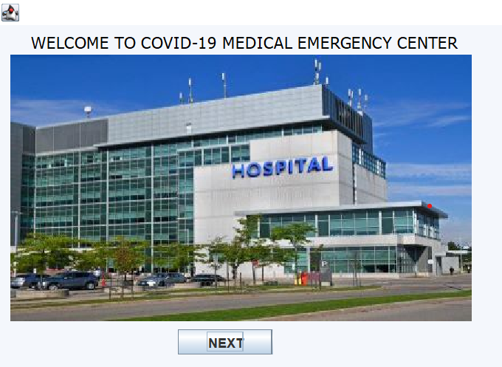

**Fill the necessary details:**

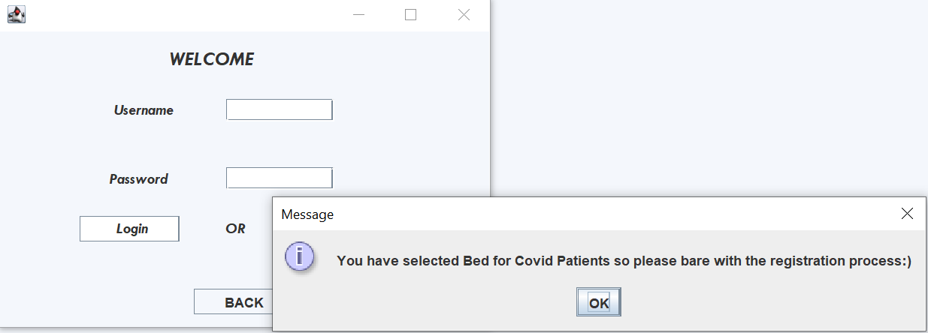

**Select the sevice you want to be:**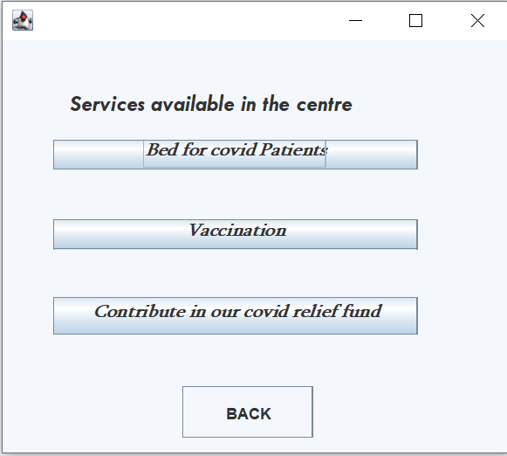

**Fill the details:**

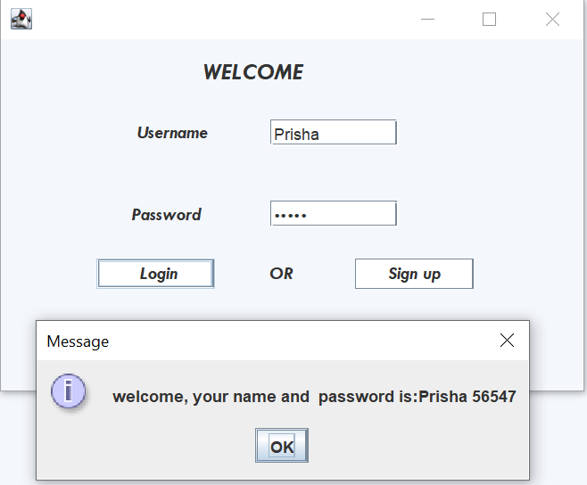

**Sign up the page if you are new user:**

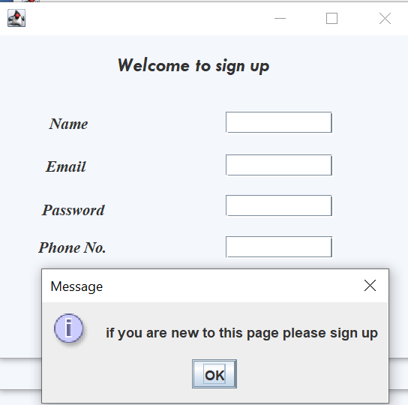

**Fill the details and you move to the next page:**

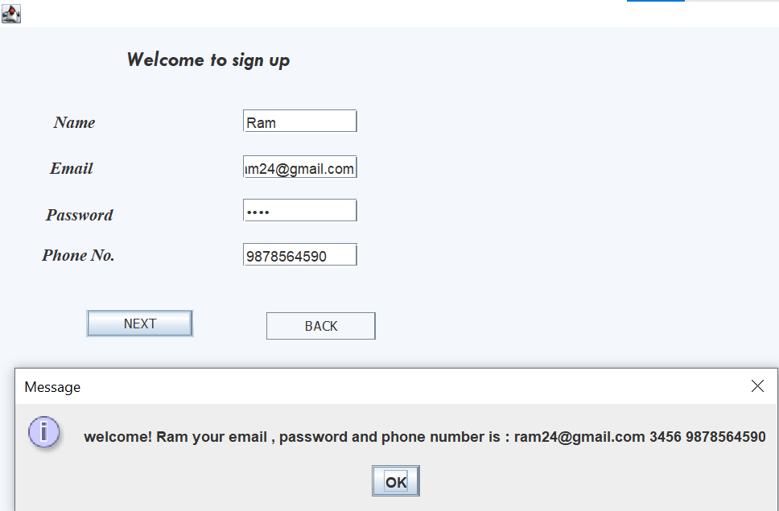

**Mark the symptons that you have:**

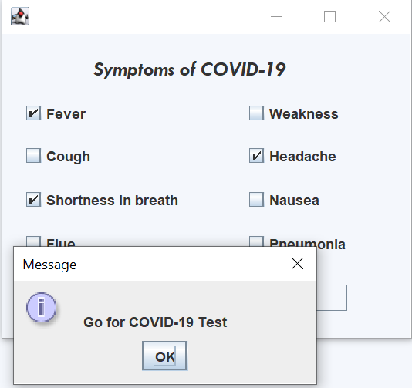

**Select the covid result and submit the report if you tested positive:**

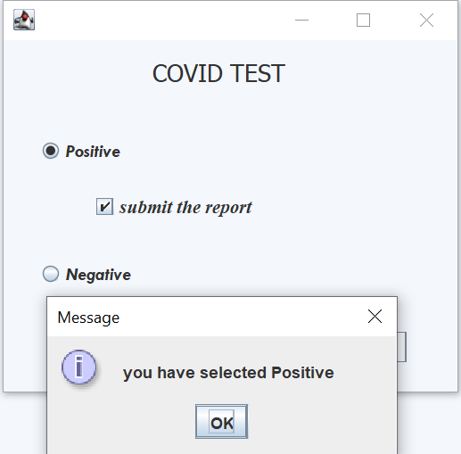

**Select the covid result:**

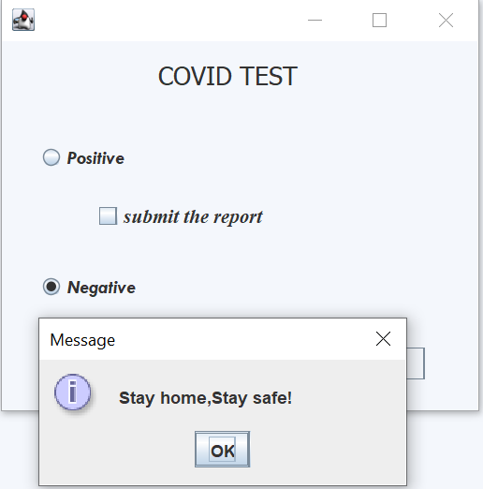

**Choose the place where you want to admit or quarantine:**

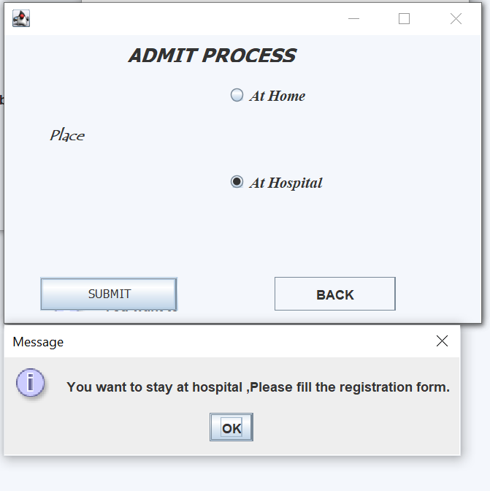

**Fill your details for your registration:**

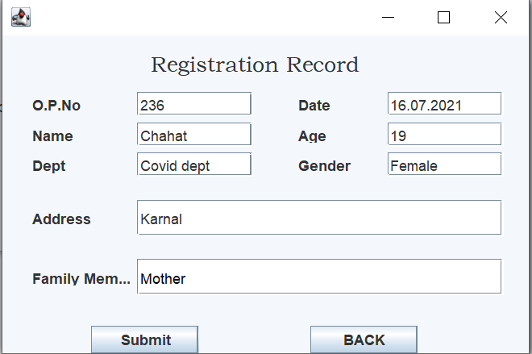

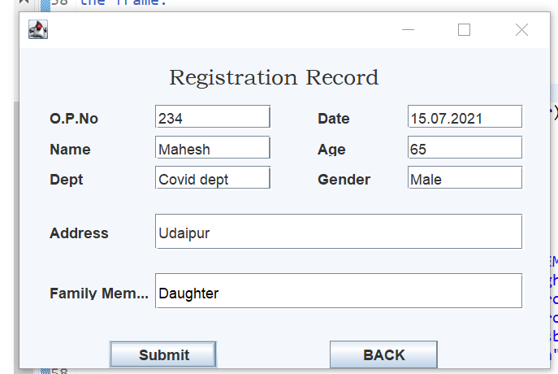

**No more beds available ,try in another hospital:**

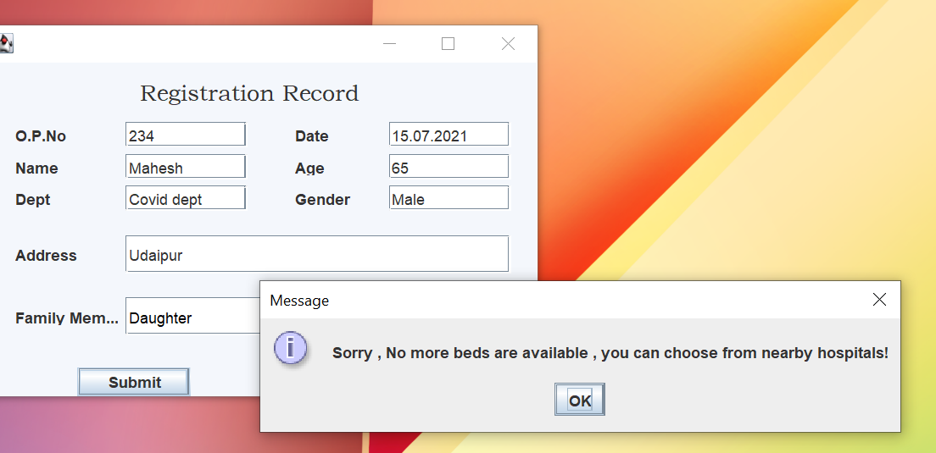

**Here is the list of admitted patients:**

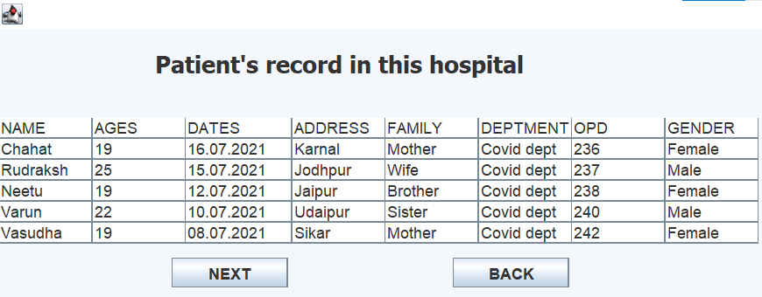

**Bed details of nearby 10 hospitals:**

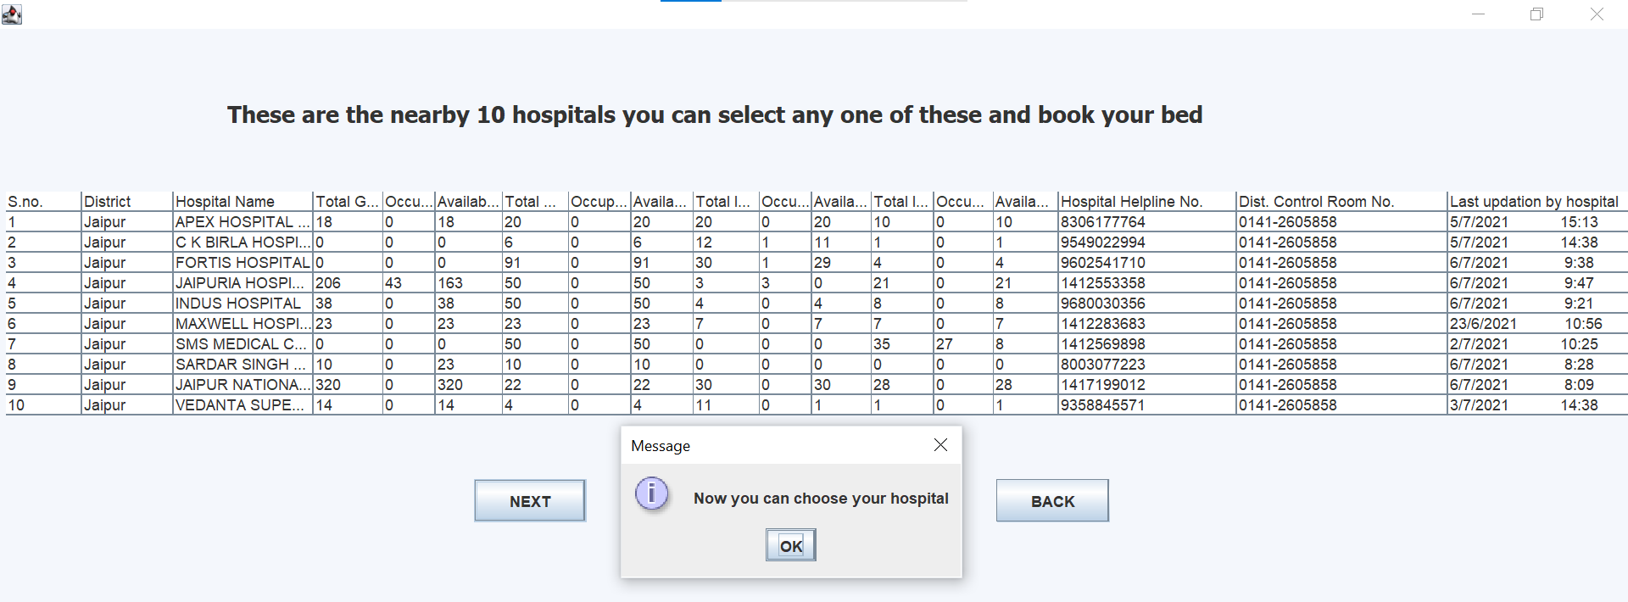

**Admit summary in other hospitals:**

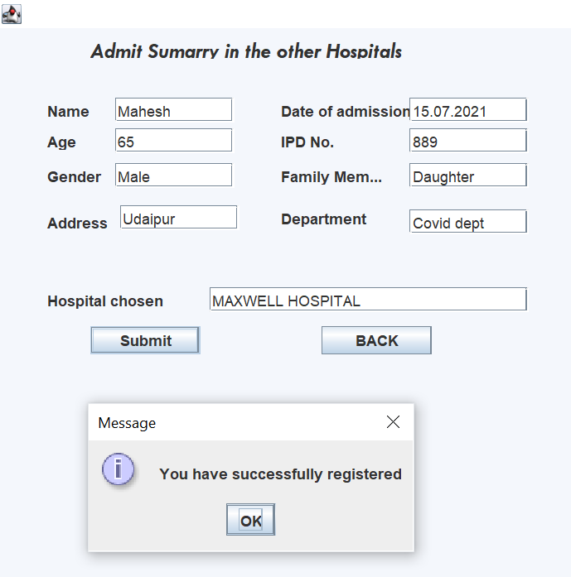

**Patients details:**

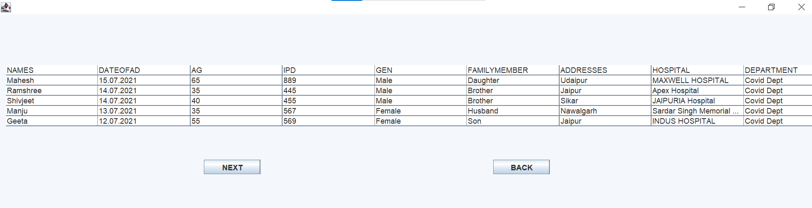

**Patient care services:**

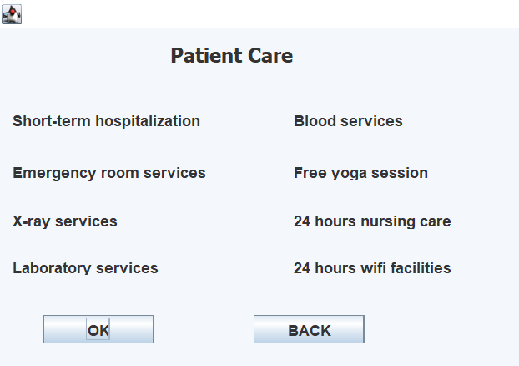

**Hospital charges:**

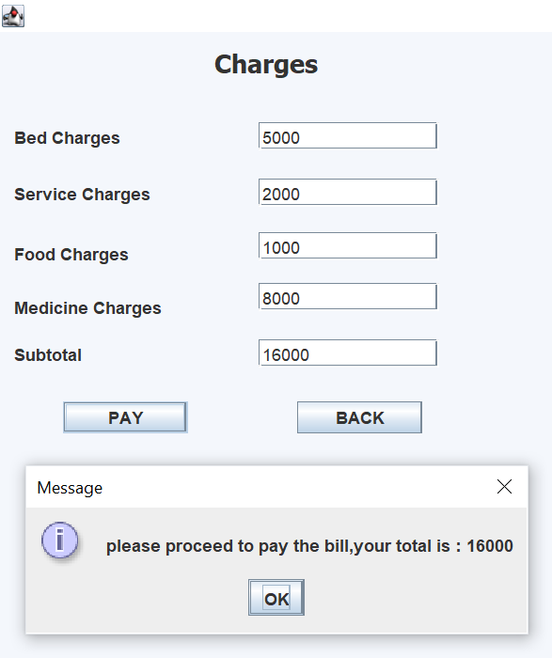

**Discharge summary of patient:**

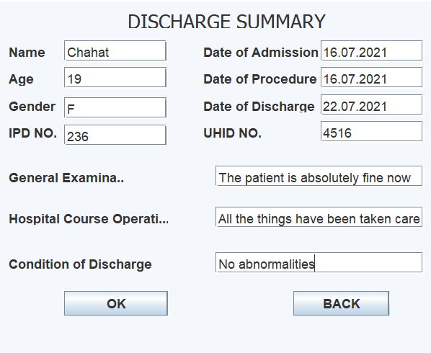

**Discharge summary of all patients:**

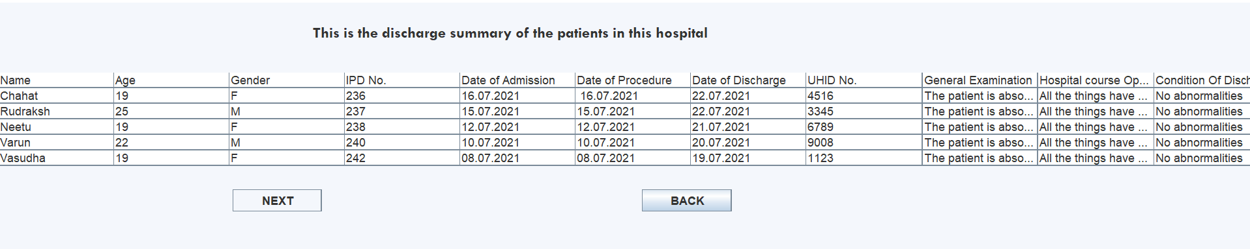

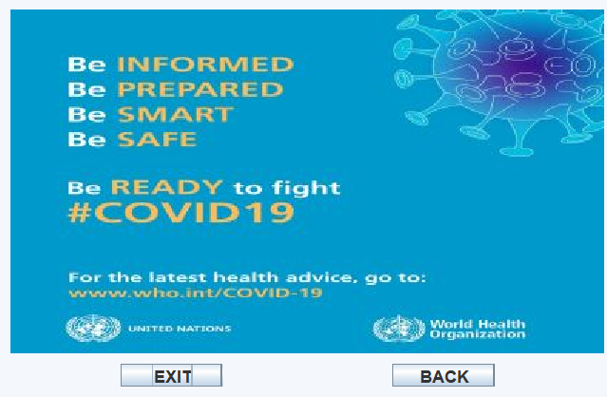

**Now procced for vaccination process:**

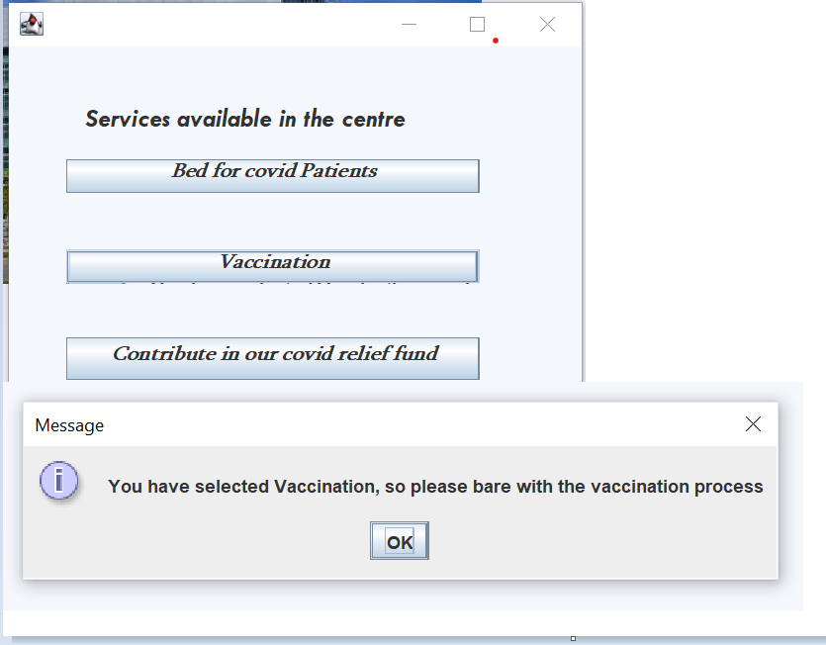

**Here is the detail of available doses og vaccine and select whether you want to vaccinate or not?**

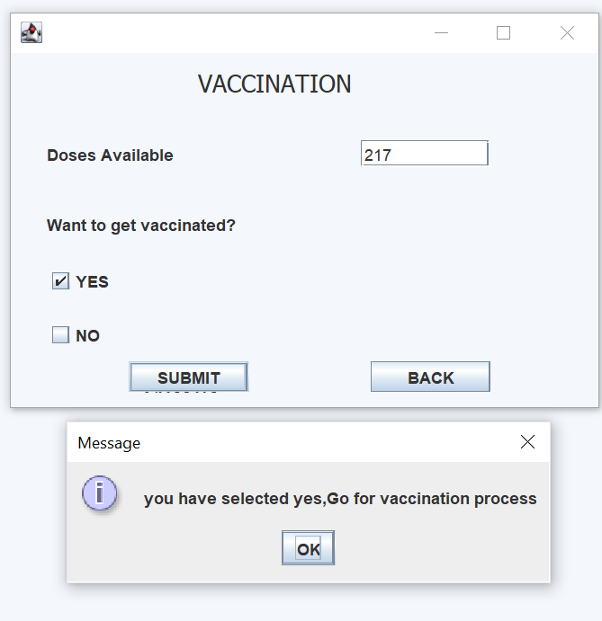

**You have selected for vaccination so enter your details and fill the otp that sent to your mobile no. :**

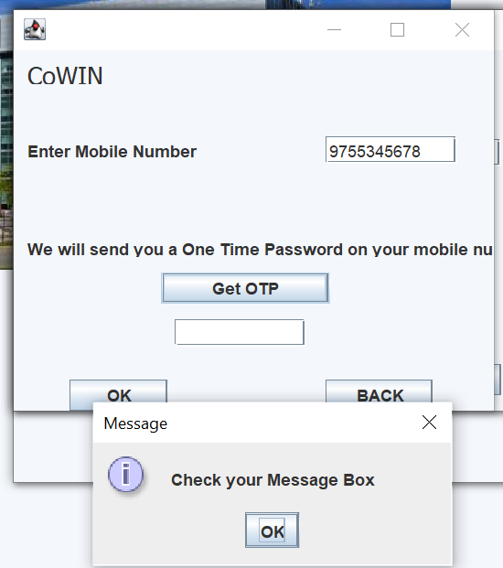

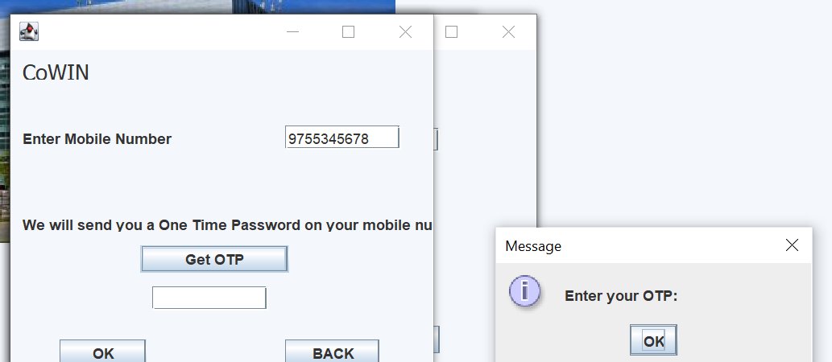

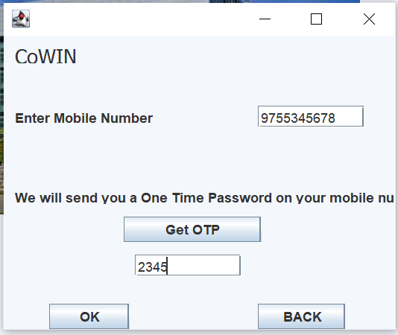

**Fill all necessary details to register for vaccination:**

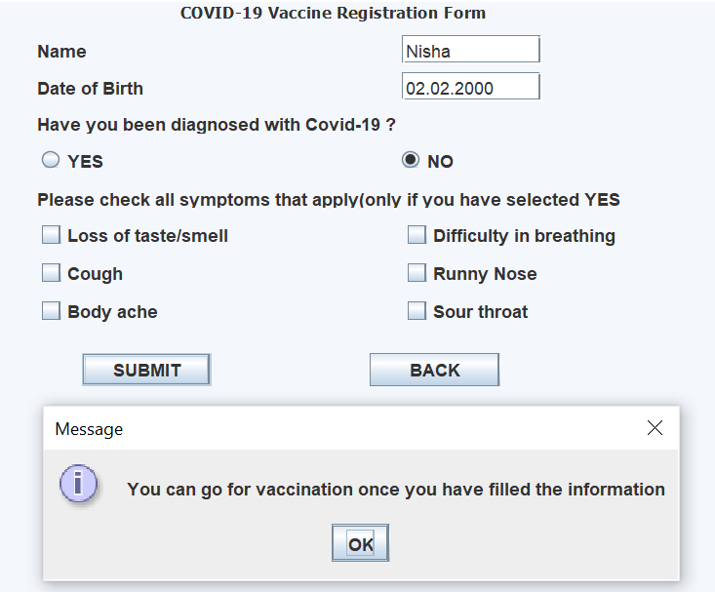

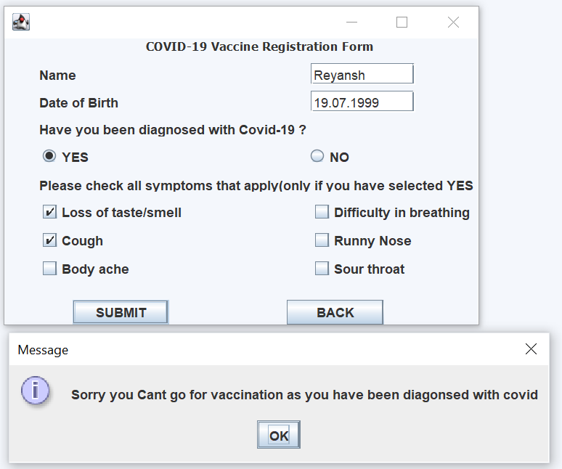

**List of patients who got vaccinated:**

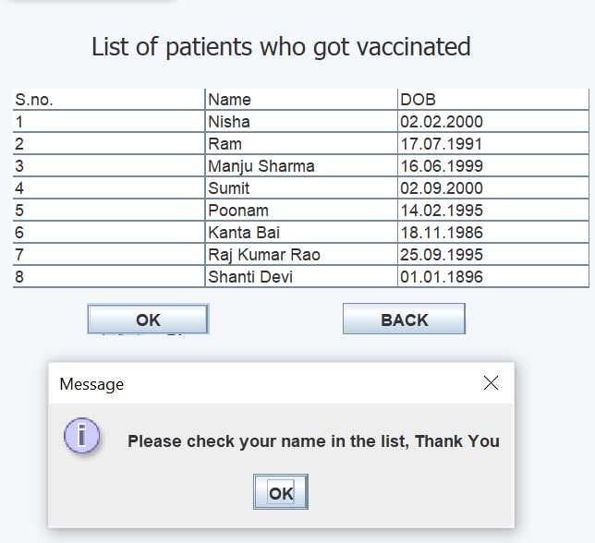

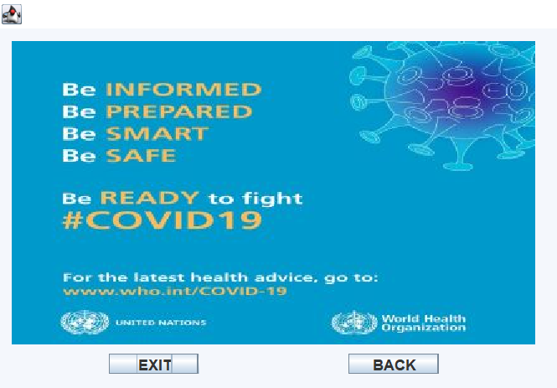

**Let’s move to the contribution process for covid relief fund:**

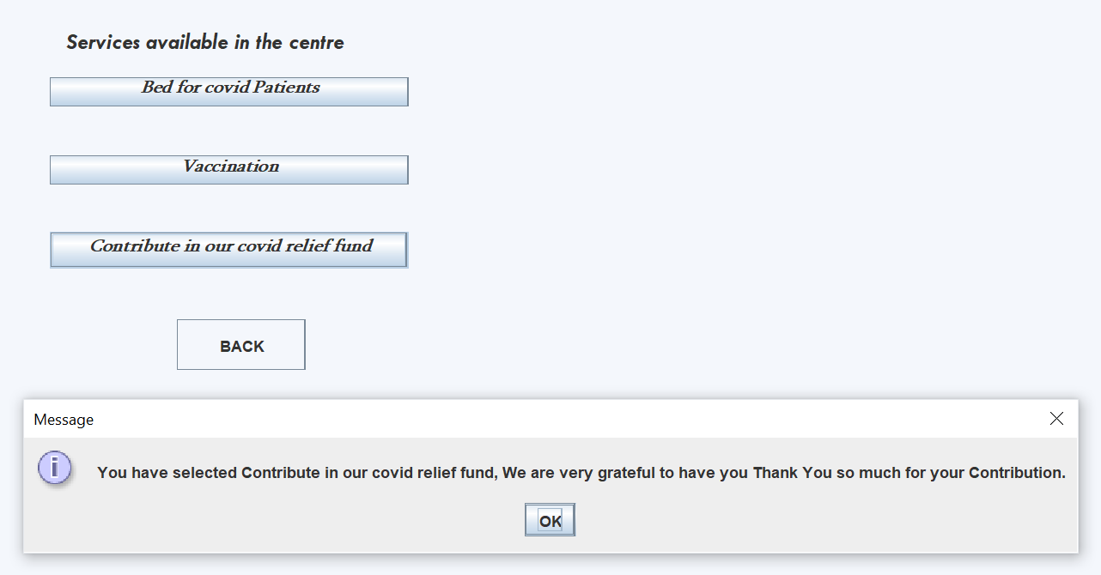

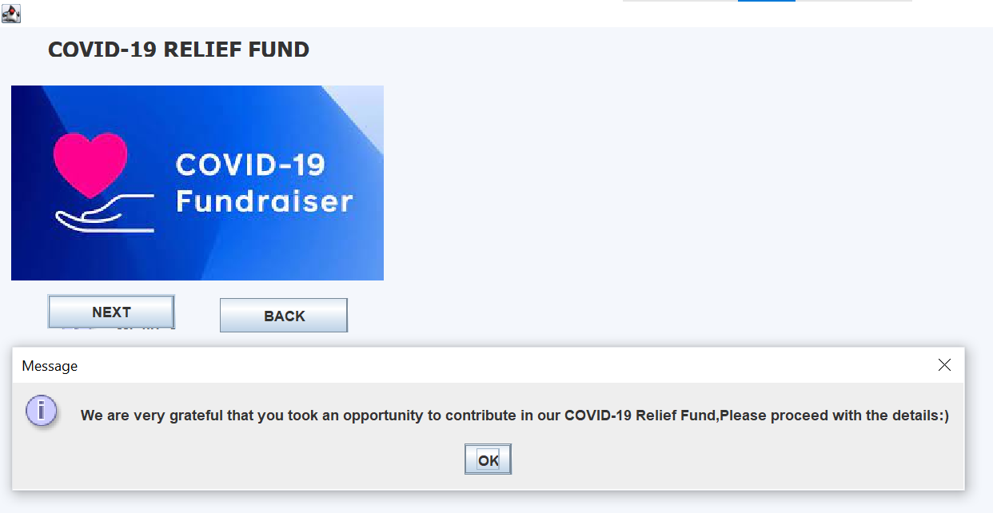

**Fill all details for contribution and pay the relief fund:**

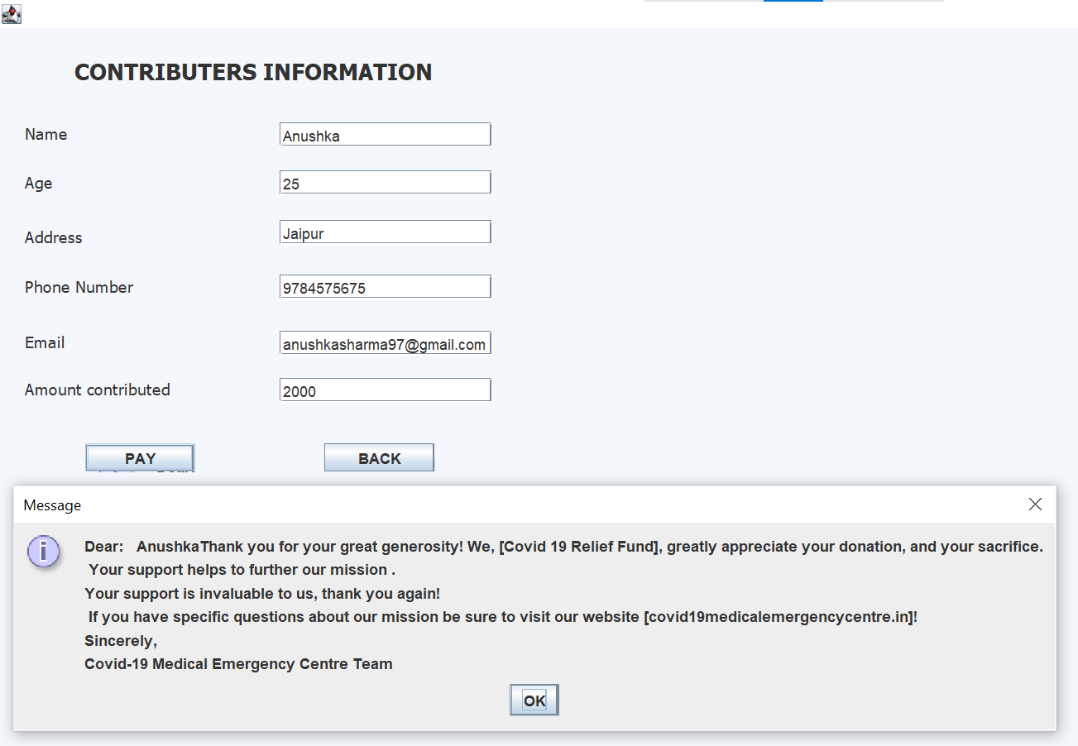

**Now you exit the page :**

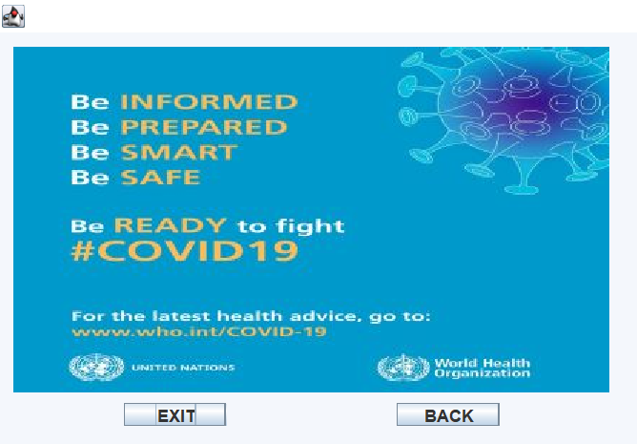

**Thanks for contributing and helping the needed ones.**