**REPORT**

Preparation of accurate and prompt reports: -

This becomes a difficult task as information is difficult to collect from various register.

**Objective:-**

1) Define hospital

2) Recording information about the Patients that come.

3) Generating bills.

4) Recording information related to diagnosis given to Patients.

5) Keeping record of the Immunization provided to children/patients.

6) Keeping information about various diseases and medicines available to cure them. These are the various jobs that need to be done in a Hospital by the operational staff and Doctors. All these works are done on papers.

**Scope of the Project:-**

1) Information about Patients is done by just writing the Patients name, age and gender. Whenever the Patient comes up his information is stored freshly.

2) Bills are generated by recording price for each facility provided to Patient on a separate sheet and at last they all are summed up.

3) Diagnosis information to patients is generally recorded on the document, which contains Patient information. It is destroyed after some time period to decrease the paper load in the office.

4) Immunization records of children are maintained in pre-formatted sheets, which are kept in the file

5) Information about various diseases is not kept as any document. Doctors themselves do this job by

remembering various medicines. All this work is done manually by the receptionist and other operational staff and lot of papers are needed to be handled and taken care of. Doctors have to remember various medicines available for diagnosis and sometimes miss better alternatives as they can’t remember them.

**SCREENSHOTS:**

**Welcome to the covid -19 medical emergency center:**

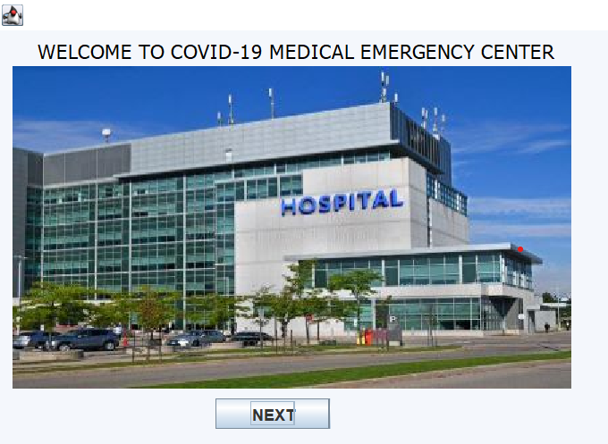

**Fill the necessary details:**

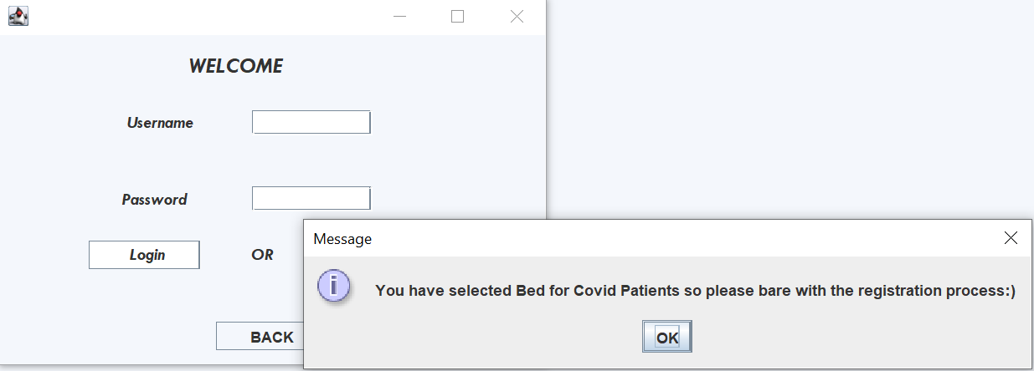

**Select the sevice you want to be:**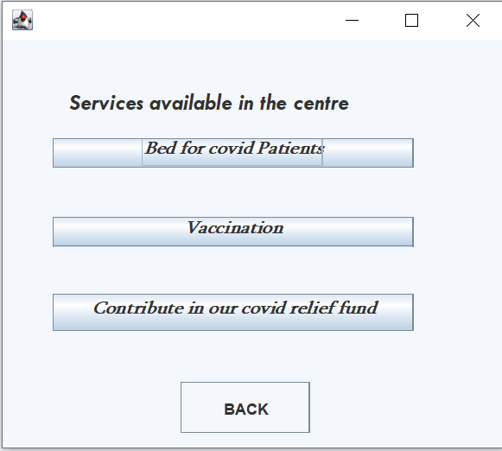

**Fill the details:**

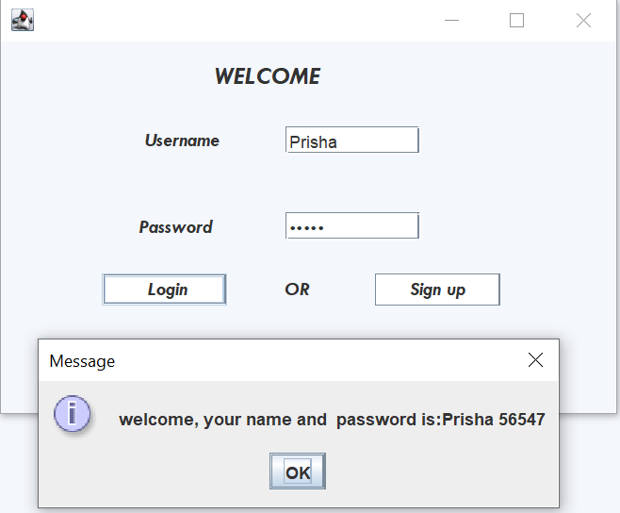

**Sign up the page if you are new user:**

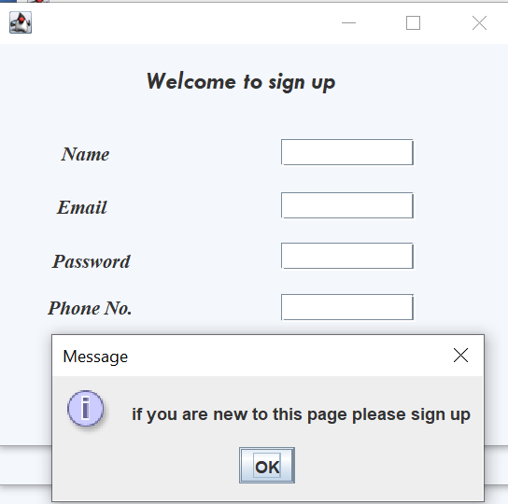

**Fill the details and you move to the next page:**

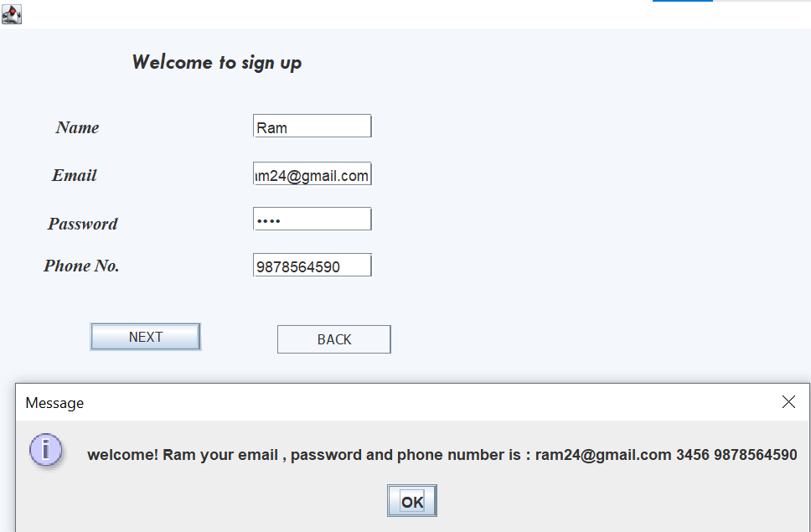

**Mark the symptons that you have:**

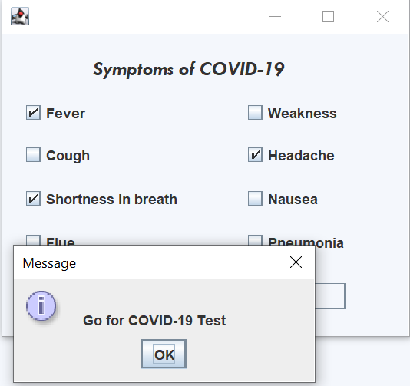

**Select the covid result and submit the report if you tested positive:**

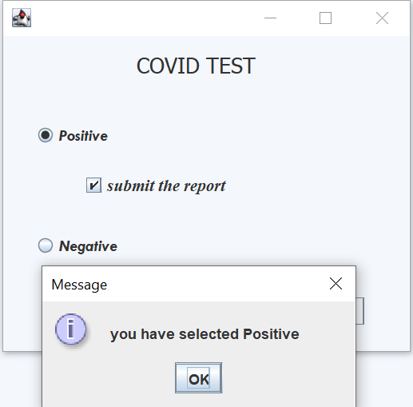

**Select the covid result:**

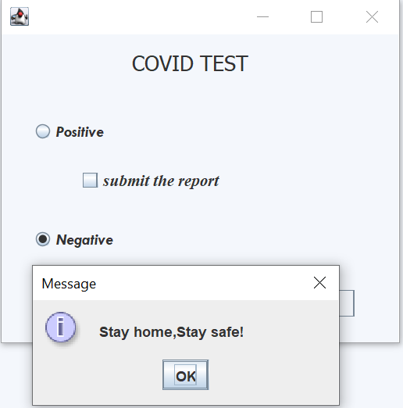

**Choose the place where you want to admit or quarantine:**

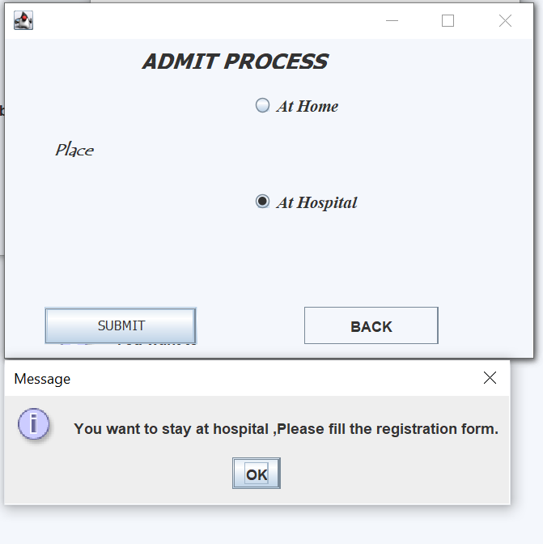

**Fill your details for your registration:**

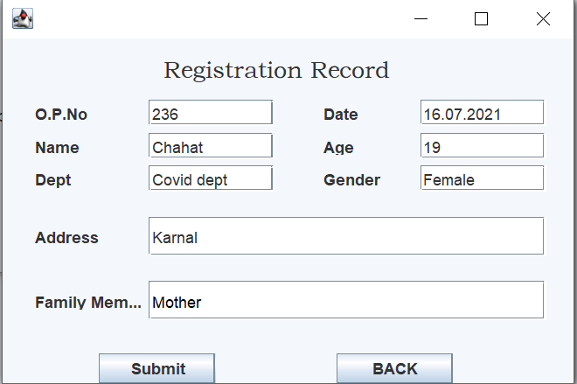

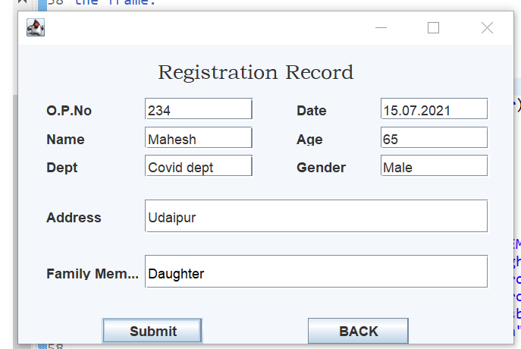

**No more beds available ,try in another hospital:**

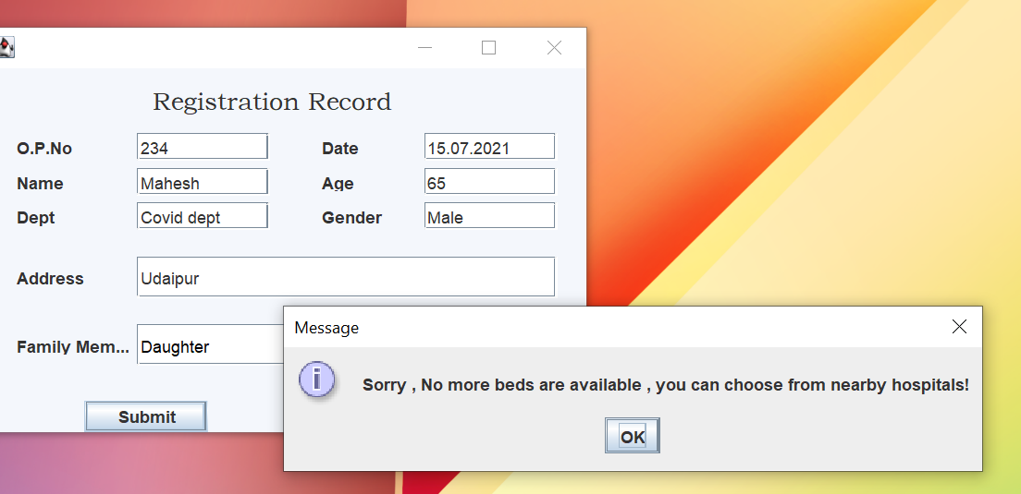

**Here is the list of admitted patients:**

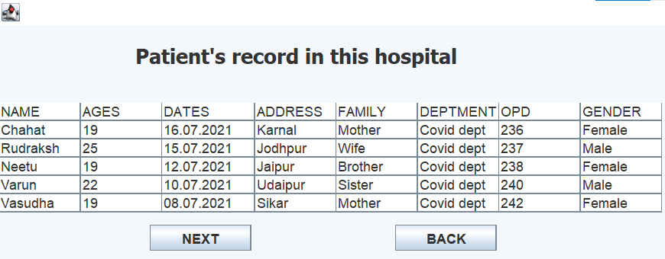

**Bed details of nearby 10 hospitals:**

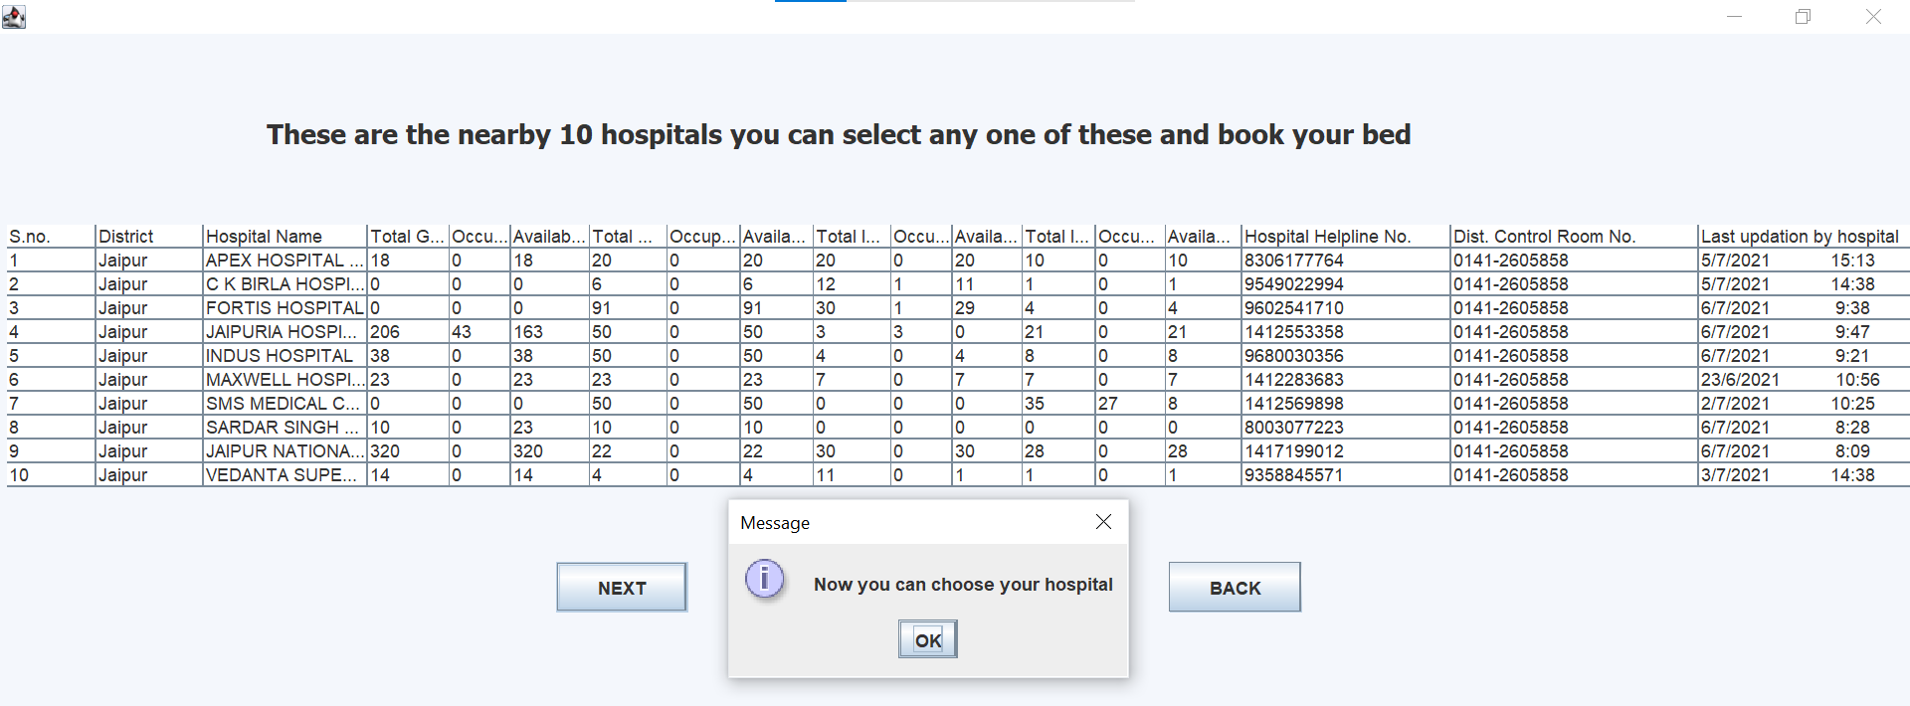

**Admit summary in other hospitals:**

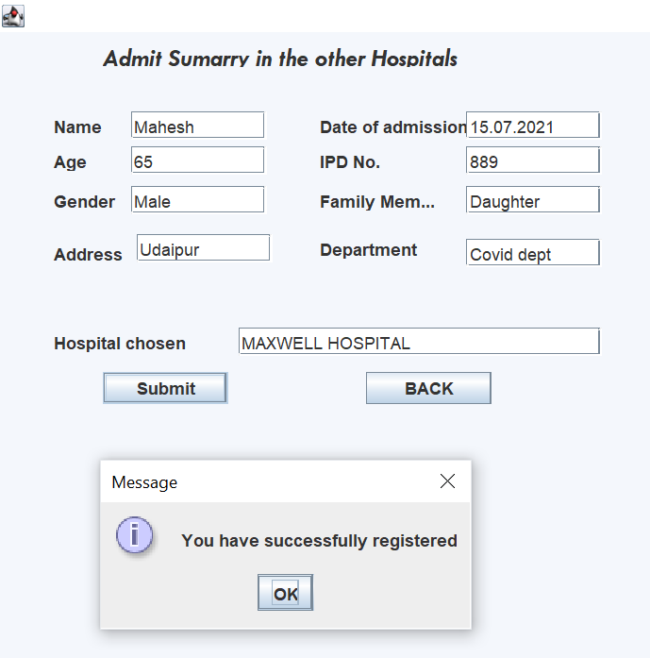

**Patients details:**

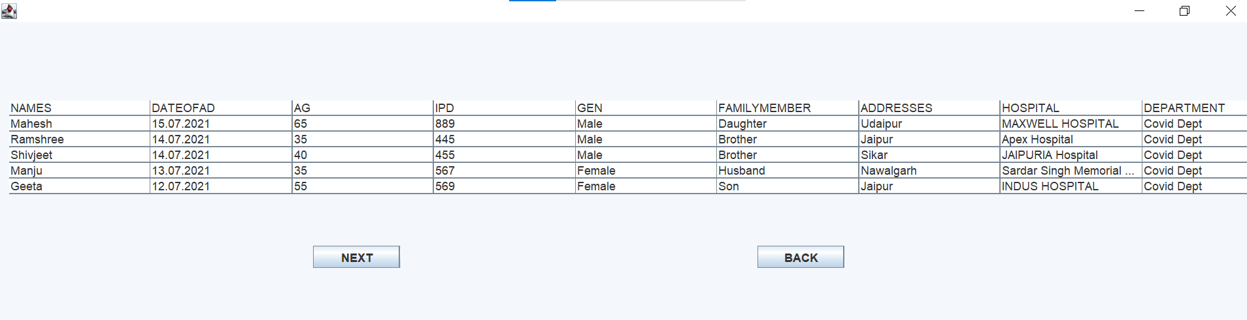

**Patient care services:**

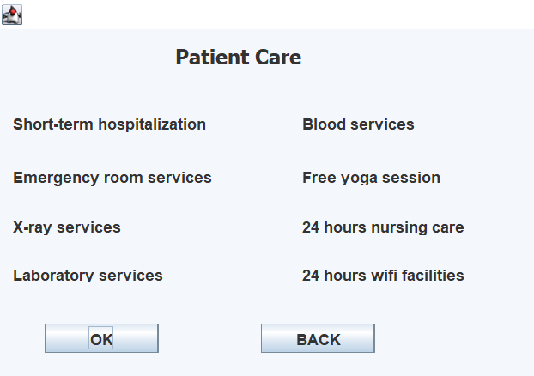

**Hospital charges:**

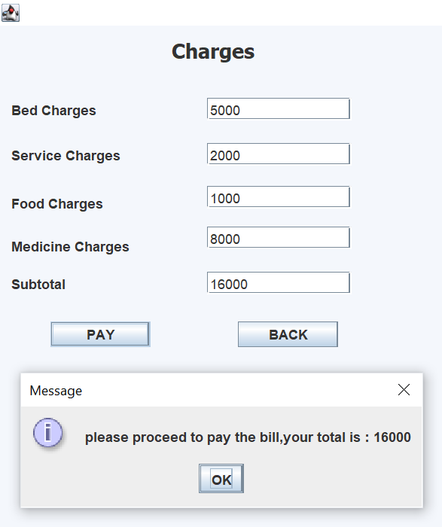

**Discharge summary of patient:**

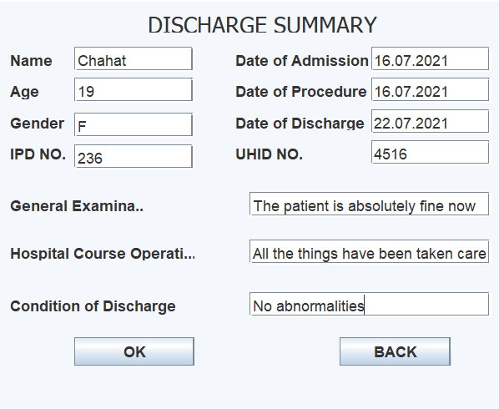

**Discharge summary of all patients:**

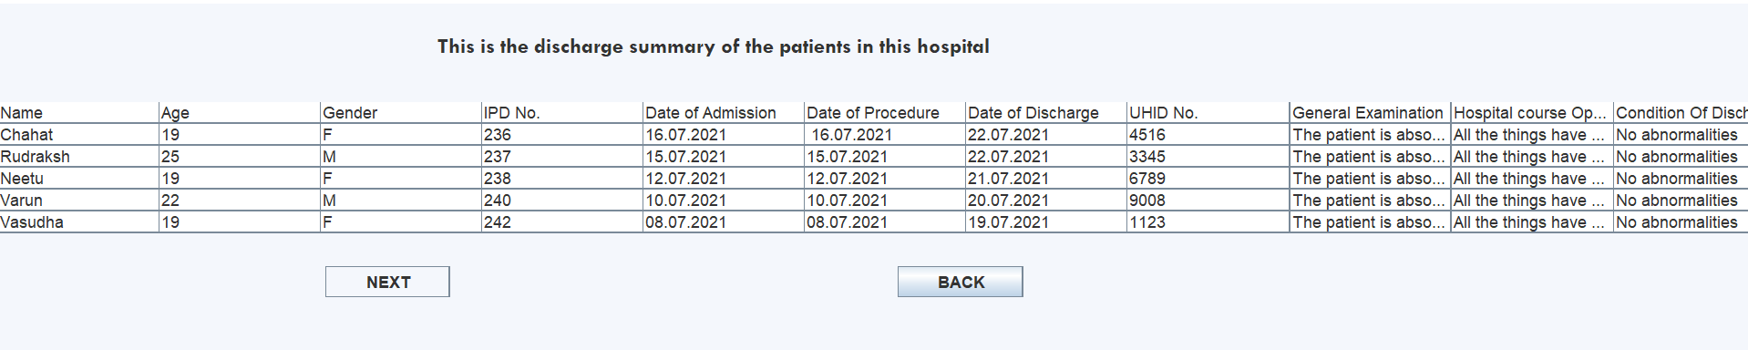

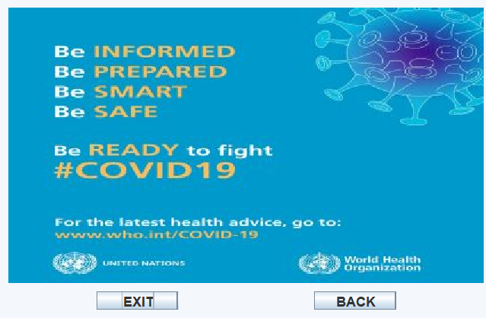

**Now procced for vaccination process:**

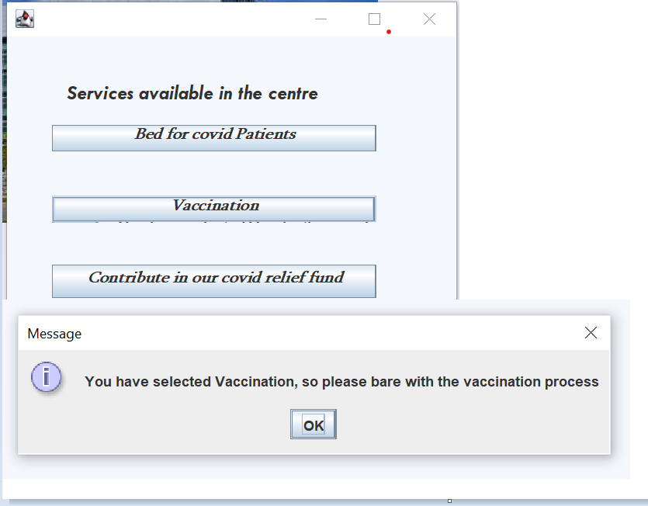

**Here is the detail of available doses og vaccine and select whether you want to vaccinate or not?**

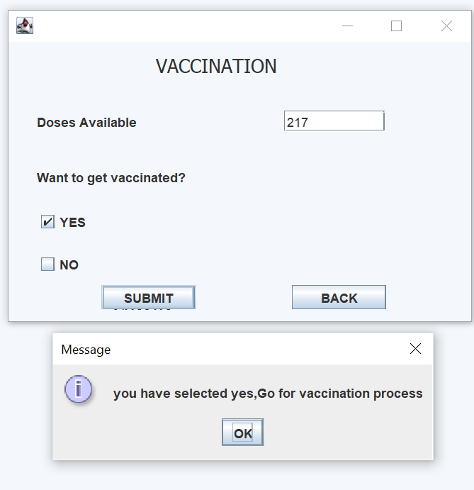

**You have selected for vaccination so enter your details and fill the otp that sent to your mobile no. :**

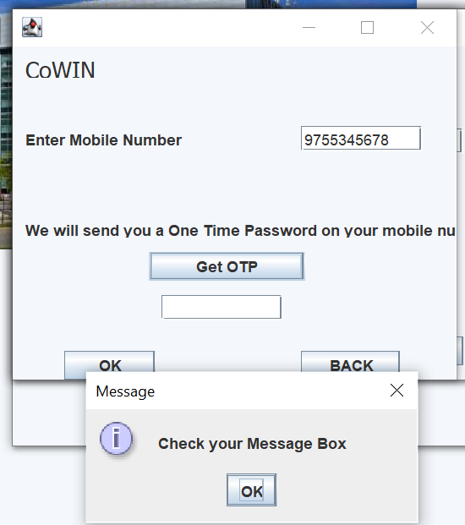

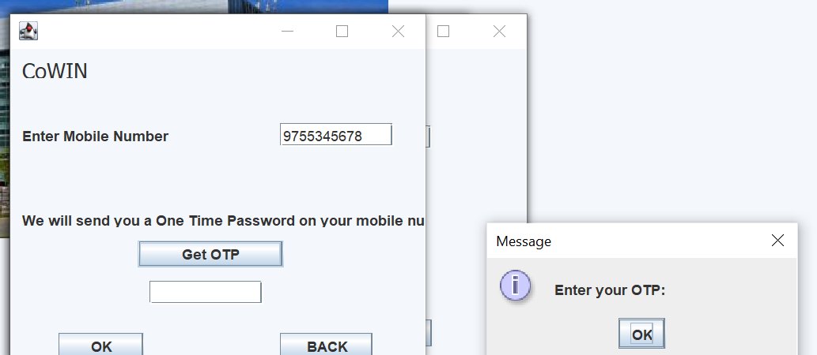

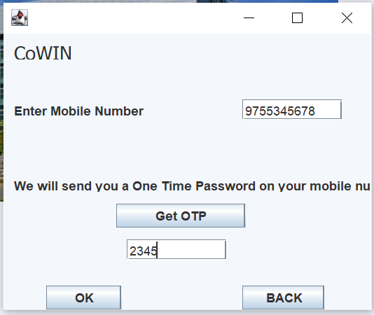

**Fill all necessary details to register for vaccination:**

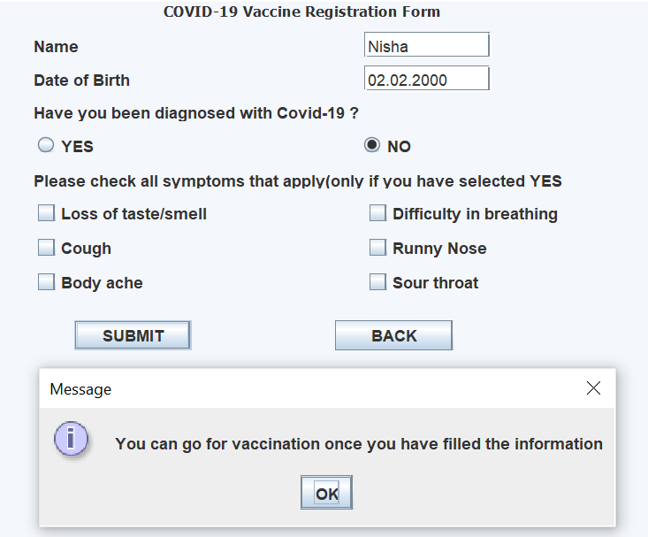

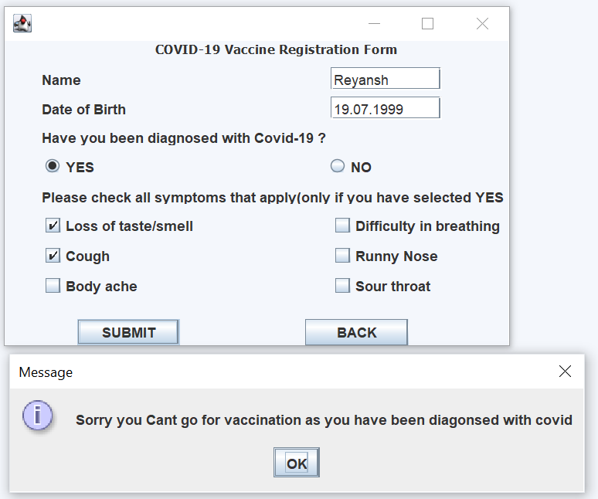

**List of patients who got vaccinated:**

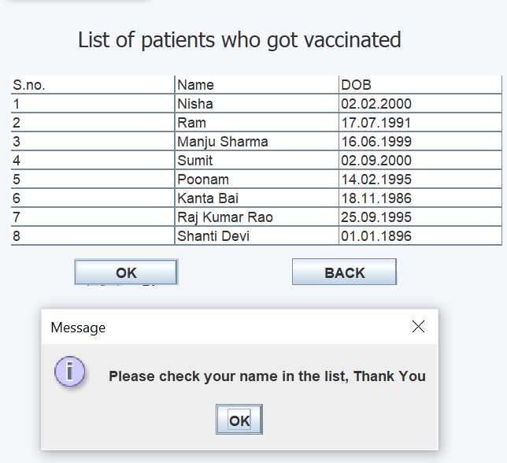

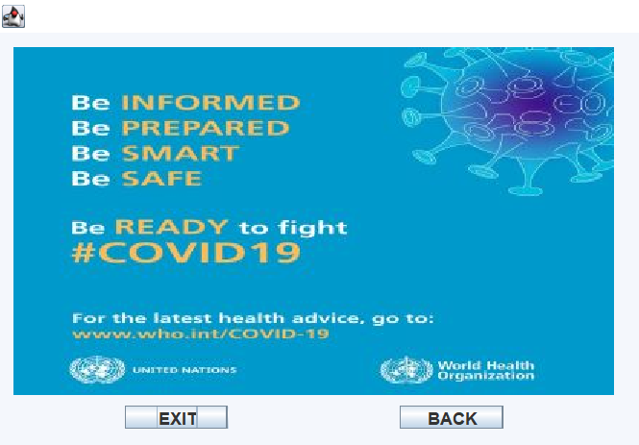

**Let’s move to the contribution process for covid relief fund:**

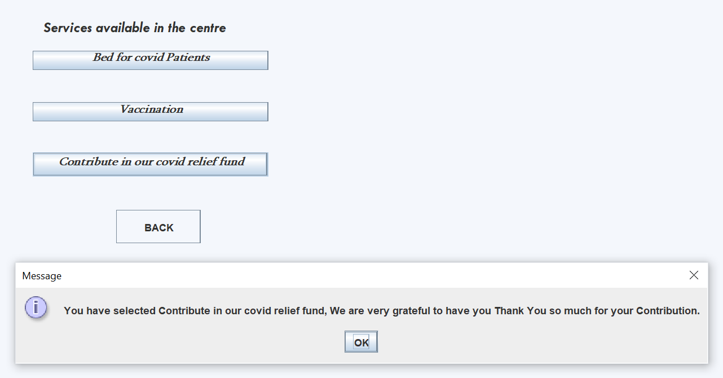

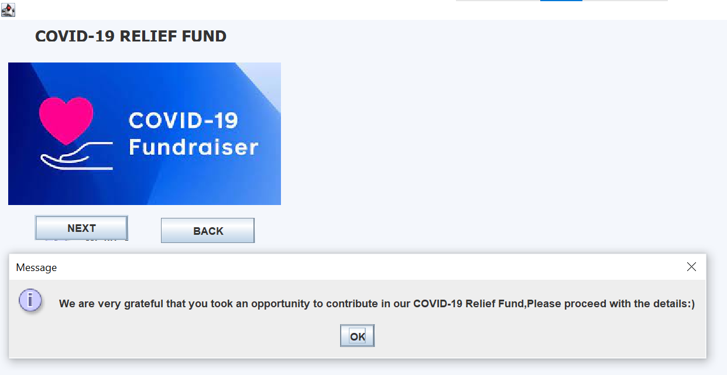

**Fill all details for contribution and pay the relief fund:**

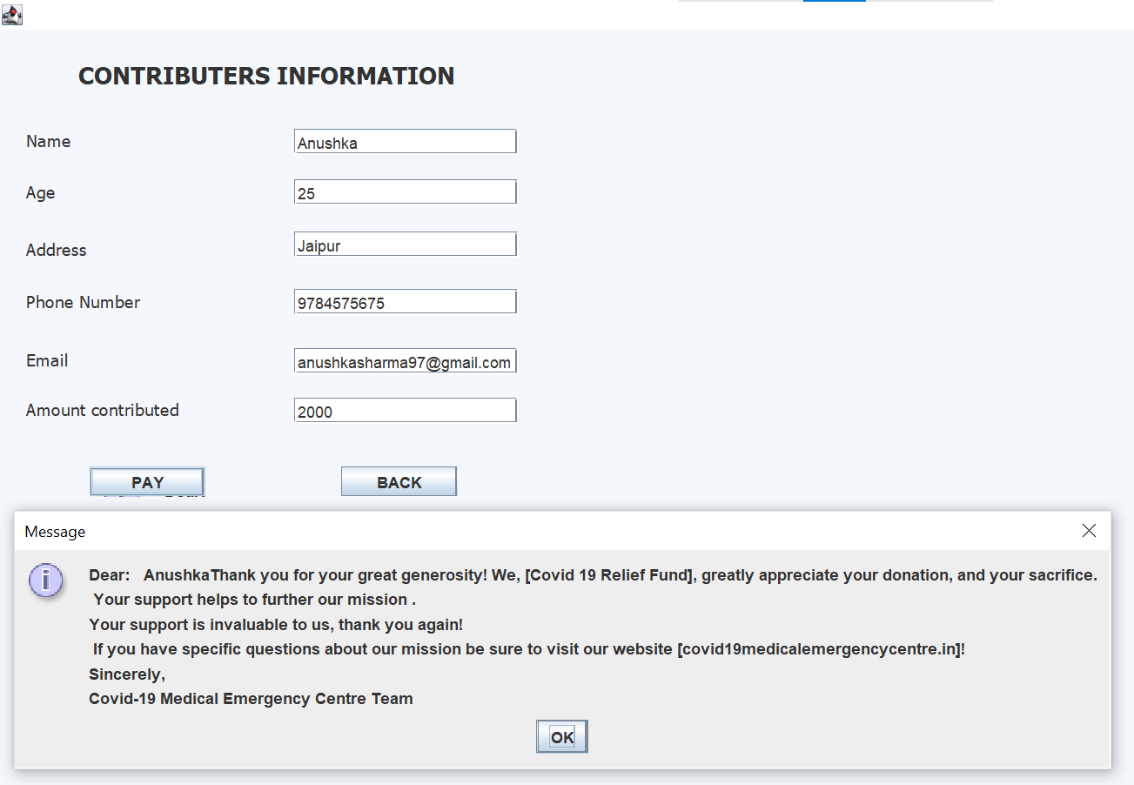

**Now you exit the page :**

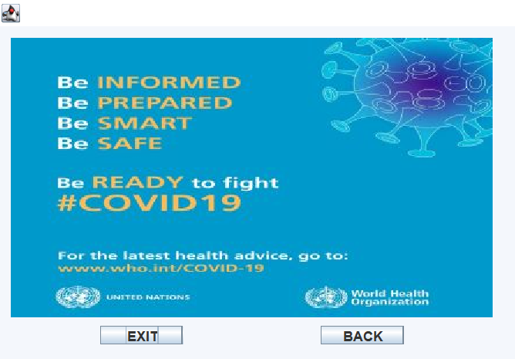

**Thanks for contributing and helping the needed ones.**