Week 1 Task
Data Cleaning and Preliminary Analysis with R
Daily Mandi Prices of Agricultural Commodities across India (data.gov.in)
Submitted by: Ankita Maheshwary
Internship: Virtual R Data Analyst Intern, YuvaIntern
Tools: R 4.6.1, RStudio, dplyr, ggplot2, readxl
Date: 19 October 2026

Contents
1. Executive Summary 1
2. Dataset Overview 1
2.1 Source and selection 1
2.2 Variables 1
3. Tools and Setup 1
4. Data Cleaning Process 1
4.1 Initial inspection 1
4.2 Column names and data types 1
4.3 Summary statistics and duplicates 1
4.4 Missing and invalid values 1
4.5 Logical consistency check 1
4.6 Outlier detection 1
4.7 Normalization 1
4.8 Encoding categorical variables 1
4.9 Cleaning summary 1
5. Exploratory Data Analysis 1
5.1 Descriptive statistics 1
5.2 Commodity-level summary 1
5.3 Geographic coverage 1
5.4 Correlation between price variables 1
6. Key Insights 1
7. Limitations 1
8. Conclusion and Next Steps 1
Appendix: Code and Files 1

(Right-click the table above and choose Update Field to refresh page numbers.)

1. Executive Summary
This report documents the cleaning and preliminary analysis of a real government dataset of daily wholesale (mandi) prices for agricultural commodities across India. The raw file contained 9,516 records and 10 variables. Using R, the data was inspected, type-corrected, checked for duplicates, missing and invalid values, logical errors and outliers, then normalized and encoded for future modelling. The final analysis-ready dataset contains 9,223 records.
Three findings stand out. First, 26 price entries were invalid, caused either by data-entry errors (prices of Rs 0.01 per quintal) or by a unit inconsistency in which leafy vegetables in Pune markets appear to be priced per bunch or kg instead of per quintal. Second, minimum, maximum and modal prices are almost perfectly correlated (r ≈ 0.99). Third, the dataset is heavily concentrated: 67% of clean records come from Tamil Nadu, which limits how far national conclusions can be drawn.

2. Dataset Overview

2.1 Source and selection
Dataset: Current Daily Price of Various Commodities from Various Markets (Mandi)
Publisher: Ministry of Agriculture and Farmers Welfare (Agmarknet), via the Open Government Data Platform India, data.gov.in
Arrival date of records: 19 October 2026 (a single-day snapshot)
Size: 9,516 rows × 10 columns
The dataset was chosen because it is public, large and policy-relevant, and because it contains the complexities the task asks for: a mix of categorical and numerical variables, invalid values hidden inside apparently complete columns, strongly skewed prices and commodity-specific outliers.

2.2 Variables
Variable | Type in R | Kind | Description
State | chr → factor | Categorical | State of the market
District | chr | Categorical | District of the market (325 unique)
Market | chr | Categorical | Mandi / APMC name (788 unique)
Commodity | chr → factor | Categorical | Crop or produce (182 unique)
Variety | chr | Categorical | Variety of the commodity (311 unique)
Grade | chr → factor | Categorical | Quality grade, e.g. FAQ, Large, Local
Arrival_Date | POSIXct → Date | Date | Date of arrival at the market
Min_Price | num | Numerical | Minimum price (Rs per quintal)
Max_Price | num | Numerical | Maximum price (Rs per quintal)
Modal_Price | num | Numerical | Most frequent trading price (Rs per quintal); main variable

3. Tools and Setup
The analysis was carried out in RStudio with R version 4.6.1. Three packages were used: readxl to import the Excel file, dplyr for grouping and summarising, and ggplot2 for visualisation. All charts were saved to an outputs folder with ggsave() so that the work is reproducible.
R Code
install.packages(c("dplyr", "ggplot2", "readxl")) # first time only
library(dplyr)
library(ggplot2)
library(readxl)
Data_Internship <- read_excel("Data_Internship.xlsx")
df <- as.data.frame(Data_Internship) # working copy; original stays safe

4. Data Cleaning Process

4.1 Initial inspection
The first step was to understand the structure of the data with dim() and str().
R Code
dim(df)
str(df)
R Output
[1] 9516 10
'data.frame': 9516 obs. of 10 variables:
$ State : chr "Keralam" "Keralam" "Keralam" ...
$ District : chr "Kozhikode(Calicut)" ...
$ Market : chr "Mukkom Market" ...
$ Commodity : chr "Banana" "Bhindi(Ladies Finger)" ...
$ Variety : chr "Other" "Bhindi" "Cucumbar" ...
$ Grade : chr "Large" "FAQ" "FAQ" "FAQ" ...
$ Arrival_Date : POSIXct, format: "2026-10-19" ...
$ Min_x0020_Price : num 6500 4400 3600 14500 2500 ...
$ Max_x0020_Price : num 7500 4700 4000 15500 2500 ...
$ Modal_x0020_Price: num 7000 4600 3800 15000 2500 ...
The data has six categorical (character) columns, three numerical price columns and one date-time column. Two issues were visible immediately: the price column names contain the code "_x0020_" (an encoded space), and the date is stored as date-time even though all records share one day.

4.2 Column names and data types
R Code
names(df) <- gsub("_x0020_", "_", names(df)) # Min_x0020_Price -> Min_Price
df$Arrival_Date <- as.Date(df$Arrival_Date) # date-time -> date
After this step the price columns are named Min_Price, Max_Price and Modal_Price and Arrival_Date is of class Date. The price columns were already numeric, so no conversion was needed.

4.3 Summary statistics and duplicates
R Code
summary(df[, c("Min_Price", "Max_Price", "Modal_Price")])
sum(duplicated(df))
df <- df[!duplicated(df), ]
R Output
Min_Price Max_Price Modal_Price
Min. : 0.01 Min. : 0.01 Min. : 0.01
1st Qu.: 2500.00 1st Qu.: 3000.00 1st Qu.: 2750.00
Median : 4000.00 Median : 4500.00 Median : 4250.00
Mean : 5265.62 Mean : 6027.36 Mean : 5655.78
3rd Qu.: 6000.00 3rd Qu.: 7000.00 3rd Qu.: 6500.00
Max. :280000.00 Max. :280000.00 Max. :280000.00
> sum(duplicated(df))
[1] 0
No duplicate rows were found. The summary, however, revealed two problems: a minimum price of Rs 0.01 per quintal, which is impossible in a wholesale market, and a mean well above the median (5,656 vs 4,250), which signals a right-skewed distribution.

4.4 Missing and invalid values
colSums(is.na(df)) returned 0 for every column, so the file had no blank cells. Missing information was instead hidden as invalid values. Rows with a modal price below Rs 100 per quintal were listed for inspection:
R Code
df[df$Modal_Price < 100, c("Commodity", "Market", "Min_Price", "Max_Price", "Modal_Price")]
R Output
Commodity Market Min_Price Max_Price Modal_Price
1809 Green Chilli Patti APMC 0.01 0.01 0.01
1811 Bitter gourd Patti APMC 0.01 0.01 0.01
2804 Mint(Pudina) Pune(Moshi) 10.00 10.00 10.00
6612 Spinach Pune(Moshi) 10.00 10.00 10.00
6844 Coriander(Leaves) Pune(Pimpri) 8.00 10.00 9.00
7523 Tomato Patti APMC 0.01 0.01 0.01
8565 Methi(Leaves) Pune(Moshi) 25.00 30.00 28.00
... (26 rows in total)
Two distinct causes were identified:
- Data-entry errors: several records from Patti APMC carry a placeholder price of Rs 0.01.
- Unit inconsistency: leafy vegetables (spinach, mint, methi, coriander) in Pune markets are priced at Rs 8 to 28, which only makes sense per bunch or per kg, not per quintal.
In both cases the values cannot be compared with the rest of the data, so they were treated as missing. Each affected row was flagged, its three prices were set to NA, and the NAs were imputed with the median price of the same commodity. The median was used rather than the mean because the price distribution is skewed.
R Code
df$Price_Flag <- df$Modal_Price < 100 # 26 rows flagged
df$Min_Price[df$Price_Flag] <- NA
df$Max_Price[df$Price_Flag] <- NA
df$Modal_Price[df$Price_Flag] <- NA

df <- df %>%
group_by(Commodity) %>%
mutate(across(c(Min_Price, Max_Price, Modal_Price),
~ ifelse(is.na(.x), median(.x, na.rm = TRUE), .x))) %>%
ungroup() %>% as.data.frame()
Twenty-four rows were filled. Two rows (both Rajgir, from Pune markets) remained NA because no valid Rajgir price existed elsewhere in the data to compute a median. These two rows were removed, leaving 9,514 records.

4.5 Logical consistency check
A valid market record must satisfy Min_Price ≤ Modal_Price ≤ Max_Price.
R Code
wrong <- df$Min_Price > df$Modal_Price | df$Modal_Price > df$Max_Price
sum(wrong)
R Output
[1] 0
No record violated this rule, which confirms the internal consistency of the price columns after cleaning.

4.6 Outlier detection
Because commodities differ greatly in price (cardamom versus cabbage, for example), outliers were detected within each commodity rather than across the whole dataset, using the interquartile range (IQR) rule: a value is an outlier if it lies below Q1 − 1.5×IQR or above Q3 + 1.5×IQR of its own commodity.
R Code
df <- df %>%
group_by(Commodity) %>%
mutate(Q1 = quantile(Modal_Price, 0.25),
Q3 = quantile(Modal_Price, 0.75),
IQR_val = Q3 - Q1,
Outlier = Modal_Price < (Q1 - 1.5 * IQR_val) |
Modal_Price > (Q3 + 1.5 * IQR_val)) %>%
ungroup() %>% as.data.frame()
sum(df$Outlier); round(mean(df$Outlier) * 100, 2)
R Output
[1] 291
[1] 3.06
Commodity Market Modal_Price Q1 Q3
9 Brinjal Gunpur APMC 7900 2200 4000
33 Raddish Shahabad APMC 800 2750 4000
100 Green Chilli Malout APMC 1500 4500 6000
291 records (3.06%) were flagged. Examples include brinjal at Rs 7,900 in Gunpur APMC (about double the upper quartile) and radish at Rs 800 in Shahabad APMC (far below the usual range).
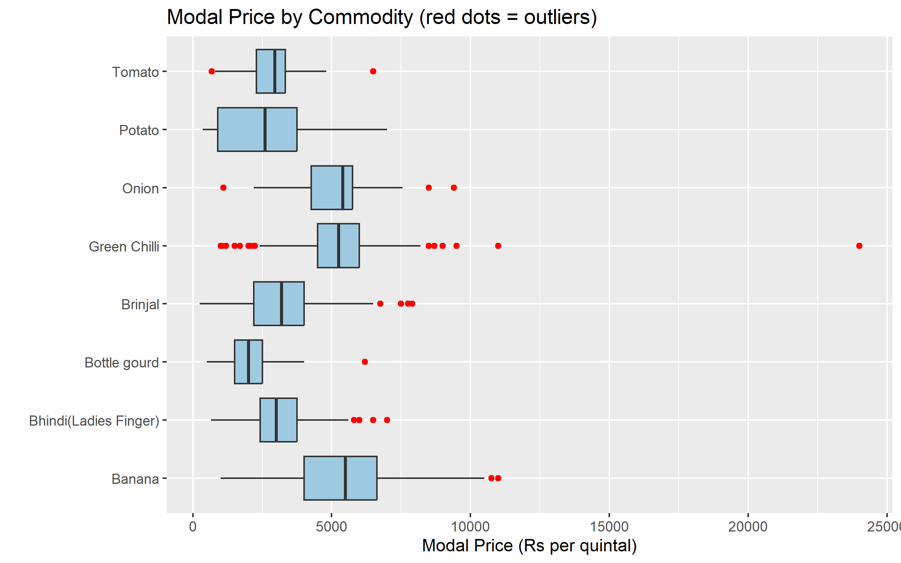
Figure 1. Modal price for the eight most-recorded commodities; red points are outliers.
Figure 1 shows that green chilli has the most outliers, including one near Rs 24,000 per quintal, while banana has the highest median and potato the widest spread across markets. Because sharp local price swings can be genuine (supply shocks, weather, festivals), outliers were flagged rather than deleted in the full dataset, and a separate analysis copy, df_clean, was created without them (9,223 records).
R Code
df_clean <- df[!df$Outlier, ]
df_clean <- df_clean[, !(names(df_clean) %in% c("Q1", "Q3", "IQR_val", "Outlier"))]

4.7 Normalization
Prices range from about Rs 100 to Rs 1,39,000 per quintal. Two transformations were added: min-max scaling to bring values into the range 0 to 1, and a natural-log transformation to reduce skew.
R Code
min_max <- function(x) (x - min(x)) / (max(x) - min(x))
df_clean$Modal_Price_scaled <- min_max(df_clean$Modal_Price)
df_clean$Modal_Price_log <- log(df_clean$Modal_Price)
Statistic | Modal_Price | Modal_Price_scaled | Modal_Price_log
Min | 100 | 0.000 | 4.605
1st Quartile | 2,750 | 0.019 | 7.919
Median | 4,250 | 0.030 | 8.355
Mean | 5,623 | 0.040 | 8.365
3rd Quartile | 6,280 | 0.044 | 8.745
Max | 1,39,023 | 1.000 | 11.842

On the original scale the mean exceeds the median by about Rs 1,370. After the log transformation the mean (8.365) and median (8.355) are almost equal, showing that the log scale makes the distribution close to symmetric. This will be useful for statistical modelling in later weeks.

4.8 Encoding categorical variables
State, Commodity and Grade were converted to factors. Two encoding methods were then demonstrated:
- Label encoding: each State receives an integer code (State_code). It is compact but implies an order that does not exist.
- One-hot encoding: model.matrix() creates one 0/1 column for each of the 12 Grade categories (GradeFAQ, GradeLarge, GradeLocal, GradeNon-FAQ, GradeSmall and others), which avoids any false ordering.
R Code
df_clean$State <- as.factor(df_clean$State)
df_clean$Commodity <- as.factor(df_clean$Commodity)
df_clean$Grade <- as.factor(df_clean$Grade)
df_clean$State_code <- as.numeric(df_clean$State) # label encoding
grade_dummies <- model.matrix(~ Grade - 1, data = df_clean) # one-hot encoding
df_clean <- cbind(df_clean, grade_dummies)
The final df_clean contains 9,223 rows and 26 columns.

4.9 Cleaning summary
Step | Action | Rows after step
Raw data | Imported from data.gov.in Excel file | 9,516
Duplicates | 0 found | 9,516
Invalid prices | 26 flagged as NA; 24 imputed with commodity median | 9,516
Unrecoverable NAs | 2 Rajgir rows removed | 9,514
Logical check | 0 violations | 9,514
Outliers | 291 flagged (3.06%); excluded from df_clean | 9,223

5. Exploratory Data Analysis

5.1 Descriptive statistics
For the cleaned data, the modal price has a median of Rs 4,250, a mean of Rs 5,623 and a standard deviation of Rs 5,996 per quintal. The standard deviation is larger than the mean, reflecting the wide variety of 181 commodities, from low-cost vegetables to high-value spices.
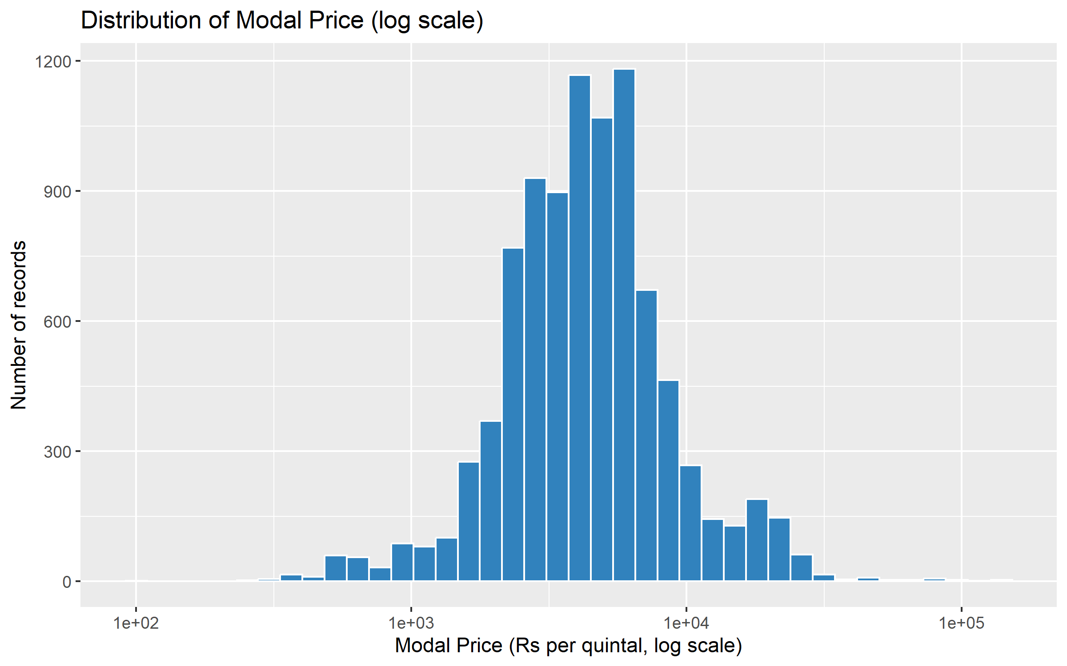
Figure 2. Distribution of modal price (log scale).
The log scale is used so that both cheap and expensive commodities remain visible in one chart. The distribution has one main peak: the middle 50% of records lie between Rs 2,750 and Rs 6,280 per quintal, where everyday vegetables trade. A smaller second bump appears between about Rs 15,000 and Rs 30,000. Of the 481 records in that band, the largest groups are lemon (109), garlic (76), green ginger (74) and pomegranate (42), which are higher-value produce. A thin tail of very expensive items reaches above Rs 1,00,000.

5.2 Commodity-level summary
R Code
commodity_summary <- df_clean %>%
group_by(Commodity) %>%
summarise(Records = n(), Avg_Price = round(mean(Modal_Price)),
Median_Price = median(Modal_Price)) %>%
arrange(desc(Records))
head(commodity_summary, 10)
R Output
Commodity Records Avg_Price Median_Price
1 Tomato 294 2780 2950
2 Brinjal 277 3098 3200
3 Potato 274 2530 2600
4 Bhindi(Ladies Finger) 254 3070 3000
5 Onion 253 5057 5400
6 Green Chilli 234 5307 5250
7 Bottle gourd 230 2019 2000
8 Banana 229 5298 5500
9 Bitter gourd 211 4863 5250
10 Cabbage 208 2365 2500
Tomato (294 records), brinjal (277) and potato (274) are the most widely reported commodities. Among the ten most recorded, bottle gourd (median Rs 2,000) and cabbage (Rs 2,500) are the cheapest, while banana, onion and green chilli trade above Rs 5,000 per quintal.

5.3 Geographic coverage
R Code
round(head(sort(prop.table(table(df_clean$State)) * 100, decreasing = TRUE), 5), 1)
R Output
Tamil Nadu Uttar Pradesh Gujarat Himachal Pradesh Punjab
67.0 4.2 4.0 3.5 3.0
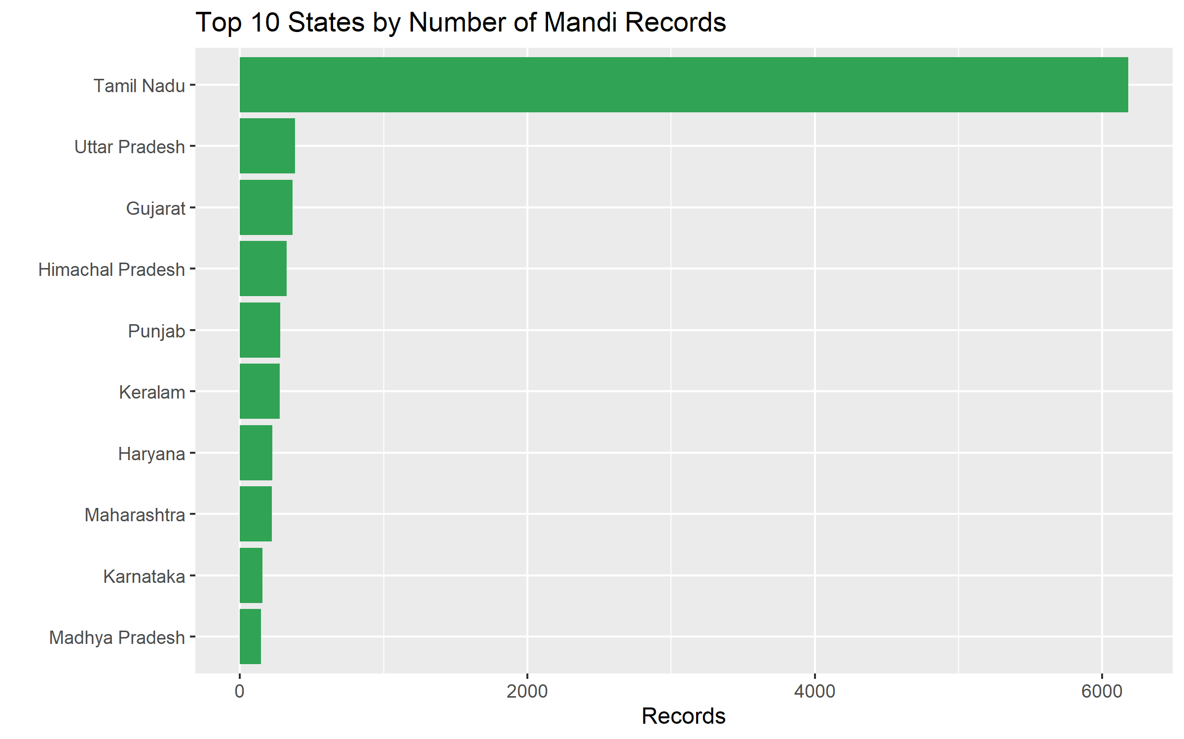
Figure 3. Top 10 states by number of mandi records.
Tamil Nadu alone accounts for 67% of clean records, far ahead of Uttar Pradesh (4.2%) and Gujarat (4.0%). The most common district (Salem) and market (Anna Nagar Uzhavar Sandhai) are also in Tamil Nadu. Any all-India average from this dataset is therefore largely a Tamil Nadu average.

5.4 Correlation between price variables
R Code
round(cor(df_clean[, c("Min_Price", "Max_Price", "Modal_Price")]), 3)
R Output
Min_Price Max_Price Modal_Price
Min_Price 1.000 0.978 0.992
Max_Price 0.978 1.000 0.995
Modal_Price 0.992 0.995 1.000
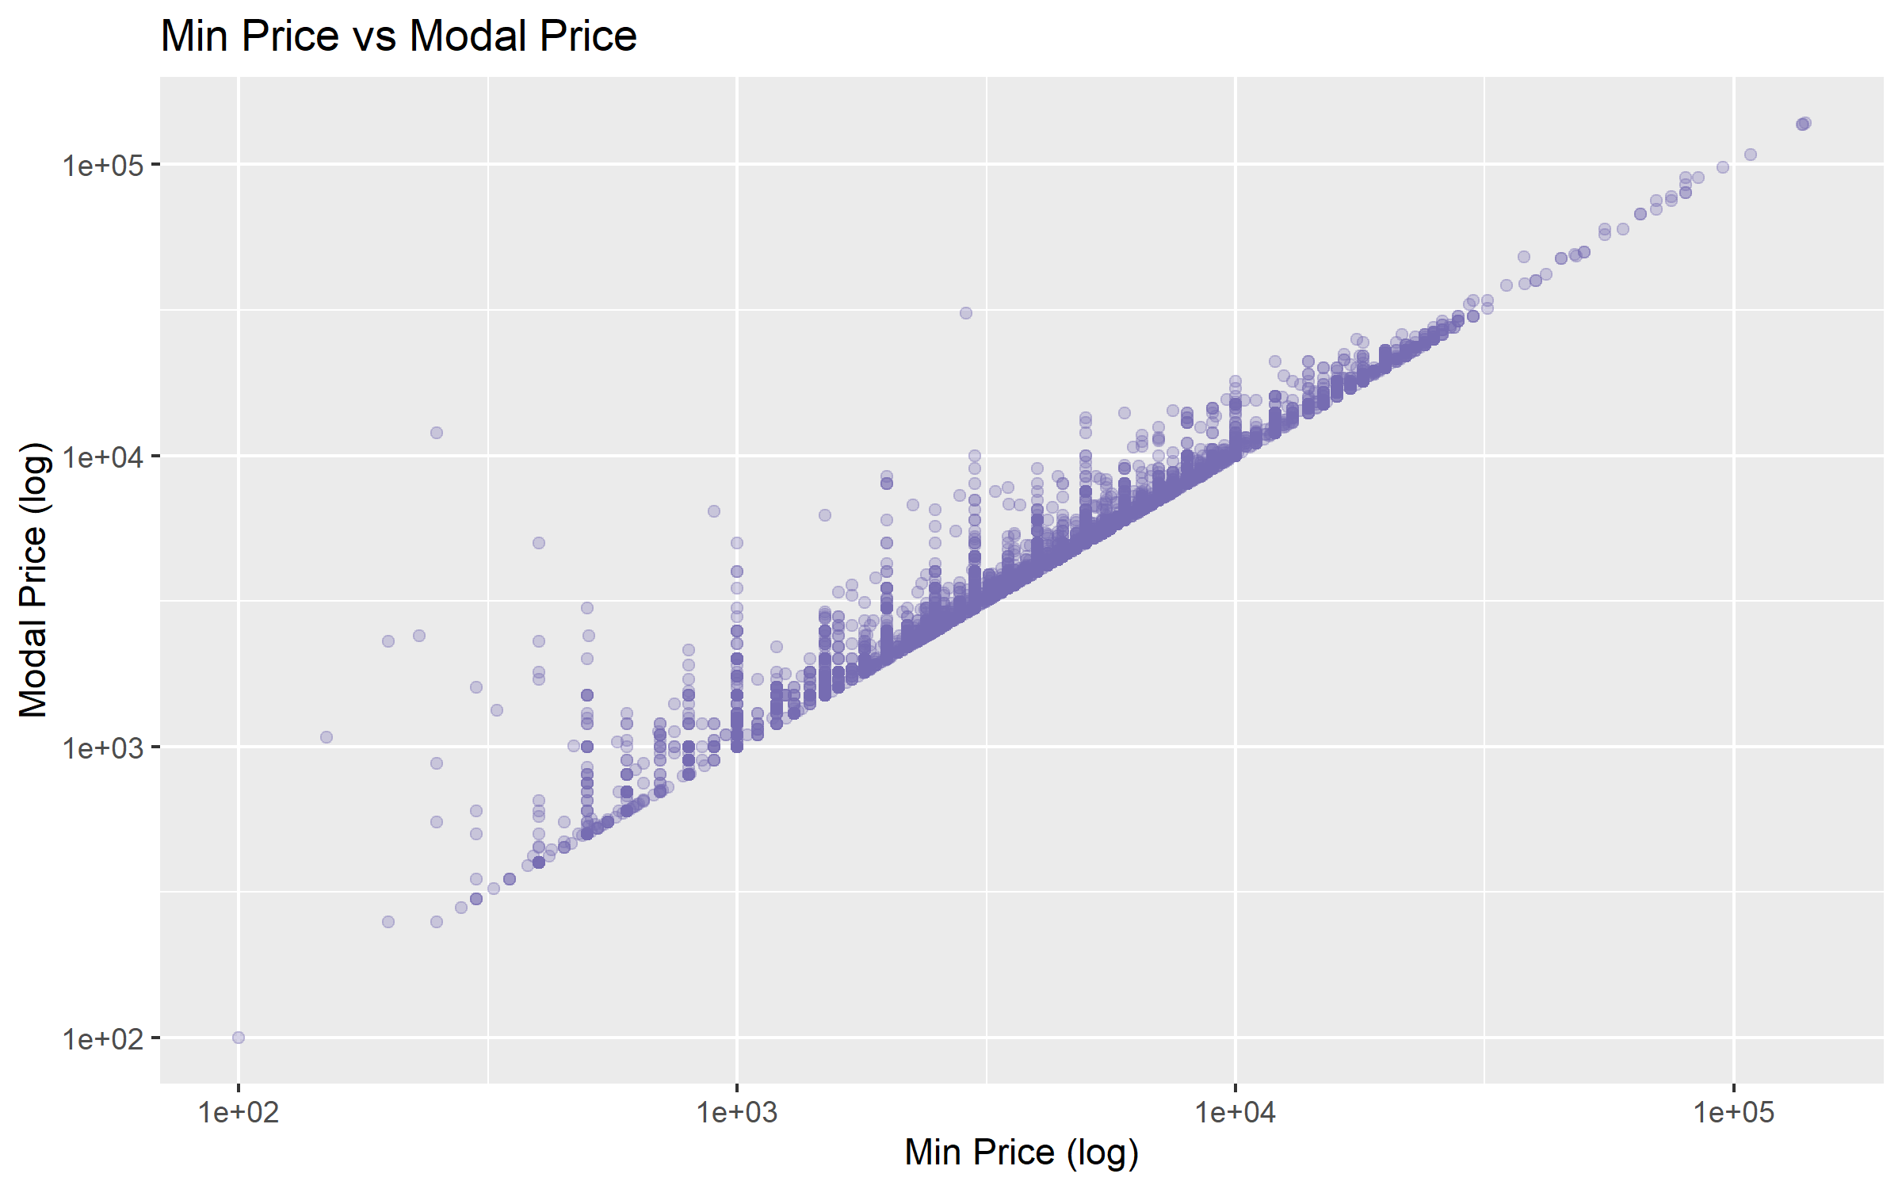
Figure 4. Minimum price versus modal price (both on log scale).
All three price variables are almost perfectly correlated (0.978 to 0.995). Figure 4 shows the points lying along a straight diagonal, and no point falls below the line, which visually confirms the logical rule that the modal price is never lower than the minimum price.

6. Key Insights
- The dataset looked complete (0% blank cells) but contained 26 invalid prices. Checking value ranges, not only blanks, is essential.
- A unit inconsistency was found: leafy vegetables in Pune markets appear to be priced per bunch or kg rather than per quintal.
- Prices are strongly right-skewed. A log transformation makes the distribution nearly symmetric (mean 8.365 vs median 8.355).
- About 3% of records are commodity-level outliers, with green chilli showing the most extreme values.
- Minimum, maximum and modal prices move together (r ≈ 0.99), so using Min or Max Price to predict Modal Price in later modelling would be close to circular. Location, commodity and grade are more meaningful predictors.
- Coverage is uneven: 67% of records are from Tamil Nadu.

7. Limitations
- Single-day snapshot: all records are from 19 October 2026, so no trends over time can be studied.
- Sampling bias: the dominance of Tamil Nadu limits national generalisation.
- Imputation: 24 prices were replaced by commodity medians, which reduces variability slightly for those commodities.
- Outlier rule: the IQR rule is statistical. Some flagged values may be genuine market prices, which is why they were retained in the full dataset.

8. Conclusion and Next Steps
The raw mandi price data was transformed into a clean, consistent and analysis-ready dataset of 9,223 records with scaled, log-transformed and encoded variables. The preliminary analysis established the shape of the price distribution, the most traded commodities, the regional concentration of the data and the near-perfect relationship among the price variables.
In the following weeks this cleaned dataset will be used for richer visualisation (Week 2), for hypothesis testing and a predictive model of modal price using commodity, state and grade (Week 3), and for a consolidated final report (Week 4).

Appendix: Code and Files
The complete, reproducible R script (week1_data_cleaning.R), the four charts and the cleaned dataset (mandi_prices_clean.csv) are available in the GitHub repository:
https://github.com/ankitamaheshwari91-hub/r-data-analyst-internship
Data source: Open Government Data Platform India, "Current Daily Price of Various Commodities from Various Markets (Mandi)", https://data.gov.in/resource/current-daily-price-various-commodities-various-markets-mandi

