Department of Computer Engineering Course : Laboratory Practice III

Answer | Coding Efficiency | Viva | Timely  Completion | Total | Dated Sign of Subject  Teacher
5 | 5 | 5 | 5 | 20

Expected Date of Completion:...................... Actual Date of Completion:.......................

Group A Assignment No: 4
Title of the Assignment: Write a program to solve a 0-1 Knapsack problem using dynamic programming or branch and bound strategy.
Objective of the Assignment: Students should be able to understand and solve 0-1 Knapsack problem using dynamic programming
Prerequisite:

1. Basic of Python or Java Programming

2. Concept of Dynamic Programming

3. 0/1 Knapsack problem
--------------------------------------------------------------------------------------------------------------- Contents for Theory:
1. Greedy Method

2. 0/1 Knapsack problem

3. Example solved using 0/1 Knapsack problem

---------------------------------------------------------------------------------------------------------------

What is Dynamic Programming?

● Dynamic Programming is also used in optimization problems. Like divide-and-conquer method, Dynamic Programming solves problems by combining the solutions of subproblems.

● Dynamic Programming algorithm solves each sub-problem just once and then saves its answer in a table, thereby avoiding the work of re-computing the answer every time.

● Two main properties of a problem suggest that the given problem can be solved using Dynamic

Programming. These properties are overlapping sub-problems and optimal substructure.

● Dynamic Programming also combines solutions to sub-problems. It is mainly used where the solution of one sub-problem is needed repeatedly. The computed solutions are stored in a table, so that these don’t have to be re-computed. Hence, this technique is needed where overlapping sub-problem exists.

● For example, Binary Search does not have overlapping sub-problem. Whereas recursive program of

Fibonacci numbers have many overlapping sub-problems.

Steps of Dynamic Programming Approach

Dynamic Programming algorithm is designed using the following four steps −

● Characterize the structure of an optimal solution.

● Recursively define the value of an optimal solution.

● Compute the value of an optimal solution, typically in a bottom-up fashion.

● Construct an optimal solution from the computed information.

Applications of Dynamic Programming Approach

● Matrix Chain Multiplication

● Longest Common Subsequence

● Travelling Salesman Problem

Knapsack Problem

You are given the following-

● A knapsack (kind of shoulder bag) with limited weight capacity.

● Few items each having some weight and value.

The problem states-

Which items should be placed into the knapsack such that-

● The value or profit obtained by putting the items into the knapsack is maximum.

● And the weight limit of the knapsack does not exceed.

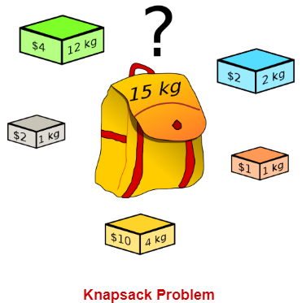

Knapsack Problem Variants

Knapsack problem has the following two variants-

1. Fractional Knapsack Problem
2. 0/1 Knapsack Problem

0/1 Knapsack Problem-
In 0/1 Knapsack Problem,

● As the name suggests, items are indivisible here.

● We can not take a fraction of any item.

● We have to either take an item completely or leave it completely.

● It is solved using a dynamic programming approach.

0/1 Knapsack Problem Using Greedy Method-

Consider-

● Knapsack weight capacity = w
● Number of items each having some weight and value = n

0/1 knapsack problem is solved using dynamic programming in the following steps-

Step-01:

● Draw a table say ‘T’ with (n+1) number of rows and (w+1) number of columns.
● Fill all the boxes of 0th row and 0th column with zeroes as shown-

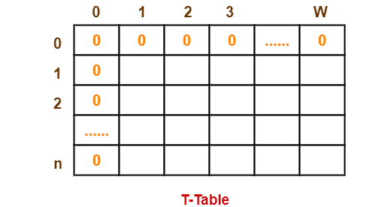

Step-02:

Start filling the table row wise top to bottom from left to right. Use the following formula-
T (i , j) = max { T ( i-1 , j ) , valuei + T( i-1 , j – weighti ) }

Here, T(i , j) = maximum value of the selected items if we can take items 1 to i and have weight restrictions of j.

● This step leads to completely filling the table.
● Then, value of the last box represents the maximum possible value that can be put into the knapsack.

Step-03:

● To identify the items that must be put into the knapsack to obtain that maximum profit,

● Consider the last column of the table.

● Start scanning the entries from bottom to top.

● On encountering an entry whose value is not same as the value stored in the entry immediately above it, mark the row label of that entry.
● After all the entries are scanned, the marked labels represent the items that must be put into the knapsack

Problem-.

For the given set of items and knapsack capacity = 5 kg, find the optimal solution for the 0/1 knapsack problem making use of a dynamic programming approach.

S ep 02

S a ng he ab e ow w se op o bo om om e o gh us ng he o mu a

T (i j) = max { T i-1 value + T( i-1 – weight }

SNJB s La e Sau K B Ja n Co ege o Eng nee ng Chandwad
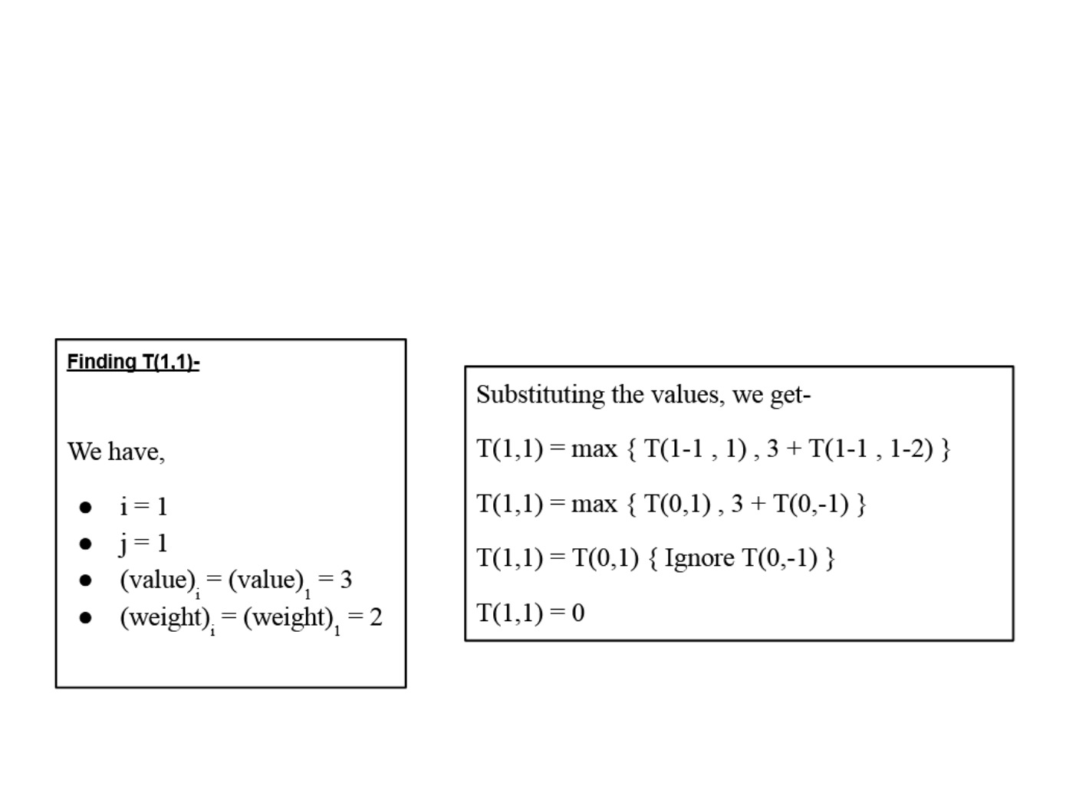

Solution-

Given

● Knapsack capacity (w) = 5 kg
● Number of items (n) = 4

Step-01:

● Draw a table say ‘T’ with (n+1) = 4 + 1 = 5 number of rows and (w+1) = 5 + 1 = 6 number of columns.
● Fill all the boxes of 0th row and 0th column with 0.

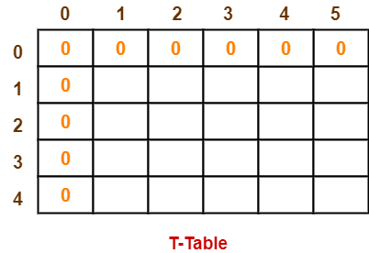

t - :

t rt filli | t | t l r | i t t | tt | fr | l ft t ri | t | i | t | f r |  | l -
 |  |  | , |  |  | ( , j ) , |  | i |  |  | , j |  | i )

Depa men o Compu e Eng nee ng Cou se Labo a o y P ac ce

SNJB s La e Sau K B Ja n Co ege o Eng nee ng Chandwad

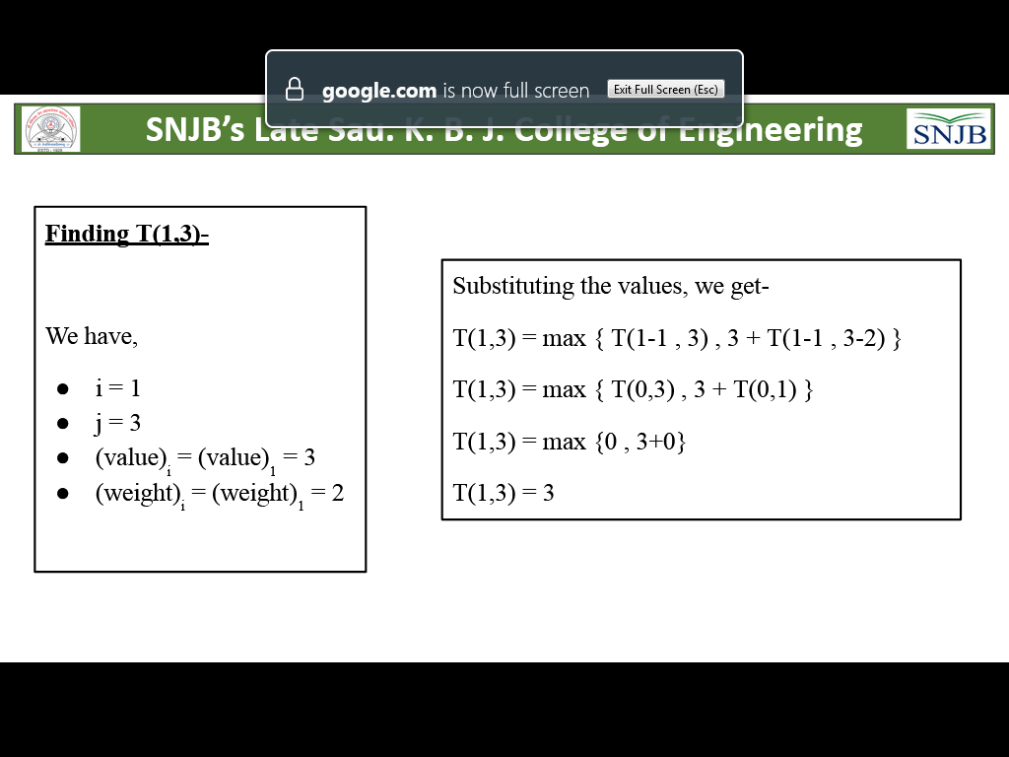
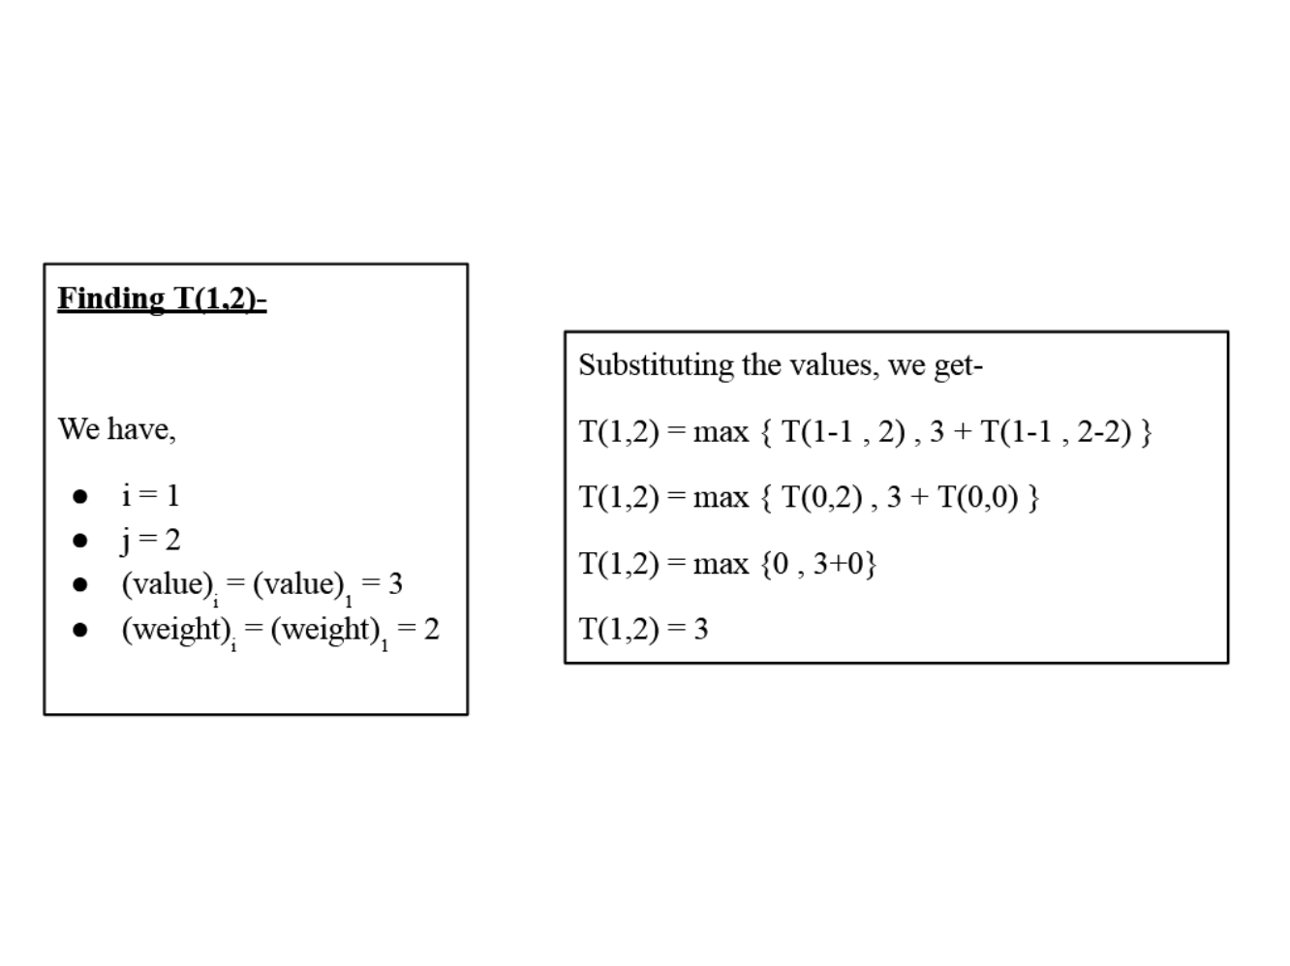

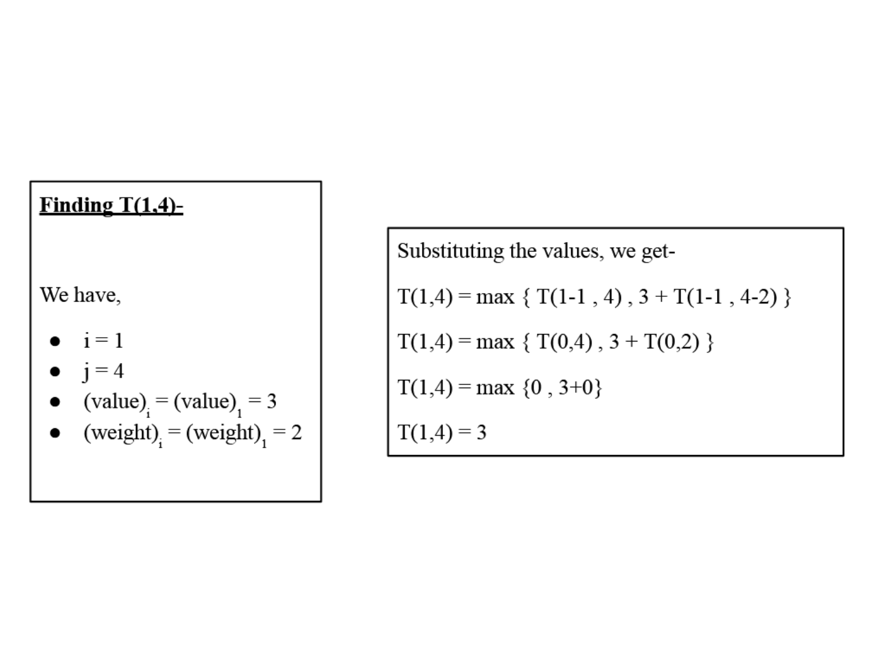

Depa men o Compu e Eng nee ng Cou se Labo a o y P ac ce

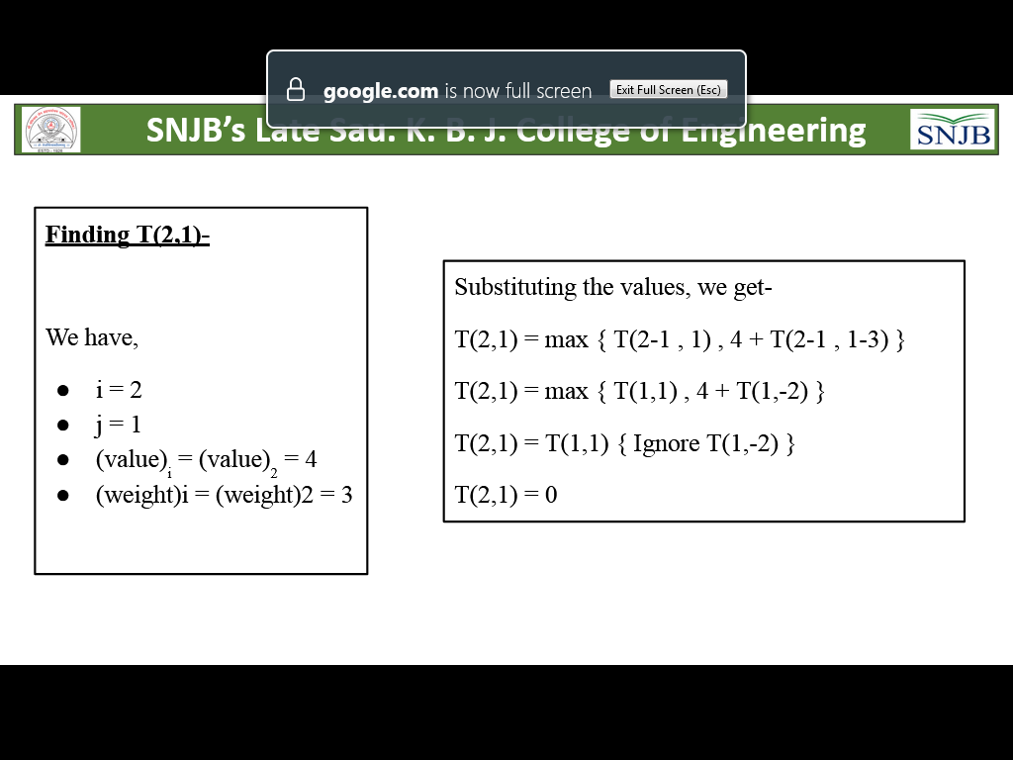
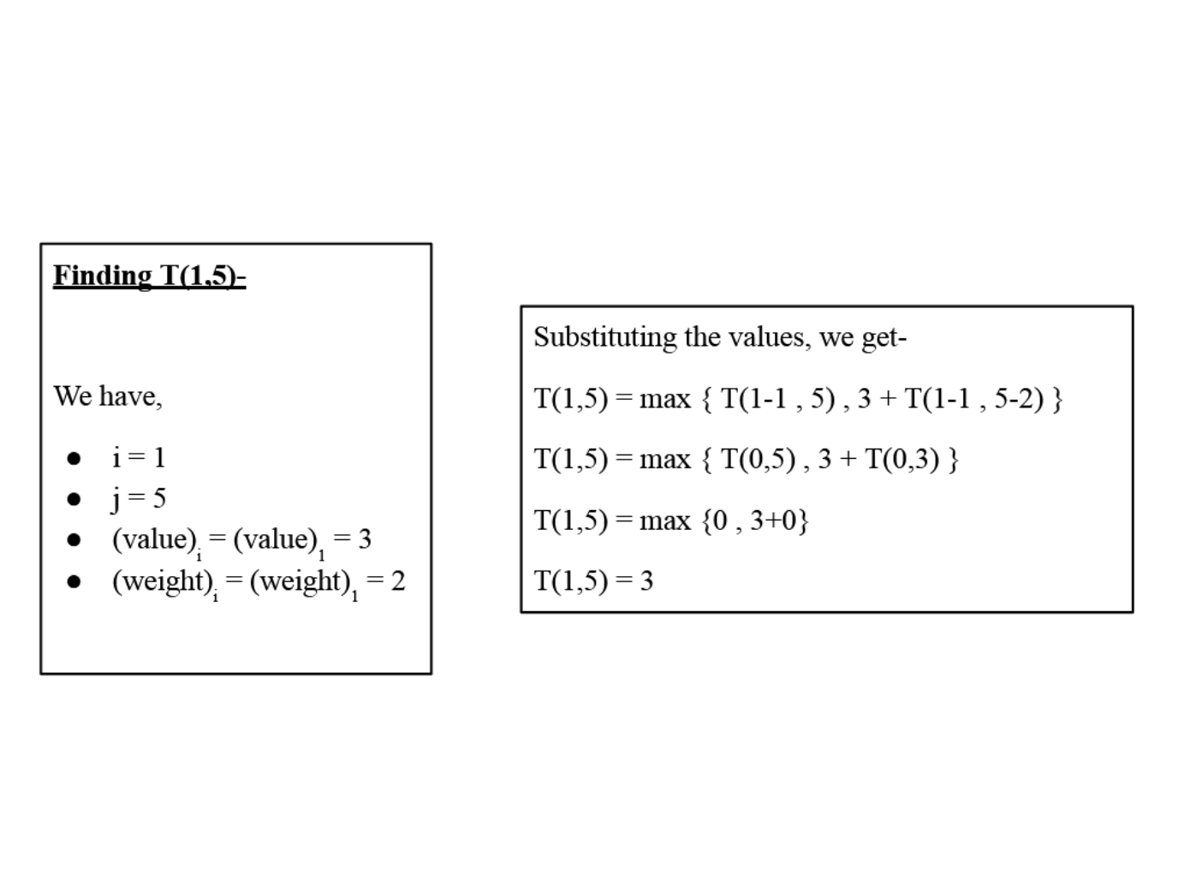

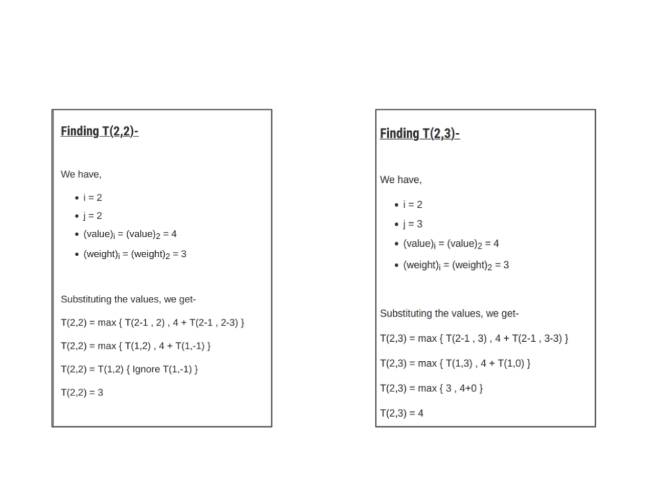

SNJB s La e Sau K B Ja n Co ege o Eng nee ng Chandwad

Similarly, compute all the entries.

After all the entries are computed and filled in the table, we get the following table-

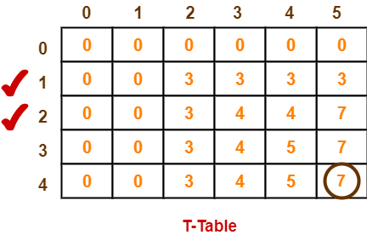
● The last entry represents the maximum possible value that can be put into the knapsack.

● So, maximum possible value that can be put into the knapsack = 7.

Identifying Items To Be Put Into Knapsack

Following Step-04,

● We mark the rows labelled “1” and “2”.

● Thus, items that must be put into the knapsack to obtain the maximum value 7 are-

Item-1 and Item-2

Time Complexity-

● Each entry of the table requires constant time θ(1) for its computation.

● It takes θ(nw) time to fill (n+1)(w+1) table entries.

● It takes θ(n) time for tracing the solution since tracing process traces the n rows.

● Thus, overall θ(nw) time is taken to solve 0/1 knapsack problem using dynamic programming

Conclusion-In this way we have explored Concept of 0/1 Knapsack using Dynamic approch

Assignment Question

1. What is Dynamic Approach?

2. Explain concept of 0/1 knapsack

3. Difference between Dynamic and Branch and Bound Approach.Which is best?

4. Solve one example based on 0/1 knapsack(Other than Manual) Reference link

● https://www.gatevidyalay.com/0-1-knapsack-problem-using-dynamic-programming-appr oach/
● https://www.youtube.com/watch?v=mMhC9vuA-70
● https://www.tutorialspoint.com/design_and_analysis_of_algorithms/design_and_analysi s_of_algorithms_fractional_knapsack.htm

