7 | a. Analyze the malware found in the file Lab13-01.exe.
 | i. Compare the strings in the malware (from the output of the strings command) with the information available via dynamic analysis. Based on this comparison, which elements might be encoded?
 | ii. Use IDA Pro to look for potential encoding by searching for the string xor. What type of encoding do you find?
 | iii. What is the key used for encoding and what content does it encode?
 | iv. Usethestatic toolsFindCrypt2, Krypto ANALyzer(KANAL), and the IDA Entropy Plugin to identify any other encoding mechanisms. What do you find?
 | v. What type of encoding is used for a portion of the network traffic sent by the malware?
 | vi. Where is the Base64 function in the disassembly?
 | vii. What is the maximum length of the Base64-encoded data that is sent? What is encoded?
 | viii. In this malware, would you ever see the padding characters (=or ==) in the Base64-encoded data?
 | ix. What does this malware do?
 | b. Analyze the malware found in the file Lab13-02.exe.
 | i. Using dynamic analysis, determine what this malware creates.
 | ii. Use static techniques such as an xor search, FindCrypt2, KANAL, and the IDA Entropy Plugin to look for potential encoding. What do you find?
 | iii. Based on your answer to question 1, which imported function would be a good prospect for finding the encoding functions?
 | iv. Where is the encoding function in the disassembly?
 | v. Trace from the encoding function to the source of the encoded content. What is the content?
 | vi. Can you find the algorithm used for encoding? If not, how can you decode the content?
 | vii. Using instrumentation, can you recover the original source of one of the encoded files?
 | c. Analyze the malware found in the file Lab13-03.exe.
 | i. Compare the output of strings with the information available via dynamic analysis. Based on this comparison, which elements might be encoded?
 | ii. Use static analysis to look for potential encoding by searching for the string xor. What type of encoding do you find?
 | iii. Use static tools like FindCrypt2, KANAL, and the IDA Entropy Plugin to identify any other encoding mechanisms. How do these findings com- pare with the XOR findings?
 | iv. Which two encoding techniques are used in thismalware?
 | v. For each encoding technique, what is the key?
 | vi. For the cryptographic encryption algorithm, is the key sufficient? What else must be known?
 | vii. What does this malware do?
 | viii. Create code to decrypt some of the content produced during dynamic analysis. What is this content?

Practical No. 7
a. Analyze the malware found in the file Lab13-01.exe.
i. Compare the strings in the malware (from the output of the strings command) with the information available via dynamic analysis. Based on this comparison, which elements might be encoded?
In IDA Pro, we can see the following strings which are of not much meaning. However on execution, if we were to strings the memory using process explorer and sniff the network traffic, we can observe some new strings such as http://www.practicalmalwareanalysis.com.
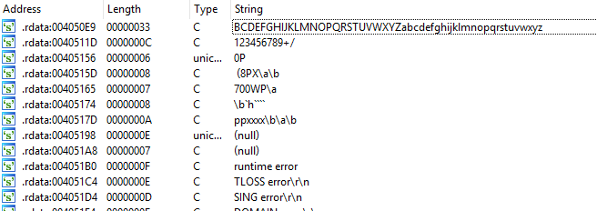
Figure 1. Meaningless string
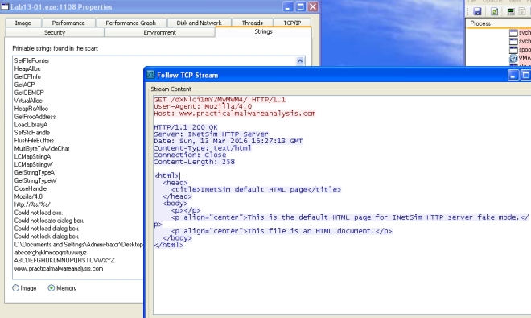Figure 2. URL found
ii. Use IDA Pro to look for potential encoding by searching for the string xor. What type of encoding do you find?
The subroutine @0x00401300 loads a resource in the binary and xor the value with “;“.
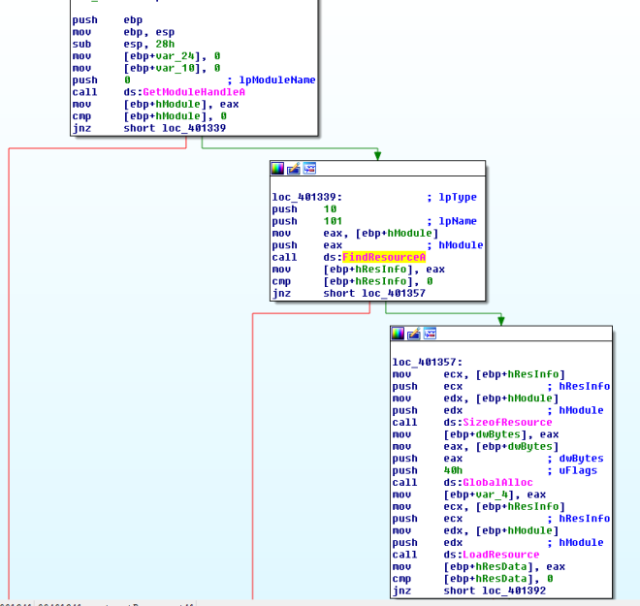
Figure 3. FIndResourceA 101
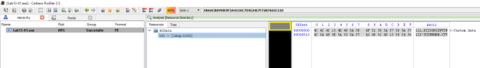
Figure 4. Resource String
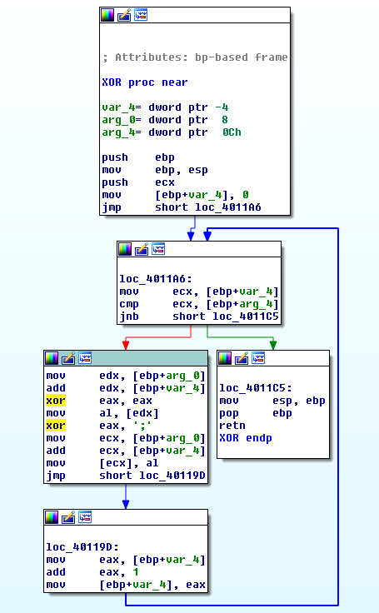
Figure 5. XOR with ;
iii. What is the key used for encoding and what content does it encode?
The key used is “;“. The decoded content is http://www.practicalmalwareanalysis.com.
iv. Use the static tools FindCrypt2, Krypto ANALyzer (KANAL), and the IDA Entropy Plugin to identify any other encoding mechanisms. What do you find?
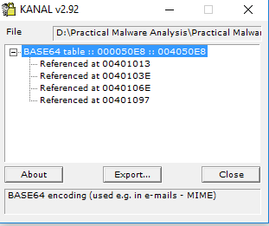
KANAL plugin located 4 addresses that uses “ABCDEFGHIJKLMNOPQRSTUVWXYZabcdefghijklmnopqrstuvwxyz0123456789+/”
v. What type of encoding is used for a portion of the network traffic sent by the malware?
base64 encoding is used to encode the computer name.
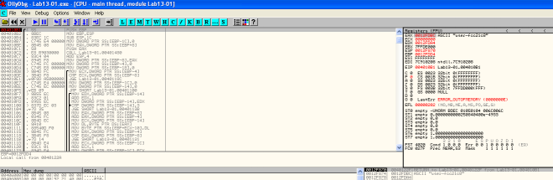
Figure 7. Encoding string
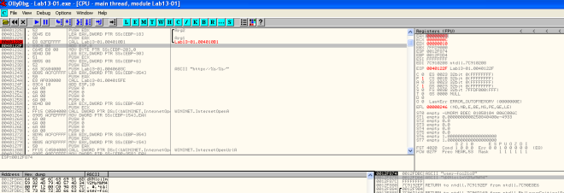
Figure 8. String encoded

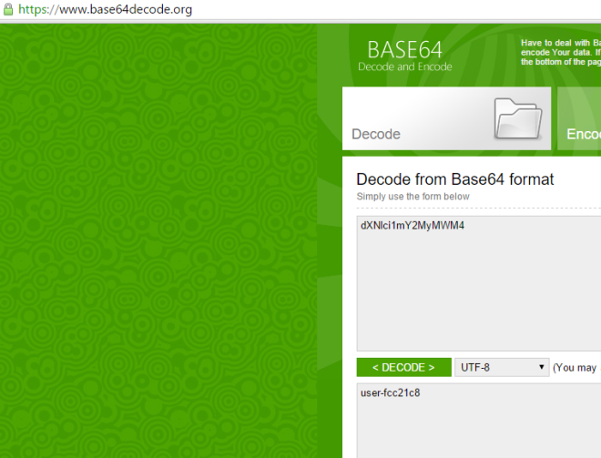Figure 9. Checking base64 encoded string
vi. Where is the Base64 function in the disassembly?
At address 0x004010B1.
vii. What is the maximum length of the Base64-encoded data that is sent? What is encoded?
The maximum length is 12 characters. The maximum base64 length is 16 bytes.
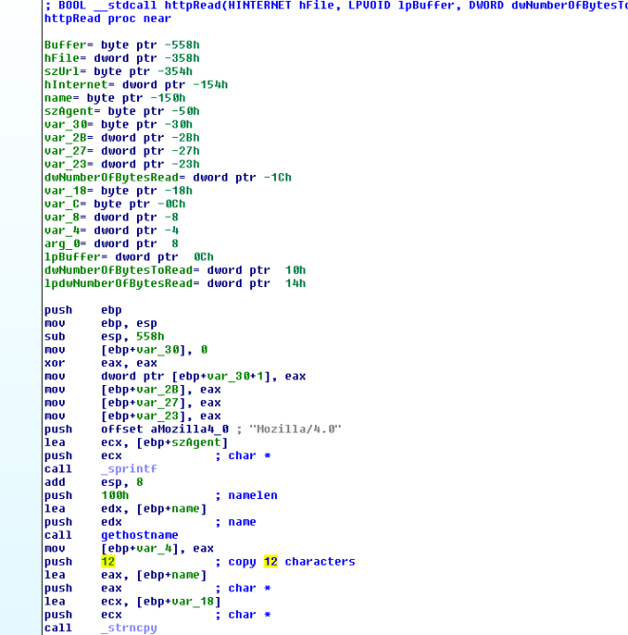Figure 10. Only 12 Characters
viii. In this malware, would you ever see the padding characters (= or ==) in the Base64-encoded data?
According to wiki. If the plain text is not divisible by 3, padding will present in the encoded string.
ix. What does this malware do?
It keeps sending the computer name (max 12 bytes) to http://www.practicalmalwareanalysis.com every 30 seconds until 0x6F is received as the first character in the response.

b. Analyze the malware found in the file Lab13-02.exe
i. Using dynamic analysis, determine what this malware creates.
A file with size 6,214 KB is written on the same folder as the executable every few seconds. The naming convention of the file is temp[8xhexadecimal]. The file created seems random.
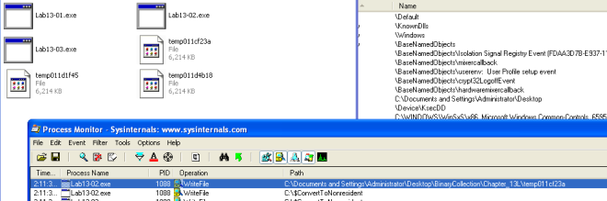Figure 1. Proc Mon
ii. Use static techniques such as an xor search, FindCrypt2, KANAL, and the IDA Entropy Plugin to look for potential encoding. What do you find?
Only managed to find XOR instructions. Based on the search result, we would need to look at the following subroutine
- 0x0040128D
- 0x00401570
- 0x00401739
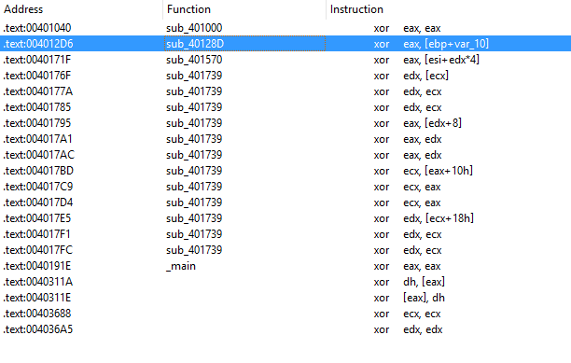
Figure 2. XOR
iii. Based on your answer to question 1, which imported function would be a good prospect for finding the encoding functions?
WriteFile. Trace up from WriteFile and we might locate the function responsible for encoding the contents.
iv. Where is the encoding function in the disassembly?
The encoding function is @0x0040181F. Tracing up from WriteFile, you will come across a function @0x0040181F. The function calls another subroutine(0x00401739) that performs the XOR operations and some shifting operations.
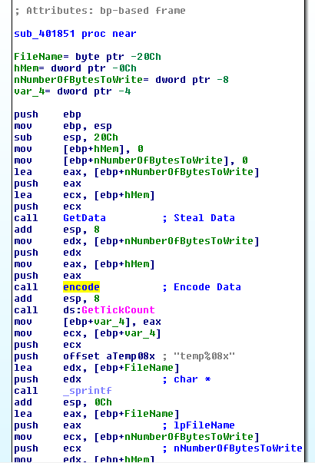Figure 3. encode
v. Trace from the encoding function to the source of the encoded content. What is the content?
Based on the subroutine @0x00401070. The malware is taking a screenshot of the desktop.
GetDesktopWindow: Retrieves a handle to the desktop window. The desktop window covers the entire screen. The desktop window is the area on top of which other windows are painted.
GetDC: The GetDC function retrieves a handle to a device context (DC) for the client area of a specified window or for the entire screen. You can use the returned handle in subsequent GDI functions to draw in the DC. The device context is an opaque data structure, whose values are used internally by GDI.
CreateCompatibleDC: The CreateCompatibleDC function creates a memory device context (DC) compatible with the specified device.
CreateCompatibleBitmap: The CreateCompatibleBitmap function creates a bitmap compatible with the device that is associated with the specified device context.
BitBlt: The BitBlt function performs a bit-block transfer of the color data corresponding to a rectangle of pixels from the specified source device context into a destination device context.
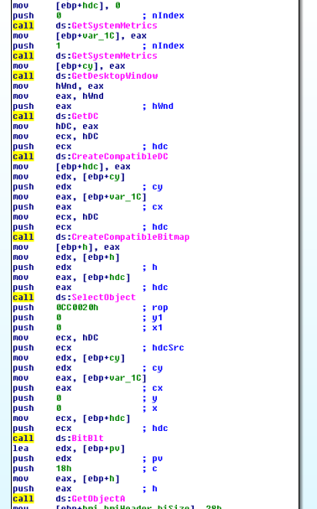
Figure 4. Screenshot
vi. Can you find the algorithm used for encoding? If not, how can you decode the content?
The encoder used is pretty lengthy to go through, However if we look at the codes in 0x401739, we can see lots of xor operations. If it is xor encoding we might be able to get back the original data if we call this subroutine again with the encrypted data.
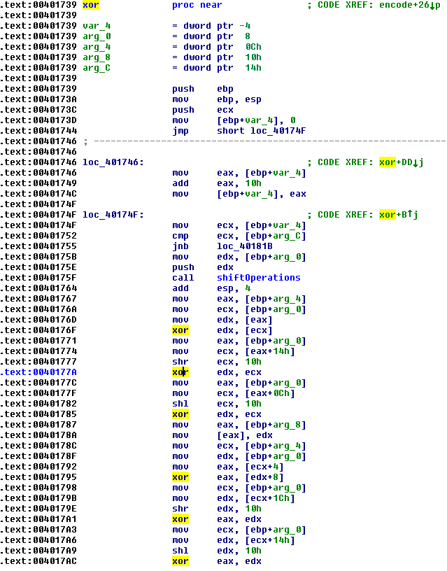
Figure 5. xor operations
vii. Using instrumentation, can you recover the original source of one of the encoded files?
My way of decoding the encoded files is to use DLL injection. To do that, i write my own DLL and create a thread to run the following function on DLL_PROCESS_ATTACHED. To attach the DLL to the malware process, we first run the malware and use a tool called Remote DLL injector by securityxploded to inject the DLL into the malicious process.
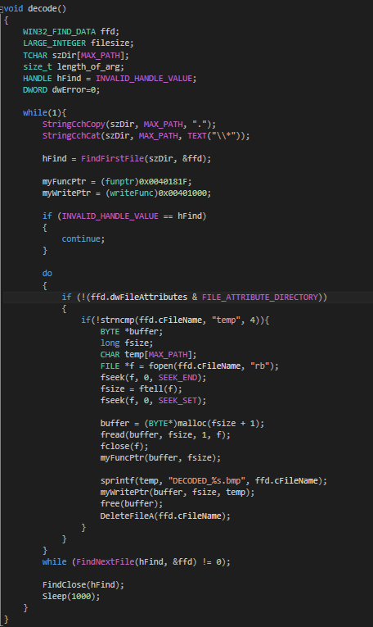
Figure 6. Decode Function
The above codes simply scan the path in which the executable resides in for encoded files that start with “temp“. It then reads the file and pass the data to the encoding function @0x40181F. Once the data is decoded, we make use of the function @0x401000 to write out the file to “DECODED_[encoded file name].bmp“. Last but not least i shall delete the encoded file so as not to clutter the folder.
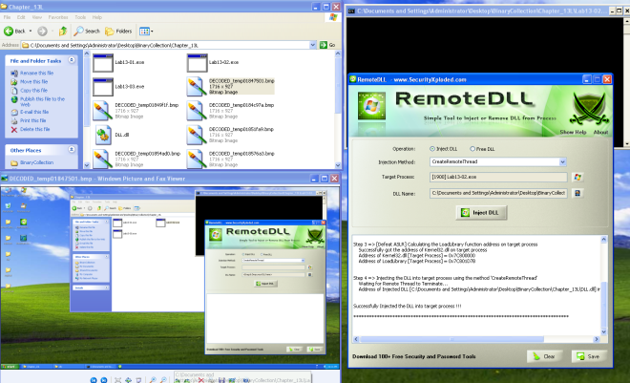
c. Analyze the malware found in the file Lab13-03.exe.
i. Compare the output of strings with the information available via dynamic analysis. Based on this comparison, which elements might be encoded?
Based on Wireshark and program response we could see the following strings.
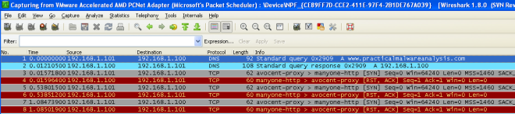Figure 1. http://www.practicalmalwareanalysis.com 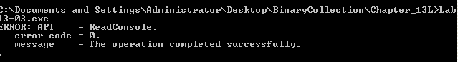Figure 2. Error Message
In IDA Pro we can see the domain host name and some possible debug messages.
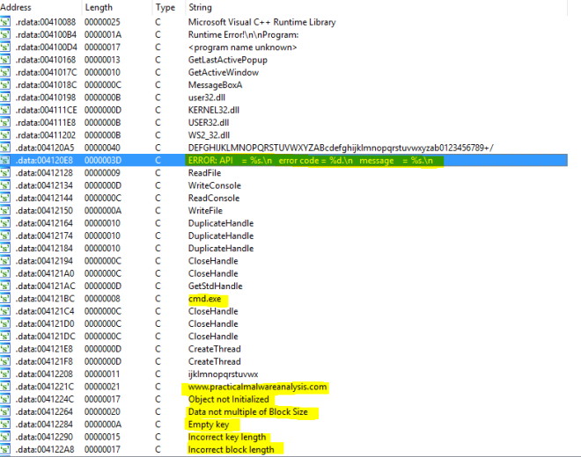Figure 3. IDA Pro strings
ii. Use static analysis to look for potential encoding by searching for the string xor. What type of encoding do you find?
There are quite a lot of xor operations to go through. But based on the figure below, it is highly possible that AES is being used; The Advanced Encryption Standard (AES) is also known as Rijndae.
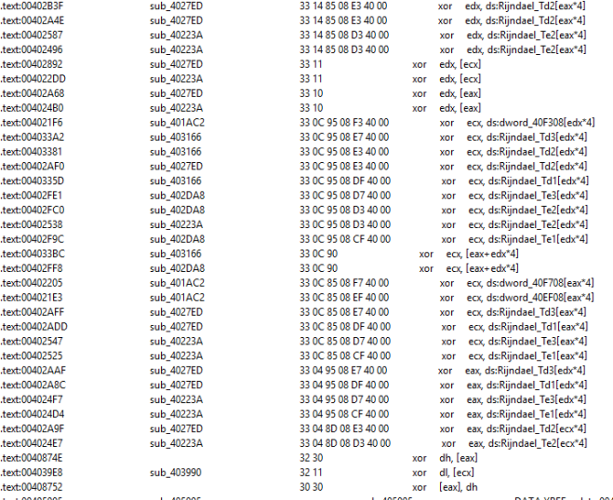Figure 4. XOR operations
iii. Use static tools like FindCrypt2, KANAL, and the IDA Entropy Plugin to identify any other encoding mechanisms. How do these findings compare with the XOR findings?
Most likely AES is being used in the malware.
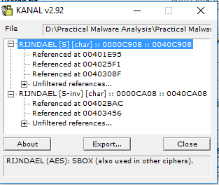
Figure 5. PEID found AES
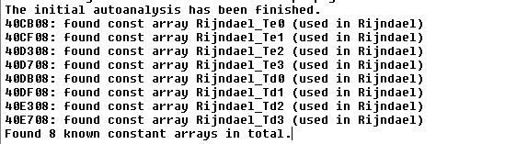
Figure 6. Find Crypt 2 Plugin Found AES
iv. Which two encoding techniques are used in this malware?
@0x4120A4 we can see a 65 characters string. Which seems like a custom base64 key. The standard base64 key should be “ABCDEFGHIJKLMNOPQRSTUVWXYZabcdefghijklmnopqrstuvwxyz0123456789+/=” which consists of A-Z, a-z, 0-9, +, / and =.
Figure 7. Custom Base64
A custom Base64 and AES are used in this malware.
v. For each encoding technique, what is the key?
The custom base64 string uses “CDEFGHIJKLMNOPQRSTUVWXYZABcdefghijklmnopqrstuvwxyzab0123456789+/” To test if this key is valid i used a online custom base64 tool to verify.
Online Tool: https://www.malwaretracker.com/decoder_base64.php
Using the above tool with the custom key, I encoded HELLOWORLD and pass it to the program via netcat to decode. True enough, the encoded text was decoded back to the original text.
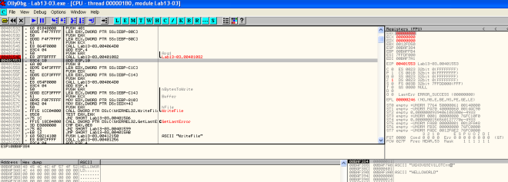Figure 8. Base64 decode
Based on some debug message, this function (0x00401AC2) seems to be initializing the AES key.
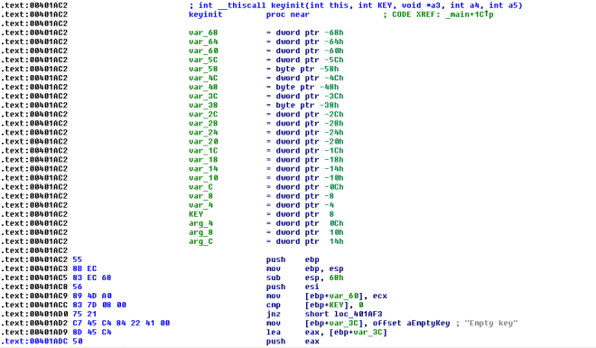Figure 9. Init Key
x-ref the function and locate the 2nd argument… the key is most likely to be “ijklmnopqrstuvwx“.
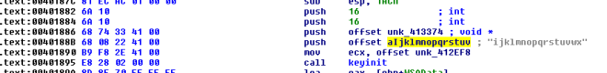Figure 10. Key pass in as 2nd argument
vi. For the cryptographic encryption algorithm, is the key sufficient? What else must be known?
For custom base64, we would just need the custom base64 string.
For AES, we would need the Cipher’s encryption mode, key and IV.
vii. What does this malware do?
The malware connects to an http://www.practicalmalwareanalysis.com’s 8190 port and establishes a remote shell. It then reads input from the attacker. The inputs are custom base64 encoded. Once decoded, the command is pass to cmd.exe for execution. The return results is encrypted using AES and send back to the attacker’s server.
viii. Create code to decrypt some of the content produced during dynamic analysis. What is this content?
Using the key, we use CBC mode with no IV to decrypt the AES encrypted packet. The content is the response from the command sent earlier via the remote shell from the attacker.
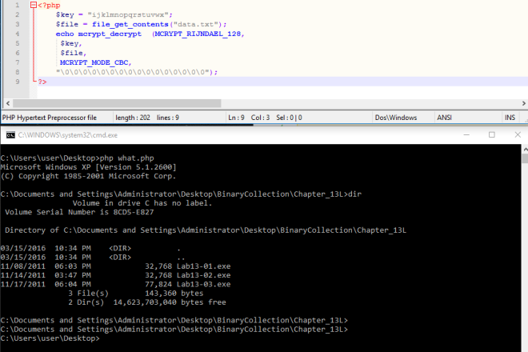Figure 11. Decrypted Data

