8 | a. Analyze the malware found in file Lab14-01.exe. This program is not harmful to your system.
 | i. Which networking libraries does the malware use, and what are their advantages?
 | ii. What source elements are used to construct the networking beacon, and what conditions would cause the beacon to change?
 | iii. Why might the information embedded in the networking beacon be of interest to the attacker?
 | iv. Does the malware use standard Base64 encoding? If not, how is the encoding unusual?
 | v. What is the overall purpose of this malware?
 | vi. What elements of the malware’s communication may be effectively detected using a network signature?
 | vii. What mistakes might analysts make in trying to develop a signature for this malware?
 | viii. What set of signatures would detect this malware (and future variants)?
b. Analyze the malware found in file Lab14-02.exe. This malware has been configured to beacon to a hard-coded loopback address in order to prevent it from harming your
system, but imagine that it is a hard-coded external address.
 | i. What are the advantages or disadvantages of coding malware to use direct IP addresses?
 | ii. Which networking libraries does this malware use? What are the advantages or disadvantages of using these libraries?
 | iii. What is the source of the URL that the malware uses for beaconing? What advantages does this source offer?
 | iv. Which aspect of the HTTP protocol does the malware leverage to achieve its objectives?
 | v. What kind of information is communicated in the malware’s initial beacon?
 | vi. What are some disadvantages in the design of this malware’s communication channels?
 | vii. Is the malware’s encoding scheme standard?
 | viii. How is communication terminated?
 | ix. What is the purpose of this malware, and what role might it play in the attacker’s arsenal?
 | c. This lab builds on Practical 8 a. Imagine that this malware is an attempt by the attacker to improve his techniques. Analyze the malware found in file Lab14-03.exe.
 | i. What hard-coded elements are used in the initial beacon? What elements, if any, would make a good signature?
 | ii. What elements of the initial beacon may not be conducive to a long lasting signature?
 | iii. How does the malware obtain commands? What example from the chapter used a similar methodology? What are the advantages of this technique?
 | iv. When the malware receives input, what checks are performed on the input to determine whether it is a valid command? How does the attacker hide the list of commands the malware is searching for?
 | v. What type of encoding is used for command arguments? How is it different from Base64, and what advantages or disadvantages does it offer?
 | vi. What commands are available to this malware?
 | vii. What is the purpose of this malware?
 | viii. This chapter introduced the idea of targeting different areas of code with independent signatures (where possible) in order to add resiliency to network indicators. What are some distinct areas of code or configuration data that can be targeted by network signatures?
 | ix. What set of signatures should be used for this malware?
 | d. Analyze the sample found in the file Lab15-01.exe. This is a command-line program that takes an argument and prints “Good Job!” if the argument matches a secret code.
 | i. What anti-disassembly technique is used in this binary?
 | ii. What rogue opcode is the disassembly tricked into disassembling?
 | iii. How many times is this technique used?
 | iv. What command-line argument will cause the program to print “Good Job!”?
 | e. Analyze the malware found in the file Lab15-02.exe. Correct all anti-disassembly countermeasures before analyzing the binary in order to answer the questions.
 | i. What URL is initially requested by the program?
 | ii. How is the User-Agent generated?
 | iii. What does the program look for in the page it initially requests?
 | iv. What does the program do with the information it extracts from the page?
 | f. Analyze the malware found in the file Lab15-03.exe. At first glance, this binary appears to be a legitimate tool, but it actually contains more functionality than advertised.
 | i. How is the malicious code initially called?
 | ii. What does the malicious code do?
 | iii. What URL does the malware use?
 | iv. What filename does the malware use?

Practical No. 8
a. Analyze the malware found in file Lab14-01.exe. This program is not harmful to your system.
i. Which networking libraries does the malware use, and what are their advantages?
The networking library used is urlmon’s URLDownlaodToCacheFileA.
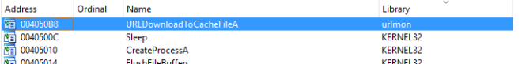Figure 1. urlmon’s URLDownlaodToCacheFileA
The advantage of using this api call is that the http packets being sent looks like a typical packet from the victim’s browser.
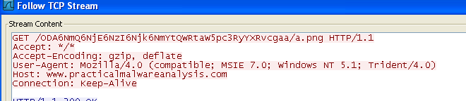Figure 2. User-Agent
ii. What source elements are used to construct the networking beacon, and what conditions would cause the beacon to change?
From the figure below, we can observe that the networking beacon is constructed from a partial GUID(19h to 24h) via GetCurrentHWProfileA and username via GetUserNameA.
Based on MSDN, szHwProfileGuid is a globally unique identifier (GUID) string for the current hardware profile. The string returned by GetCurrentHwProfile encloses the GUID in curly braces, {}; for example: {12340001-4980-1920-6788-123456789012}.
Therefore on different machine, the GUID should be different which infers that the beacon will change. On top of that, another variable used is the username therefore different users logging in to the same infected machine will generate a different beacon as well.
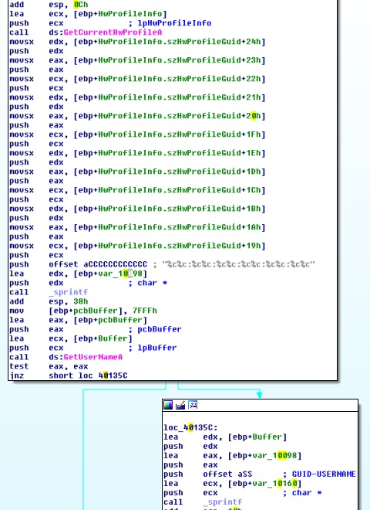
Figure 3. GUID & Username
iii. Why might the information embedded in the networking beacon be of interest to the attacker?
So that the attacker can have a unique id to keep track of the infected machines and users.
iv. Does the malware use standard Base64 encoding? If not, how is the encoding unusual?
Yes except that the padding used is different.
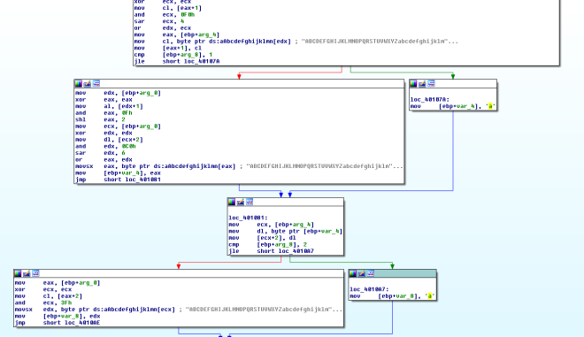Figure 4.padding ‘a’ is used instead of ‘=’
To prove that let’s try it using ollydbg. Set breakpoint @0x004013A2 and we can step through the base64 algo in action. In my test experiment i used AA:AA:AA:AA:AA:AA-AAAAAAAAAAAAA to let it encode. By right the standard base64 should give me the following results.
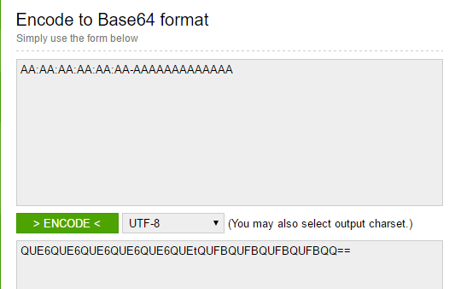Figure 5. Encoding AA:AA:AA:AA:AA:AA-AAAAAAAAAA
However we got back QUE6QUE6QUE6QUE6QUE6QUEtQUFBQUFBQUFBQUFBQQaa instead. Which further reinforced what we have seen earlier in IDA Pro where ‘a’ is used instead of ‘=’ for padding.
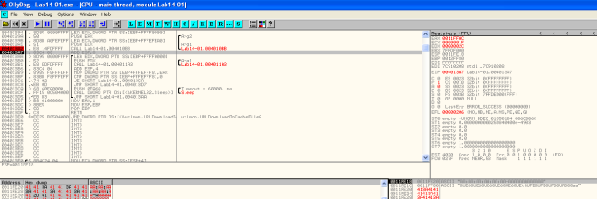Figure 6. Encoding in ollydbg
v. What is the overall purpose of this malware?
The malware attempts to download file from the c2 server and executes it every 60 seconds.
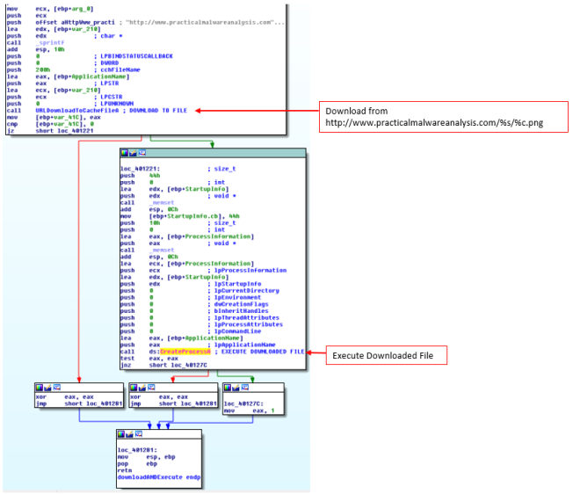
Figure 7. Download and execute
vi. What elements of the malware’s communication may be effectively detected using a network signature?
We can use to following elements to detect for this malware
- domain: http://www.practicalmalwareanalysis.com
- Get request ends with /[%c].png
- Get request pattern is as follows “/[A-Z|a-z|0-9]{3}6[A-Z|a-z|0-9]{3}6[A-Z|a-z|0-9]{3}6[A-Z|a-z|0-9]{3}6[A-Z|a-z|0-9]{3}6[A-Z|a-z|0-9]{3}t[A-Z|a-z|0-9]*\/[A-Z|a-z|0-9].png/”
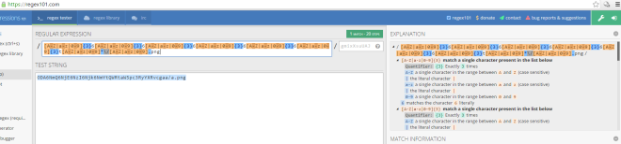Figure 8. online reg exp tool
vii. What mistakes might analysts make in trying to develop a signature for this malware?
- thinking that the GET request is a static base64 string
- thinking that the file requested is “a.png”
viii. What set of signatures would detect this malware (and future variants)?
refer to question vi.
b. Analyze the malware found in file Lab14-02.exe. This malware has been configured to beacon to a hard-coded loopback address in order to prevent it from harming your system, but imagine that it is a hard-coded external address.
i. What are the advantages or disadvantages of coding malware to use direct IP addresses?
Pro
If the attacker’s IP were to be blocked, other same variant of malware that uses different IP would not be affected.
Con
If the IP is blacklisted as malicious and blocked by the feds, the attacker would have lost access to the malware. If the attacker were to use a domain name, he can easily just redirect to another IP.
ii. Which networking libraries does this malware use? What are the advantages or disadvantages of using these libraries?
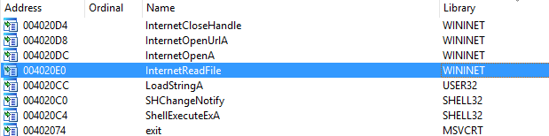Figure 2. WININET
WININET library is used by this malware.
Pro
Caching and cookies are automatically set by the OS. If cache are not cleared before re-downloading of files, the malware could be getting a cached file instead of a new code that needs to be downloaded.
Con
User agent need to be set by the malware author, usually the user agent is hard coded.
iii. What is the source of the URL that the malware uses for beaconing? What advantages does this source offer?
The url is hidden in the string resource. Once a malware is compiled, the attacker would just need to reset the resource to another ip without recompiling the malware. Also using a resource make do without an additional config file.
iv. Which aspect of the HTTP protocol does the malware leverage to achieve its objectives?
Threads are created by the malware. One to send data out in the user agent field after encoding it using custom base64. The other to receive data.
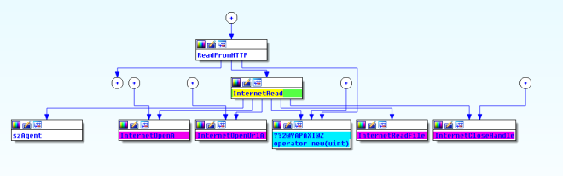Figure 3. Read Data 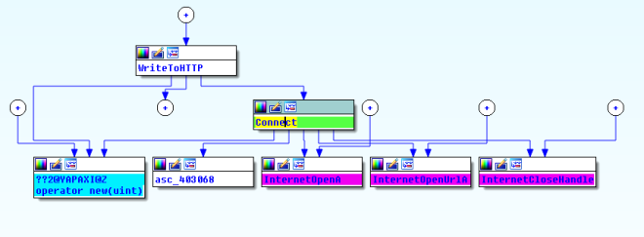Figure 4. Send Data
Read Data Thread uses a static user agent “Internet Surf” as shown below.
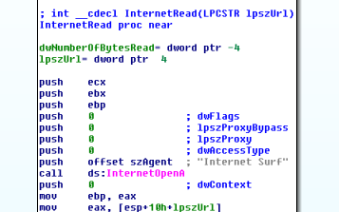
Figure 5. Internet Surf User-agent
v. What kind of information is communicated in the malware’s initial beacon?
Setting a breakpoint @0x00401750, we will break before the malware attempts to send packets out. Here you will see a custom base64 encoded data being package ready to send out.
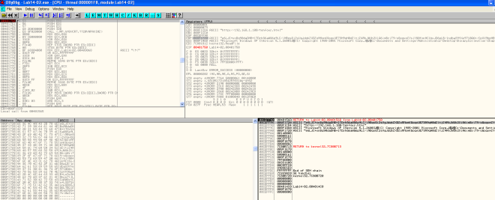
Figure 6. Base64 encoded data
The decoded text is the cmd.exe prompt.
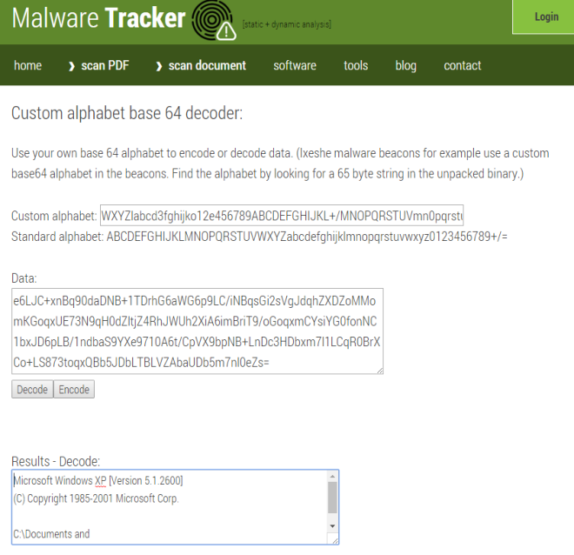Figrue 7. Decoded Base64
vi. What are some disadvantages in the design of this malware’s communication channels?
- Only outgoing traffic is encoded thus incoming commands are in plain for defender to see
- The user agent used is hard coded for one of the thread which makes it easy to form a signature to detect it.
- The other user agent looks out of place and defender can spot it if he/she go through the packet header.
vii. Is the malware’s encoding scheme standard?
No. We can see the custom base64 key in the following figure.
Figure 8. Custom base64 key
viii. How is communication terminated?
In the subroutine @0x00401800, once the malware reads the word exit from the C2 server, the thread will exit.
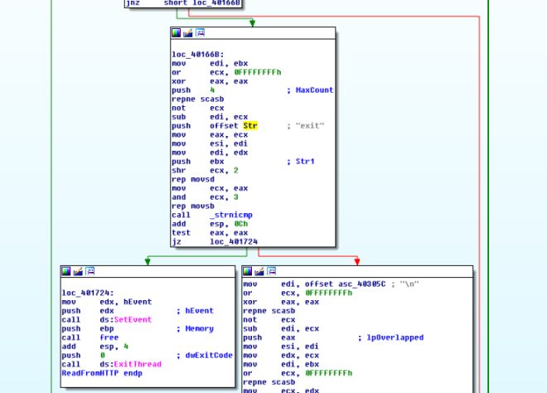Figure 9. exit keyword
ix. What is the purpose of this malware, and what role might it play in the attacker’s arsenal?
Reverse Shell via http. On termination of the malware a subroutine (0x00401880) will be called to delete itself from the system.
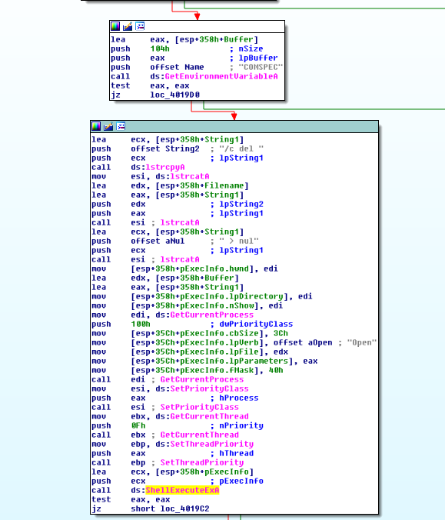
Figure 10. self delete
c. This lab builds on Practical 8 a. Imagine that this malware is an attempt by the
attacker to improve his techniques. Analyze the malware found in file Lab14-03.exe.
i. What hard-coded elements are used in the initial beacon? What elements, if any, would make a good signature?
From the figure below, we can see hard-coded user-agent and headers (Acccept, Accept-Language, Accept-Encoding, and a unique UA-CPU field). All of these can be used as a signature especially the UA-CPU field. It is also noted that the author pass the string “User-Agent: xxx” into InternetOpenA API call. This results in User-Agent field being set to User-Agent:User-Agent:xxx… A duplicate error in which we can used it to generate a good signature too.
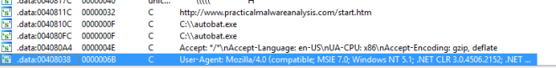Figure 1. HTTP Headers
ii. What elements of the initial beacon may not be conducive to a longlasting signature?
In the subroutine @0x401457, we can see that the url “http://www.practicalmalwareanalsysis.com/start.htm” is being set as the beacon destination. However that is provided that “c:\\autobat.exe” does not exists, if it exists, the contents will be read and parsed as the beacon destination instead. Using “http://www.practicalmalwareanalsysis.com/start.htm” as a signature might not be a good idea since an attacker might be able to change the beacon destination.
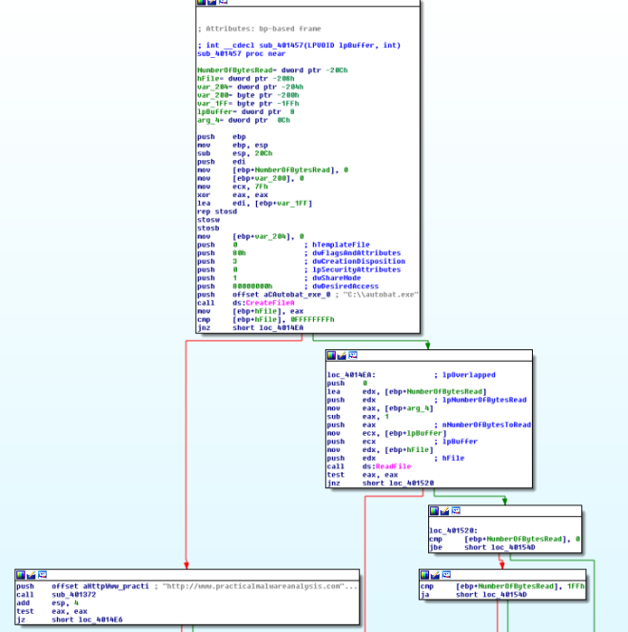
Figure 2. autobat.exe
iii. How does the malware obtain commands? What example from the chapter used a similar methodology? What are the advantages of this technique?
The malware scan the response for a <noscript> tag. The text after the tag is the command to execute. The advantage of using this technique is that it is hiding the commands in plain sight that blends in the returned html page. Therefore making detection hard for defender.
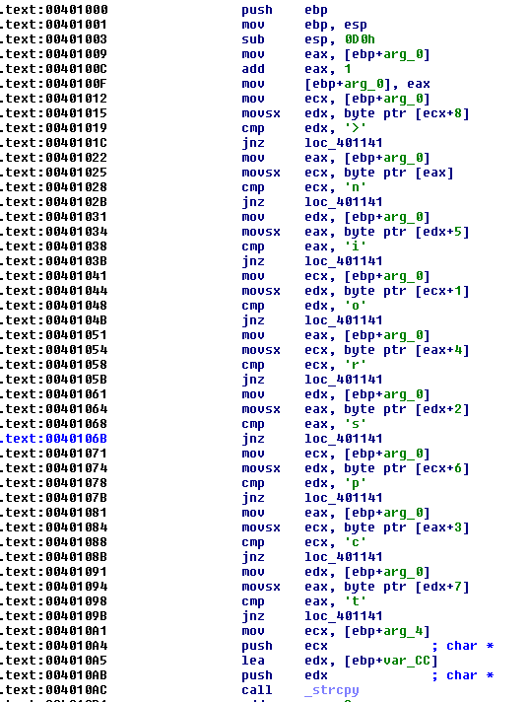
Figure 3. <noscript>
iv. When the malware receives input, what checks are performed on the input to determine whether it is a valid command? How does the attacker hide the list of commands the malware is searching for?
Analyzing subroutine @00401000 & 0x00401684. The checks are as follows
- starts with <noscript>
- url exists after <noscript>
- url ends with “69′”
- commands must be in the form of /command/parameter
The attacker hides the commands by using only the first character to switch between predefined commands. Therefore he can use different words to represent same command so long as the first character matches in the switch.
v. What type of encoding is used for command arguments? How is it different from Base64, and what advantages or disadvantages does it offer?
The malware divides the parameters by 2 characters. Each 2 characters are passed to atoi function to convert it to integer. It then references the following string to get the exact character it represents.
Figure 4. Decode string
Pro
It is a custom encoding technique thus not easily detected by existing tools
Con
It is pretty simple to reverse.
vi. What commands are available to this malware?
Command | Description
d | Download & Execute
n | Exit
s | Sleep
r | Write autobat.exe
vii. What is the purpose of this malware?
The malware serves as a backdoor by downloading and execute new codes on the victim’s machine via http request. It can also rewrite the config file “autobat.exe” to let it connect to a different C2 Server.
viii. This chapter introduced the idea of targeting different areas of code with independent signatures (where possible) in order to add resiliency to network indicators. What are some distinct areas of code or configuration data that can be targeted by network signatures?
- “http://www.practicalmalwareanalsysis.com/start.htm&#8221;
- Any new url found in “c:\\autobat.exe”
- Headers such as UA-CPU and User Agent (duplicated User-Agent)
- http response contains <noscript>[url][69′]
ix. What set of signatures should be used for this malware?
refer to question 8.
d. Analyze the sample found in the file Lab15-01.exe. This is a command-line program that takes an argument and prints “Good Job!” if the argument matches a secret code.
i. What anti-disassembly technique is used in this binary?
Xor was used followed by jz to trick the disassembler into making a jump. An opcode “E8” is used to make IDA Pro disassemble the code wrongly.
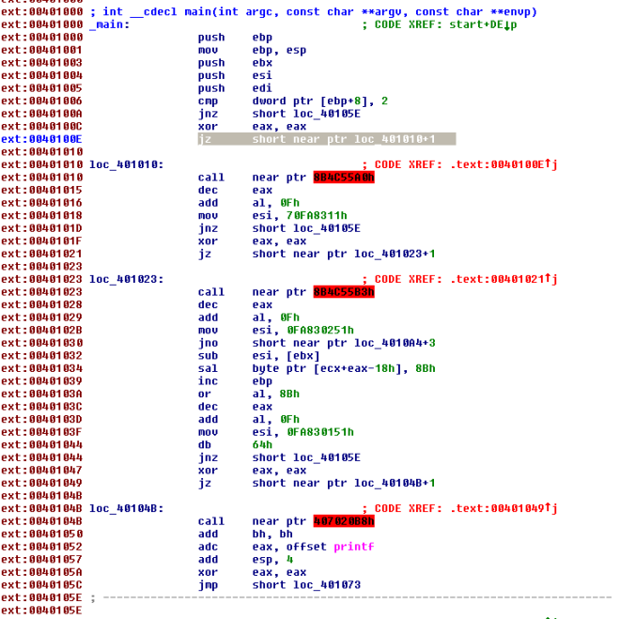
Figure 1. A confuse looking IDA Pro

We can undefine the code and reanalyze the code as shown below.
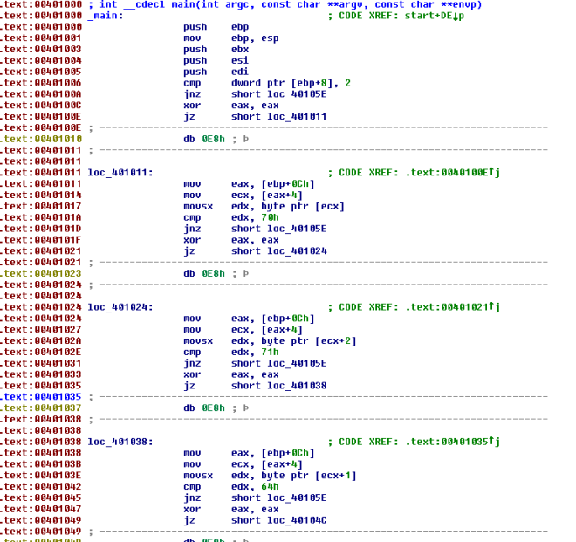Figure 2. Reanalyzing opcodes
ii. What rogue opcode is the disassembly tricked into disassembling?
E8 was used to trick the dis assembler.
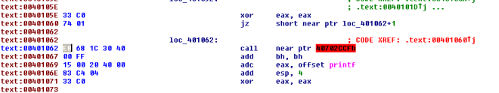Figure 3. E8 opcode
iii. How many times is this technique used?
5 times. Just count the number of 0xE8(refer to figure 2) you can find.
iv. What command-line argument will cause the program to print “Good Job!”?
Based on the analysis of the following codes, we need to pass in a pass phrase “pdq“.
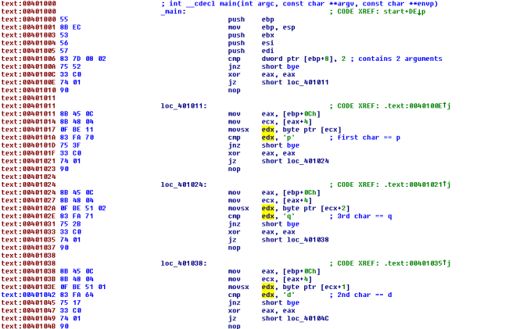Figure 4. decoding the pass phrase 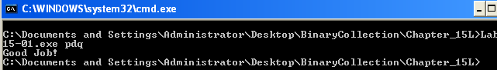Figure 5. Good Job!
e- Analyze the malware found in the file Lab15-02.exe. Correct all anti-disassembly countermeasures before analyzing the binary in order to answer the questions.
i. What URL is initially requested by the program?
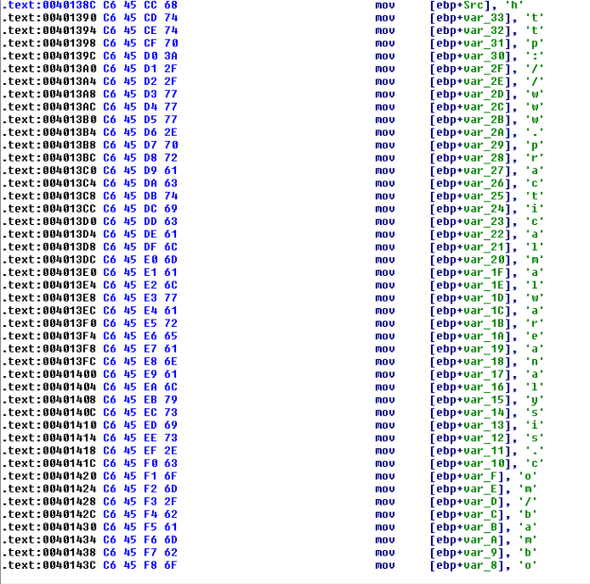Figure 1. URL http://www.practicalmalwareanalysis.com/bamboo.html
ii. How is the User-Agent generated?
via modifying GetHostName returned string.
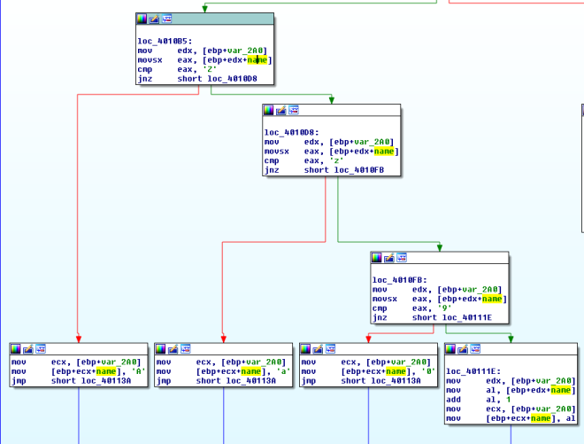Figure 2. shift right
The above code will shift the string by 1 character. To prevent invalid ascii, Z is changed to A, z is changed to a and 9 is changed to 0.
iii. What does the program look for in the page it initially requests?
Bamboo::
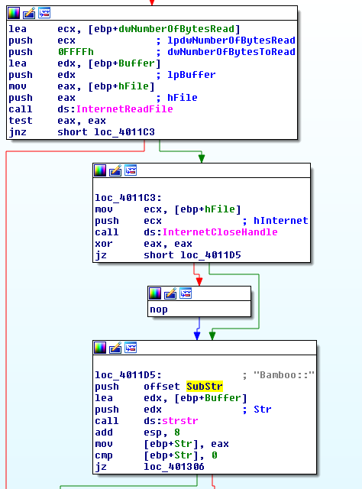Figure 3. strstr
iv. What does the program do with the information it extracts from the page?
It extracts out another url and download its content via InternetOpenUrlA and InternetReadFile saving it under Account Sumamry.xls.exe. It then executes it via ShellExecuteA.
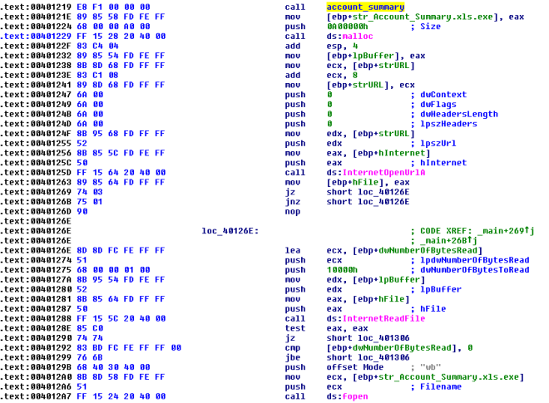Figure 4. InternetOpenUrlA followed by InternetReadFile followed by fopen,fwrite then ShellExecuteA
f. Analyze the malware found in the file Lab15-03.exe. At first glance, this binary appears to be a legitimate tool, but it actually contains more functionality than advertised.
i. How is the malicious code initially called?
The return address was overwritten by the malicious code address at the start of the program. the stack which contains the ret address was written with 0x40148c.
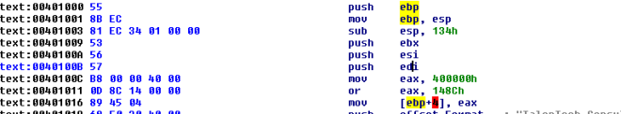Figure 1. Overwriting return address
ii. What does the malicious code do?
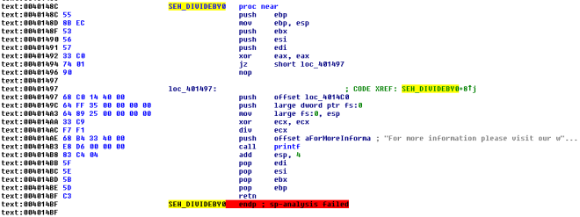Figure 2. SEH
@0x40148c we can see that the malware is adding a SEH handler (0x4014C0) via fs:0. It then performs a divide by 0 error to trigger the SEH.
The handler download a file from a url and executes it via WinExec.
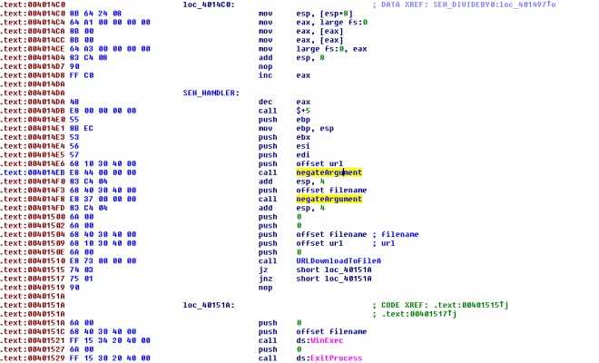Figure 3. SEH Handler
iii. What URL does the malware use?
I decided to write a script to decode the url. the decoding function is simple… just negate the inputs.
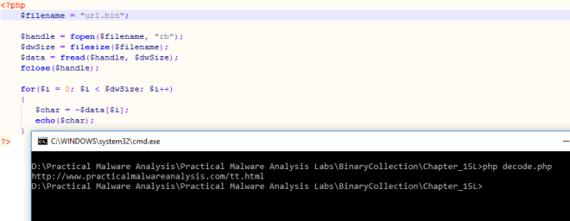Figure 4. Decoded URL
The url is: http://www.practicalmalwareanalaysis.com/tt.html
iv. What filename does the malware use?
spoolsrv.exe
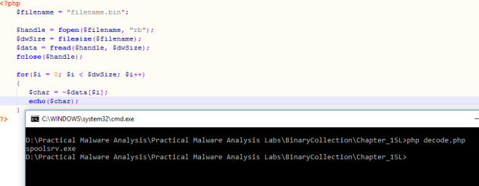Figure 5. Decoded filename

