9 | a. Analyze the malware found in Lab16-01.exe using a debugger. This is the same malware as Lab09-01.exe, with added anti-debugging techniques.
 | i. Which anti-debugging techniques does this malwareemploy?
 | ii. What happens when each anti-debugging technique succeeds?
 | iii. How can you get around these anti-debugging techniques?
 | iv. How do you manually change the structures checked during runtime?
 | v. Which OllyDbg plug-in will protect you from the anti-debugging tech niques used by this malware?
 | b. Analyze the malware found in Lab16-02.exe using a debugger. The goal of this lab is to figure out the correct password. The malware does not drop a malicious payload.
 | i. What happens when you run Lab16-02.exe from the command line?
 | ii. What happens when you run Lab16-02.exe and guess the command-line parameter?
 | iii. What is the command-line password?
 | iv. Load Lab16-02.exe into IDA Pro. Where in the mainfunction is strncmp
 | v. found?
 | vi. What happens when you load this malware into OllyDbg using the defaultsettings?
 | vii. What is unique about the PE structure of Lab16-02.exe?
 | viii. Where is the callback located? (Hint: Use CTRL-E in IDA Pro.)
ix. Which anti-debugging technique is the program using to terminate
immediately in the debugger and how can you avoid this check?
 | x. What is the command-line password you see in the debugger after you disable the anti-debugging technique?
 | xi. Does the password found in the debugger work on the command line?
 | c. Analyze the malware in Lab16-03.exe using a debugger. This malware is similar to Lab09-02.exe, with certain modifications, including the introduction of anti debugging techniques.
 | i. Which strings do you see when using static analysis on the binary?
 | ii. What happens when you run this binary?
 | iii. How must you rename the sample in order for it to run properly?
 | iv. Which anti-debugging techniques does this malware employ?
 | v. For each technique, what does the malware do if it determines it is running in a debugger?
 | vi. Why are the anti-debugging techniques successful in this malware?
 | vii. What domain name does this malware use?
 | d. Analyze the malware found in Lab17-01.exe inside VMware. This is the same malware as Lab07-01.exe, with added anti-VMware techniques.
 | i. What anti-VM techniques does this malware use?
 | ii. If you have the commercial version of IDA Pro, run the IDA Python script from Listing 17-4 in Chapter 17 (provided here as findAntiVM.py). What does it find?
 | iii. What happens when each anti-VM technique succeeds?
 | iv. Which of these anti-VM techniques work against your virtual machine?
 | v. Why does each anti-VM technique work or fail?
 | vi. How could you disable these anti-VM techniques and get the malware to run?
 | e. Analyze the malware found in the file Lab17-02.dll inside VMware. After answering the first question in this lab, try to run the installation exports using rundll32.exe and monitor them with a tool like procmon. The following is an example command line for executing the DLL: rundll32.exe Lab17-02.dll,InstallRT (or InstallSA/InstallSB)
 | i. What are the exports for this DLL?
 | ii. What happens after the attempted installation using rundll32.exe?
 | iii. Which files are created and what do they contain?
 | iv. What method of anti-VM is in use?
 | v. How could you force the malware to install during runtime?
 | vi. How could you permanently disable the anti-VMtechnique?
 | vii. How does each installation export function work?
 | f. Analyze the malware Lab17-03.exe inside VMware.
 | i. What happens when you run this malware in a virtual machine?
 | ii. How could you get this malware to run and drop its keylogger?
 | iii. Which anti-VM techniques does this malware use?
 | iv. What system changes could you make to permanently avoid the anti-VM techniques used by this malware?
v. How could you patch the binary in OllyDbg to force the anti-VM
techniques to permanently fail?

Practical No. 9
a-Analyze the malware found in Lab16-01.exe using a debugger. This is the same malware as Lab09-01.exe, with added anti-debugging techniques.
i. Which anti-debugging techniques does this malware employ?
Based on the figures below, the anti debugging techniques used are
- checking being debugged flag
- checking process heap[10h]
- checking NtGlobalFlag
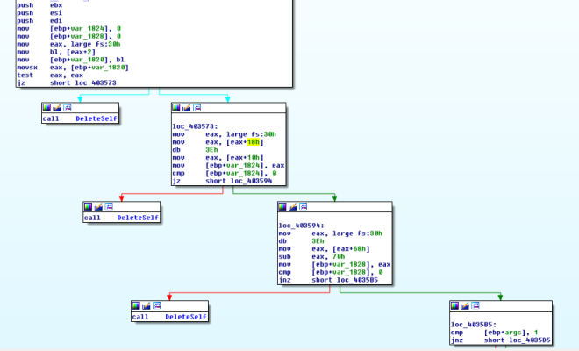
Figure 1. Anti debugger 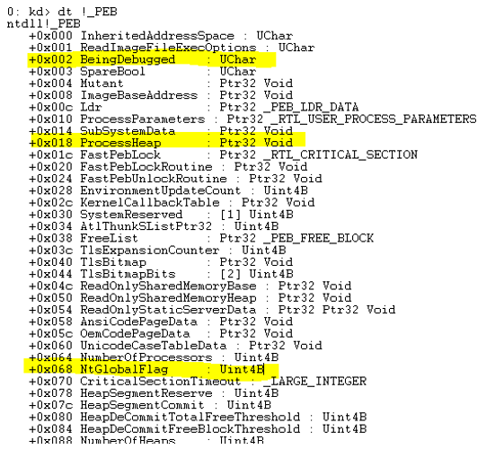
Figure 2. the offset used
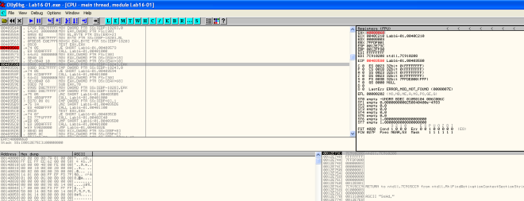Figure 3. Checking process heap
ii. What happens when each anti-debugging technique succeeds?
It will self delete and then terminates by calling the subroutine @00401000.
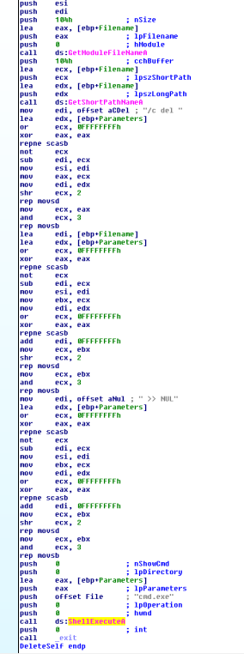
Figure 4. Self Delete & terminates
iii. How can you get around these anti-debugging techniques?
- Set breakpoint at the checks and manually change the flow in ollydbg
- Patch the program to make jz to jnz etc
- use plugins such as phantom.
iv. How do you manually change the structures checked during runtime?
use command line and enter dump fs:[30]+2 (refer to figure 2). Set the byte to 0.
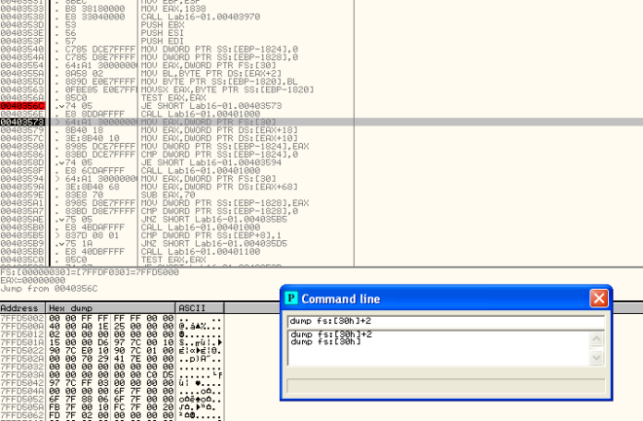Figure 5. Changing structure
v. Which OllyDbg plug-in will protect you from the anti-debugging techniques used by this malware?
PhantOm plugin will do the job
b. Analyze the malware found in Lab16-02.exe using a debugger. The goal of this lab is to figure out the correct password. The malware does not drop a malicious payload.

i. What happens when you run Lab16-02.exe from the command line?
Picture worth a thousand words.
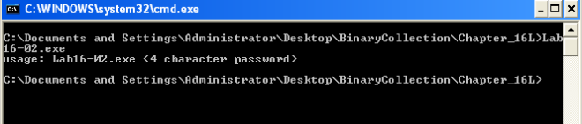Figure 1. password required
ii. What happens when you run Lab16-02.exe and guess the command-line parameter?
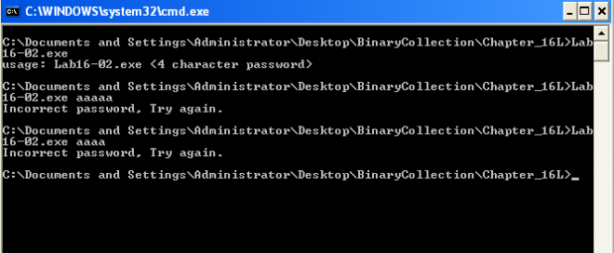Figure 2. Incorrect password
iii. What is the command-line password?
To get the command-line password, we can set breakpoint @0040123A to see what the malware is comparing the password against. However, on running the malware, the program simply terminates.
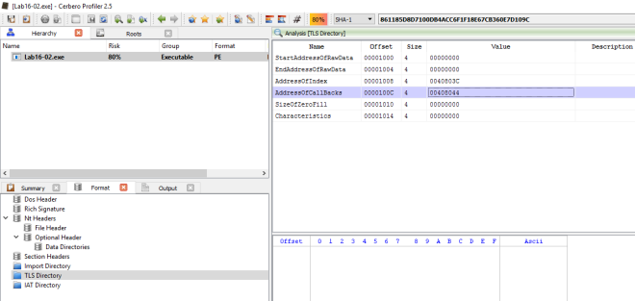Figure 3. Callbacks
Seems like 0x00408033 subroutine was called before we reach main method. Analyzing it in IDA Pro, this subroutine is checking for OLLYDBG window via FindWindowA and it is also using OutputDebugString to detect for debugger. Just nop the function at let it return to bypass these checks.
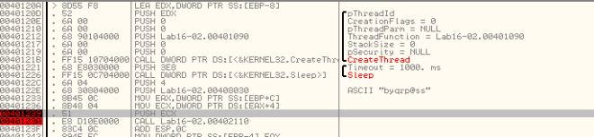Figure 4. byqrp@ss
and so we got the password… however this password is invalid when tried on the command line with debugger attached.
Lets look at the subroutine @00401090 which is called by the CreateThread function. This function is responsible for generating the password to check against.
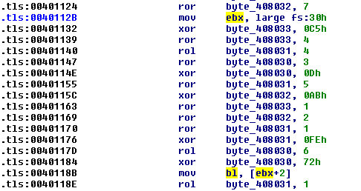Figure 5. BeingDebugged Flag
In the subroutine we can see that there is a check against BeingDebugged Flag… maybe this is the cause of it. Let’s fix the structure and see how it goes.
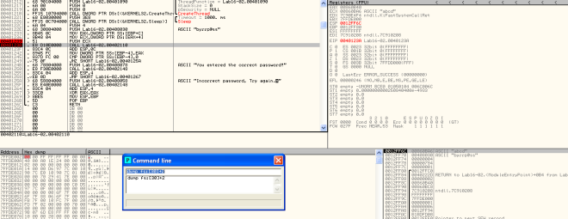Figure 6. byrrp@ss
The decoded password is “byrrp@ss”. However the strncmp will only compare the first 4 characters.
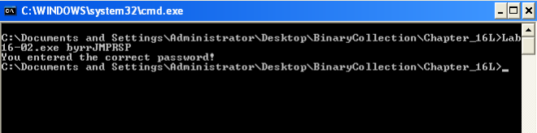Figure 7. Correct Password
iv. Load Lab16-02.exe into IDA Pro. Where in the main function is strncmp found?
@0x40123A
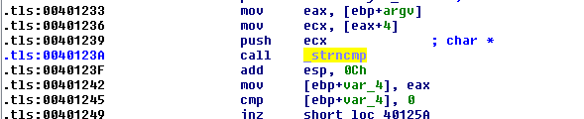Figure 8. strncmp
v. What happens when you load this malware into OllyDbg using the default settings?
The program just terminates. In fact even if I am running it in command line but ollydbg is running in the background, the application will also terminates.
vi. What is unique about the PE structure of Lab16-02.exe?
There is a .tls section.
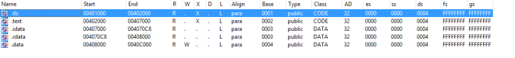Figure 9. .tls section
vii. Where is the callback located? (Hint: Use CTRL-E in IDA Pro.)
At address 0x00401060.
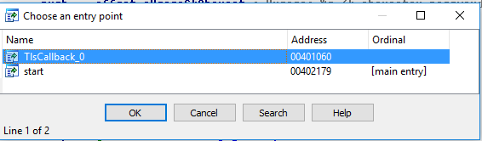Figure 10. Ctrl-E
viii. Which anti-debugging technique is the program using to terminate immediately in the debugger and how can you avoid this check?
- OLLYDBG window via FindWindowA
- OutputDebugString to detect for debugger
- BeingDebugged Flag via fs:[30h]+2
ix. What is the command-line password you see in the debugger after you disable the anti-debugging technique?
refer to solution for question iii.
x. Does the password found in the debugger work on the command line?
refer to solution for question iii.
xi. Which anti-debugging techniques account for the different passwords in the debugger and on the command line, and how can you protect against them?
- OutputDebugString (nop out the callback function)
- BeingDebuggedFlag (change the structure to set debug flag back to 0)
c. Analyze the malware in Lab16-03.exe using a debugger. This malware is similar to Lab09-02.exe, with certain modifications, including the introduction of anti-debugging techniques.

i. Which strings do you see when using static analysis on the binary?
these are the only strings of interest to us that we can observe statically.
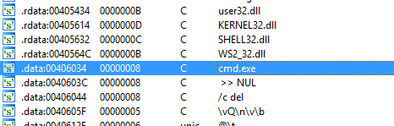Figure 1. strings
ii. What happens when you run this binary?
Nothing happen. It just terminates.
iii. How must you rename the sample in order for it to run properly?
In ollydbg, we set breakpoint @0x401518 (strncmp) to see what the malware is comparing against. The executable name needs to be “qgr.exe“. However nothing happen when we attempt to run the malware via command line…
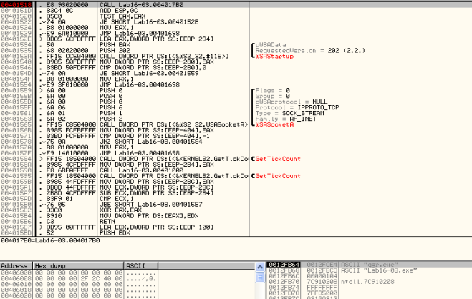Figure 2. qgr.exe
Firing up IDA Pro we trace back the variable that was used to match against the current running executable filename.
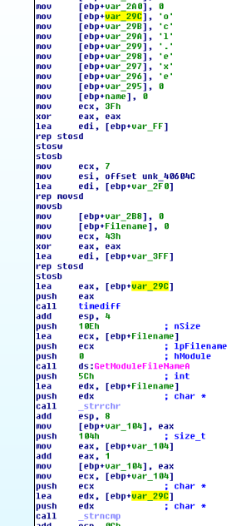Figure 3. var_29C
Seems like the variable is initially set to ocl.exe. It is then passed to a function where QueryPerformanceCounter was called twice… In between the 2 QueryPerformanceCounter is a Division by zero opcodes that is purposely set there to slow down the debugged process.
The time difference between the 2 QueryPerformanceCounter will determine if var_118 is 2 or 1 which will affect the return result of this subroutine. If we are using debugger the QueryPerformanceCounter difference might be above 1200 due to the triggering of the division by 0 error… if the time difference is above 1200, var_118 will be set to 2 and the filename should be qgr.exe else var_118 will be set to 1 and the filename should be peo.exe.
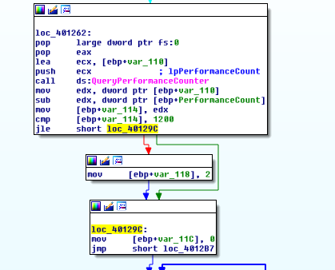Figure 4. QueryPerformanceCounter
By manually making sure that var_118 is set to 1 and not 2, we get the following filename; peo.exe.
Renaming the executable as peo.exe will do the trick in running the app properly.
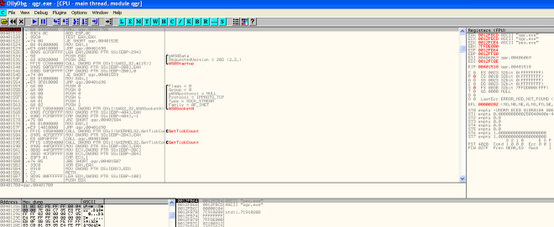Figure 5. peo.exe
iv. Which anti-debugging techniques does this malware employ?
The techniques used are all time based approach
- QueryPerformanceCounter
- GetTickCount
- rdtsc (subroutine: @0x401300)
v. For each technique, what does the malware do if it determines it is
running in a debugger?
- QueryPerformanceCounter – determines what name should the executable be, in order to execute properly
- GetTickCount – crashes the program by referencing a null pointer
- rdtsc – call subroutine @0x004010E0; self delete
vi. Why are the anti-debugging techniques successful in this malware?
The malware purposely triggers division by 0 error that will cause any attached debugger to break and for the analyst to rectify. This action itself is time consuming as compared to a program without debugger attached throwing exception and letting SEH handler to do the job. Therefore the malware codes are able to determine whether a debugger is being attached just via the time difference.
vii. What domain name does this malware use?
adg.malwareanalysisbook.com
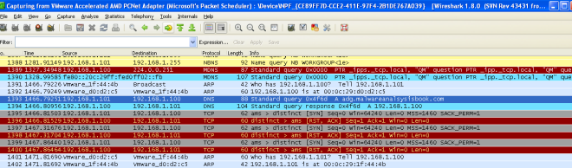Figure 6. adg.malwareanalysisbook.com
d. Analyze the malware found in Lab17-01.exe inside VMware. This is the same malware as Lab07-01.exe, with added anti-VMware techniques.

i. What anti-VM techniques does this malware use?
The malware uses vulnerable instruction: sidt,sldt and str
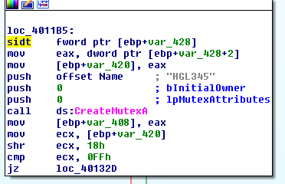
Figure 1. sidt instruction
The malware issues the sidt instruction as shown above, which stores the contents of IDTR into the memory location pointed to by var_428. The IDTR is 6 bytes, and the fifth byte offset contains the start of the base memory address. That fifth byte is compared to 0xFF, the VMware signature. We can see that var_428+2 is set to var_420. Later on in the opcodes we can observe that var_420 is shifted right by 3 bytes thus pointing it to the 5th byte.
ii. If you have the commercial version of IDA Pro, run the IDA Python script from Listing 17-4 in Chapter 17 (provided here as findAntiVM.py). What does it find?
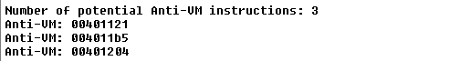Figure 2. 3 Anti-VM instructions found
- 00401121 – sldt
- 004011b5 – sidt
- 00401204 – str
iii. What happens when each anti-VM technique succeeds?
- 00401121 – sldt; service created but thread to openurl is not created the program terminates.
- 004011b5 – sidt; sub routine 0x401000 will be invoked, the program will be deleted
- 00401204 – str; sub routine 0x401000 will be invoked, the program will be deleted
iv. Which of these anti-VM techniques work against your virtual machine?
None…
v. Why does each anti-VM technique work or fail?
It depends on the hardware and the vmware used.
vi. How could you disable these anti-VM techniques and get the malware to run?
- nop the instruction
- patch the jmp instruction
e. Analyze the malware found in the file Lab17-02.dll inside VMware. After answering the first question in this lab, try to run the installation exports using rundll32.exe and monitor them with a tool like procmon. The following is an example command line for executing the DLL:
rundll32.exe Lab17-02.dll,InstallRT (or InstallSA/InstallSB)
i. What are the exports for this DLL?
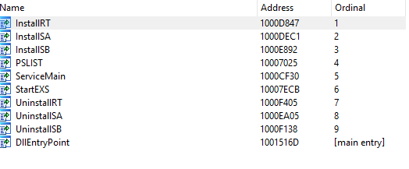
Figure 1. Exports
ii. What happens after the attempted installation using rundll32.exe?
The dll gets deleted. A File xinstall.log was dropped. vmselfdelete.bat file was dropped,executed and subsequently deleted as well. From the log file created, it seems that the malware has detected that it is running in a VM thus deleting itself.
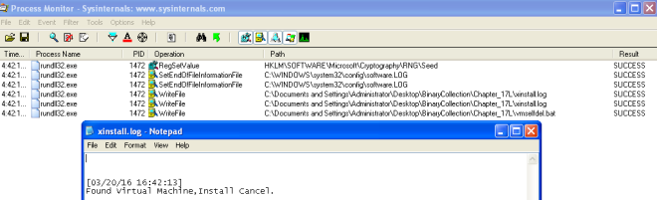Figure 2. xinstall.log
iii. Which files are created and what do they contain?
2 files are created; xinstall.log & vmselfdel.bat.
vmselfdel.bat can be traced to the subroutine @10005567 using IDA Pro. Needless to say, the purpose of the batch file is to delete the dll and itself from the system.
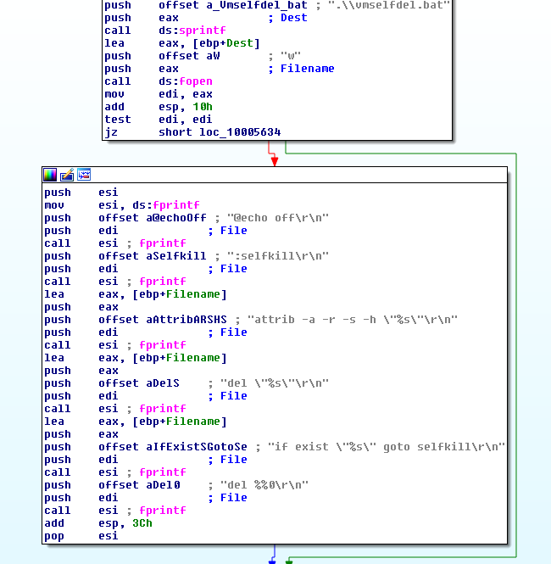Figure 3. self delete
iv. What method of anti-VM is in use?
querying I/O communication port.
VMware uses virtual I/O ports for communication between the virtual machine and the host operating system to support functionality like copy and paste between the two systems. The port can be queried and compared with a magic number to identify the use of VMware.
The success of this technique depends on the x86 in instruction, which copies data from the I/O port specified by the source operand to a memory location specified by the destination operand. VMware monitors the use of the in instruction and captures the I/O destined for the ommunication channel port 0x5668 (VX). Therefore, the second operand needs to be loaded
with VX in order to check for VMware, which happens only when the EAX register is loaded with the magic number 0x564D5868 (VMXh). ECX must be loaded with a value corresponding to the action you wish to perform on the port. The value 0xA means “get VMware version type” and 0x14 means “get the memory size.” Both can be used to detect VMware, but 0xA is more popular because it may determine the VMware version.
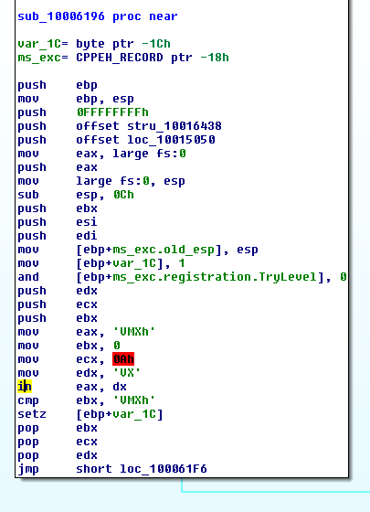
Figure 4. Querying I/O comm port
v. How could you force the malware to install during runtime?
- Patch the jump condition (3 places need to patch since checkVM sub routine is xref 3 times)
- patch the in instruction in Figure 4 to nop
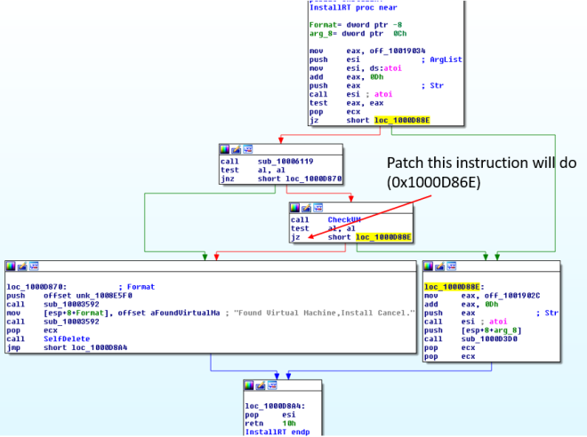Figure 5. patching
vi. How could you permanently disable the anti-VM technique?
Just patch the above and make the changes to the disk. Based on Figure 5, we could also patch the string @ offset 10019034 -> 10019248 from [This is DVM]5 to [This is DVM]0 to disable the check.
vii. How does each installation export function work?
1.InstallRT
Inject dll into either iexplore.exe or a custom process name that is passed in as argument.
In brief the subroutine @1000D847 will do the following
- Get the dll filename via GetModuleFileNameA
- Get System Directory path via GetSystemDirectoryA
- Copy the current dll into system directory with the same file name
- Get the pid of a process; either iexplore.exe by default or a custom process name passed in as an argument
- Get higher privilege by changing token to SeDebugPrivilege
- Inject dll via CreateRemoteThread on the pid retrieved in 4.
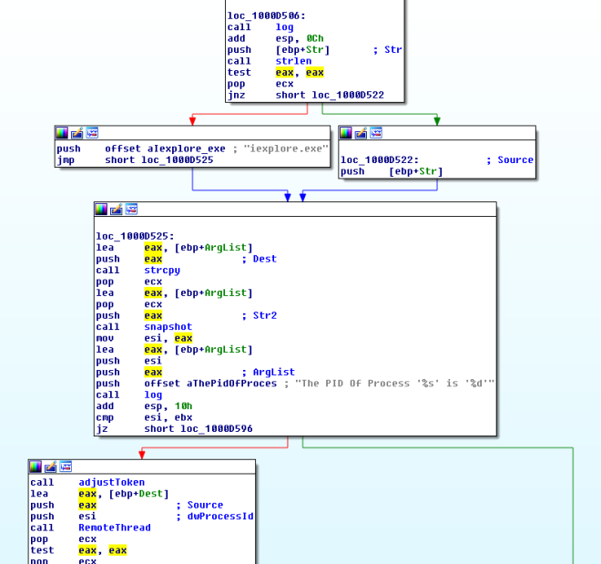Figure 6. Install RT
2.InstallSA
Install as a Service
In brief the subroutine @1000D847 will do the following
- RegOpenKeyExA – HKLM\SOFTWARE\Microsoft\Windows NT\CurrentVersion\Svchost
- RegQueryValueExA – netsvcs
- loop through the data to find either Irmon or a custom string passed in as an argument
- CreateServiceA – with service name as Irmon or a custom string passed in as an argument
- Add data to HKLM\SYSTEM\ControlSet001\Services\[Irmon | custom]\description
- Creates a parameter key in HKLM\SYSTEM\CurrentControlSet\Services\[Irmon | custom]
- Creates a Servicedll key in HKLM\SYSTEM\CurrentControlSet\Services\[Irmon | custom] with the path of the dll as the value
- Start the service
- Creates a win.ini file in windows directory
- Writes a Completed key to SoftWare\MicroSoft\Internet Connection Wizard\ if SoftWare\MicroSoft\Internet Connection Wizard\ does not exists
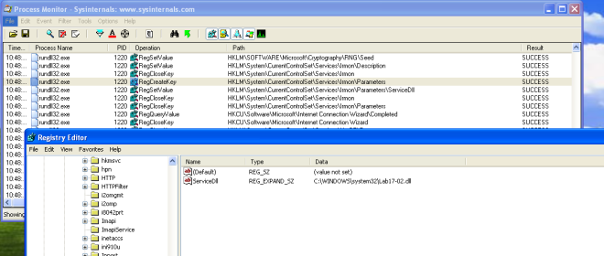Figure 7. InstallSA
3. InstallSB
It first calls sub rountine 0x10005A0A to
- Attain higher privileges via adjusting token to SeDebugPrivilige
- It then gets the WinLogon Pid
- It then get the windows version to determine which sfc dll name to use
- It then uses CreateRemoteThread to get Winlogon process to disable file protection via sfc
It then calls the subroutine @0x1000DF22 to
- It first query service config of NtmsSvc service
- If service dwStartType is > 2, it will then change the service to SERVICE_AUTO_START
- If then checks if the service is running or paused. If it is running or in paused state, it will stop the service.
- It then queries HKLM\\SOFTWARE\Microsoft\Windows NT\CurrentVersion\Svchost\\Netsvc values
- It then gets the PID of svchost and check if the malicious module is loaded
- backup c:\\windows\\system32\\ntmssvc.dll to c:\\windows\\system32\\ntmssvc.dll.obak
- copy current dll to c:\\windows\\system32\\ntmssvc.dll
- If ntmssvc.dll isn’t loaded, the malware will then inject it into svchost
- Starts the created service
- Creates a win.ini file in windows directory
- Writes a Completed key to “SoftWare\MicroSoft\Internet Connection Wizard\” if “SoftWare\MicroSoft\Internet Connection Wizard\” does not exists

f. Analyze the malware Lab17-03.exe inside VMware.
i. What happens when you run this malware in a virtual machine?
The malware terminates.
ii. How could you get this malware to run and drop its keylogger?
we can patch the jump instructions at the following address
- 0x004019A1
- 0x004019C0
- 0x00401A2F
- 0x00401467
iii. Which anti-VM techniques does this malware use?
@00401A80: I/O communication port
@004011C0: checking registry key SYSTEM\CurrentControlSet\Control\DeviceClasses\vmware
@00401670: checking mac address
@00401130: checking for vmware process name (hash of first 6 chars)
iv. What system changes could you make to permanently avoid the anti-VM techniques used by this malware?
- Patch the binaries
- Change Mac Address
- Remove VMware tools
v. How could you patch the binary in OllyDbg to force the anti-VM techniques to permanently fail?
Change the following instruction to xor instead
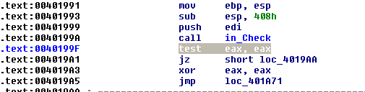
Figure 5. in instruction patch
Change the following instruction to xor instead
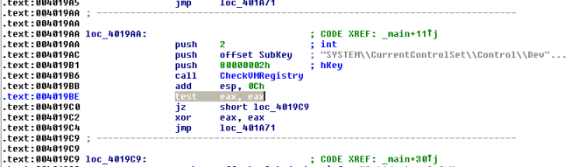Figure 6. Registry checking patch
Nop out the calling of this subroutine
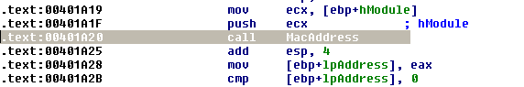
Figure vii. Mac Address patching
Change the hash to AAAAAAAAh to invalidate the search
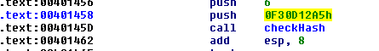
Figure 8. Process Name Hash patching

