2. | a. Analyze the malware found in the file Lab05-01.dll using only IDA Pro. The goal of this lab is to give you hands-on experience with IDA Pro. If you’ve already worked with IDA Pro, you may choose to ignore these questions and focus on reverse engineering the malware.
 | i. What is the address of DllMain?
 | ii. Use the Imports window to browse to gethostbyname. Where is the import located?
 | iii. How many functions call gethostbyname?
 | iv. Focusing on the call to gethostbynamelocated at 0x10001757, can you fig ure out which DNS request will be made?
 | v. How many local variables has IDA Pro recognized for the subroutine at 0x10001656?
 | vi. How many parameters has IDA Pro recognized for the subroutine at 0x10001656?
 | vii. Use the Strings window to locate the string \cmd.exe /cin the disassembly. Where is it located?
 | viii. What is happening in the area of code that references \cmd.exe/c?
 | ix. In the same area, at 0x100101C8, it looks like word_1008E5C4 is a global variable that helps decide which path to take. How does the malware set dword_1008E5C4? (Hint: Use dword_1008E5C4’s cross-references.)
 | x. A few hundred lines into the subroutine at 0x1000FF58, a series of com parisons use memcmpto compare strings. What happens if the string compar ison to robotworkis successful (when memcmpreturns 0)?
 | xi. What does the export PSLISTdo?
 | xii. Use the graph mode to graph the cross-references from sub_10004E79. Which API functions could be called by entering this function? Based on the API functions alone, what could you rename this function?
 | xiii. How many Windows API functions does DllMaincall directly? How many at a depth of 2?
 | xiv. At 0x10001358, there is a call to Sleep (an API function that takes one parameter containing the number of milliseconds to sleep). Looking backward through the code, how long will the program sleep if this code executes?
 | xv. At 0x10001701 is a call to socket. What are the three parameters?
 | xvi. Using the MSDN page for socketand the named symbolic constants func tionality in IDA Pro, can you make the parameters more meaningful? What are the parameters after you apply changes?
 | xvii. Search for usage of the in instruction (opcode 0xED). This instruction is used with a magic string VMXh to perform VMware detection. Is that in use in this malware? Using the cross-references to the function that executes the in instruction, is there further evidence of VMware detection?
 | xviii. Jump your cursor to 0x1001D988. What do you find?
 | xix. If you have the IDA Python plug-in installed (included with the com- mercial version of IDA Pro), run Lab05-01.py, an IDA Pro Python script provided with the malware for this book. (Make sure the cursor is at 0x1001D988.) What happens after you run the script?
 | xx. With the cursor in the same location, how do you turn this data into a single ASCII string?
 | xxi. Open the script with a text editor. How does it work?
 | b. analyze the malware found in the file Lab06-01.exe.
 | i. What is the major code construct found in the only subroutine called by main?
 | ii. What is the subroutine located at 0x40105F?
 | iii. What is the purpose of this program?
 | c. Analyze the malware found in the file Lab06-02.exe.
 | i. What operation does the first subroutine called by mainperform?
 | ii. What is the subroutine located at 0x40117F?
 | iii. What does the second subroutine called by maindo?
 | iv. What type of code construct is used in this subroutine?
 | v. Are there any network-based indicators for this program?
 | vi. What is the purpose of this malware?
 | d. analyze the malware found in the file Lab06-03.exe.
 | i. Compare the calls in main to Lab 6-2’s main method. What is the new function called from main?
 | ii. What parameters does this new function take?
 | iii. What major code construct does this function contain?
 | iv. What can this function do?
 | v. Are there any host-based indicators for this malware?
 | vi. What is the purpose of this malware?
 | e. analyze the malware found in the file Lab06-04.exe.
 | i. What is the difference between the calls made from the main method in Labs 6-3 and 6-4?
 | ii. What new code construct has been added to main?
 | iii. What is the difference between this lab’s parse HTML function and those of the previous labs?
 | iv. How long will this program run? (Assume that it is connected to the Internet.)
 | v. Are there any new network-based indicators for this malware?
 | vi. What is the purpose of this malware?

Practical No. 2
a. Analyze the malware found in the file Lab05-01.dll using only IDA Pro. The goal of this lab is to give you hands-on experience with IDA Pro. If you’ve already worked with IDA Pro, you may choose to ignore these questions and focus on reverse engineering the malware
IDA Pro, an Interactive Disassembler, is a disassembler for computer programs that generates assembly language source code from an executable or a program. IDA Pro enables the disassembly of an entire program and performs tasks such as function discovery, stack analysis, local variable identification, in order to understand (or change) its functionality.
This lab utilises IDA to explore a malicious .dll and demonstrates various techniques for navigation and analysis. Any useful shortcuts will be identified.

i. What is the address of DllMain?
The address off DllMain is 0x1000D02E. This can be found within the graph mode, or within the Functions window (figure 2).
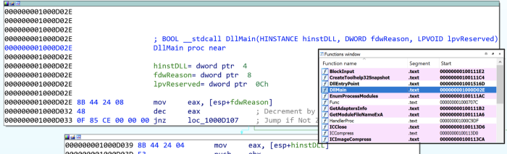
Figure 2: Address of DllMain

ii. Where is the import gethostbyname located?
gethostbyname is located at 0x100163CC within .idata (figure 3).This is found through the Imports window and double-clicking the function. Here we can also see gethostbyname also takes a single parameter — something like a string.
Figure 3: Location of gethostbyname

iii. How many functions call gethostbyname?
Searching the xrefs (ctrl+x) on gethostbyname shows it is referenced 18 times, 9 of which are type (p) for the near calll, and the other 9 are read (r) (figure 4). Of these, there are 5 unique calling functions.
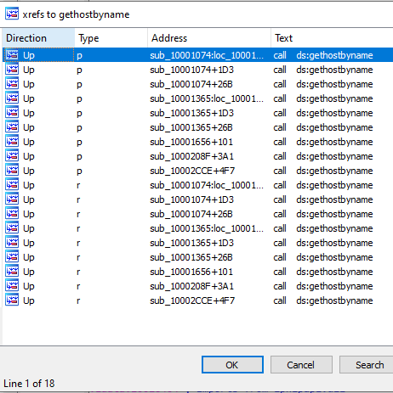
Figure 4: gethostbyname xrefs

iv. For gethostbyname at 0x10001757, which DNS request is made?
Pressing G and navigating to 0x10001757, we see a call to thegethostbyname function, which we know takes one parameter; in this case, whatever is in eax — the contents of off_10019040 (figure 5)
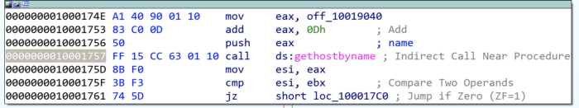
Figure 5: gethostbyname at 0x10001757
The contents of off_10019040 points to a variable aThisIsRdoPicsP which contains the string [This is RDO]pics.practicalmalwareanalysis.com. This is moved into eax (figure 6).
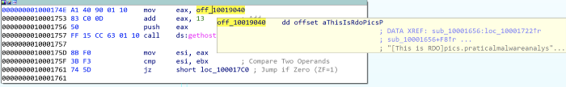
Figure 6: Contents of off_1001904 (aThisIsRdoPicsP)
Importantly, 0Dh is added to eax, which moves the pointer along the current contents. 0Dh can be converted in IDA by pressing H, to 13. This means the eax now points to 13 characters inside of its current contents, skipping past the prefix [This is RDO] and resulting in the DNS request being made for pics.practicalmalwareanalysis.com.

v & vi. How many parameters and local variables are recognized for the subroutine at 0x10001656?
There are a total of 24 variables and parameters for sub_10001656 (figure 7).
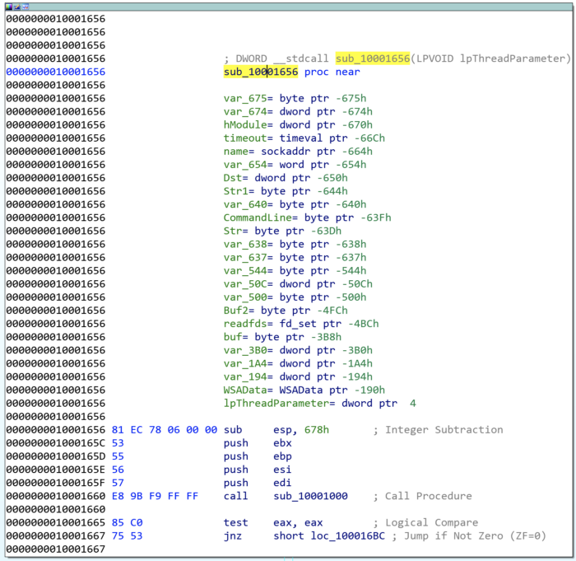
Figure 7: sub_10001656 parameters and varliables
Local variables correspond to negative offsets, where there are 23. Many are generated by IDA and prepended with var_ however there are some which have been resolved, such as name or commandline. As we work through, we generally rename any of the important ones.
Parameters have positive offsets. Here there is one, currently lpThreadParameter. This may also be seen as arg_0 if not automagically resolved.

vii. Where is the string \cmd.exe /c located in the disassembly?
Press Alt+T to perform a string search for \cmd.exe /c, which is stored as aCmdExeC, found within sub_1000FF58 at offset 0x100101D0 (figure 8).
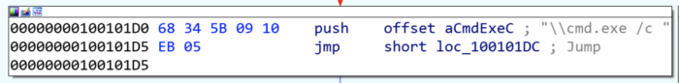
Figure 8: Location of ‘\cmd.exe /c’

viii. What happens around the referencing of \cmd.exe /c?
The command cmd.exe /c opens a new instance of cmd.exe and the /c parameter instructs it to execute the command then terminate. This suggests that there is likely a construct of something to execute somewhere nearby.
Taking a cursory look around sub_1000FF58, we see several indications of what might be happening. Look for push offset X for quick wins.
Towards the top of the function, we see an address that is quite telling of what is happening. The offset aHiMasterDDDDDD called at 0x1001009Dcontains a long message which includes several strings relating to system time information (actually initialised just before), but more notably reference to a Remote Shell (figure 9).
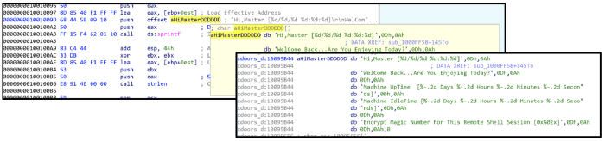
Figure 9: Contents of offset aHiMasterDDDDDD
Further on throughout the function, there are more interesting offset addresses with strings that may provide an indication of activity.
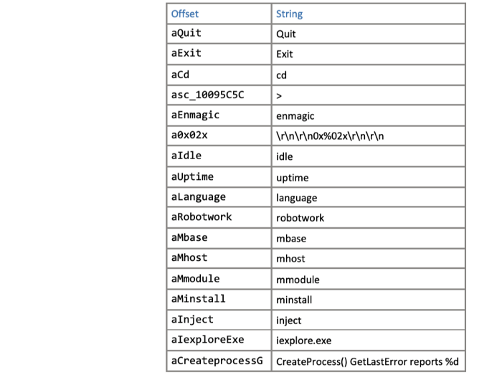
Figure 10: Offset strings within sub_1000FF58
Some of which are likely part of any commandline activity, whereas others may be additional modules. Some of the notable ones might be
aInject, aIexploreExe, and aCreateProcessG, which could be indicative of process injection into iexplore.exe.
ix. At 0x100101C8, dword_1008E5C4 indicates which path to take. How does the malware set dword_1008E5C4?
The comparison of dword_1008E5C4 and ebx will determine whether \cmd.exe /c or \command.exe /c is pushed; likey based upon the Operating System version to utilise the correct command prompt (figure 11).
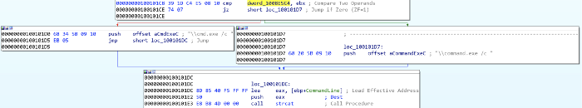
Figure 11: cmd.exe or command.exe options
Following the xrefs of dword_1008E5C4 , we see it written (type w) in sub_10001656, with the value of eax. There is a preceding call to sub_10003695, where the function takes a look at the system’s Version Information (using API call GetVersionExA) (figure 12).
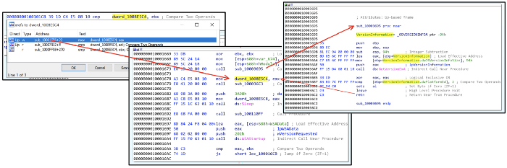
Figure 12:
There is a comparison between the VersionInformation.dwPlatformId and 2, so looking at the Windows Platform IDs we see that it is looking to see if ‘The operating system is Windows NT or later.’ If it is, then \cmd.exe /c is pushed. If not, then it is \command.exe /c.

x. What happens if the string comparison to robotwork is successful?
The robotwork string comparison is completed using the function memcmp, which returns 0 if the two strings are identical. The JNZ branch jumps if the result Is Not Zero. This means, if the robotwork comparison is successful, returning 0, then the jump does not execute (the red path). If the memcmp was unsuccessful, then some other non-zero value would be returned and the jump (green path) would be followed (figure 13).
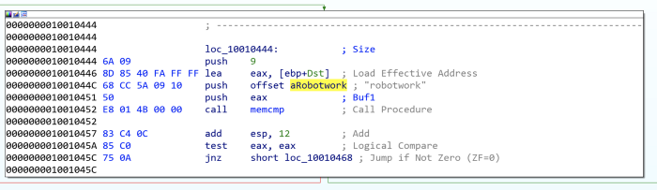
Figure 13: memcmp of robotwork
Not jumping, (and following the red path), leads to a new function sub_100052A2 which includes registry keys SOFTWARE\Microsoft\Windows\CurrentVersion WorkTime and WorkTimes. The function is looking for values within the WorkTime and WorkTimes ( RegQueryValueExA) and if so, are displayed as part of the relevant aRobotWorktime offset addresses (via %d) (figure 14).
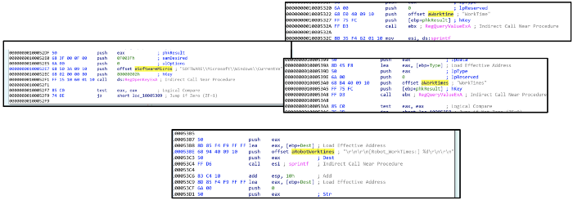
Figure 14: Querying SOFTWARE\Microsoft\Windows\CurrentVersion WorkTime and WorkTimes registry keys
The start of the function takes in a parameter for SOCKET as s , which is then passed through to a new function (sub_100038EE) along with the registry values (ebp) (figure 15).
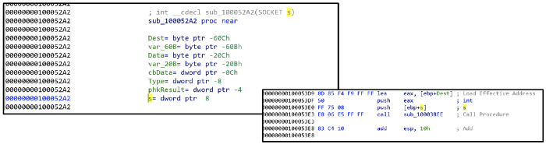
Figure 15: Passing registry values through SOCKET s
Therefore, if the string comparison for robotwork is successful, the registry keys SOFTWARE\Microsoft\Windows\CurrentVersion WorkTime and WorkTimes are queried and the values passed through (likely) the remote shell connection.

xi. What does the export PSLIST do?
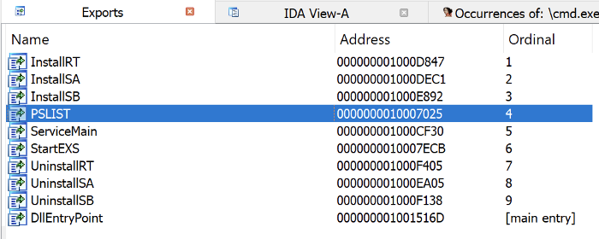
Figure 16: Exports view
Open the exports list and find the exported function PSLIST. (figure 16).
Navigate here and see there are three subroutines. One of which queries OS version information (similar as seen in Q9, but this time also sees if dwMajorVersion is 5 for more specific OS footprinting (dwMajorVersions)), and depending on the outcome, will call either sub_10006518 or sub_1000664C (figure 17).
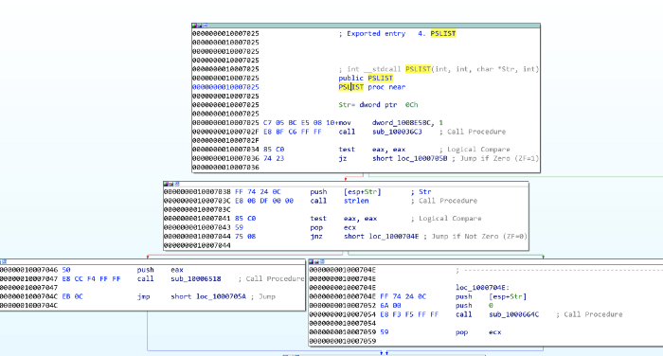
Figure 17: PSLIST exported function paths
Both sub_10006518 and sub_1000664C utilise CreateToolhelp32Snapshot to take a snapshot of the specified processes and associated information, and then execute appropriate commands to query the running processes IDs, names, and the number of threads. sub_1000664C also includes the SOCKET (s) to send the output out to (figure 18).
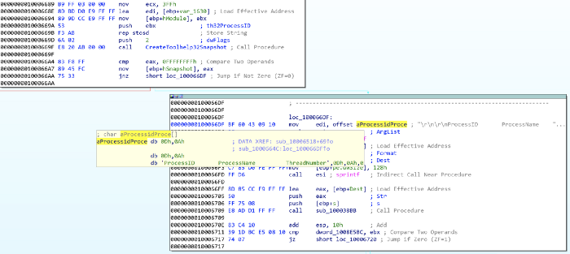
Figure 18: Using CreateToolhelp32Snapshot, quering running processes, and sending to socket

xii. Which API functions could be called by entering sub_10004E79?
A useful way to quickly see what API functions are called by a certain subroutine is through the Proximity Brower view, this transforms the standard Graph or Text views into a much more condensed graph highlighting which API functions or subroutines are called (figure 19)
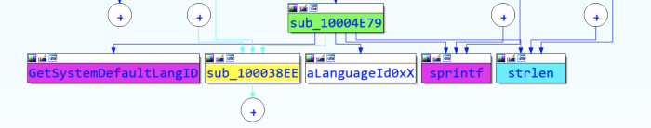
Figure 19: Proximity View of sub_10004E79
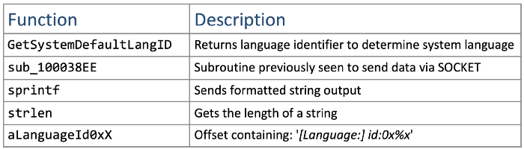
Figure 20: Functions called by sub_10004E79
The functions called from sub_10004E79 (figure 20) indicate that the functionality is to identify the language used on the system, and then pass that information through the SOCKET (as we’ve seen sub_100038EE before). It might make sense to rename sub_10004E79 to something like getSystemLanguage. While we’re at it, we might aswell rename sub_100038EE to something like sendSocket.

xiii. How many Windows API functions does DllMain call directly, and how many at a depth of 2?
Another way to view the API functions called from somewhere, is through View -> Graphs -> User XRef Chart. Set start and end addresses to DllMain and the Recursion depth to 1 to see four API functions called (figure 21). At a depth of 2, there are around 32, with some duplicates.
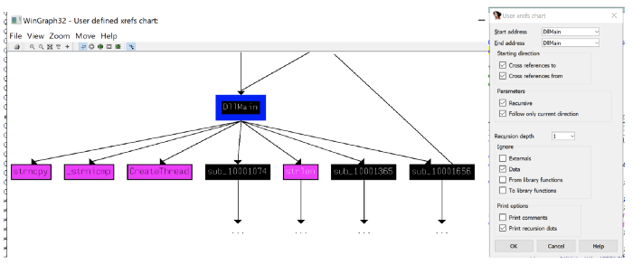
Figure 21: API functions called by DllMain.
Some of the more notable API calls which may provide indication of functionality are: sleep winexec gethostbyname inet_nota CreateThread WSAStartup inet_addr recv send socket connect LoadLibraryA

xiv. How long will the Sleep API function at 0x10001358 execute for?
At first glance, one might think that the value passed to the sleep is 3E8h (1000), equating to 1 second, however it is a imul call which means the value at eax is getting multiplied by 1000. Looking up, we see that aThisIsCti30 at the offset address is moved into eax and then the pointer is moved 13 along (similar to what's seen in Q2) (figure 22).
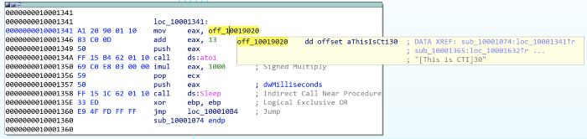
Figure 22: Sleep for 30 seconds
This means that the value of eax when it is pushed is 30. atoi converts the string to an integer, and it is multiplied by 1000. Therefore, the Sleep API function sleeps for 30 seconds.

xv & xvi. What are the three parameters for the call to socket at 0x10001701?
The three values pushed to the stack, labeled as protocol, type, and af, and are 6, 1, 2 respectively, are the three parameters used for the call to socket (figure 23).
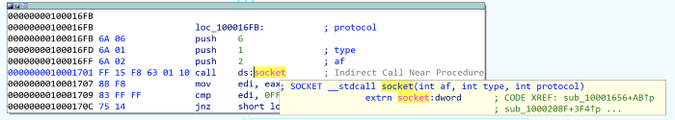
Figure 23: Call to socket at 0x10001701
These depict what type of socket is created. Using Socket Documentation we can determine that in this case, it is TCP IPV4. At this point, we might aswell rename those operands (figure 24).
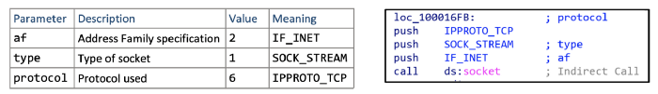
Figure 24: Definitions and renaming of socket parameters

xvii. Is there VM detection?
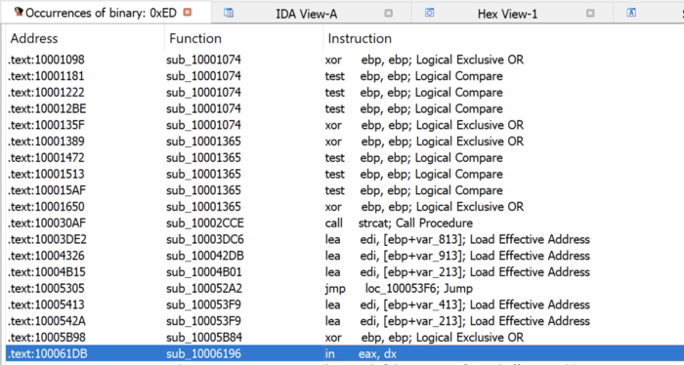
Figure 25: Searching for the in instruction using 0xED in binary.
The in instruction (opcode 0xED) is used with the string VMXh to determine whether the malware is running inside VMware. 0xED can be searched (alt+B) and look for the in instruction (figure 25).
From here, we can navigate into the function and see what is going on within sub_10006196.
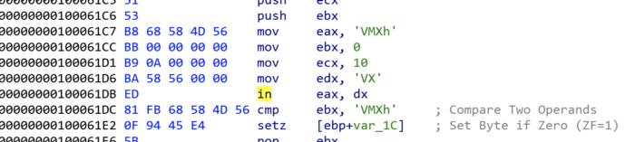
Figure 26: in instruction within sub_10006196
Directly around the in instruction, we see evidence of the string VMXh (converted from original hex value) (figure 26), which is potentially indicative of VM detection. If we look at the other xrefs of sub_10006196 we see three occurrences, each of which contains aFoundVirtualMa, indicating the install is canceling if a Virtual Machine is found (figure 27).
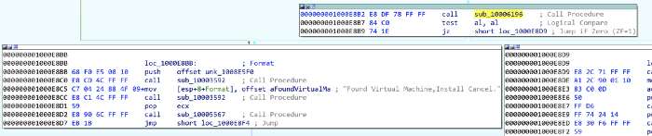
Figure 27: Found Virtual Machine string found after VMXh string

xviii, xix, & xx. What is at 0x1001D988?
The data starting at 0x1001D988 appears illegible, however, we can convert this to ASCII (by pressing A), albeit still unreadable (Figure 28).
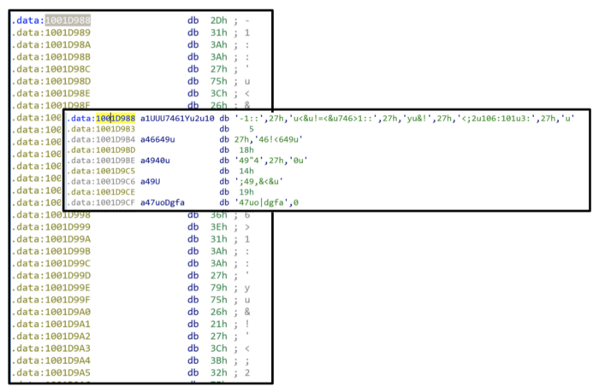
Figure 28: Random data at 0x1001D988
We have been provided a python script with the lab lab05–01.py which is to be used as an IDA plugin for a simple script. For 0x50 bytes from the current cursor position, the script performs an XOR of 0x55, and prints out the resulting bytes, likely to decode the text (figure 29).
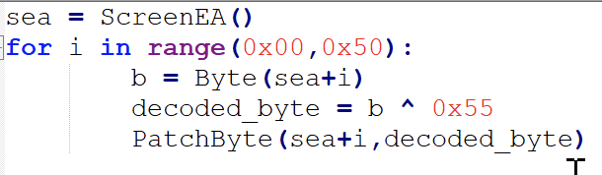
Figure 29: XOR 0x55 script
We are unable to do this within the free version of IDA, however we can loosely do it manually ourselves by taking the bytes from 0x1001D988 and doing XOR 0x55.
Evidently, the conversion to ASCII and manual decoding has messed up something with the capitalisation, but we can see some plaintext and determine the completed message (figure 30)
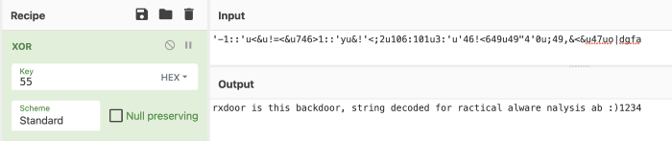
Figure 30: Manual XOR 0x55
b. analyze the malware found in the file Lab06-01.exe.

i. What is the major code construct found in the only subroutine called by main?
Before we start, it is worth noting that sometimes IDA does not recognise the main subroutine. We can find this quite quickly by traversing from the start function and finding sub_401040. This is main as it contains the required parameters (argc and **argv). I renamed the subroutine to main (figure 1).
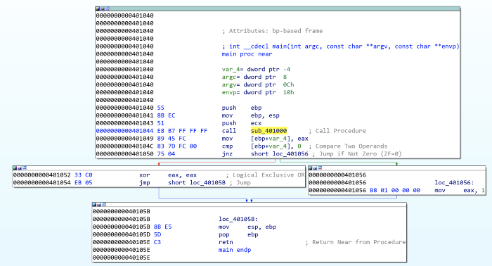
Figure 1: Lab06–01 | main subroutine
Navigating into the first subroutine called in main (sub_401000) (figure 2), we see it executes an external API call InternetGetConnectedState, which returns a TRUE if the system has an internet connection, and FALSE otherwise. This is followed by a comparison against 0 (FALSE) and then a JZ (Jump If Zero). This means the jump will be successful if InternetGetConnectedState returns FALSE (0) (There is no internet connection).
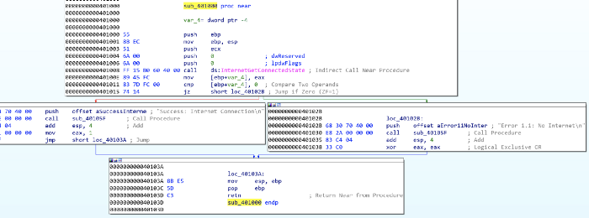
Figure 2: Lab06–01 | sub_401000 internet connection test
Therefore, the jump path (short loc_40102B) is taken and the string returned will be ‘Error 1.1: No Internet\n’.
InternetGetConnectedState returns TRUE, then the jump is not successful, and the returned string is ‘Success: Internet Connection\n’.
Based upon this, it can be determined that the major code construct is a basic If Statement.

ii. What is the subroutine located at 0x40105F?
Given the proximity to the strings at the offset addresses in each path, it can be assumed that sub_40105F is printf, a function used to print text with formatting (supported by the \n for newline in the strings).
IDA didn’t automatically pick this up for me, but with some cross-referencing and looking into what we would expect as parameters, we can be safe in the assumption.

iii. What is the purpose of this program?
Lab06–01.exe is a simple program to test for internet connection. It utilises API call InternetGetConnectedState to determine whether there is internet, and prints an advisory string accordingly.
c. Analyze the malware found in the file Lab06–02.exe.

i & ii. What operation does the first subroutine called by main perform? What is the subroutine located at 0x40117F?
This is very similar to Lab06–01.exe. We can easily find the main subroutine again (this time sub_401130), and again we see the first subroutine called is sub_401000. This is very similar as it calls InternetGetConnectedState and prints the appropriate message (figure 3). We also can verify that 0x40117F is still the printf function, which I’ve renamed.
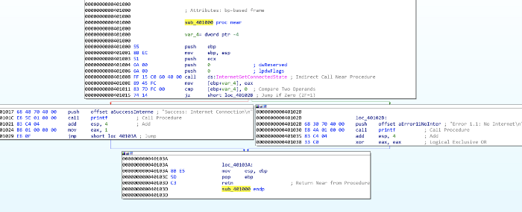
Figure 3: Lab06–02 | sub_401000 internet connection test & sub_40117F (printf)

iii. What does the second subroutine called by main do?
This is something new now; the main function in lab06–02.exe is a little more complex with an added subroutine and another conditional statement (figure 4). We can see that sub_401040 is reached by the preceding cmp to 0 being successful (jnz jump if not 0), which therefore means we’re hoping for the returned value from sub_401000 to be not 0 — indication there IS internet connection.
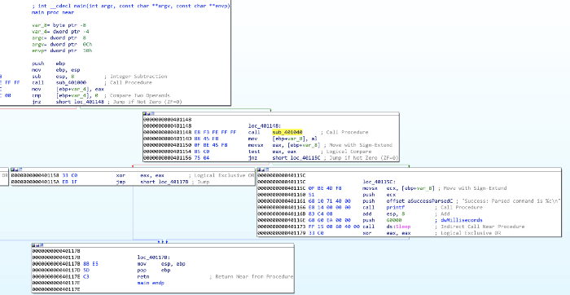
Figure 4: Lab06–02 | main subroutine
Navigating to sub_401040, we immediately see some key information, which supports the determination that this occurs if there is an internet connection.
The most stand-out information is the two API calls, InternetOpenA and InternetOpenUrlA, which are used to initiate an internet connection and open a URL. We also see some strings at offset addresses just before these, indicating these are passed to the API calls (figure 5).
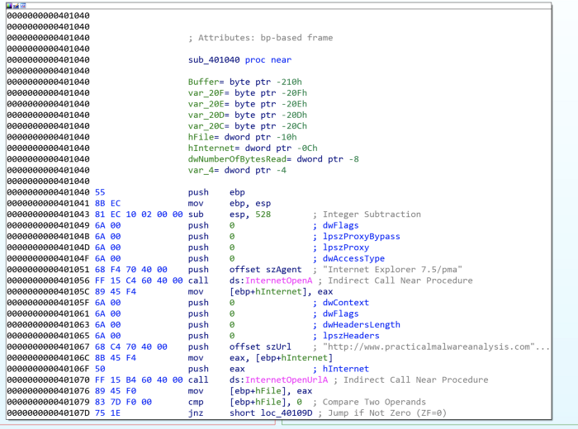
Figure 5: Lab06–02 | Internet connection API calls and strings
First, szAgent containing string “Internet Explorer 7.5/pma”, which is a User-Agent String, is passed to InternetOpenA.
szUrl contains the string “http://www.practicalmalwareanalysis.com/cc.htm” which is the URL for InternetOpenUrlA.
This has another jnz where the jump is not taken if hFile returned from InternetOpenUrlA is 0 (meaning no file was downloaded), where a message is printed “Error 2.2: Fail to ReadFile\n” and the internet connection is closed.

iv. What type of code construct is used in sub_40140?
If szURl is found, the program attempts to read 200h (512) bytes of the file (cc.htm) using the API call InternetReadFile (the jnz unsuccessful path leads to “Error 2.2: Fail to ReadFile\n” printed and connections closed) (figure 6).
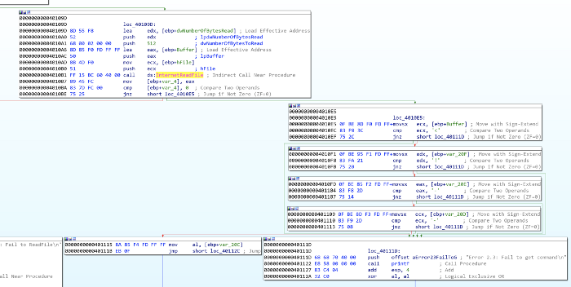
Figure 6: Lab06–02 | Reading first 4 bytes of cc.htm
There are then four cmp / jnz blocks which each comparing a single byte from the Buffer and several variables. These may also be seen as Buffer+1, Buffer+2, etc. This is a notable code construct in which a character array is filled with data from InternetReadFile and is read one by one.
These values have been converted (by pressing R) to ASCII. Combined these read <!--, indicative of the start of a comment in HTML. If the value comparisons are successful, then var_20C (likely the whole 512 byes in Buffer, but just mislabeled by IDA) is read. If at any point a byte read is incorrect, then an alternative path is taken and the string “Error 2.3: Fail to get command\n” is printed.
Looking back at main, if this all passes with no issues, the string “Success: Parsed command is %c\n” is printed and the system does Sleep for 60000 milliseconds (60 seconds) (figure 7). The command printed (displayed through formatting of %c is variable var_8) is the returned value from sub_401040, the contents of cc.htm.
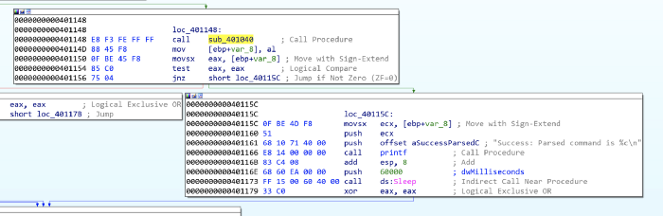
Figure 7: Lab06–02 | Reporting successful read of command and sleeping for 60 seconds

v. Are there any network-based indicators for this program?
The key NBIs (network-based indicators) from the program are the user-agent string and URL found related to the InternetOpenA and InternetOpenUrlA calls; Internet Explorer 7.5/pma and http://www.practicalmalwareanalysis.com/cc.htm

vi. What is the purpose of this malware?
Very similar to Lab06–01.exe, Lab06–02.exe tests for internet connection and prints an appropriate message. Upon successful connection, however, the program then attempts to download and read the file from http://www.practicalmalwareanalysis.com/cc.htm.
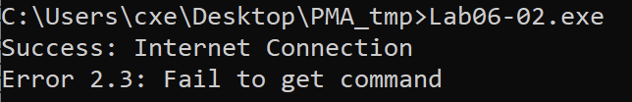
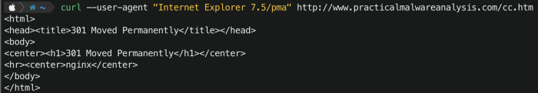
Figure 8: Lab06–02.exe | Tested execution
Upon testing, this file is not available on the server. The program did not successfully read the required first 4 bytes therefore an error message was printed (figure 8).
d. Analyze the malware found in the file Lab06–03.exe.

i. Compare the calls in main to Lab06–02.exe’s main method. What is the new function called from main?
For both executables, I have renamed all of the functions that we have already analysed. The differentiator between the two is an additional function once internet connection has been tested, the file has been downloaded, and the successful parsing of the command message has been printed — sub_401130 (figure 9).
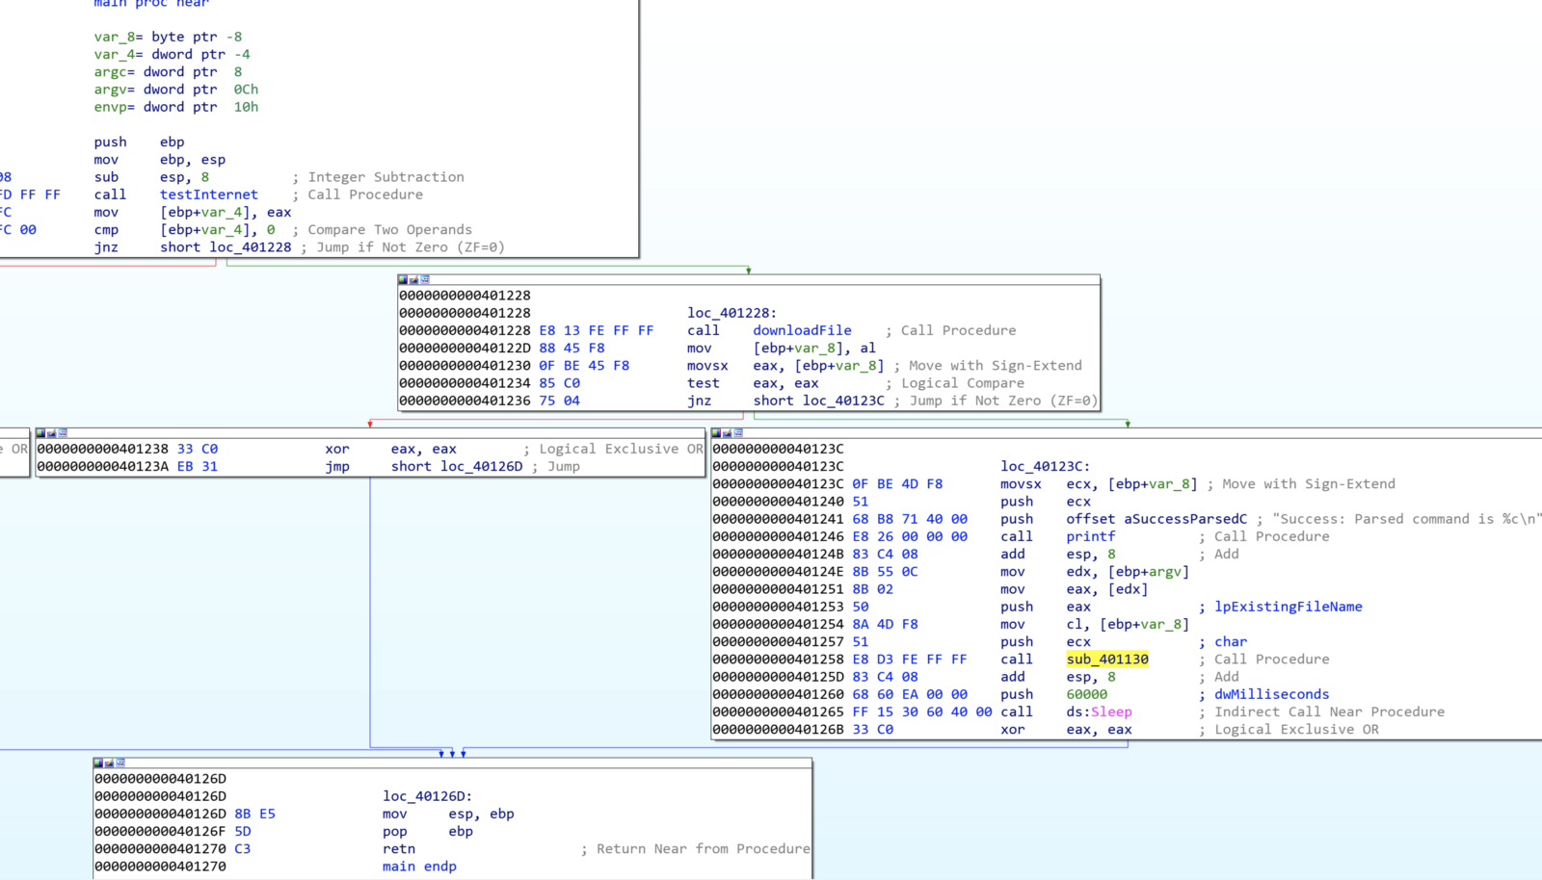
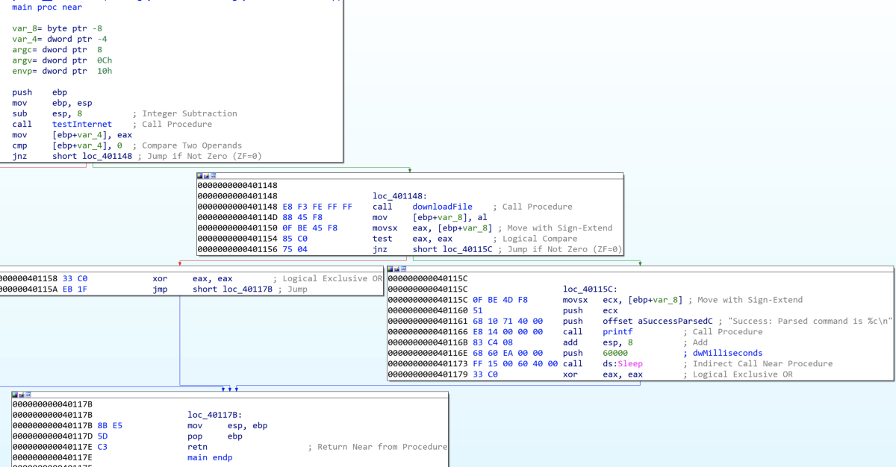
Figure 9: Lab06–03.exe | Comparisons of Lab06–03.exe (left) and Lab06–02.exe (right) main functions

ii. What parameters does this new function take?
sub_401130 takes 2 parameters. The first is char, the command character read from http://www.practicalmalwareanalysis.com/cc.htm and lpExistingFileName (a long pointer to a character string, ‘Existing File Name’, which is the program’s name ( Lab06–03.exe) (figure 10). These were both pushed onto the stack as part of the main function.
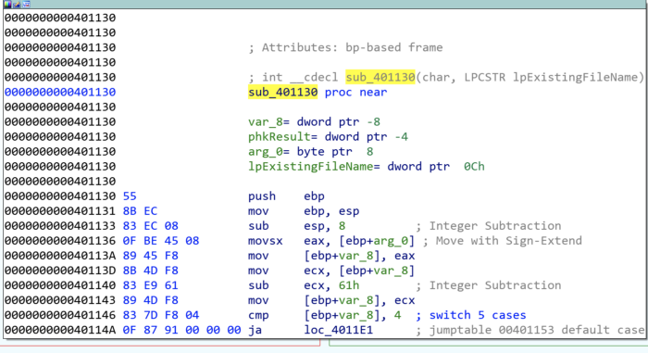
Figure 10: Lab06–03.exe | sub_401130 parameters.

iii. What major code construct does this function contain?
IDA has helpfully indicated that the major code construct is a five-case switch statement by adding comments for 'switch 5 cases' and the 'jumptable 00401153 default case'. We have previously seen similar cmp which are if statements, however, in this case, there is a possibility of five paths. We can confirm this in the flowchart graph view, where there are five switch cases and one default case (figure 11).
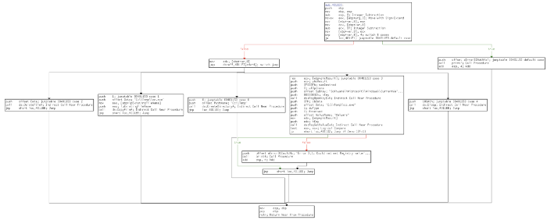
Figure 11: Lab06–03.exe | sub_401130 flowchart

iv. What can this function do?
The five switch cases are as follows (figure 12):
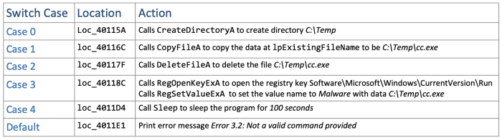
Figure 12: Lab06–03.exe | sub_401130 switch cases
Depending on the command provided (0–4) the program will execute the appropriate API calls to perform directory operations or registry modification. lpExistingFileName is the current file, Lab06–03.exe. Setting the registry key Software\Microsoft\Windows\CurrentVersion\Run\Malware with file C:\Temp\cc.exe is a method of persistence to execute the malware on system startup.

v. Are there any host-based indicators for this malware?
The key HBIs (host-based indicators) are the file written to disk (C:\Temp\cc.exe), and the registry key used for persistence ( Software\Microsoft\Windows\CurrentVersion\Run /v Malware | C:\Temp\cc.exe)

vi. What is the purpose of this malware?
Following on from the functionality of the simpler Lab06–01.exe and Lab06–02.exe, Lab06–03.exe also tests for internet connection and prints an appropriate message. The program attempts to download and read the file from http://www.practicalmalwareanalysis.com/cc.htm. The program then has a set of possible functionalities based upon the contents of cc.htm and the switch code construct to perform one of:
- Create directory C:\Temp
- Copy the current file (Lab06–03.exe) to C:\Temp\cc.exe
- Set the Run registry key as Malware | C:\temp\cc.exe for persistence
- Delete C:\Temp\cc.exe
- Sleep the program for 100 seconds
e. analyze the malware found in the file Lab06-04.exe.

i. What is the difference between the calls made from the main method in Lab06–03.exe and Lab06-04.exe?
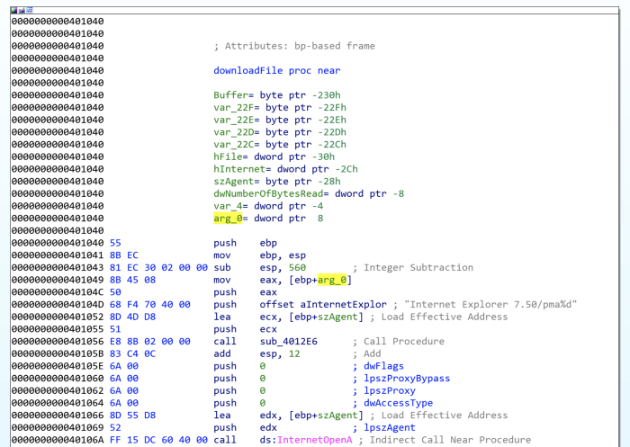
Figure 13: Lab06–04.exe | Modified downloadFile function with arg_0
Of the subroutines called from main we have analysed (renamed to testInternet, printf, downloadFile, and commandSwitch) only downloadFile has seen a notable change. The aInternetExplor address contains the value Internet Explorer 7.50/pma%d for the user-agent (szAgent) which includes an %d not seen previously, as well as a new local variable arg_0 (figure 13).
This instructs the printf function to take the passed variable arg_0 as an argument and print as an int. The variable is a parameter taken in the calling of downloadFile , donated by IDA as var_C(figure 14).
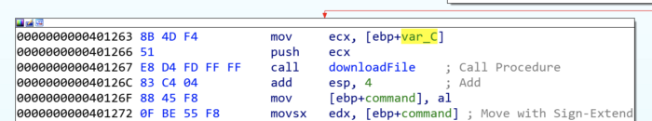
Figure 14: Lab06–04.exe | Variable passed to downloadFile
Some of the called subroutines have different memory addresses to what we saw in the previous Lab06–0X.exes, due to the main function being somewhat more complex and expanded.

ii. What new code construct has been added to main?
main has been developed upon to include a for loop code construct, as observed in the flowchart graph view (figure 15).
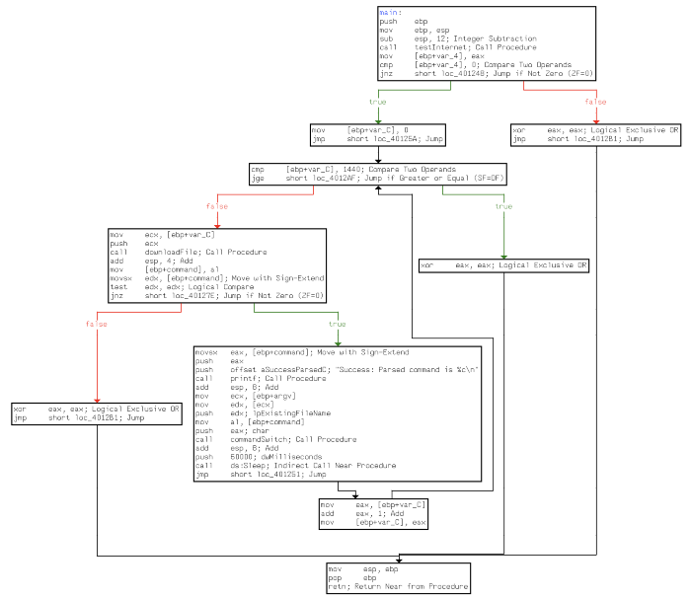
Figure 15: Lab06–04.exe | For loop within main
A for loop code construct contains four main components — initialisation, comparison, execution, and increment. All of which are observed within main (figure 16):
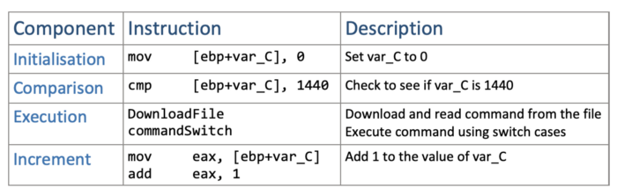
Figure 16: Lab06–04.exe | For loop components

iii. What is the difference between this lab’s parse HTML function and those of the previous labs?
As previously identified, the parse HTML function (downloadFile) now includes a passed variable. Having analysed this and main, we can determine that it is the for loop’s current conditional variable (var_C) value which is passed through to downloadFile’s user-agent Internet Explorer 7.50/pma%d, as arg_0 as this will increment by 1 each time, it may potentially be used to indicate how many times it has been run.

iv. How long will this program run? (Assume that it is connected to the Internet.)
There are several aspects of main’s for loop which can help us roughly work how long the program will run. Firstly, we know that there is a Sleep for 60 seconds, after the commandSwitch function. We also know that the conditional variable (var_C) is incremented by 1 each loop. (Figure 17).
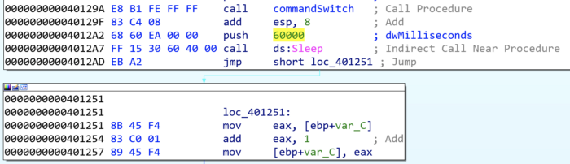
Figure 167: Lab06–04.exe | Sleep function and for loop increment
The for loop starts var_C at 0, and will break the loop once it reaches 1440. This means that there are 1440 60second loops, equalling 86400 seconds (24hours). The program may run for longer if the command instructs the switch within commandSwitch to sleep for 100seconds at any of the 1440 iterations.

v. Are there any new network-based indicators for this malware?
The only new NBI for Lab06–04.exe is the aInternetExplor “Internet Explorer 7.50/pma%d”, with “http://www.practicalmalwareanalysis.com/cc.htm” as the other, already known, indicator.

vi. What is the purpose of this malware?
Lab06–04.exe is the most complex of the four samples, where a basic program to check for internet connection has been developed into an application that connects to a C2 domain to retrieve commands and perform specific actions on the host. The malware runs for a minimum of 24hrs or at least makes 1440 connections to the C2 domain with 60-second sleep intervals. The functionality of the malware allows it to copy itself to a new directory, set it as autorun for persistence by modifying a registry, delete the new file, or sleep for 100 seconds.

