4 | a. This lab includes both a driver and an executable. You can run the executable from anywhere, but in order for the program to work properly, the driver must be placed in the C:\Windows\ System32 directory where it was origi- nally found on the victim computer. The executable is Lab10-01.exe, and the driver is Lab10-01.sys.
 | i. Does this program make any direct changes to the registry? (Use procmon to check.)
 | ii. The user-space program calls the ControlService function. Can you set a breakpoint with WinDbg to see what is executed in the kernel as a result of the call to ControlService?
 | iii. What does this program do?
 | b. The file for this lab is Lab10-02.exe.
 | i. Does this program create any files? If so, what are they?
 | ii. Does this program have a kernel component?
 | iii. What does this program do?
 | c. This lab includes a driver and an executable. You can run the executable from anywhere, but in order for the program to work properly, the driver must be placed in the C:\Windows\System32 directory where it was originally found on the victim computer. The executable is Lab10-03.exe, and the driver is Lab10-03.sys.
 | i. What does this program do?
 | ii. Once this program is running, how do you stop it?
 | iii. What does the kernel component do?

Practical No. 4
a. This lab includes both a driver and an executable. You can run the executable from anywhere, but in order for the program to work properly, the driver must be placed in the C:\Windows\ System32 directory where it was originally found on the victim computer. The executable is Lab10-01.exe, and the driver is Lab10-01.sys
i. Does this program make any direct changes to the registry? (Use procmon to check.)
Not really. Looking at the following figure, the only direct changes made by the malware is RNG\Seed. However if you were to look into the registries created by services.exe, we will see that it is trying to add a service.
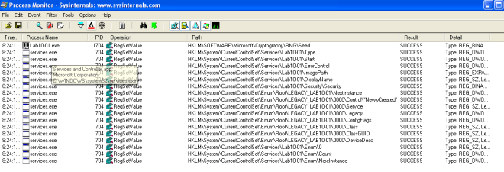Figure 1. Registry changes
but this is not the case for regshot! There are some HKLM policies added to the machine.
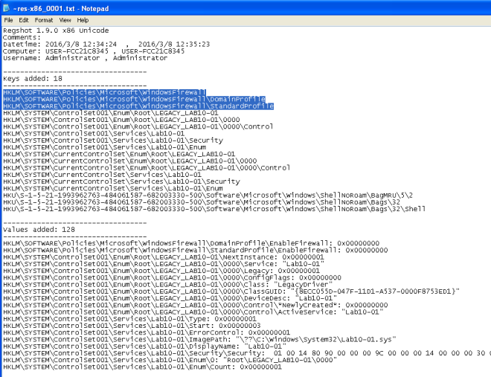Figure 2. More Registry changes in Regshot
ii. The user-space program calls the ControlService function. Can you set a breakpoint with WinDbg to see what is executed in the kernel as a result of the call to ControlService?
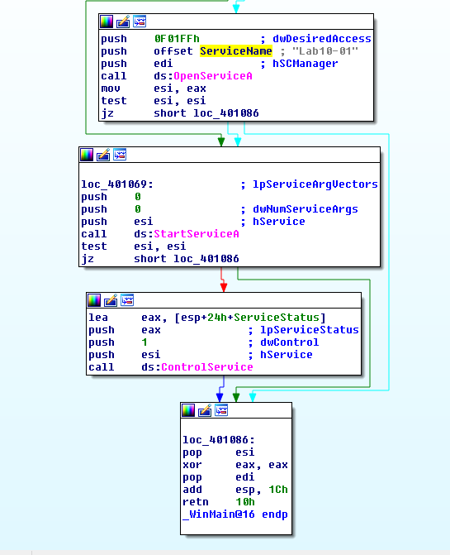
Figure 3. ControlService
The above figure shows the malware opening Lab10-01 service, starting the service and eventually closing it via ControlService; SERVICE_CONTROL_STOP.
breaking the kernel debugger and using the following command !object \Driver shows the loaded drivers…
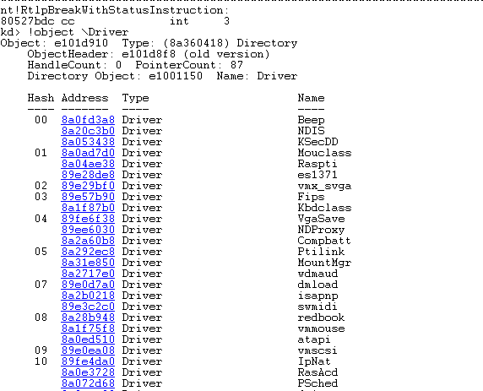
Figure 3. !object \Driver
SERVICE_CONTROL_STOP will call DriverUnload function. To figure out what is the address of DriverUnload function is I would first place a breakpoint on Lab10-01 Driver entry.
kd> bu Lab10_01!DriverEntry
Note that “-” is converted to “_”. Next we need to step till Lab10_01.sys is loaded. Use step out till you see this nt!IopLoadUnloadDriver+0x45.
kd> !object \Driver
to list the loaded drivers, then we use display type (dt) to display out the LAB10-01 driver.
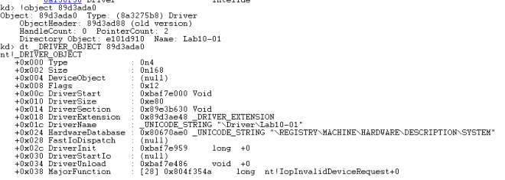Figure 4. dt _DRIVER_OBJECT
In the above image, we can see the address for DriverUnload. Now we just need to set breakpoint on that address as shown below.
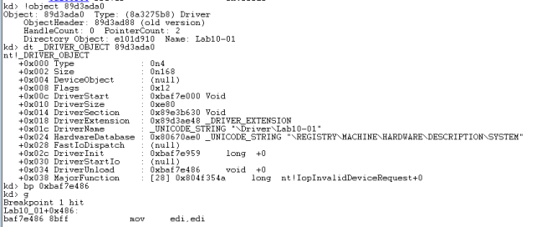Figure 5. breakpoint unload
Stepping through the functions we will see RtlCreateRegistryKey and RtlWriteRegistryValue being called.
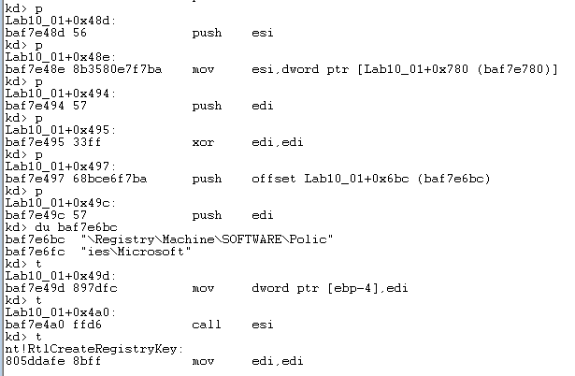Figure 6. RtlCreateRegistryKey
The following image is the dissembled code of the driver in IDA Pro. Stepping the above instructions is the same as going through the instructions below.
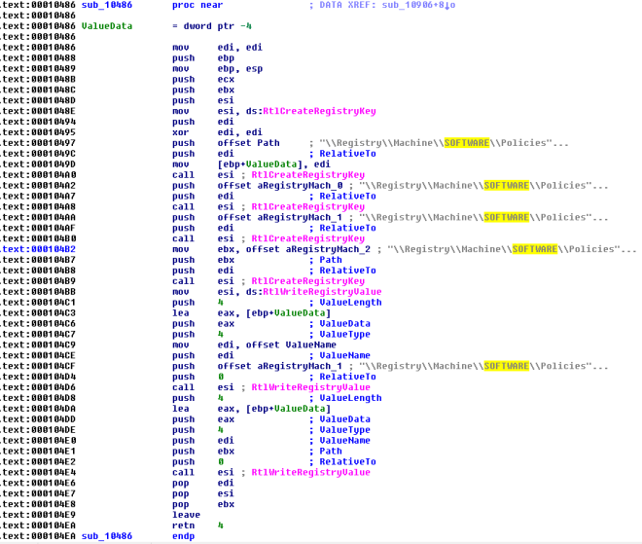Figure 7. Lab10-01.sys IDA Pro
iii. What does this program do?
The malware creates a service Lab10-01 that calls the driver located at “c:\windows\system32\Lab10-01.sys”. It then starts the service, executing the driver and then stops the driver causing the driver to unload itself. In the driver’s unload function the driver attempts to create and write registry key using kernel function call. The following are the registry modification made by the driver.
- RtlCreateRegistryKey: \\Registry\\Machine\\SOFTWARE\\Policies\\Microsoft
- RtlCreateRegistryKey: \\Registry\\Machine\\SOFTWARE\\Policies\\Microsoft\\WindowsFirewall
- RtlCreateRegistryKey: \\Registry\\Machine\\SOFTWARE\\Policies\\Microsoft\\WindowsFirewall\\DomainProfile
- RtlCreateRegistryKey: \\Registry\\Machine\\SOFTWARE\\Policies\\Microsoft\\WindowsFirewall\\StandardProfile
- RtlWriteRegistryValue: \\Registry\\Machine\\SOFTWARE\\Policies\\Microsoft\\WindowsFirewall\\DomainProfile – 0 (data)
- RtlWriteRegistryValue: \\Registry\\Machine\\SOFTWARE\\Policies\\Microsoft\\WindowsFirewall\\StandardProfile – 0 (data)
According to msdn, the above registry modifications will disable Windows Firewall for both the domain and standard profiles on the victim’s machine.
b-The file for this lab is Lab10-02.exe
i. Does this program create any files? If so, what are they?
Cerbero Profiler highlighted that the malware contains a PE Resource. Instinct tells me that this malware behaves like a packer and will extract this resource onto the target’s machine.
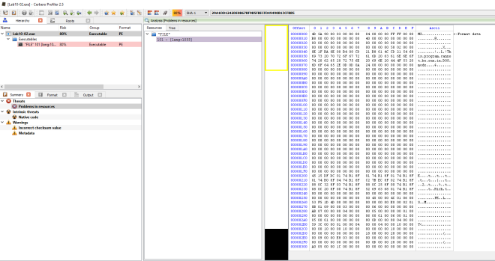Figure 1. MZ header in resource 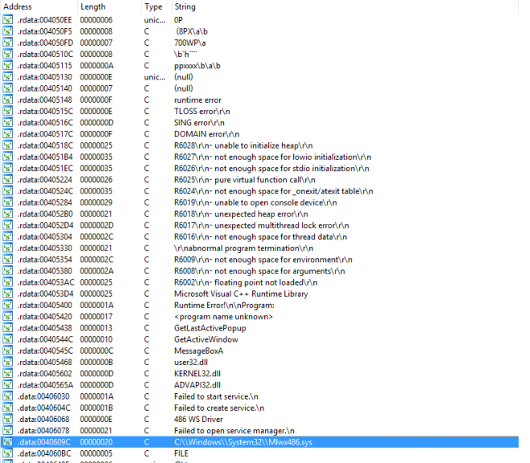Figure 2. IDA Pro’s string
“C:\\Windows\\System32\\Mlwx486.sys” seems suspicious. xRef this string might help us to solve this problem.
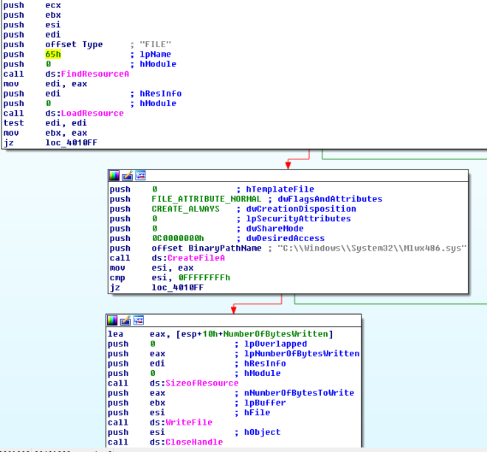Figure 3. Extract Resource
In the main method, we can see that the code is trying to extract the FILE resource into “C:\\Windows\\System32\\Mlwx486.sys”.
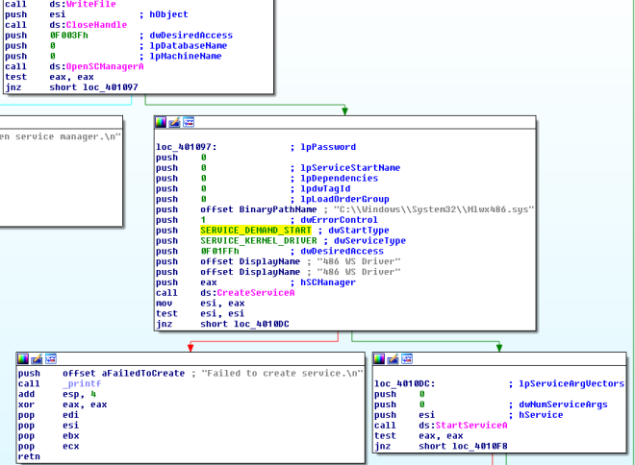
After extracting the driver, the malware then goes on to create a service (486 WS Driver) and start it using StartServiceA.
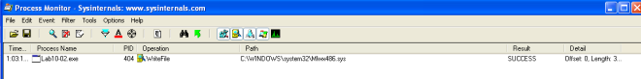
Using Proc mon we can observe that WriteFile to “C:\\Windows\\System32\\Mlwx486.sys” was captured by the tool.
ii. Does this program have a kernel component?
Attempts to locate the dropped driver in system32 folder was fruitless. Somehow the file is not in the folder. So instead I decided to extract the driver out from the resource directly. Firing up IDA Pro we can see DriverEntry function suggesting that this executable is a driver.
iii. What does this program do?
DrierEntry leads us to the following subroutine in IDA Pro (0x10706). The malware is attempting to change the flow of the kernel Service Descriptor Table and the target that it is attempting to hook is the NtQueryDirectoryFile. The malware calls MmGetSystemRoutineAddress to get the pointer to the NtQueryDirectoryFile and KeServiceDescriptorTable subroutine. Then it loops through the service descriptor table looking for the address of NtQueryDirectoryFile. Once found, it will overwrite the address with the evil hook (custom subroutine).
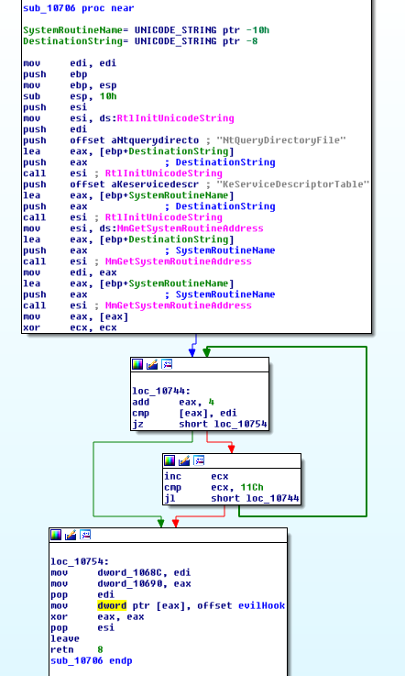
Figure 6. Evil Hook
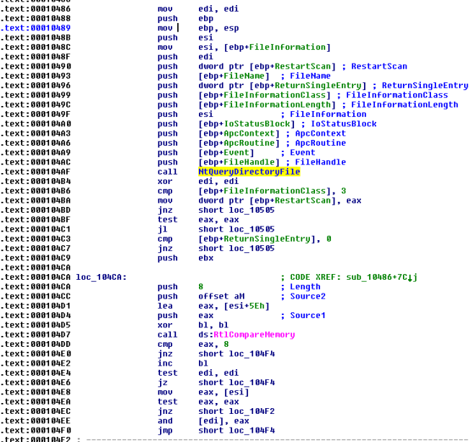Figure 6. NTQueryDirectoryFile
In the driver, NTQueryDirectoryFile function is used. According to msdn, this function returns various kinds of information about files in the directory specified by a given file handle. Further down, we can see that RtlCompareMemory is called. A comparison was made between the filename and the following string “Mlwx“. If it matches, the file will be hidden.
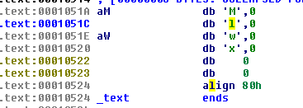
Figure 7. Mlwx string
To see all this win action, fire up Windbg and attach it to the kernel.
use the following command to list the service descriptor table. This table has yet been tampered with…
kd> dps nt!KiServiceTable l 100
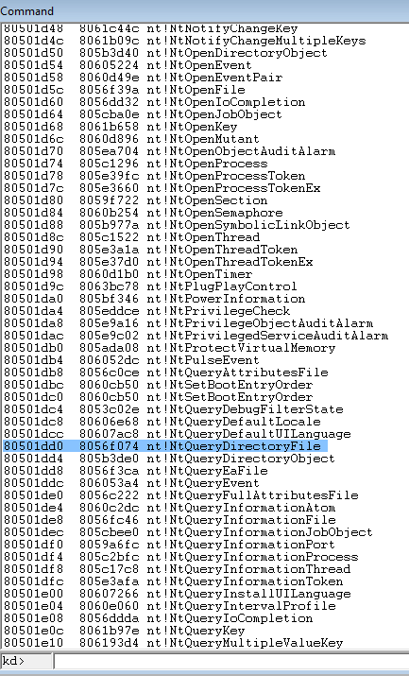
Figure 8. Default Service Descriptor Table
Set breakpoint by using this command bu Mlwx486!DriverEntry. Run Lab10-02.exe and windbg should break.Set breakpoint at nt!IopLoadDriver+0x66a and let the program run again. Once the kernel breaks, you will be able to run !object \Driver to list the loaded drivers. DriverInit for the malware has yet been executed at this stage so you can set your breakpoint from this point on.
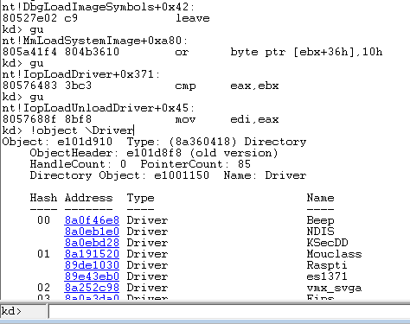
Figure 9. Break @ DriverEntry 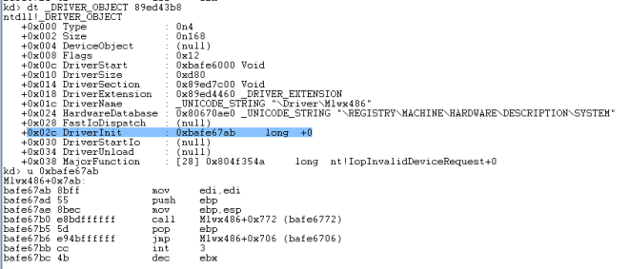Figure 10. DriverInit 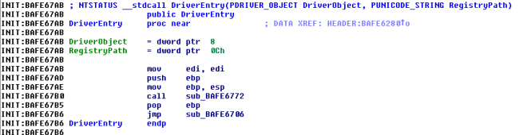Figure 11. DriverEntry
From Figure 10 & 11, we can see that DriverInit is actually DriverEntry in IDA Pro.
runing kd> dps nt!KiServiceTable l 100 now shows that the service descriptor table has been modified.
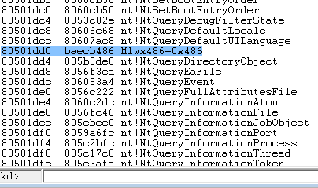
Figure 12. Service Descriptor Table modified
To conclude, the malware uses ring 0 rootkit to hide files that starts with “Mlwx” via hooking of the service descriptor table.

