5 | a. Analyze the malware found in Lab11-01.exe
 | i. What does the malware drop to disk?
 | ii. How does the malware achieve persistence?
 | iii. How does the malware steal user credentials?
 | iv. What does the malware do with stolen credentials?
 | v. How can you use this malware to get user credentials from your test environment?
 | b. Analyze the malware found in Lab11-02.dll. Assume that a suspicious file named Lab11-02.ini was also found with this malware.
 | i. What are the exports for this DLL malware?
 | ii. What happens after you attempt to install this malware using
 | iii. rundll32.exe?
 | iv. Where must Lab11-02.ini reside in order for the malware to install properly?
 | v. How is this malware installed for persistence?
 | vi. What user-space rootkit technique does this malware employ?
 | vii. What does the hooking code do?
 | viii. Which process(es) does this malware attack and why?
 | ix. What is the significance of the .ini file?
 | c. Analyze the malware found in Lab11-03.exe and Lab11-03.dll. Make sure that both files are in the same directory during analysis
 | i. What interesting analysis leads can you discover using basic static analysis?
 | ii. What happens when you run this malware?
 | iii. How does Lab11-03.exe persistently install Lab11-03.dll?
 | iv. Which Windows system file does the malware infect?
 | v. What does Lab11-03.dll do?
 | vi. Where does the malware store the data it collects?

Practical No. 5
a-Analyze the malware found in Lab11-01.exe
i. What does the malware drop to disk?
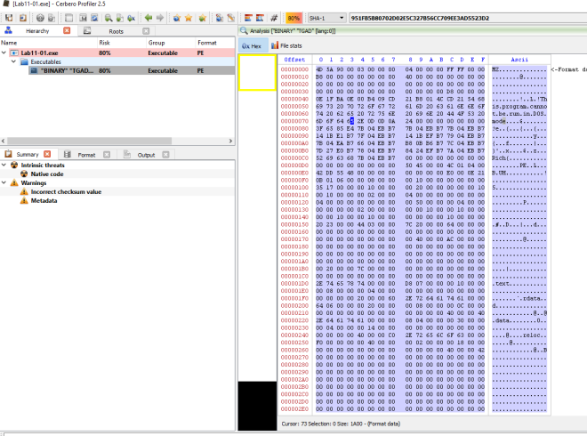Figure 1. Binary resource in Lab11-01.exe’s TGAD
There is a binary in the resource section of Lab11-01.exe.
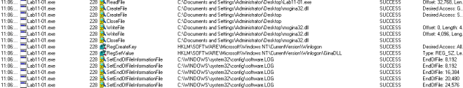Figure 2. msgina32.dll dropped
From Proc Mon we can observe that msgina32.dll and software.LOG are dropped on the machine.
ii. How does the malware achieve persistence?
In figure 2, the malware adds “HKLM\SOFTWARE\Microsoft\Windows NT\CurrentVersion\Winlogon\GinaDLL” into the registry.
According to MSDN, Winlogon, the GINA, and network providers are the parts of the interactive logon model. The interactive logon procedure is normally controlled by Winlogon, MSGina.dll, and network providers. To change the interactive logon procedure, MSGina.dll can be replaced with a customized GINA DLL. Winlogon will trigger the use of the malicious dll and that is how the malware achieve persistency.
iii. How does the malware steal user credentials?
Looking at the dropped dll’s export, it seems like it is a custom dll to hook to the winlogon process.
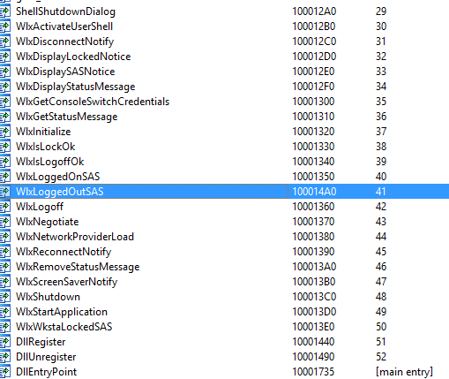Figure 3. WlxLoggedOutSAS
After checking through the exports function, only 1 function (WlxLoggedOutSAS) behaves suspiciously. The rest simply pass the inputs to the original function address.
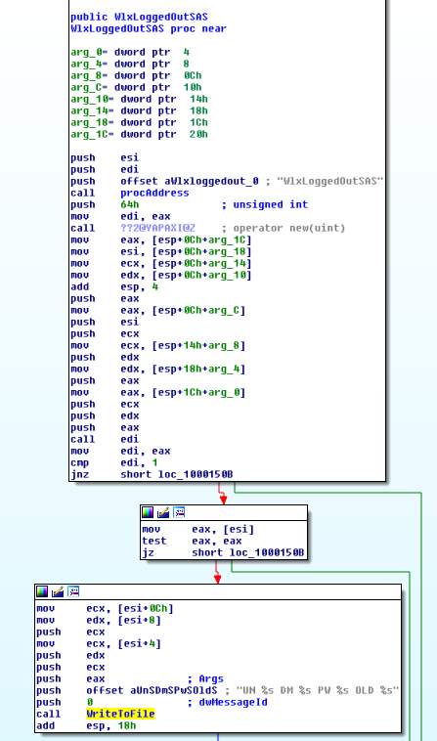
Figure 4. Intercepting WlxLoggedOutSAS
The above figure is pretty straight forward, the inputs are passed to the original WlxLoggedOutSAS function and a copy of the inputs are passed to a function to write to a file.
iv. What does the malware do with stolen credentials?
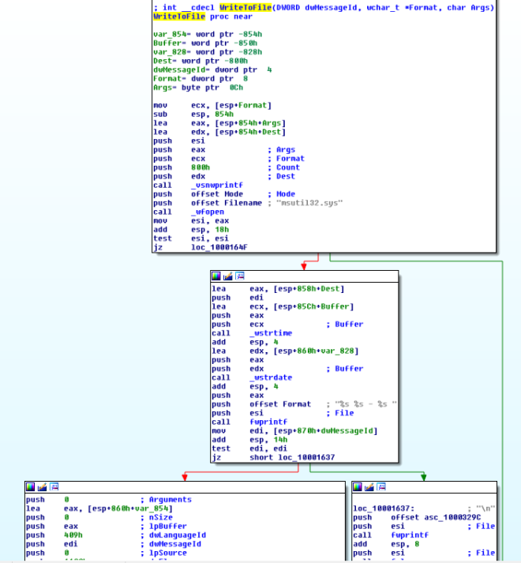Figure 5. Write to file
The above figure shows the malicious dll writing the stolen values into c:\windows\system32\msutil32.sys file.
v. How can you use this malware to get user credentials from your test environment?
By rebooting the machine or by logging off and re-login again. c:\windows\system32\msutil32.sys will contains the password used to login to the windows.
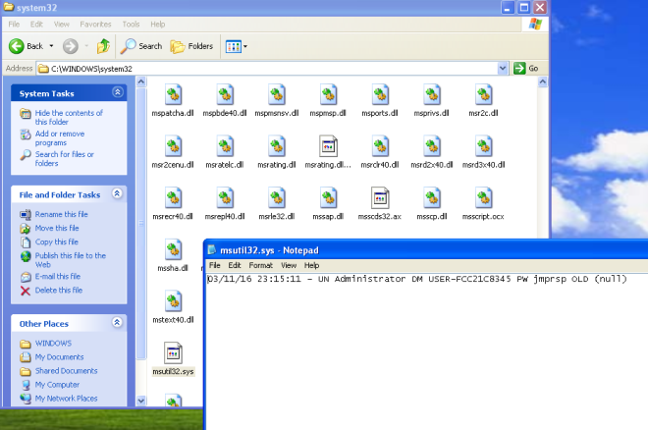Figure 6. Captured Password
b- Analyze the malware found in Lab11-02.dll. Assume that a suspicious file named Lab11-02.ini was also found with this malware.
i. What are the exports for this DLL malware?
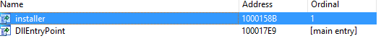
Figure 1. Exports
ii. What happens after you attempt to install this malware using rundll32.exe?
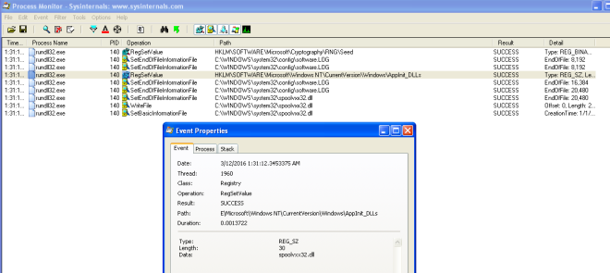Figure 2. Set Registry & WriteFile
The malware add a registry value in HKLM\\SOFTWARE\\Microsoft\\Windows NT\\CurrentVersion\\Windows\\AppInit_DLLS.
It then copy itself; the dll as C:\Windows\System32\spoolvxx32.dll.
The malware then tries to open C:\Windows\System32\Lab11-02.ini.
iii. Where must Lab11-02.ini reside in order for the malware to install properly?
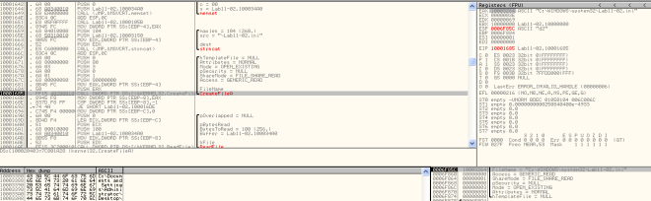Figure 3. Loads config file
The malware will attempt to load the config from C:\Windows\System32\Lab11-02.ini. We would need to place the ini file in system32 folder.
iv. How is this malware installed for persistence?
According to MSDN, AppInit_DLLs is a mechanism that allows an arbitrary list of DLLs to be loaded into each user mode process on the system. By adding AppInit_DLLs in HKLM\\SOFTWARE\\Microsoft\\Windows NT\\CurrentVersion\\Windows\\ we are loading the malicious DLL into each user mode process that gets executed on the system.
v. What user-space rootkit technique does this malware employ?
If we look at the subroutine @0x100012A3, you will see that it is attempting to get the address of send from wscock32.dll. It then pass the address to subroutine @0x10001203.
The subroutine @0x10001203 is employing the inline hook technique. It first get the offset from the hook position to the function where it wants to jump to. It then uses VirtualProtect to make 5 bytes of space from the start of the subroutine address to PAGE_EXECUTE_READWRITE. Once it is done it then rewrite the code to jmp to the hook function. Finally it reset the 5 bytes of memory space back to the old protection attributes.
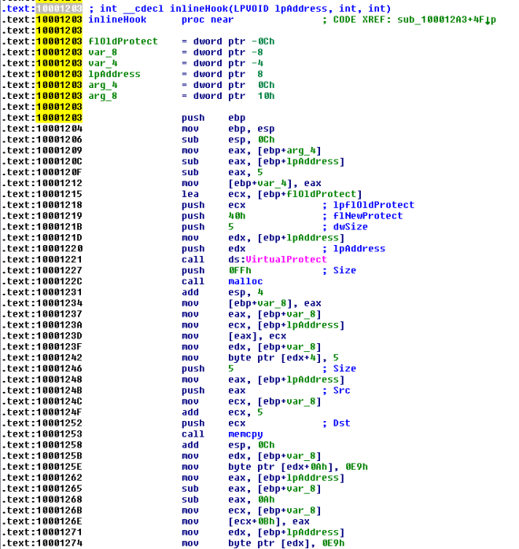Figure 4. inline hook
However, the malware only hook 3 programs; THEBAT.EXE, OUTLOOK.EXE, MSIMM.EXE.
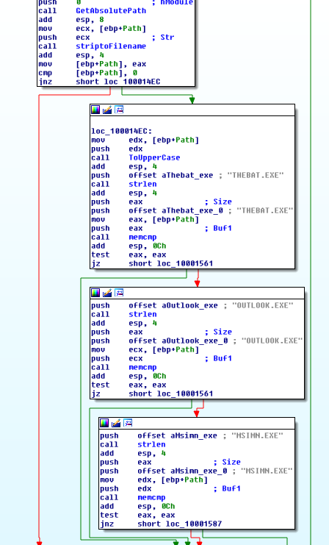
Figure 5. Hook selected programs
To conclude, the malware is attempting to do an inline hook on wsock32.dll’s send function for selected programs.
vi. What does the hooking code do?
We first look at what the malware is retrieving from the config file.
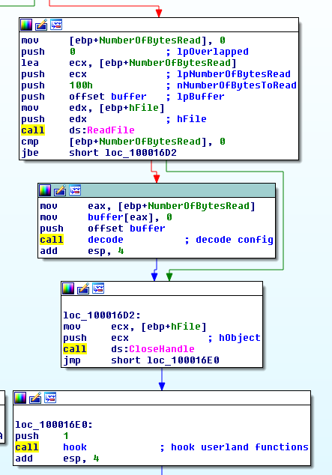
Figure 6. Decoding config
After reading the data from the config file, the malware then decode it by calling the subroutine @0x100016CA. If we dive into this subroutine, you will realize that it is a xor decoding function. Let’s place a hook there in ollydbg to see what comes out.
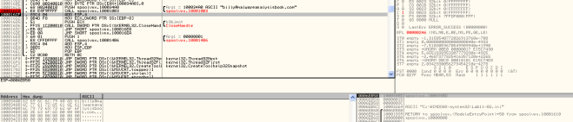Figure 7. billy@malwareanalysisbook.com
This decoded string will be use in the following function.
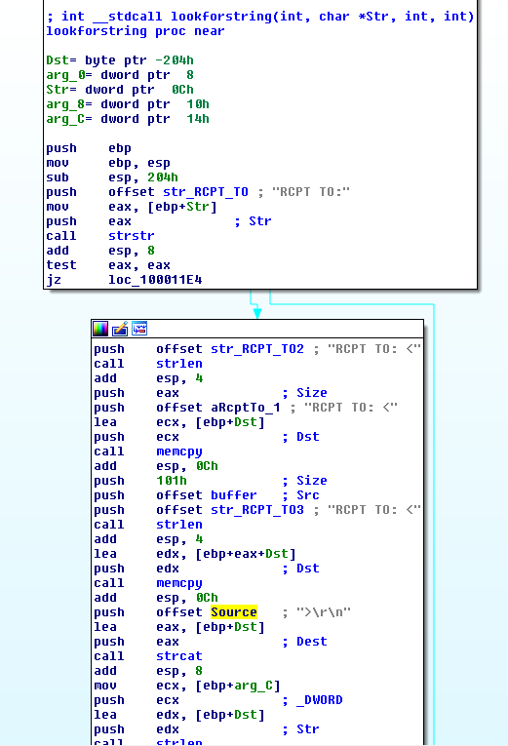
Figure 8. replacing send data
The inline hook jumps to the above function. Its starts off with checking if the send buffer contains the string “RCPT TO”. If it does, it will create a new buffer “RCPT TO:<billy@malwareanalysisbook.com>\r\n” and send it off via the original send function. The function will then end of by simply forwarding the original data to the send function.
vii. Which process(es) does this malware attack and why?
As answered in question v… the malware only hook 3 programs; THEBAT.EXE, OUTLOOK.EXE, MSIMM.EXE. They are all email clients.
viii. What is the significance of the .ini file?
As answered in question v… the config.ini contains the encoded attacker email address. It is use to replace recipient address causing email to be send to the attacker instead.
c- Analyze the malware found in Lab11-03.exe and Lab11-03.dll. Make sure that both files are in the same directory during analysis.
i. What interesting analysis leads can you discover using basic static analysis?
Lab11-03.exe
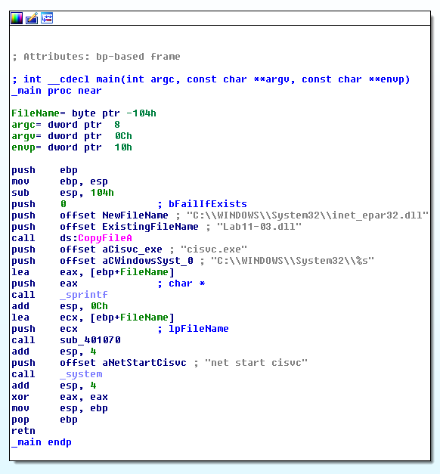
Figure 1. Installation
The main method in Dll11-03.exe is pretty straight forward. It first copy the Lab11-03.dll to C:\\Windows\\System32\\inet_epar32.dll. It then attempts to modify C:\\Windows\\System32\\cisvc.exe and executes the infected executable by starting a service via the command “net start cisvc”
Lab11-03.dll
The dll contains some interesting stuff… In export, we can see a suspicious looking function; zzz69806582.
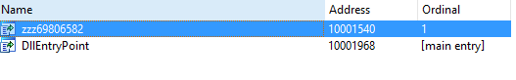Figure 2. Export function surface a funny function
The imports contains GetAsyncKeyState and GetForegroundWindow which highly suggests that this is a keylogger.
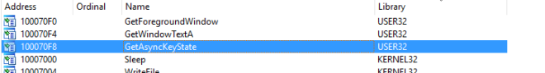Figure 3. imports
The function @zzz69806582 is pretty simple. It just creates a thread.
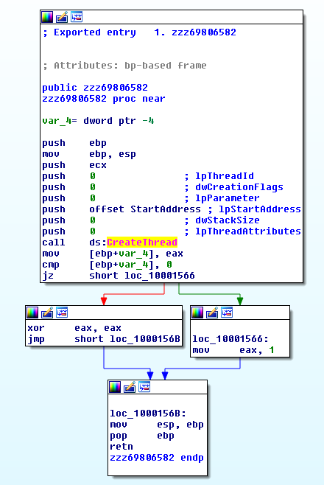
Figure 3. function zzz69806582
The thread that the above function creates first check for mutex; MZ.
It then create a file @ C:\\Windows\\System32\\kernel64x.dll.
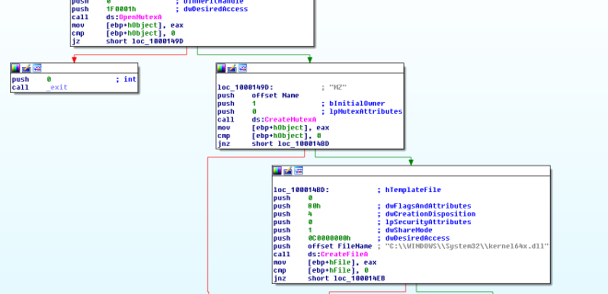
Figure 4.Mutex MZ
Next, the thread calls a subroutine to record keystrokes.
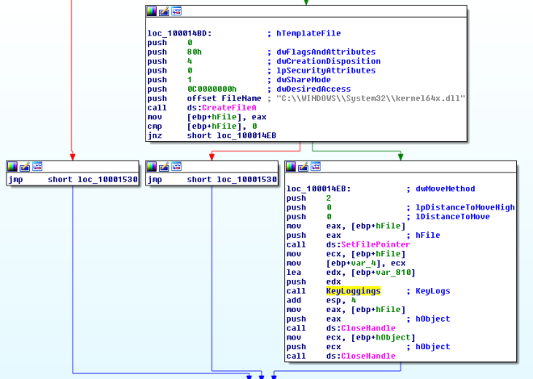Figure 5. Keylogs
ii. What happens when you run this malware?
As answered in question 1, It first copy the Lab11-03.dll to C:\\Windows\\System32\\inet_epar32.dll. It then attempts to modify C:\\Windows\\System32\\cisvc.exe and executes the infected executable by starting a service via the command “net start cisvc”
The infected service then begin to log keystroke and save it in C:\\Windows\\System32\\kernel64x.dll.
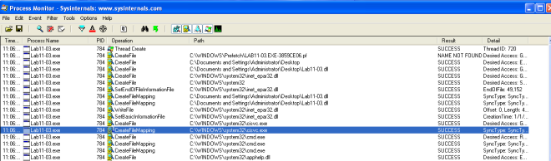Figure 6. Procmon showing file creation in infected system
iii. How does Lab11-03.exe persistently install Lab11-03.dll?
It infects C:\\Windows\\System32\\cisvc.exe; an indexing service by inserting shellcodes into the program. The infected cisvc.exe will load C:\\Windows\\System32\\inet_epar.dll as shown in the figure below.
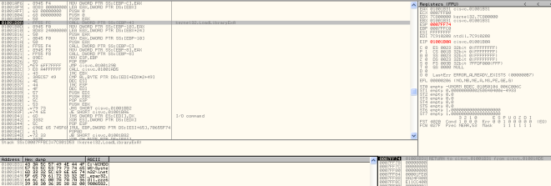Figure 7. LoadLibrary
Comparing the infected executable with the original one, we could see some additional functions added to it. On top of that we can observe that the entry point has been changed.
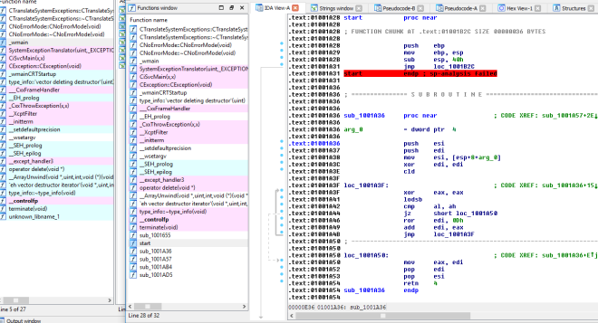Figure 8. Additional Functions 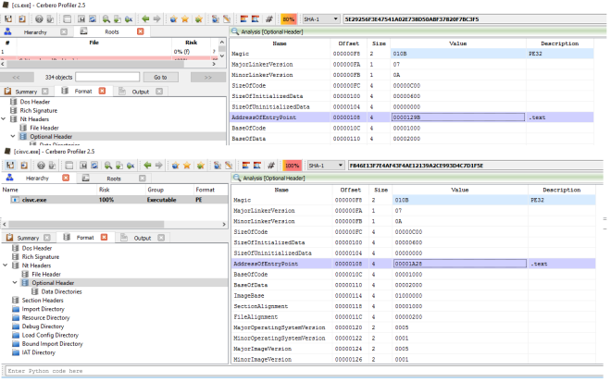Figure 9. Changes in Entry Point
iv. Which Windows system file does the malware infect?
It infects C:\\Windows\\System32\\cisvc.exe.
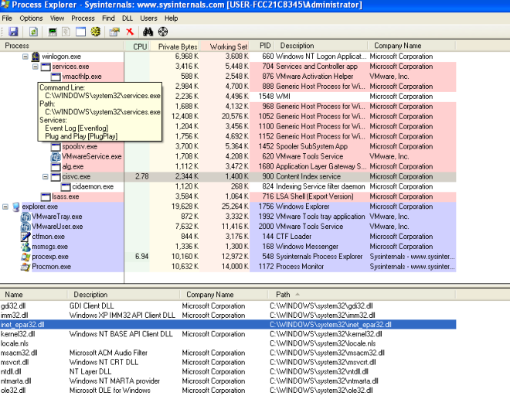
Figure 10. inet_epar32.dll loaded in cisvc.exe
v. What does Lab11-03.dll do?
Using GetAsyncKeyState and GetForegroundWindow, the dll logs keystrokes into C:\\Windows\\System32\\kernel64x.dll. The dll also uses a mutex “MZ” to prevent multiple instances of the keylogger is running at once.
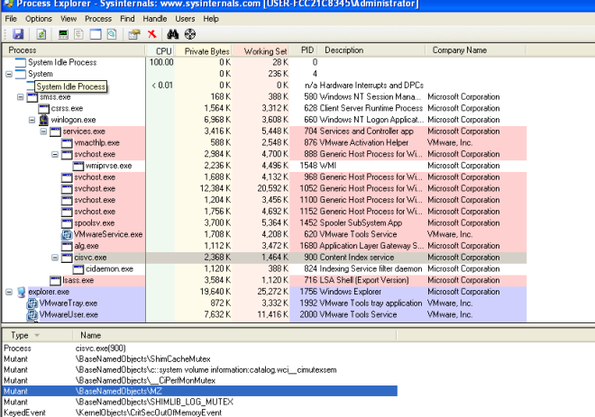Figure 11. Mutex MZ
vi. Where does the malware store the data it collects?
In C:\\Windows\\System32\\kernel64x.dll
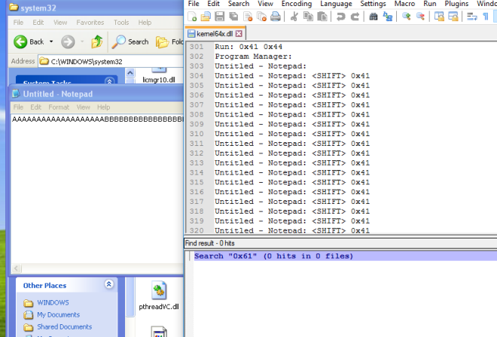Figure 12. Key Logs Captured

