1. a. Files: Lab01-01.exe and Lab01-01.dll.
i. Upload the files to http://www.VirusTotal.com/ and view the reports. Does either file match any existing antivirus signatures?
ii. When were these files compiled?
iii. Are there any indications that either of these files is packed or obfuscated? If so, what are these indicators?
iv. Do any imports hint at what this malware does? If so, which imports are they?
v. Are there any other files or host-based indicators that you could look for on infected systems?
vi. What network-based indicators could be used to find this malware on infected machines?
vii. What would you guess is the purpose of these files?
b. Analyze the file Lab01-02.exe.
i. Upload the Lab01-02.exe file to http://www.VirusTotal.com/. Does it match any existing antivirus definitions?
ii. Are there any indications that this file is packed or obfuscated? If so, what are these indicators? If the file is packed, unpack it if possible.
iii. Do any imports hint at this program’s functionality? If so, which imports are they and what do they tell you?
iv. What host- or network-based indicators could be used to identify this malware on infected machines?
c. Analyze the file Lab01-03.exe.
i. Upload the Lab01-03.exe file to http://www.VirusTotal.com/. Does it match any existing antivirus definitions?
ii. Are there any indications that this file is packed or obfuscated? If so, what are these indicators? If the file is packed, unpack it if possible.
iii. Do any imports hint at this program’s functionality? If so, which imports are they and what do they tell you?
iv. What host- or network-based indicators could be used to identify this malware on infected machines?
d. Analyze the file Lab01-04.exe.
i. Upload the Lab01-04.exe file to http://www.VirusTotal.com/. Does it match any existing antivirus definitions?
ii. Are there any indications that this file is packed or obfuscated? If so, what are these indicators? If the file is packed, unpack it if possible.
iii. When was this program compiled?
iv. Do any imports hint at this program’s functionality? If so, which imports are they and what do they tell you?
v. What host- or network-based indicators could be used to identify this malware on infected machines?
vi. This file has one resource in the resource section. Use Resource Hacker to examine that resource, and then use it to extract the resource. What can you learn from the resource?
e. Analyze the malware found in the file Lab03-01.exe using basic dynamic analysis tools.
i. What are this malware’s imports and strings?
ii. What are the malware’s host-based indicators?
iii. Are there any useful network-based signatures for this malware? If so, what are they?
f. Analyze the malware found in the file Lab03-02.dll using basic dynamic analysis tools.
i. How can you get this malware to install itself?
ii. How would you get this malware to run after installation?
iii. How can you find the process under which this malware is running?
iv. Which filters could you set in order to use procmon to glean information?
v. What are the malware’s host-based indicators?
vi. Are there any useful network-based signatures for this malware?
g. Execute the malware found in the file Lab03-03.exe while monitoring it using basic dynamic analysis tools in a safe environment
i. What do you notice when monitoring this malware with Process Explorer?
ii. Can you identify any live memory modifications?
iii. What are the malware’s host-based indicators?
iv. What is the purpose of this program?
h. Analyze the malware found in the file Lab03-04.exe using basic dynamic analysis tools.
i. What happens when you run this file?
ii. What is causing the roadblock in dynamic analysis?
iii. Are there other ways to run this program?

Practical No. 1
a- This lab uses the files Lab01–01.exe and Lab01–01.dll.
i- To begin with, we have Lab01–01.exe and Lab01–01.dll. At first glance, we can might assume these associated. As .dlls can’t be run on their own, potentially Lab01–01.exe is used to run Lab01–01.dll. We can upload these to http://www.VirusTotal.com to gain a useful amount of initial information (Figure 1.1).
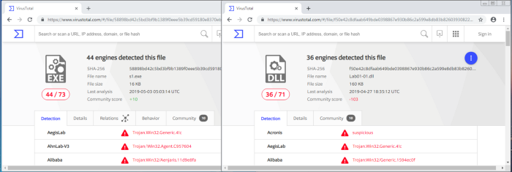

Figure 1.1— VirusTotal.com reports for Lab01–01.exe and Lab01–01.dll.
Although the book states that these files are initially unlikely to appear within VirusTotal, they have become part of the antivirus signatures so have been recognised. We currently see that 44/73 antivirus tools pick up on malicious signatures from Lab01–01.exe, whereas 36/71 identify Lab01–01.dll as malicious.
ii-We can use VirusTotal to identify more information, such as when the files were compiled. We see that the two files were compiled almost at the same time (around 2010–12–19 16:16:19) — this strengthens the theory as the two files are associated. Other tools can also be utilised to identify Time Date Stamp, such as PE Explorer (Figure 2.1).
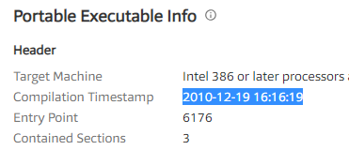
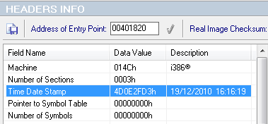
Figure 2.1 — Date Time Stamps from VirusTotal.com and PE Explorer.
iii-When a file is packed, it is more difficult to analyse as it is typically obfuscated and compressed. Key indicators that a program is packed, is a lack of visible strings or information, or including certain functions such as LoadLibrary or GetProcAddress — used for additional functions. A packed executable has a wrapper program which decompresses and runs the file, and when statically analysing a packed program, only the wrapper program is examined.
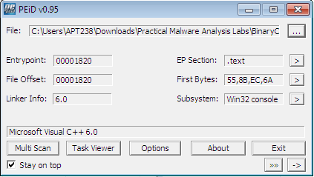
Figure 3.1 — PEiD of Lab01–01.exe
PEiD can be used to identify whether a file is packed, as it shows which packer or compiler was used to build the program. In this case Microsoft Visual C++ 6.0 is used for both the Lab01–01.exe and Lab01–01.dll (figure 3.1), whereas a packed file would be packed with something like UPX.
iv- Investigating the imports is useful in identifying what the malware might do. Imports are functions used by a program, but are actually stored in a different program, such as common libraries.
Any of the previously used tools (VirusTotal, PEiD, and PE Explorer) can be used to identify the imports. These are stored within the ImportTable and can be expanded to see which functions have been imported.
Lab01–01.exe imports functions from KERNEL32.dll and MSVCRT.dll, with Lab01–01.dll also importing functions from KERNEL32.dll, MSVCRT.dll, and WS2_32.dll (figure 4.1)
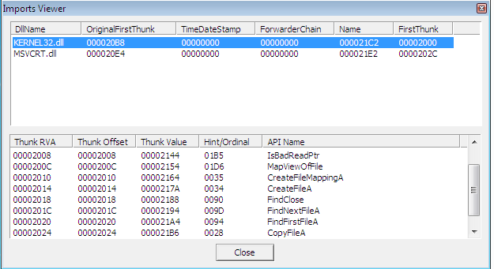

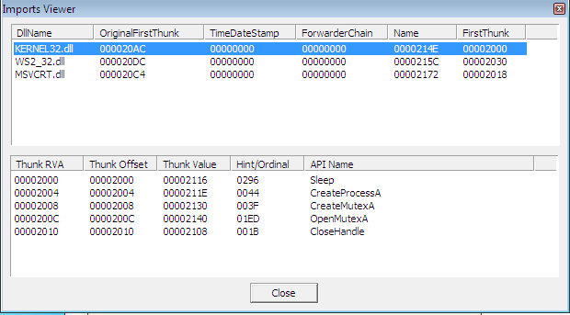
Figure 4.1— Import Tables from Lab01–01.exe and Lab01–01.dll.
- KERNEL32.dll is a common DLL which contains core functionality, such as access and manipulation of memory, files, and hardware. The most significant functions to note for Lab01–01.exe are are FindFirstFileA and FindNextFileA , which indicates the malware will search through the filesystem, as well as open and modify. On the other hand, Lab01–01.dll most notably uses Sleep and CreateProcessA.
- WS2_32.dll provides network functionality, however in this case is imported by ordinal rather than name, it is unclear which functions are used.
- MSVCRT.dll imports are functions that are included in most as part of the compiler wrapper code.
Assessing the combination of imported functions, so far it could be assumed that this malware allows for a network-enabled back door.
v-Along with Lab01–01.exe and Lab01–01.dll, there are other ways to identify malicious activity on infected systems. Disassembling Lab01–01.exe in PE Explorer shows us a set of strings around kerne132.dll which is supposed to be disguised as the common kernel32.dll — note 1 rather than l (figure 5.1).
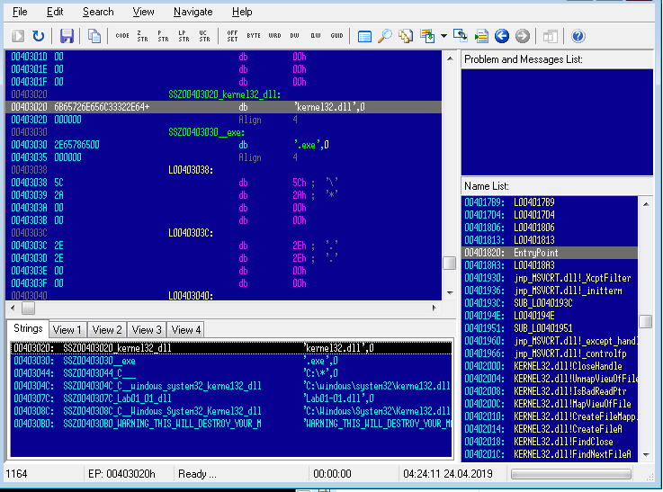
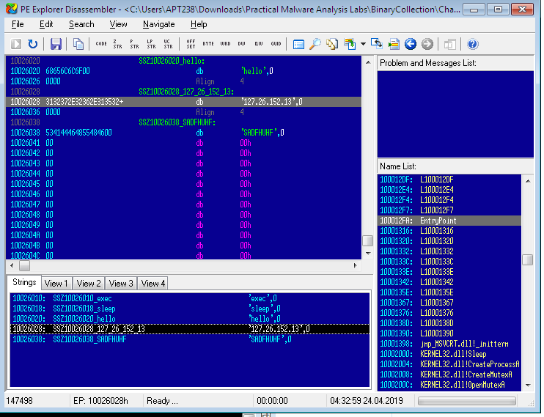
Figure 5.1— Disassembly of Lab01–01.exe and Lab01–01.dll using PE Explorer
vi- Further investigating the strings, however for Lab01–01.dll, it is apparent that there is an IP address of 127.26.152.13 , which would act as a network based indicator of malicious activity (figure 5.1).
vii-Bringing all the pieces together, there can be an assumption made that Lab01–01.exe, and by extension Lab01–01.dll, is malware which creates a backdoor. VirusTotal provided indication that the files were malicious, and utilising this or PE Explorer it was established that the two were likely related, with the .dll is dependant upon the .exe. The files are not packed(as identified by PEiD), small programs, with no exports, however specific imports which indicate that Lab01–01.exe might search through directories and create/manipulate files such as the disguised kernel32.dll, as well possibly searching for executables on the target system, as suggested by the string exec within Lab01–01.dll. In addition, there are network based imports, an IP address, as well as the functions imported from kernel32.dll, CreateProcess and sleep, which are commonly used in backdoors.
b- Analyse Lab01–02.exe.
i-As with the previous lab, uploading Lab01–02.exe in VirusTotal.com shows us that 47/71 antivirus tools recognise this file’s signature as malicious (figure 1.1).
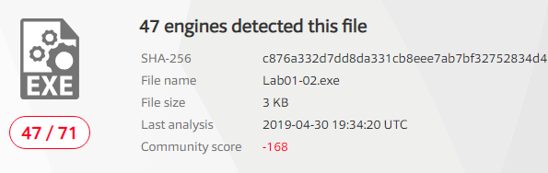
Figure 1.1— VirusTotal.com reports for Lab01–02.exe.
ii-We can identify whether the file is packed, either through VirusTotal.com or PEiD. A file which is not packed will indicate the compiler (eg, Microsoft Visual C++ 6.0), or the method in which it has been packed. Initially, PEiD declared there was Nothing found *, however after changing from a normal to deep scan, it has been determined that the file has been packed by UPX (figure 2.1).
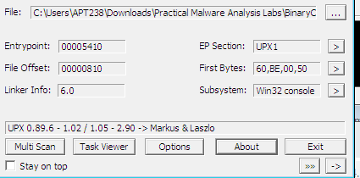
Figure 2.1 — PEiD Deep scan
- Normal scan is at the Entry Point of the PE File for documented signatures.
- Deep scan is the containing section of the Entry Point
- Hardcore scan is a complete scan of the entire file for signatures.
Another way of identifying whether the file has been packed or not, is via the Entry Point Section (EP Section) — these are UPX0, UPX1 and UPX2, section names for UPX packed files. UPX0 has a virtual size of 0x4000 but a raw size of 0 (figure 2.2), likely reserved for uninitialized data — the unpacked code.
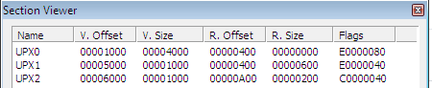
Figure 2.2 — PEiD PE Section Viewer
We are able to unpack the file directly within PE Explorer, with the UPX Unpacker Plug-in. When enabled, this automatically unpacks the file when loaded (Figure 2.3).
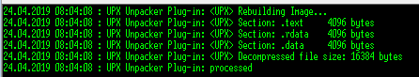
Figure 2.3 — UPX Unpacker Plug-in running in PE Explorer
iii- When the file is unpacked, we can investigate strings and imports to see what the malware gets up to. From the Import Viewer within PE Explorer, we see there are four imports (figure 3.1).
- KERNEL32.DLL — imported to most programs and doesn’t tell us much other than suggesting the potential of creating threads/processes.
- ADVAPI32.dll — specifically CreateServiceA is of note.
- MSVCRT.dll — imported to most programs and doesn’t tell us much.
- WINNET.dll — specifically InternetOpenA and InternetOpenURLA are of note.
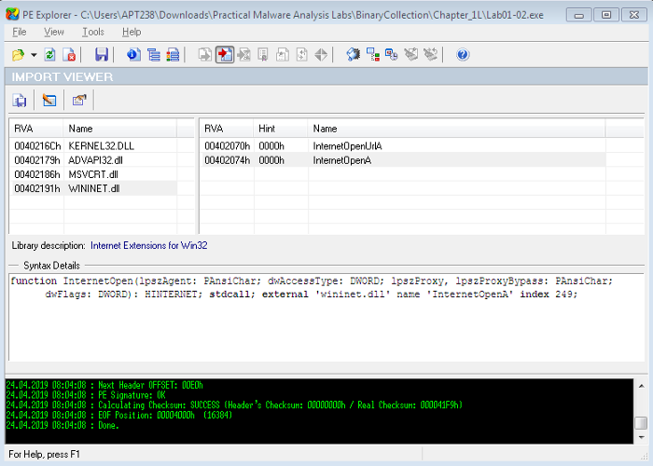
Figure 3.1 — Import Viewer within PE Explorer
iv-So far, this is suggesting that the malware is creating a service and connecting to a URL. Checking out the strings of the file in the Disassembler, we see ‘Malservice’, ‘http://www.malwareanlysisbook.com’ and ‘Internet Explorer 8.0’ (figure 3.2). These potentially act as host or network based indicators of malicious activity, though the service to run, URL to connect to, and the preferred browser.
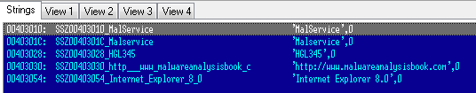
Figure 3.2 — Disassembler Strings
C. Analyze the file Lab01-03.exe.
i- Once again, uploading to VirusTotal.com indicates that Lab01–03.exe is malicious due to 58/69 antivirus tools currently recognising signatures.
ii Scanning this with PEiD demonstrates that Lab01–03.exe is packed with FSG 1.0 (figure 2.1 left). This is much more difficult to unpack than UPX and must be done manually. Currently we are unable to unpack this. Check out Lab 18–2 (Chapter 18, Packers and Unpacking) to unpack in OllyDbg.
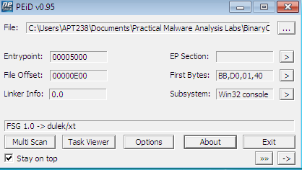
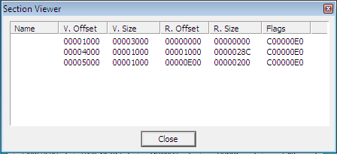
Figure 2.1 —PEiD showing Lab01–03.exe packed with FSG 1.0 (left) and Section VIewer (right)
Other indicators that the file is packed, are the missing names in the EP Section viewer (Figure 2.1 right), as well as the first section having a virtual size of 0x3000 and a raw size of 0 — again most likely reserved for the unpacked code.
iii- Although Lab01–03.exe is currently unpackable, we can still try to identify any imports to get an idea of what the file might do.
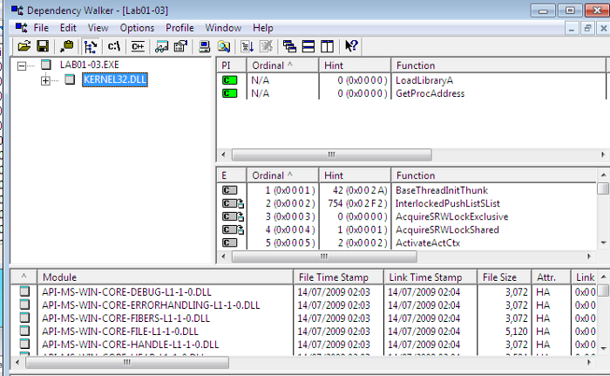
Figure 3.1 — Dependency Walker for Lab01–03.exe
Loading the file into PE Explorer unfortunately shows a blank Import Table, and running it in the Disassembler is also unhelpful. Another useful program is Dependency Walker, which lists the imported and exported functions of a portable executable (PE) file (figure 3.1).
Here, we can see that Lab01–03.exe is dependant upon (and therefore imports) KERNEL32.DLL. The particular functions here are LoadLibraryA and GetProcAddress, however this does not tell us much about the functionality other than the fact the file is packed.
iv- We are unable to unpack the file the visible imports are uninformative, and we can’t see any strings in PE Explorer (figure 4.1), it is difficult to suggest what the file might do, or identify any host/network based malware-infection indicators.
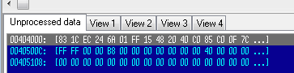
Figure 4.1 — PE Explorer showing no strings information for packed Lab01–03.exe
D- Analyze the file Lab01-04.exe.
i- Lab01–04.exe is recognised as malicious, with 53/72 engines detecting malicious signatures (Figure 1.1).
ii- PEiD shows us that the file is unpacked (and compiled with Microsoft Visual C++ 6.0) (figure 2.1). Likewise, the EP section shows the valid file names as well as actual raw sizes for them all, rather than UPX0-3 or blanks, as well as a raw size of 0, typically seen for packed files (figure 2.1). As this is not packed, there is no need to unpack it.
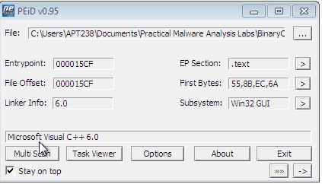
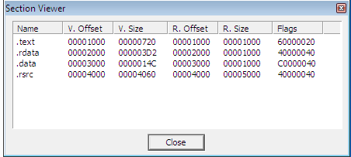
Figure 2.1 — PEiD showing Lab01–04.exe is not packed and Section VIewer
iii- Loading Lab01–04.exe into PE Explorer, we initially see that the Date Time Stamp is clearly faked (figure 3.1). At the time of writing it looks as though the file was compiled months in the future, and it's not immediately clear what the real stamp should be.
Figure 3.1 — Date Time Stamp of Lab01–04.exe
iv- Switching to the Import Viewer within PE Explorer, we see that there are three of the common .dll imported (figure 4.1).
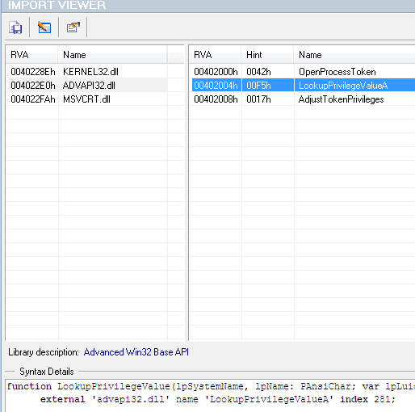
Figure 4.1 — Import Viewer for Lab01–04.exe
- KERNEL32.dll — Core functionality, such as access and manipulation of memory, files, and hardware.
- ADVAPI32.dll — Access to advanced core Windows components such as the Service Manager and Registry. The functions here look like they’re doing something with privileges.
- MSVCRT.dll — imports are functions that are included in most as part of the compiler wrapper code.
Assessing the combination of imports, there are a few key ones which can point us in the direction of the program’s functionality.
- SizeOfResource, FindResource, and LoadResource indicate that the file is searching for data in a specific resource.
- CreateFile, WriteFile and WinExec suggests that it might write a file to disk and execute it.
- LookupPrivilegeValueA and AdjustTokenPrivilages indicates that it might access protected files with special permissions.
v- Looking at the strings is often a good way to identify any host/network based malware-infection indicators. Again, this can be done through the Disassembler in PE Explorer (Figure 5.1)
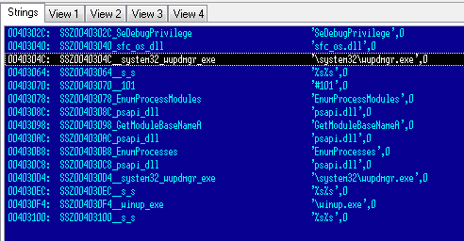
Figure 5.1 — Lab01–04.exe strings within PE Explorer Disassembler
The strings of note here look like ‘\system32\wupdmgr.exe’, ‘psapi.dll’ and ‘\winup.exe’ — potentially these are the files which the .dll identified, create, or execute.
‘\system32\wupdmgr.exe’ might correlate with KERNEL32.dll GetWindowsDirectory function to write to system directory and the malware might modify the Windows Update Manager.
This gives us some host-based indicators, however there is nothing apparent regarding network functions.
vi- Previously overlooked in PEiD’s Section Viewer, there is a resources file .rsrc —The Resource Table. This is also seen in PE Explorer’s Section Headers.
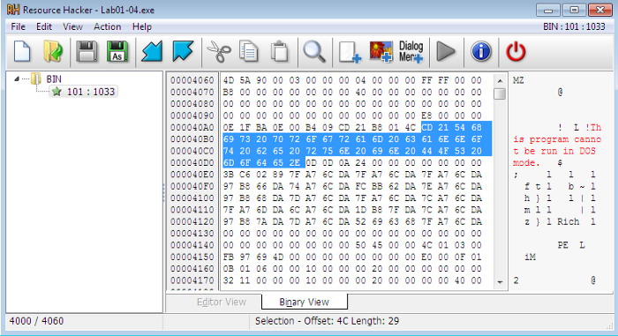
Figure 6.1 — Resource Hacker identifying Lab01–04.exe’s binary resource
We are able to open this within Resource Hacker, a tool which can be used to manipulate resources within Windows binaries. Loading Lab01–04.exe into Resource Hacker identifies that resource as binary and lets us search through it. (figure 6.1)
e. Analyze the malware found in the file Lab03-01.exe using basic dynamic
analysis tools.
i-This dynamic analysis starts with initial static analysis to hopefully gain a baseline understanding of what might be going on. Straight in with PEiD and PE Explorer we see that Lab03–01.exe is evidently PEncrypt 3.1 packed, and only visible import of kernel32.dll and function ExitProcess(figure 1.1). Also, there are are no apparent strings visible.
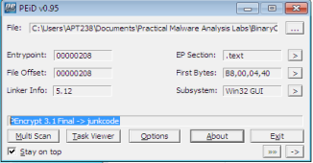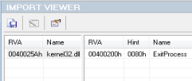Figure 1.1 — File Lab03–01.exe is packed, and has minimal imports
It’s difficult to understand this malware’s functionality with this minimal information. Potentially the file will unpack and expose more information when it is run. One thing we can do is execute strings to scan the file for UNICODE or ASCII characters not easily located. Doing this we can identify some useful information.
There is a bit of noise here which have been removed, and the main ones are highlighted in red (table 1.1).
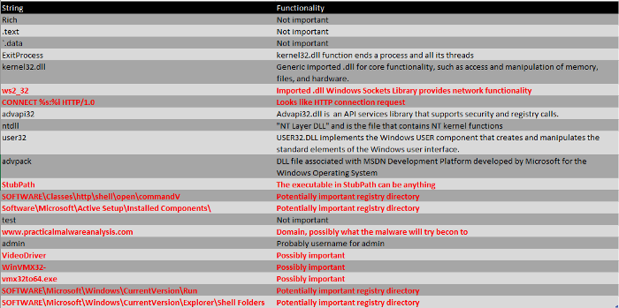
Table 1.1 — Processed output of strings function on Lab03–01.exe
Looking at these, we can make some rough assumptions that Lab03–01.exe is likely to do some network activity and download and hide some sort of file in some of the registry directories, under one of those string names.
ii- To identify host-based indicators, we can make assumptions from the previous strings output, such as potentially attaching itself to SOFTWARE\Microsoft\Windows\CurrentVersion\Run\VideoDriver — however, it is more useful to perform dynamic analysis and see what it’s doing. Take a snapshot of the VM so you’re able to revert to a pre-execution state!
Set VM networking to Host-only, and manually assign the preferred DNS server as iNetsim, or configure the DNS reply IP within ApateDNS to loopback, and set up listeners using Netcat (ports 80 and 443 are recommended as a starting point as these are common).
Clear all processes within Procmon, and apply suitable filters to clear out any noise and find out what the malware is doing. Initially filter to include Process Lab3–1.exe so we can see its activity. Likewise, start Process Explorer for collecting information about processes running on the system.
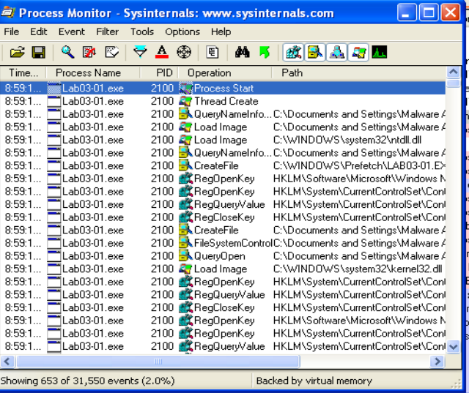
Figure 2.1 — Procmon of Lab03–01.exe
The first thing we notice when executing Lab03–01.exe is the series of Registry Key operations (Figure 2.1). This doesn’t tell us too much about what the malware is doing specifically however, it’s always useful to see an overview of the activities. We can filter this further to only show WriteFile and RegSetValue to see the key operations (figure 2.2)
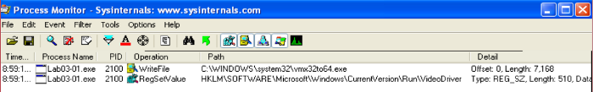
Figure 2.2 — Procmon of Lab03–01.exe, filtered for WriteFile and RegSetValue
We can investigate these operations further, and we see that they are related. First, a file is written to C:\WINDOWS\system32\vmx32to64.exe (note, this filename is a string we’ve identified as part of the initial static analysis) however, this appears to be set to the registry of HKLM\SOFTWARE\Microsoft\Windows\CurrentVersion\Run\VideoDriver (another identified string!). This is a strong host-based indicator that the malware is up to something (Figure 2.3). Most likely the malware is intended to be run at startup.
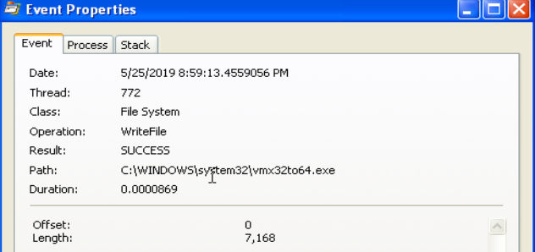
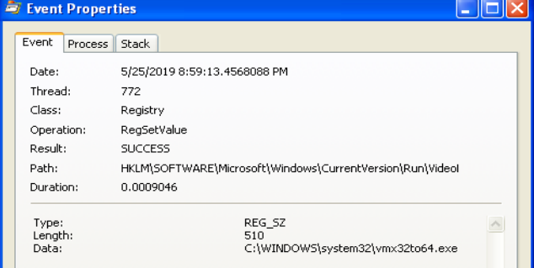
Figure 2.3 — Lab03–01.exe hiding under vmx32to64.exe and set to VideoDriver registry.
Upon further investigation, it appears as though files vmx32to64.exe and Lab03–01.exe share the same hash (figure 2.4), indicating the malware has established persistence through creating and hiding a copy of itself, as well as to execute at startup via the VideoDriver registry.
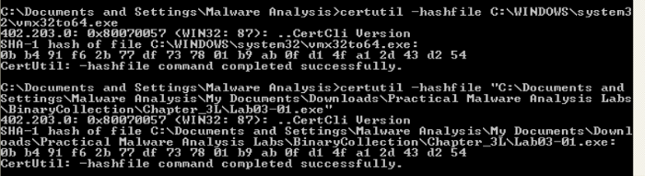
Figure 2.4 — Lab03–01.exe sharing the same SHA1 Hash as vmx32to64.exe.
Further host-based indicators can be identified through analysis of Process Explorer, to show which handles and DLLs the malware has opened or loaded.
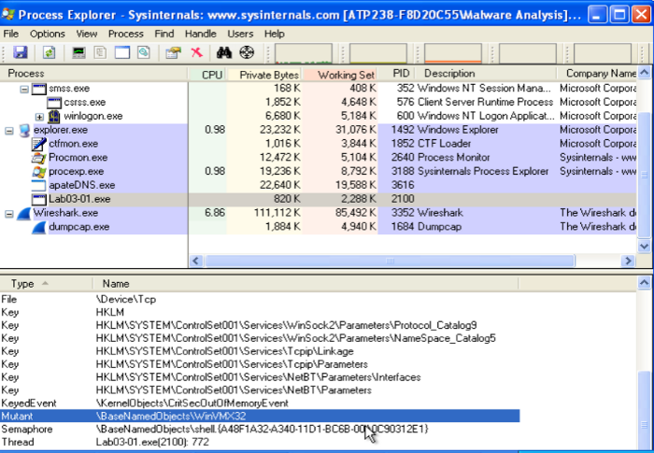
Figure 2.4 — Process Explorer showing Mutex WinVMX32
Process Explorer shows us that Lab03–01.exe has created at mutex of WinVMX32 (again, another identified string) (Figure 2.4). A mutex (mutual exclusion objects) is used to ensure that only once instance of the malware can run at a time — often assigned a fixed name. We also see Lab03–01.exe utilises ws2_32.dll and wshtcpip.dll for network capabilities.
iii-We’re able to analyse network activity either locally on the victim, or utilising iNetSim. I have demonstrated both, having configured DNS to either the iNetSim machine or loopback (for the netcat listeners). Turning our attention to ApateDNS and our iNetSim logs, we see some pretty significant network-based indicators of this malware activity. ApateDNS show regular DNS requests to www.practicalmalwareanalysis.com every 30 seconds (figure 3.1).
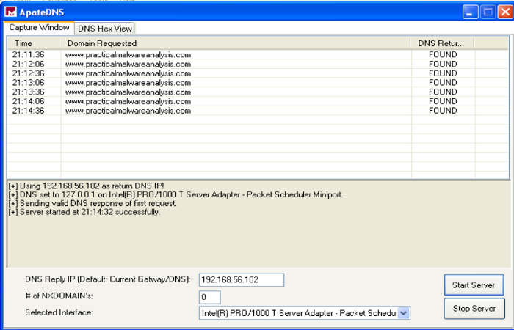
Figure 3.1 — ApateDNS showing DNS beaconing
The ApateDNS capture suggests the malware is beaconing — possibly to either to fetch updates/instructions or to send back stolen information.
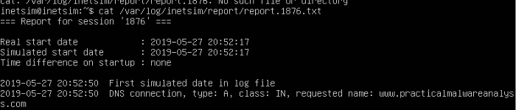
Figure 3.2 — iNetSim logs
Also, the associated iNetSim logs show a recognised DNS request for the malicious website, providing further indication of beaconing intent.
Finally, the Netcat listener (with DNS configured for loopback) has picked up a transmission on port 443. This shows a series of illegible characters emitted from the malware (Figure 3.3). On subsequent executions or periodic ticks, the transmission is unique.
Figure 3.3 — Illegible characters transmitted by Lab03–01.exe.
The combination of host and network-based indicators provide significant grounding to make assumptions regarding the malware’s activity.
- From Static Analysis, not a lot was uncovered other than the output of what might use as hard-coded parameters.
- Dynamic Analysis to uncover further host-based indicators show that the malware has replicated and masked under another file name has associated with the registry for execution on startup and has network functionality.
- Network-based activity is identified through capturing periodic DNS requests, as well as intercepting random character transmissions of HTTP & SSL
f. Analyze the malware found in the file Lab03-02.dll using basic dynamic analysis
tools.
i- At first glance, we have Lab03–02.dll. As this is not a .exe file, we are unable to directly execute it. rundll32.exe is a windows utility which loads and runs 32-bit dynamic-link libraries (.dll).
First, however, we likely require any exported functions to pass in as an argument. This can be identified through PE analysis, which shows us a set of exported and imported functions. The imported functions (Figure 1.1) give us an idea of the .dll’s capabilities. Speculation into these might suggest there will likely be some networking going on, as well as some file, directory and registry manipulation. Functions included as part of ADVAPI32.dll suggests the malware may need to be run as a service, which is backed up by Lab03–02.dll’s exports (Figure 1.1)
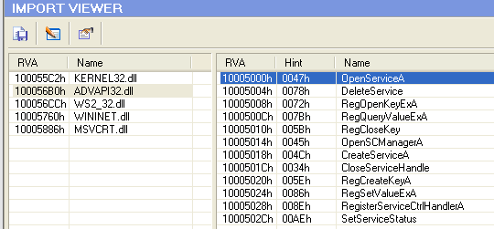
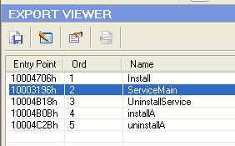
Figure 1.1 — Lab03–02.dll’s Imports and Exports showing likely service capabilities
Running streams also gives us a lot of useful insight into potential actions. Most of which are found as imported functions, however, there are others worth noting that my be useful host/network-based indicators. These include some very distinctive strings, potential registry locations and file or network names, as well as some base64 encoded strings hinting at some functionality (Figure 1.2).
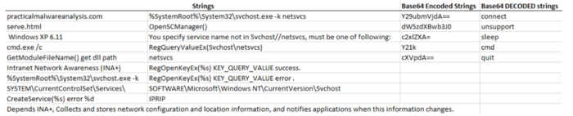
Figure 1.2 — Lab03–02.dll’s strings showing potential functionality.
Now we have a starting point to look out for, we can prepare our environment for trying to run the malware — clearing procmon, taking a registry snapshot, and setting up the network.
ii- To install the malware, pass one of Install or installA (found from the exports) into rundll32.
Executing C:\rundll32.exe Lab03-02.dll,install doesn’t give any immediate feedback on the command line, within process explorer, or Wireshark/iNetSim, however taking a 2nd registry snapshot and comparing the two, it’s clear that keys and values have been added — many of these matching up with what we found from strings (Figure 2.1)
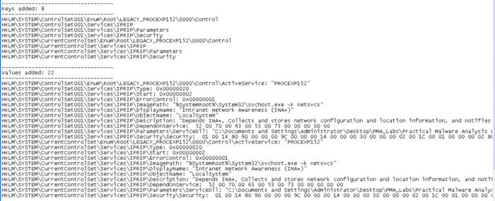
Figure 2.1 — Registry keys and values added as a result of installing Lab03–02.dll
We can see within the regshot comparison that something called IPRIP has been added as a service, with some of the more identifiable strings as \DisplayName or \Description. The image path has also been set to %SystemRoot%\System32\svchost.exe -k netsvcs which shows the malware is likely to be launched within svchost.exe with network services as an argument.
iii- Since we have installed lab03–02.dll as a service, we can now run this and we see the same \DisplayName + update found from the added reg values (Figure 3.1).
Figure 3.1 — Starting the IPRIP service
Checking out ProcessExplorer to see what’s happened, we can search for the Lab03–02.dll which will point us to the svchost.exe instance that was created.
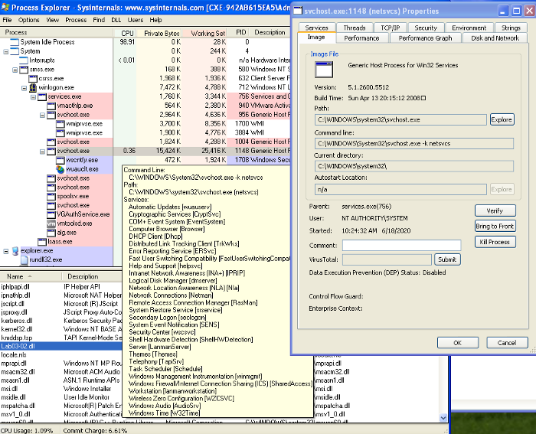
Figure 3.2 — Process Explorer showing svchost.exe launched with Lab03–02.dll
We can identify various indicators which attribute Lab03–02.dll to this instance of svchost.exe thorough the inclusion of the .dll, the service display name “Intranet Network Awareness (INA+)”, and the command line argument matching what has been found in strings. This helps us to confirm that Lab03–02.dll has been loaded — note the process ID, 1148. We’ll need this to see what’s going on in ProcMon!
iv- Checking out ProcMon, filtered on PID 1148, we see a whole load of registry RegOpenKey and ReadFiles, however, seems mostly svchost.exe related and nothing jumps out as malicious.
v- Turing our attention to look for network-based indicators, we have traffic captured within Wireshark, as well as logged within iNetSim. To give us an idea of what to look for, we can check out the iNetSim logs first (Figure5.1), which show us that we have seen 2 notable types of activity; DNS and HTTP connections. The DNS appears to be periodic requests to practicalmalwareanalysis.com (which we previously saw similar with Lab03–01.exe), as well as a HTTP GET request to http://practicalmalwareanalysis.com/serve.html which attempts to download a file. Fortunately, as we had iNetSim set up to respond, it provides a dummy file to complete the request — /var/lib/inetsim/http/fakefiles/sample.html. If we didn’t have this, we might have downloaded something real nasty.
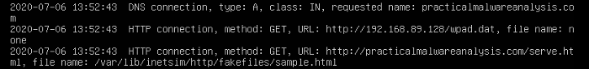
Figure 5.1 — iNetSim logs of Lab03–02.dll’s DNS and HTTP request
We’re able to look at these within Wireshark and inspect the packets in more detail. Filtering on DNS, we’re able to see the DNS request to practicalmalwareanalysis.com (Figure 5.2). Finding the conversation between the host and iNetSim and following the TCP stream, we’re able to see the content within the HTTP GET request to http://practicalmalwareanalysis.com/serve.html (Figure 5.2). This also shows iNetSim’s dummy content replacing serve.hmtl .
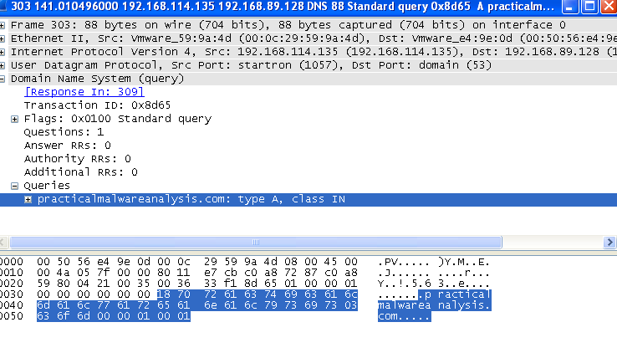
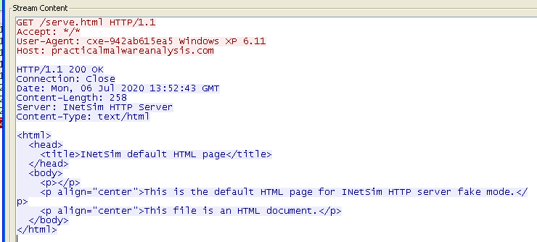
Figure 5.2 — Wireshark traffic for Lab03–02.dll DNS (left) and HTTP (right)
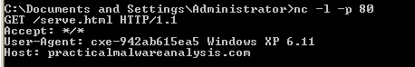
Figure 5.3 — Netcat receiving HTTP GET header
Reverting to snapshot and reinstalling & launching the malicious .dll/service, we can also capture traffic by using ApateDNS to redirect to loopback were we have a Netcat listener on port 80 (Figure 5.3). Here, we see the same HTTP GET header as we did within Wireshark.
Referring back to the strings output, “practicalmalwareanalysis.com”, “serve.html”, and “Windows XP 6.11” are also evident within the network analysis and can be used as signatures for the malware.
To recap on the main host/network-based indicators we see:
- IPRIP installed as a service, including strings such as “Intranet Network Awareness (INA+)”
- Network activity to “practicalmalwareanalysis.com/serve.html” as well as the User-Agent %ComputerName% Windows XP 6.11.
g. Execute the malware found in the file Lab03-03.exe while monitoring it using basic dynamic analysis tools in a safe environment
i- After prepping for dynamic analysis, launch Lab03–03.exe and you may notice it appear briefly within Process Explorer with a child process of svchost.exe. After a moment however, it disappears leaving svchost.exe orphaned (Figure 1.1).
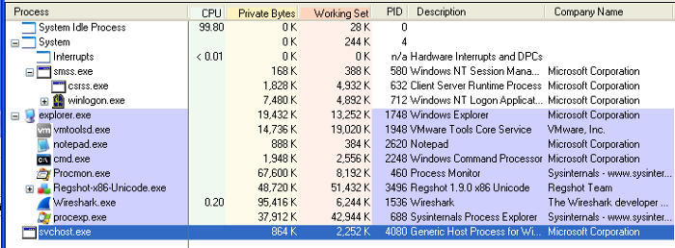
Figure 1.1 — Orphaned svchost.exe
An orphaned process is one with no parent listed in the process tree. svchost.exe typically has a parent process of services.exe, but this one being orphaned is unusual and suspicious.
Investigating this instance of svchost.exe, we see it has a Parent: Lab03-03.exe(904), confirming it’s come from executing Lab03–03.exe. Exploring the properties further, we don’t see much anomalous until we get to the strings.
ii- Utilizing strings within Process Explorer is actually a useful trick to analyse malware which is packed or encrypted, because the malware is running and unpacks/decodes itself when it starts. We’re also able to view strings in both the image on disk and in memory.
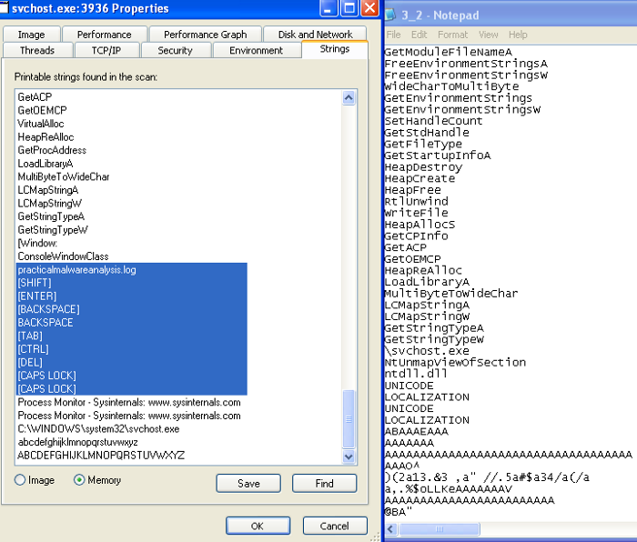
Figure 2.1 — Comparing strings in memory from process explorer and from running strings on Lab03–03.exe
Taking advantage of this, we can inspect the strings in Image and in Memory, as well as compare against what we found from strings during quick static analysis.
The strings on image appear pretty consistent with other instances of svchost.exe however, within Memory, these much greater resemble what we discovered earlier, but with a few distinct differences — practicalmalware.log and a set of keyboard commands (Figure 2.1). This is an indicator that the keylogger guess might be accurate.
iii- To test the keylogger hypothesis, we can open something and type stuff. To target explicitly on the malware, filter on the suspect svchost.exe (PID, 3936) within Process Monitor, and we see a whole load of file manipulation for practicalmalwareanalysis.log (Figure 3.1).
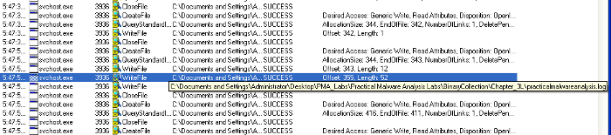
Figure 3.1 — Process Monitor file manipulation from malicious svchost.exe
iv- Opening practicalmalwareanalysis.log, we find that the file captures inputted strings and distinctive keyboard commands as seen within the memory strings from Process Explorer (Figure 4.1). This confirms that Lab03–03.exe a keylogger using process replacement on svchost.exe.
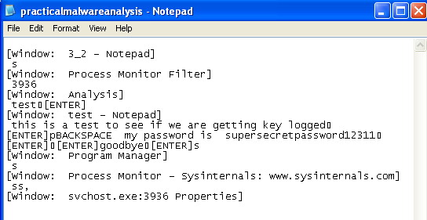
Figure 4.1 — Evidence of Lab03–03.exe keylogging
h. Analyze the malware found in the file Lab03-04.exe using basic dynamic analysis tools.
i-What happens when you run this file?
When we run the file. Process is created which opens up the CMD and then deleted the original executable after making it execute and hide itself somewhere else.
ii-What is causing the roadblock in dynamic analysis?
The executable is evasive and trying to evade itself by checking whether the system is VM or not. AV-Detection etc. Obviously this will make it difficult to observer the file via dynamic analysis.
iii- Are there other ways to run this program?
The other ways can be to open this executable using Ollydbg or IDA pro where we can analyze it in a more efficient way.

