6 | a. Analyze the malware found in the file Lab12-01.exe and Lab12-01.dll. Make sure that these files are in the same directory when performing the analysis
 | i. What happens when you run the malware executable?
 | ii. What process is being injected?
 | iii. How can you make the malware stop the pop-ups?
 | iv. How does this malware operate?
 | b. Analyze the malware found in the file Lab12-02.exe.
 | i. What is the purpose of this program?
 | ii. How does the launcher program hide execution?
 | iii. Where is the malicious payload stored?
 | iv. How is the malicious payload protected?
 | v. How are strings protected?
 | c. Analyze the malware extracted during the analysis of Lab 12-2, or use the file Lab12-03.exe.
 | i. What is the purpose of this malicious payload?
 | ii. How does the malicious payload inject itself?
 | iii. What filesystem residue does this program create?
 | d. Analyze the malware found in the file Lab12-04.exe.
 | i. What does the code at 0x401000 accomplish?
 | ii. Which process has code injected?
 | iii. What DLL is loaded using LoadLibraryA?
 | iv. What is the fourth argument passed to the CreateRemoteThread call?
 | v. What malware is dropped by the main executable?

Practical No. 6
a. Analyze the malware found in the file Lab12-01.exe and Lab12-01.dll. Make sure that these files are in the same directory when performing the analysis.
i. What happens when you run the malware executable?
A Message box with a incremental number in its title pops up every now and then…
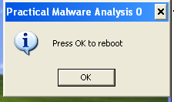
ii. What process is being injected?
In the imports table, CreateRemoteThread is used by the exe which highly suggests that the malware might be injecting DLL into processes.
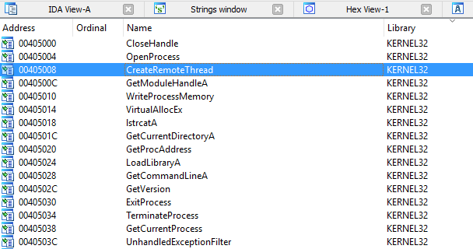Figure 2. CreateRemoteThread in imports
“explorer.exe” is found in the list of string. X-ref the string and we will come to the following subroutine. Seems like explorer.exe is being targeted to be injected with the malicious dll.
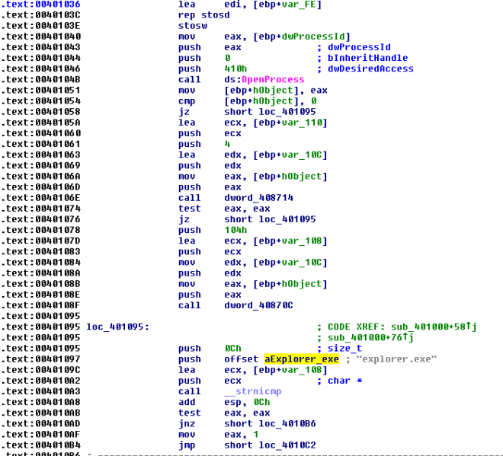Figure 3. explorer.exe
We can confirm our suspicion using process explorer as shown below.
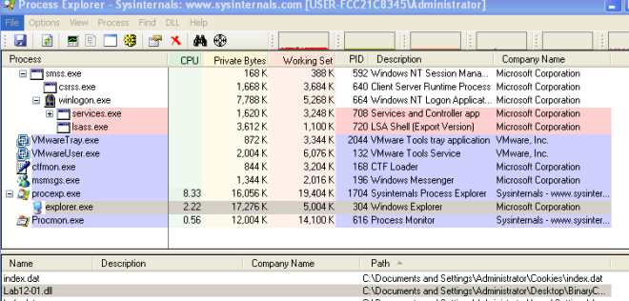Figure 4. Explorer.exe injected with dll
iii. How can you make the malware stop the pop-ups?
Kill explorer.exe and re-run it again
iv. How does this malware operate?
Lab12-01.exe
The malware begins by using psapi.dll’s EnumProcesses to loop through all running processes. Also note that it attempts to form the absolute path for the malicious dll. This will be used later to inject the dll in remote processes.
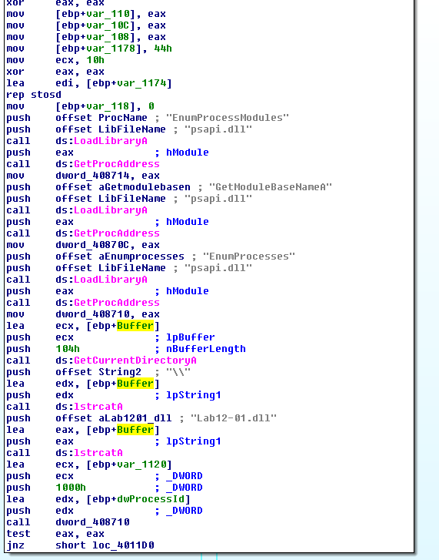
Figure 5. EnumPorcesses
While looping through the processes only “explorer.exe” will be injected. The following figure shows the filtering taking place.
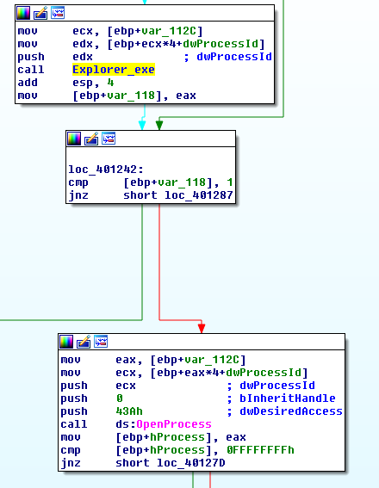
Figure 6. Check for explorer.exe
Once the malware located the “explorer.exe” process, it will ask the remote process (explorer.exe) to allocate a heap space. The space will contains the malicious dll’s absolute path as mentioned earlier. It will then get the LoadLibraryA address of explorer.exe and triggers the function via CreateRemoteThread. Explorer.exe will then invoke LoadLibraryA with the input as the malicious dll’s absolute path which is already in its heap memory and that is how explorer.exe got injected. =)
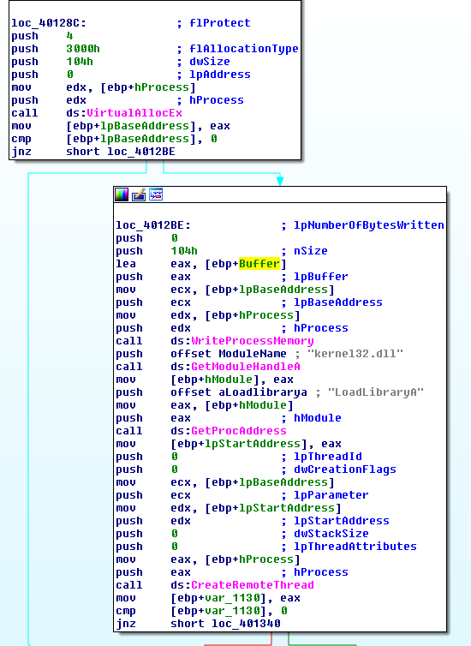
Figure 7. Injecting
Lab12-01.dll
The DllMain first creates a thread @ subroutine 0x1001030.
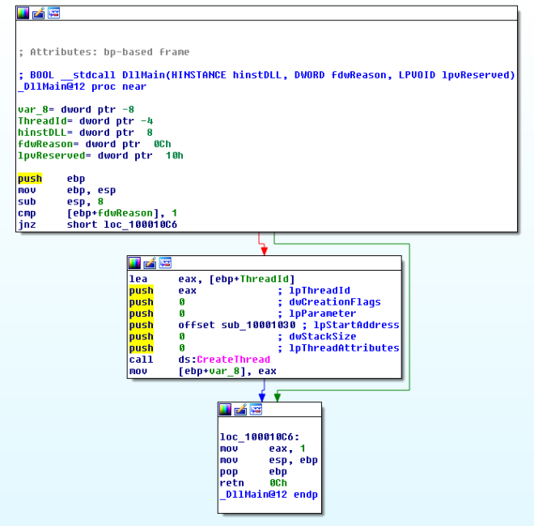Figure 8. Create Thread
Inside this subroutine, we will find a infinite loop popping a message box every 1 minute. The title of the message box is “Practical Malware Analysis %d” where %d is the value of the loop counter.

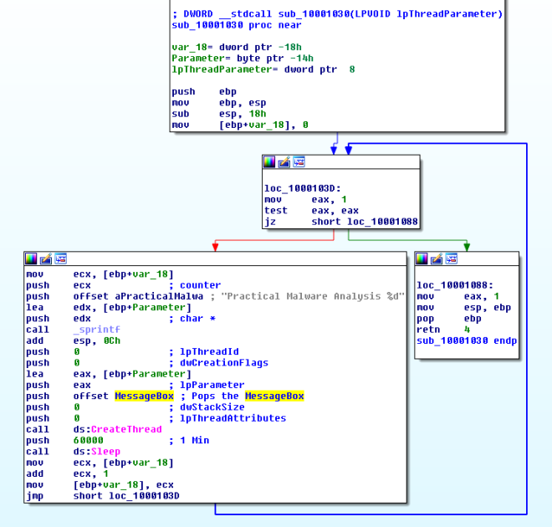Figure 9. Popping MsgBox every minute

b. Analyze the malware found in the file Lab12-02.exe.
b. What is the purpose of this program?
Based on dynamic analysis results using procmon and process explorer, we can conclude that this is a keylogger that performs process hollowing on svchost.exe.
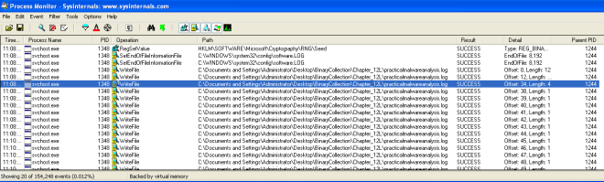Figure 1. Write file to practicalmalwareanalysis.log 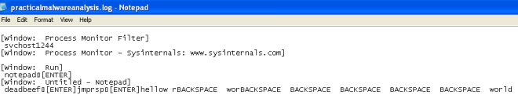Figure 2. Keystrokes in log file
ii. How does the launcher program hide execution?
The subroutine @0x004010EA is highly suspicious. It is trying to create a process in suspended state, calls UnmapViewOfSection to unmap the original code and tries to write process memory in it. Finally it resumes the process. This is a recipe for process hollowing technique in which the running process will look like svchost.exe (in this case) but it is actually running something else instead.
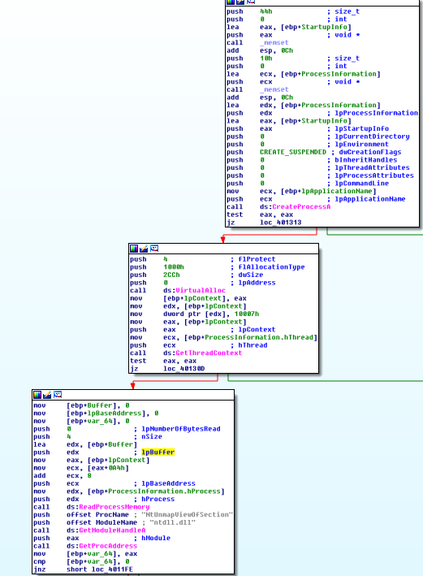
Figure 3. Create Suspended process, unmap memory
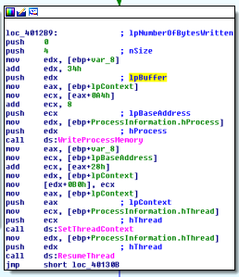
Figure 4. WriteProcessMemory, ResumeThread
iii. Where is the malicious payload stored?
In the resource, we can see a suspicious looking payload. IDA Pro further confirmed that this is the payload that will be extracted out.
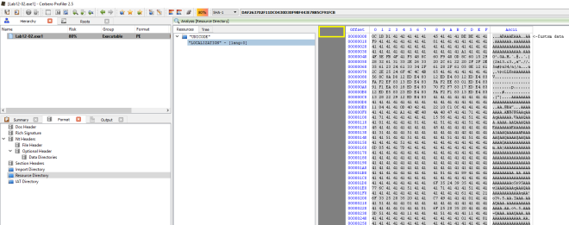

Figure 5. Resource with lots of As in it
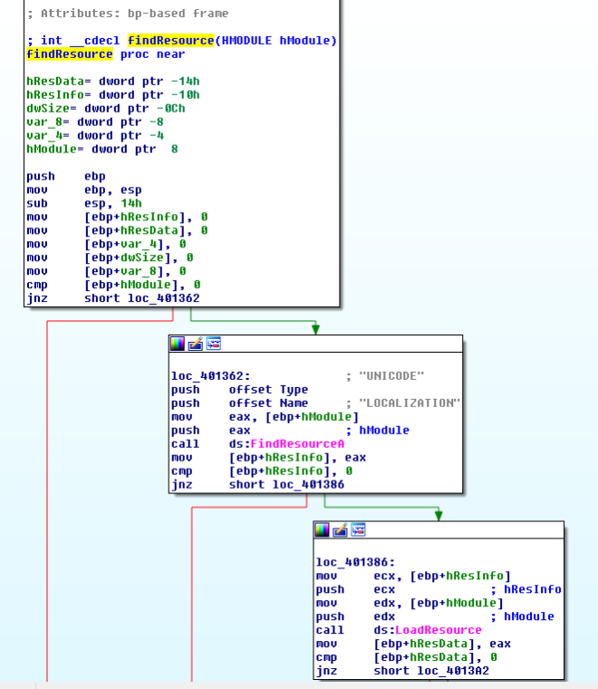
iv. How is the malicious payload protected?
By analyzing the find resource function @0x0040132C we will come across the following codes that suggests to us that the payload is XOR by “A”.
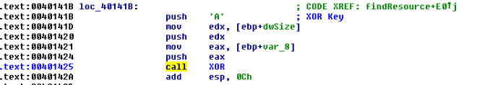Figure 7. XOR by A
v. How are strings protected?
The strings are in plain… correct me if i am wrong
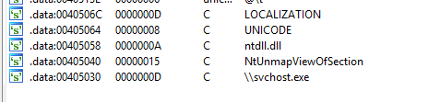
Figure 8. Strings in plain
c. Analyze the malware extracted during the analysis of Lab 12-2, or use the file Lab12-03.exe
i. What is the purpose of this malicious payload?
The use of SetWindowsHookExA with WH_KEYBOARD_LL as the id which suggests that this is a keylogger.
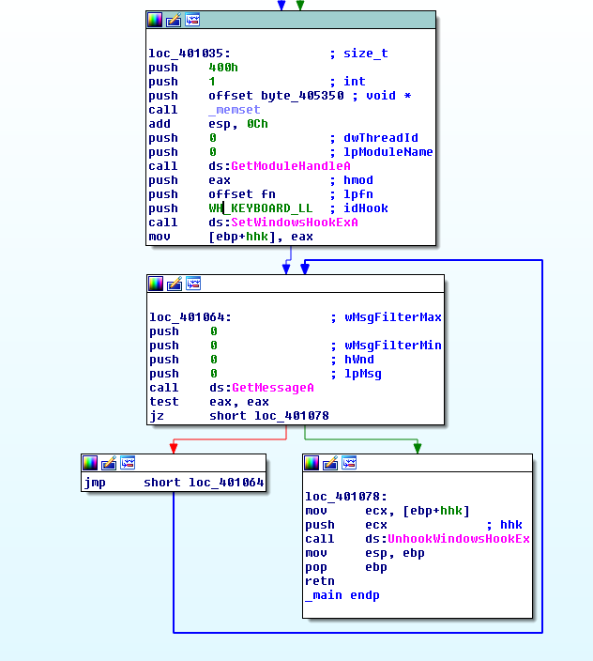
Figure 1. SetWindowsHookExA
ii. How does the malicious payload inject itself?
It uses Hook injection. Keystrokes can be captured by registering high- or low-level hooks using the WH_KEYBOARD or WH_KEYBOARD_LL hook procedure types, respectively. For WH_KEYBOARD_LL procedures, the events are sent directly to the process that installed the hook, so the hook will be running in the context of the process that created it. The malware can intercept keystrokes and log them to a file as seen in the figure below.
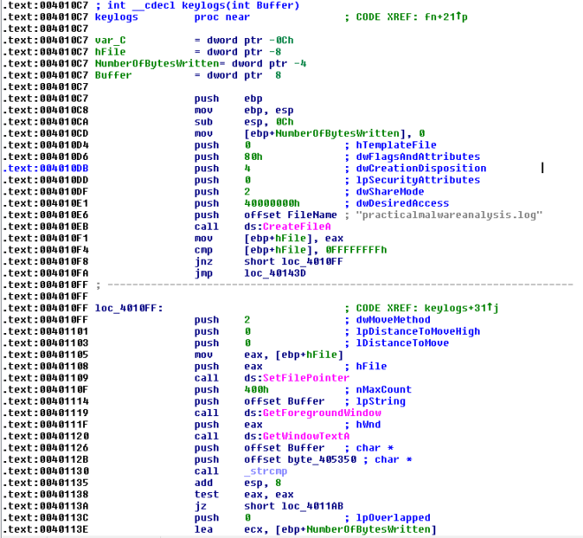Figure 2. Log to practicalmalwareanalsysis.log
iii. What filesystem residue does this program create?
The malware will leave behind a log file containing the keylogs; practicalmalwareanalsysis.log.
d. Analyze the malware found in the file Lab12-04.exe.
i. What does the code at 0x401000 accomplish?
The subroutine check if the process with the given process id is Winlogon.exe. If it is, it returns 1 else it returns 0.
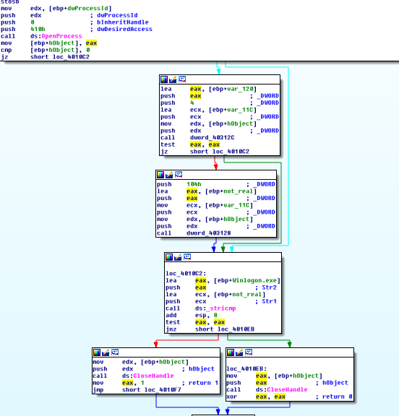
ii. Which process has code injected?
Winlogon.exe is being targeted for injection. Subroutine @0x00401174 is responsible for process injection via CreateRemoteThread. If we trace back, we can see that only winlogon’s pid is being passed to the subroutine.
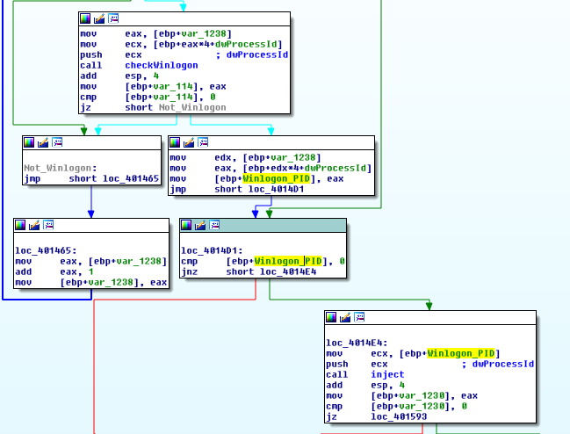Figure 2. Winlogon Pid being pushed as argument to inject subroutine
iii. What DLL is loaded using LoadLibraryA?
sfc_os.dll
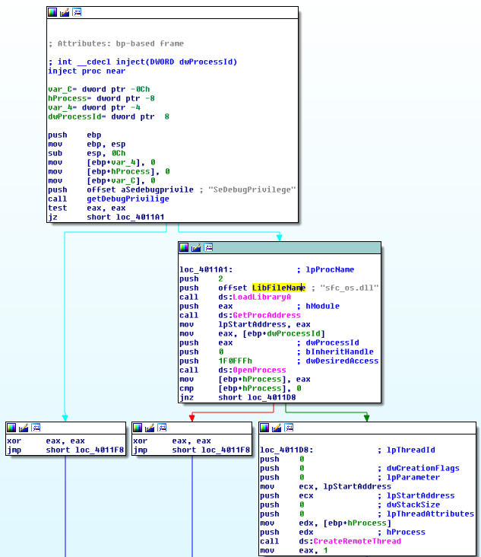
Figure 3. sfc_os.dll
iv. What is the fourth argument passed to the CreateRemoteThread call?
Based on figure 3, the fourth argument is lpStartAddress in which if we were to trace up we will uncover that lpStartAddress is the address return by GetProcAddress(LoadLibraryA(“sfc_os.dll”),2).
Loading sfc_os.dll in ida pro we can see the exports that points to ordinal 2 which resovles to SfcTerminateWatcherThread() as shown in figure 5..
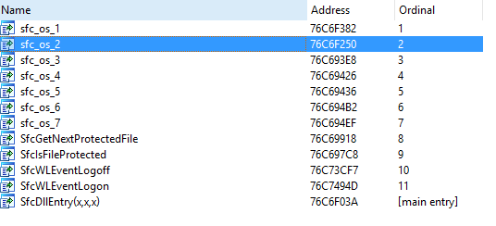
Figure 4. sfc_os.dll’s ordinal 2
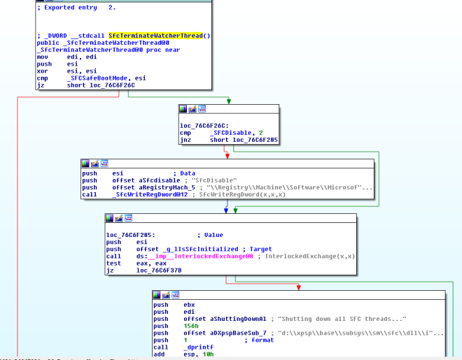Figure 5. SfcTerminateWatcherThread()
v. What malware is dropped by the main executable?
Analyzing the main method, we can see file movement from “C:\WINDOWS\system32\wupdmgr.exe” to a temp folder “C:\DOCUME~1\ADMINI~1\LOCALS~1\Temp\\winup.exe”
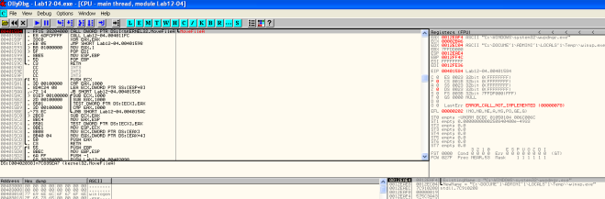Figure 6. Backing up wupdmgr.exe
The following subroutine is then called to extract the resource out from the executable and using it to replace “C:\WINDOWS\system32\wupdmgr.exe”
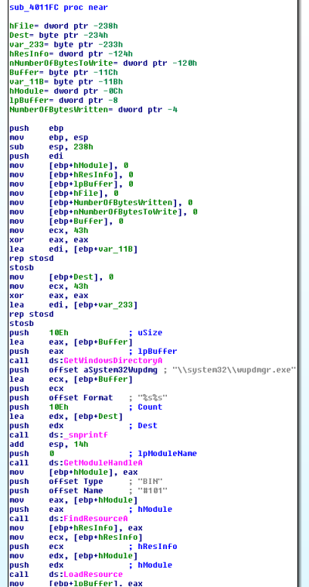
Figure 7. dropping form resource to system32\\wupdmgr.exe
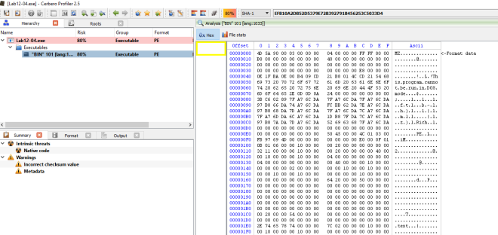Figure 8. Bin 101 in the resource section
vi. What is the purpose of this and the dropped malware?
Apparently in order for SfcTerminateWatcherThread() to work, the caller must be from winlogon.exe. That explains why the malware goes through the trouble in looping through all running threads to locate winlogon.exe and it even attempts to get higher privileges by using AdjustTokenPrivileges to change token privilege to seDebugPrivilige. With the higher privilege, the malware then calls CreateRemoteThread to ask Winlogon to invoke SfcTerminateWatcherThread(). With that, file protection mechanism will be disabled and the malware can freely change the system protected files until the next reboot.
The dropped malware in “C:\\windows\\system32\\wupdmgr.exe” executes the original wupdmgr.exe (which is now in the temp folder) and it attempts to download new malware from “http://www.practicalmalwareanalysis.com/updater.exe” and save it as “C:\\windows\\system32\\wupdmgr.exe”
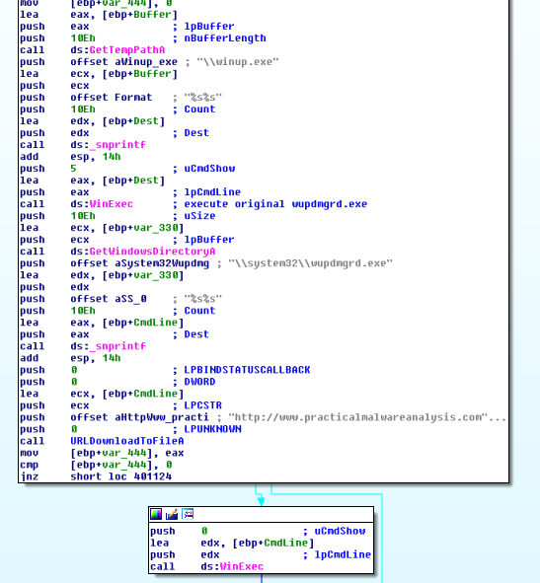
Figure 9. URLDownloadToFileA

