1. Connect to AWS CLI:

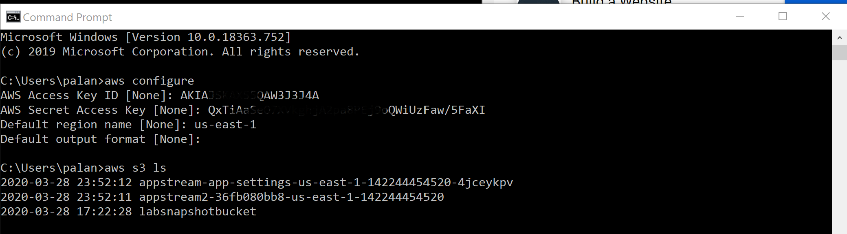

1. Create User in User Pool:

aws appstream create-user --user-name ankitaawsgrad@gmail.com --authentication-type USERPOOL



1. C:\Users\palan>aws appstream describe-image-builders

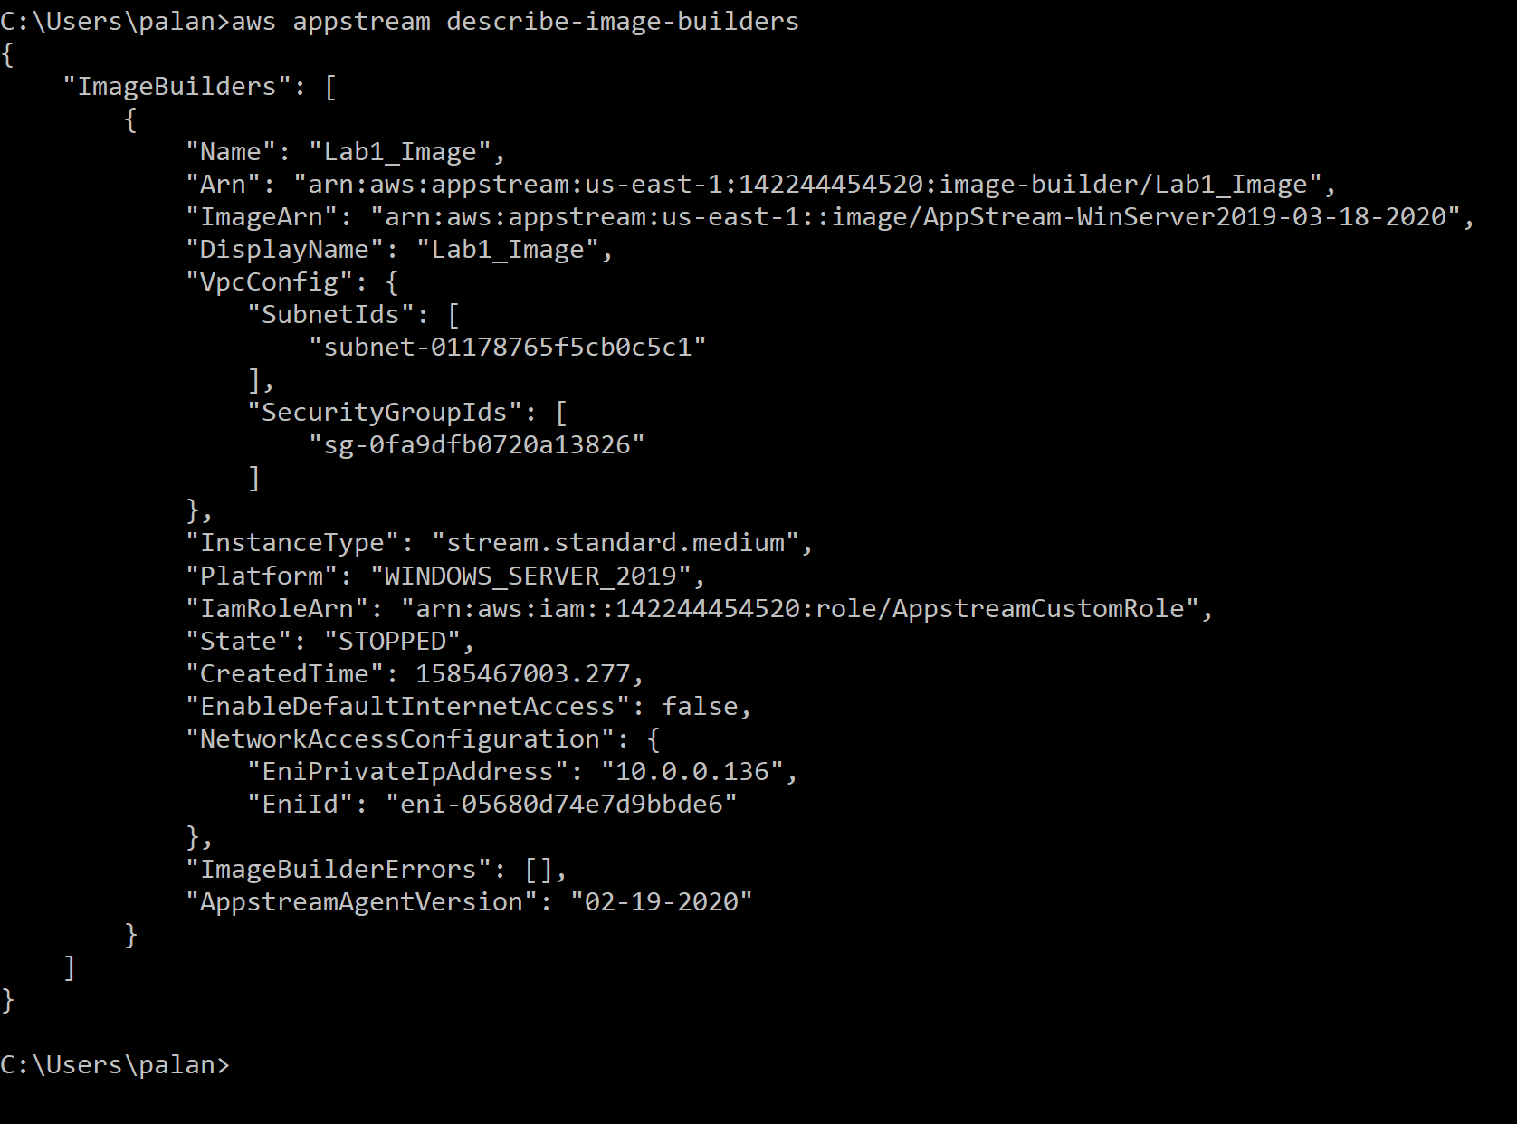

1. Select image builder with below config from AWS Console:

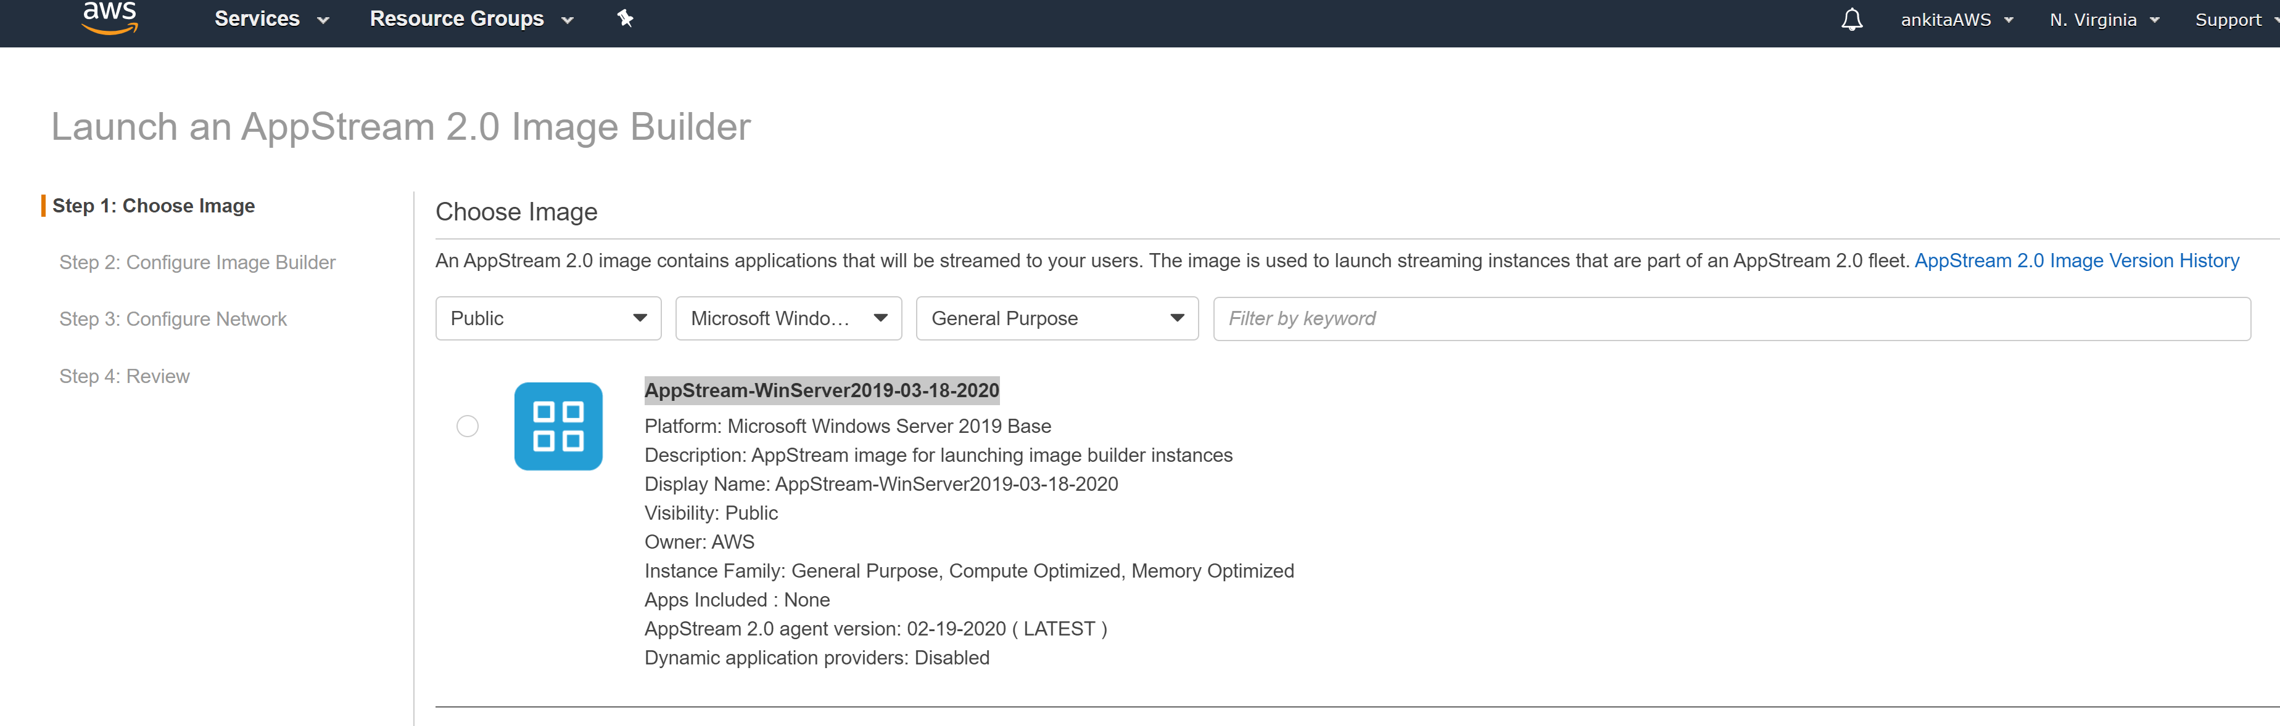

1. aws appstream create-image-builder --name GENERALCLOUDIMAGEv0 --image-name AppStream-WinServer2019-03-18-2020 --instance-type stream.standard.medium --vpc-config SubnetIds=subnet-01178765f5cb0c5c1,SecurityGroupIds=sg-0fa9dfb0720a13826 --enable-default-internet-access

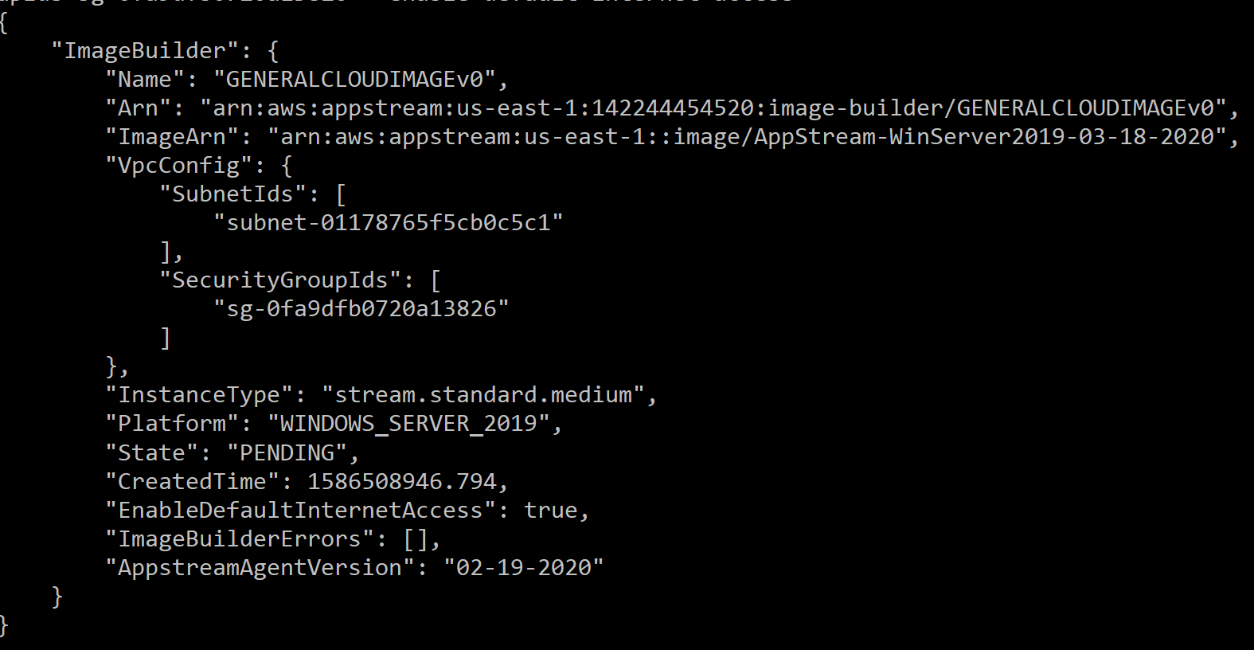

1. 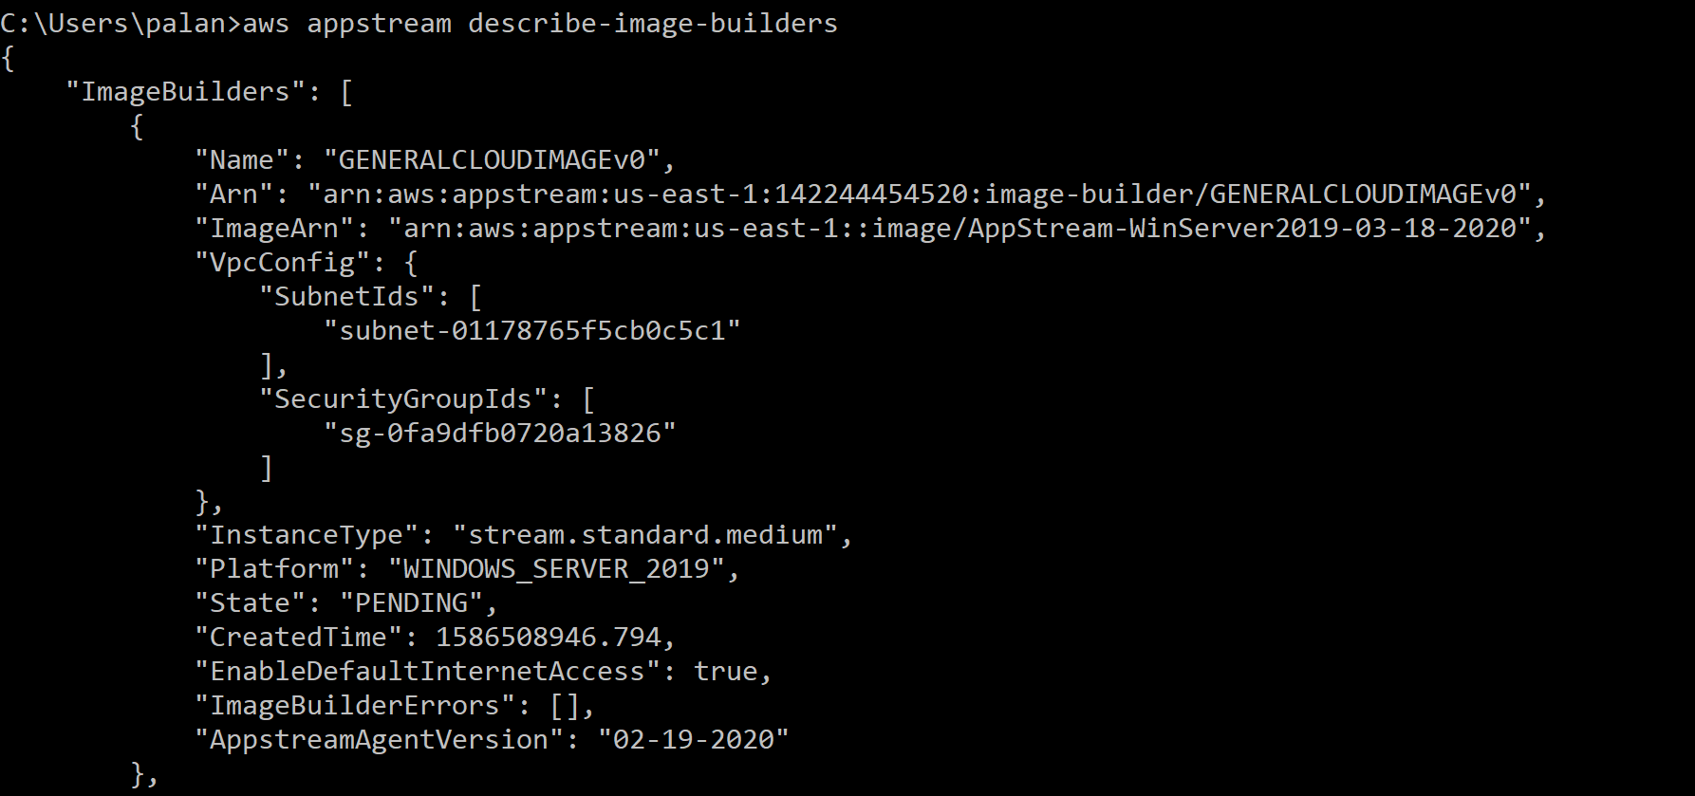

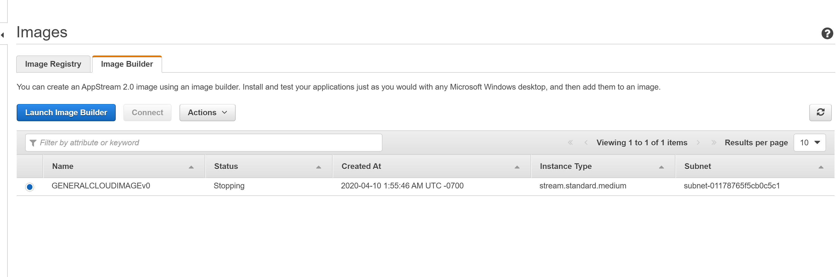

1. Schedule based scaling for fleet:

# Register the fleet as the scaling target with the application autoscaling service

$>aws application-autoscaling register-scalable-target --service-namespace appstream --resource-id fleet/samplefleet --scalable-dimension appstream:fleet:DesiredCapacity

# Scheduled actions

$>aws application-autoscaling put-scheduled-action --service-namespace appstream --resource-id fleet/samplefleet --scheduled-action-name Policy1 --schedule="cron(0 0 8 ? * MON-FRI *)" --scalable-target-action MinCapacity=50,MaxCapacity=100 --scalable-dimension appstream:fleet:DesiredCapacity

$>aws application-autoscaling put-scheduled-action --service-namespace appstream --resource-id fleet/samplefleet --scheduled-action-name Policy2 --schedule="cron(0 0 21 ? * MON-FRI *)" --scalable-target-action MinCapacity=25,MaxCapacity=50 --scalable-dimension appstream:fleet:DesiredCapacity

$>aws application-autoscaling put-scheduled-action --service-namespace appstream --resource-id fleet/samplefleet --scheduled-action-name Policy3 --schedule="cron(0 0 0 ? * MON-FRI *)" --scalable-target-action MinCapacity=10,MaxCapacity=25 --scalable-dimension appstream:fleet:DesiredCapacity

$>aws application-autoscaling put-scheduled-action --service-namespace appstream --resource-id fleet/samplefleet --scheduled-action-name Policy4 --schedule="cron(0 0 0 ? * SAT-SUN *)" --scalable-target-action MinCapacity=10,MaxCapacity=25 --scalable-dimension appstream:fleet:DesiredCapacity

