SalesPrediction

Ankita Patidar

12/1/2019

##install below packages if not already  
##install.packages("cowplot")  
##install.packages("caret")  
##install.packages("dplyr")  
#install.packages("data.table")  
#install.packages("ggplot2")

library(data.table)

## Warning: package 'data.table' was built under R version 3.6.2

#used for reading and manipulation  
library(ggplot2)

## Warning: package 'ggplot2' was built under R version 3.6.2

#used for plotting  
library(corrplot)

## Warning: package 'corrplot' was built under R version 3.6.2

## corrplot 0.84 loaded

#used for correlation plotting  
library(dplyr)

## Warning: package 'dplyr' was built under R version 3.6.2

##   
## Attaching package: 'dplyr'

## The following objects are masked from 'package:data.table':  
##   
## between, first, last

## The following objects are masked from 'package:stats':  
##   
## filter, lag

## The following objects are masked from 'package:base':  
##   
## intersect, setdiff, setequal, union

#used for manipulation and joining  
library(cowplot)

## Warning: package 'cowplot' was built under R version 3.6.2

##   
## ********************************************************

## Note: As of version 1.0.0, cowplot does not change the

## default ggplot2 theme anymore. To recover the previous

## behavior, execute:  
## theme_set(theme_cowplot())

## ********************************************************

# used for combining multiple plots  
library(caret)

## Warning: package 'caret' was built under R version 3.6.2

## Loading required package: lattice

# used for modeling

## pre-processing

#read the data  
  
train = fread("BigMart_Train.csv")  
test = fread("BigMart_Test.csv")  
submission = fread("big_Mart_Submission.csv", skip = 1)

#check the no. of columns and rows in train and test data  
dim(train)

## [1] 8523 12

dim(test)

## [1] 5681 11

#features of train and test data  
names(train)

## [1] "Item_Identifier" "Item_Weight"   
## [3] "Item_Fat_Content" "Item_Visibility"   
## [5] "Item_Type" "Item_MRP"   
## [7] "Outlet_Identifier" "Outlet_Establishment_Year"  
## [9] "Outlet_Size" "Outlet_Location_Type"   
## [11] "Outlet_Type" "Item_Outlet_Sales"

names(test)

## [1] "Item_Identifier" "Item_Weight"   
## [3] "Item_Fat_Content" "Item_Visibility"   
## [5] "Item_Type" "Item_MRP"   
## [7] "Outlet_Identifier" "Outlet_Establishment_Year"  
## [9] "Outlet_Size" "Outlet_Location_Type"   
## [11] "Outlet_Type"

Train dataset has 8523 rows and 12 features and test has 5681 rows and 11 columns. train has 1 extra column which is the target variable.

#brief summary of the features of train and test data  
str(train)

## Classes 'data.table' and 'data.frame': 8523 obs. of 12 variables:  
## $ Item_Identifier : chr "FDA15" "DRC01" "FDN15" "FDX07" ...  
## $ Item_Weight : num 9.3 5.92 17.5 19.2 8.93 ...  
## $ Item_Fat_Content : chr "Low Fat" "Regular" "Low Fat" "Regular" ...  
## $ Item_Visibility : num 0.016 0.0193 0.0168 0 0 ...  
## $ Item_Type : chr "Dairy" "Soft Drinks" "Meat" "Fruits and Vegetables" ...  
## $ Item_MRP : num 249.8 48.3 141.6 182.1 53.9 ...  
## $ Outlet_Identifier : chr "OUT049" "OUT018" "OUT049" "OUT010" ...  
## $ Outlet_Establishment_Year: int 1999 2009 1999 1998 1987 2009 1987 1985 2002 2007 ...  
## $ Outlet_Size : chr "Medium" "Medium" "Medium" "" ...  
## $ Outlet_Location_Type : chr "Tier 1" "Tier 3" "Tier 1" "Tier 3" ...  
## $ Outlet_Type : chr "Supermarket Type1" "Supermarket Type2" "Supermarket Type1" "Grocery Store" ...  
## $ Item_Outlet_Sales : num 3735 443 2097 732 995 ...  
## - attr(*, ".internal.selfref")=<externalptr>

str(test)

## Classes 'data.table' and 'data.frame': 5681 obs. of 11 variables:  
## $ Item_Identifier : chr "FDW58" "FDW14" "NCN55" "FDQ58" ...  
## $ Item_Weight : num 20.75 8.3 14.6 7.32 NA ...  
## $ Item_Fat_Content : chr "Low Fat" "reg" "Low Fat" "Low Fat" ...  
## $ Item_Visibility : num 0.00756 0.03843 0.09957 0.01539 0.1186 ...  
## $ Item_Type : chr "Snack Foods" "Dairy" "Others" "Snack Foods" ...  
## $ Item_MRP : num 107.9 87.3 241.8 155 234.2 ...  
## $ Outlet_Identifier : chr "OUT049" "OUT017" "OUT010" "OUT017" ...  
## $ Outlet_Establishment_Year: int 1999 2007 1998 2007 1985 1997 2009 1985 2002 2007 ...  
## $ Outlet_Size : chr "Medium" "" "" "" ...  
## $ Outlet_Location_Type : chr "Tier 1" "Tier 2" "Tier 3" "Tier 2" ...  
## $ Outlet_Type : chr "Supermarket Type1" "Supermarket Type1" "Grocery Store" "Supermarket Type1" ...  
## - attr(*, ".internal.selfref")=<externalptr>

#combine train and test to perform modifcation on the data  
test[,"Item_Outlet_Sales" := NA]  
combi = rbind(train,test)  
dim(combi)

## [1] 14204 12

str(combi)

## Classes 'data.table' and 'data.frame': 14204 obs. of 12 variables:  
## $ Item_Identifier : chr "FDA15" "DRC01" "FDN15" "FDX07" ...  
## $ Item_Weight : num 9.3 5.92 17.5 19.2 8.93 ...  
## $ Item_Fat_Content : chr "Low Fat" "Regular" "Low Fat" "Regular" ...  
## $ Item_Visibility : num 0.016 0.0193 0.0168 0 0 ...  
## $ Item_Type : chr "Dairy" "Soft Drinks" "Meat" "Fruits and Vegetables" ...  
## $ Item_MRP : num 249.8 48.3 141.6 182.1 53.9 ...  
## $ Outlet_Identifier : chr "OUT049" "OUT018" "OUT049" "OUT010" ...  
## $ Outlet_Establishment_Year: int 1999 2009 1999 1998 1987 2009 1987 1985 2002 2007 ...  
## $ Outlet_Size : chr "Medium" "Medium" "Medium" "" ...  
## $ Outlet_Location_Type : chr "Tier 1" "Tier 3" "Tier 1" "Tier 3" ...  
## $ Outlet_Type : chr "Supermarket Type1" "Supermarket Type2" "Supermarket Type1" "Grocery Store" ...  
## $ Item_Outlet_Sales : num 3735 443 2097 732 995 ...  
## - attr(*, ".internal.selfref")=<externalptr>

## Item_MRP, Item_Visibility, Item_Outlet_Sales,Item_Weight is continous variables

Visualize the continuous variables using histograms and categorical variables using bar plots.

#Plot target variable "Item_Outlet_Sales"  
  
ggplot(data = train) + geom_histogram(aes(train$Item_Outlet_Sales), binwidth = 100, fill = "darkgreen") + xlab("Item_Outlet_Sales")

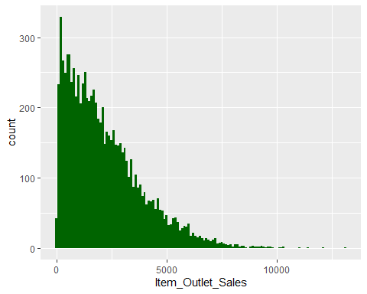

# Target variable is right skewed  
  
#Check the distribution of other numeric independent variable  
p1 = ggplot(combi) + geom_histogram(aes(combi$Item_Weight), binwidth = 0.5, fill = "blue") + xlab("Item_Weight")  
#No clear pattern in Item_Weight  
  
p2 = ggplot(combi) + geom_histogram(aes(combi$Item_MRP), binwidth = 1, fill = "blue") + xlab("Item_MRP")  
#4 different distributions for Item_MRP  
p3 = ggplot(combi) + geom_histogram(aes(combi$Item_Visibility), binwidth = 0.005, fill = "blue") + xlab("Item_Visiblity")  
#Item_Visibility is right-skewed  
  
#plot_grid is used to combine plots  
plot_grid(p1, p2,p3, nrow = 1)

## Warning: Removed 2439 rows containing non-finite values (stat_bin).

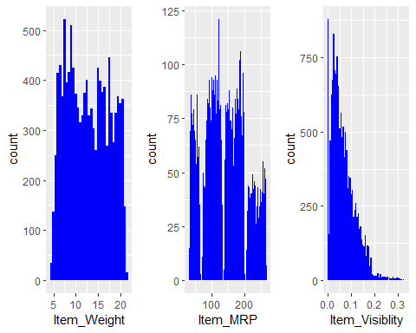 ##Outlet_Location_Type,Outlet_Type, Outlet_Identifier,Item_Type,Item_Identifier,Item_Fat_Content,Outlet_Size,

#Plot for independent categorical variables  
  
## Item_Fat_Content  
ggplot(combi) + geom_bar(aes(combi$Item_Fat_Content), fill = "coral") + xlab("Item_Fat_Content")

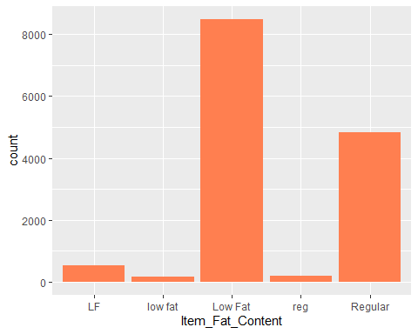

#Combining LF, low fat, Low Fat into one Low Fat  
combi$Item_Fat_Content[combi$Item_Fat_Content == "LF"] = "Low Fat"  
combi$Item_Fat_Content[combi$Item_Fat_Content == "low fat"] = "Low Fat"  
#combining reg and Regular into one Regular  
combi$Item_Fat_Content[combi$Item_Fat_Content == "reg"] = "Regular"  
ggplot(combi) + geom_bar(aes(combi$Item_Fat_Content), fill = "coral") + xlab("Item_Fat_Content")

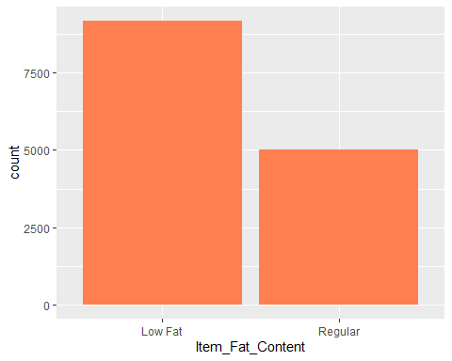

p4 = ggplot(combi %>% group_by(Item_Type) %>% summarise(Count =n())) + geom_bar(aes(Item_Type, Count), stat = "identity", fill = "coral") + xlab("") + geom_label(aes(Item_Type, Count, label = Count), vjust = 0.5) + theme(axis.text.x = element_text(angle= 45, hjust = 1)) + ggtitle("Item_Type")  
  
  
p5 = ggplot(combi %>% group_by(Item_Identifier) %>% summarise(Count =n())) + geom_bar(aes(Item_Identifier, Count), stat = "identity", fill = "coral") + xlab("") + geom_label(aes(Item_Identifier, Count, label = Count), vjust = 0.5) + theme(axis.text.x = element_text(angle= 45, hjust = 1)) + ggtitle("Item_Identifier")  
  
  
p6 = ggplot(combi %>% group_by(Outlet_Size) %>% summarise(Count =n())) + geom_bar(aes(Outlet_Size, Count), stat = "identity", fill = "coral") + xlab("") + geom_label(aes(Outlet_Size, Count, label = Count), vjust = 0.5) + theme(axis.text.x = element_text(angle= 45, hjust = 1)) + ggtitle("Outlet_Size")  
p6

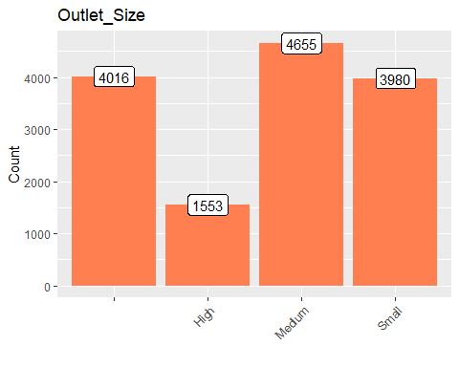

p7 = ggplot(combi %>% group_by(Outlet_Identifier) %>% summarise(Count =n())) + geom_bar(aes(Outlet_Identifier, Count), stat = "identity", fill = "coral") + xlab("") + geom_label(aes(Outlet_Identifier, Count, label = Count), vjust = 0.5) + theme(axis.text.x = element_text(angle= 45, hjust = 1)) + ggtitle("Outlet_Identifier")  
  
second_row = plot_grid( p6, p7, nrow = 1)  
  
plot_grid(p4, second_row, ncol = 1)

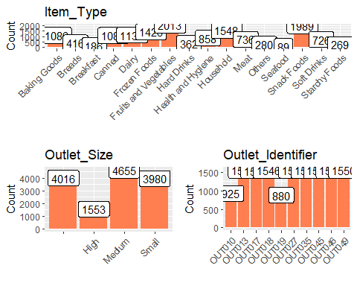

p8 = ggplot(combi %>% group_by(Outlet_Establishment_Year) %>% summarise(Count = n())) + geom_bar(aes(factor(Outlet_Establishment_Year), Count), stat = "identity", fill = "coral1") + geom_label(aes(factor(Outlet_Establishment_Year), Count, label = Count), vjust = 0.5) + xlab("Outlet_Establishment_Year") + theme(axis.text.x = element_text(size = 8.5))  
#1998 has lesser number of observation  
  
  
p9 = ggplot(combi %>% group_by(Outlet_Type) %>% summarise(Count = n())) + geom_bar(aes(Outlet_Type, Count), stat = "identity", fill = "coral1") + geom_label(aes(factor(Outlet_Type), Count, label = Count), vjust = 0.5) + theme(axis.text.x = element_text(size = 8.5))  
#Supermarket Type 1 seems to be most popular  
  
plot_grid(p8, p9, ncol = 2)

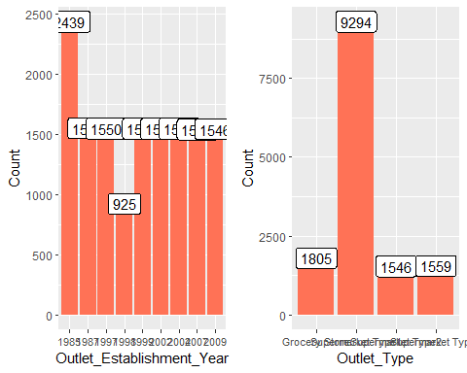

#bi-variate analysis - explore the independent variables with respect to the target variable.  
#use of scatter plots for the continuous or numeric variables and violin plots for the categorical variables.  
# extracting train data from the combined data'  
  
train = combi[1:nrow(train)]  
  
# Item_Weight vs Item_Outlet_Sales  
  
p10 = ggplot(train) + geom_point(aes(Item_Weight, Item_Outlet_Sales), colour = "red", alpha = 0.3) +theme(axis.title = element_text(size=8.5))  
p10

## Warning: Removed 1463 rows containing missing values (geom_point).

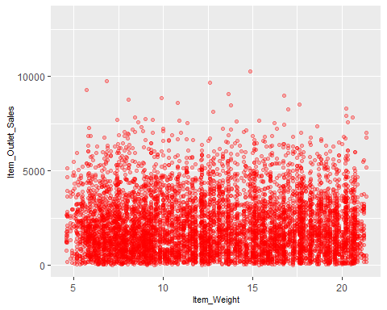

# Item_Visibility vs Item_Outlet_Sales  
  
p11 = ggplot(train) + geom_point(aes(Item_Visibility,Item_Outlet_Sales), colour = "red", alpha = 0.3) + theme(axis.title = element_text(size = 8.5))  
p11

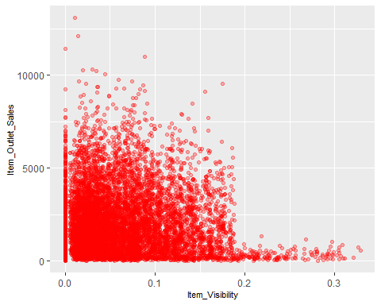

#there is a string of points at Item_Visibility = 0.0 which seems strange as item visibility cannot be completely zero  
  
# Item_MRP vs Item_Outlet_Sales  
  
p12 = ggplot(train) + geom_point(aes(Item_MRP, Item_Outlet_Sales), colour = "violet", alpha = 0.3) + theme(axis.title = element_text(size = 8.5))  
p12

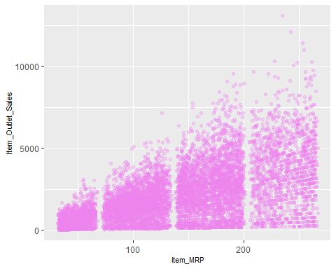

# Item_Type vs Item_Outlet_Sales   
  
p13 = ggplot(train) + geom_violin(aes(Item_Type,Item_Outlet_Sales), fill = "Magenta") + theme(axis.text.x = element_text(angle = 45, hjust = 1), axis.text = element_text(size = 6), axis.title = element_text(size = 8.5))  
p13

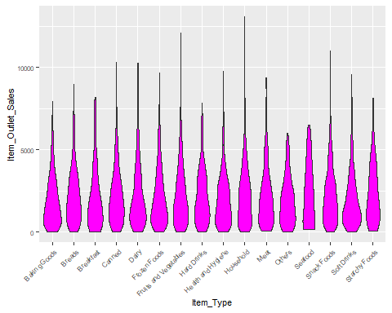

# Item_Fat_Content vs Item_Outlet_Sales  
p14 = ggplot(train) + geom_violin(aes(Item_Fat_Content, Item_Outlet_Sales), fill = "magenta") + theme(axis.text.x = element_text(angle = 45, hjust = 1), axis.text = element_text(size = 8), axis.title = element_text(size = 8.5))  
  
 p14

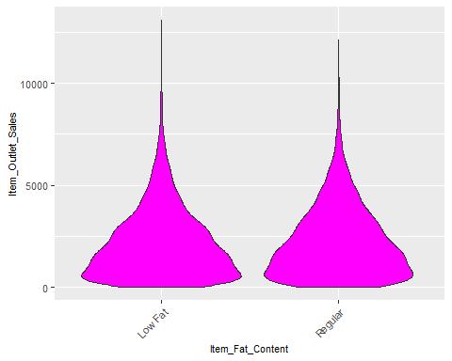

# Outlet_Identifier vs Item_Outlet_Sales  
  
p15= ggplot(train) + geom_violin(aes(Outlet_Identifier, Item_Outlet_Sales), fill = "magenta") + theme(axis.text.x = element_text(angle = 45, hjust = 1), axis.text = element_text(size = 8), axis.title = element_text(size = 8.5))  
  
p15

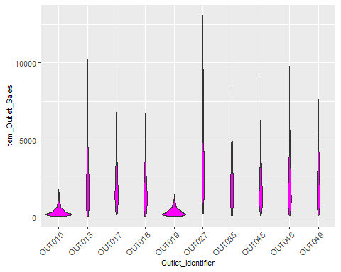

p16 = ggplot(train) + geom_violin(aes(Outlet_Size, Item_Outlet_Sales), fill = "magenta")  
  
p16

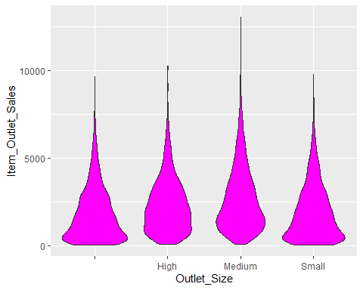

#The distribution of ‘Small’ Outlet_Size is almost identical to the distribution of the blank category (first vioin) of Outlet_Size. So, we can substitute the blanks in Outlet_Size with ‘Small’.

p17 = ggplot(train) + geom_violin(aes(Outlet_Location_Type, Item_Outlet_Sales), fill = "blue")  
#Tier 1 and Tier 3 locations of Outlet_Location_Type look similar.  
p18 = ggplot(train) + geom_violin(aes(Outlet_Type, Item_Outlet_Sales), fill = "blue")  
#Grocery Store has most of its data points around the lower sales  
  
p17

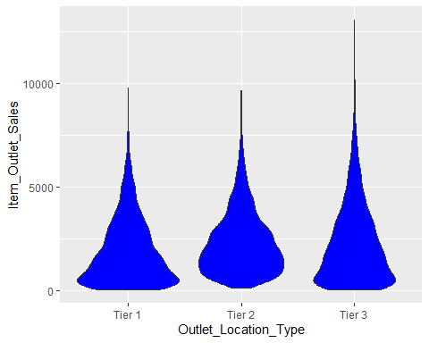

p18

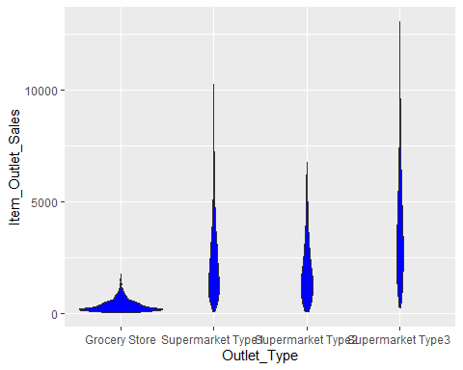

#finding missing values in variables  
sum(is.na(combi$Item_Weight))

## [1] 2439

#2439 missing values in Item_Weight  
sum(is.na(combi$Item_Fat_Content))

## [1] 0

sum(is.na(combi$Item_Identifier))

## [1] 0

sum(is.na(combi$Item_Visibility))

## [1] 0

sum(is.na(combi$Item_Type))

## [1] 0

sum(is.na(combi$Item_MRP))

## [1] 0

sum(is.na(combi$Outlet_Identifier))

## [1] 0

sum(is.na(combi$Outlet_Establishment_Year))

## [1] 0

sum(is.na(combi$Outlet_Size))

## [1] 0

sum(is.na(combi$Outlet_Location_Type))

## [1] 0

sum(is.na(combi$Outlet_Type))

## [1] 0

sum(is.na(combi$Item_Outlet_Sales))

## [1] 5681

#5681 missing values in Item_Outlet_Sales

#impute Item_Weight with mean weight based on the Item_Identifier variable  
missing_index = which(is.na(combi$Item_Weight))  
for (i in missing_index){  
 item = combi$Item_Identifier[i]  
 combi$Item_Weight[i] = mean(combi$Item_Weight[combi$Item_Identifier == item], na.rm = T)  
}  
  
sum(is.na(combi$Item_Weight))

## [1] 0

ggplot(combi) + geom_histogram(aes(Item_Visibility), bins =100)

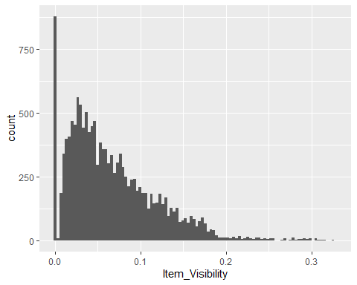

zero_index = which(combi$Item_Visibility == 0)  
#zeroes in Item_Visibility variable can be replaced with Item_Identifier wise mean values of Item_Visibility  
for (i in zero_index){  
 item = combi$Item_Identifier[i]  
 combi$Item_Visibility[i] = mean(combi$Item_Visibility[combi$Item_Identifier==item], na.rm = T)  
}  
  
ggplot(combi) + geom_histogram(aes(Item_Visibility), bins = 100)

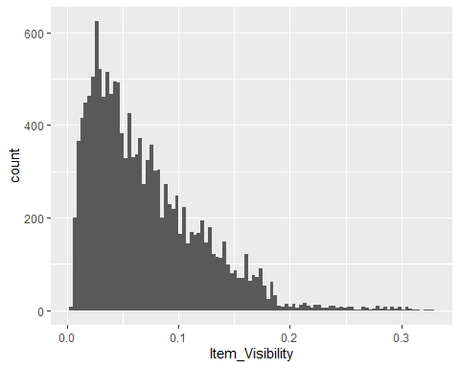

#the issue of zero item visibility has been resolved.

Create new features to help improving the model performance:

Item_Type_new: Broader categories for the variable Item_Type. Item_category: Categorical variable derived from Item_Identifier. Outlet_Years: Years of operation for outlets. price_per_unit_wt: Item_MRP/Item_Weight Item_MRP_clusters: Binned feature for Item_MRP.

#the Item_Type variable can be classified into the categories perishable and non_perishable  
perishable = c("Breads", "Breakfast", "Dairy", "Fruits and Vegetables", "Meat", "Seafood")  
  
non_perishable = c("Baking Goods", "Canned", "Frozen Foods", "Hard Drinks", "Health and Hygiene", "Household", "Soft Drinks")  
  
# create a new feature 'Item_Type_new'   
  
combi[, Item_Type_New := ifelse(Item_Type %in% perishable, "perishable", ifelse(Item_Type %in% non_perishable, "non_perishable", "not sure"))]

#the first 2 characters of Item_Identifier, i.e., ‘DR’, ‘FD’, and ‘NC’ stand for drinks, food, and non-consumable.  
table(combi$Item_Type, substr(combi$Item_Identifier,1,2))

##   
## DR FD NC  
## Baking Goods 0 1086 0  
## Breads 0 416 0  
## Breakfast 0 186 0  
## Canned 0 1084 0  
## Dairy 229 907 0  
## Frozen Foods 0 1426 0  
## Fruits and Vegetables 0 2013 0  
## Hard Drinks 362 0 0  
## Health and Hygiene 0 0 858  
## Household 0 0 1548  
## Meat 0 736 0  
## Others 0 0 280  
## Seafood 0 89 0  
## Snack Foods 0 1989 0  
## Soft Drinks 726 0 0  
## Starchy Foods 0 269 0

combi[, Item_Category := substr(combi$Item_Identifier,1,2)]  
  
combi$Item_Fat_Content[combi$Item_Category == "NC"] = "non-edible"  
  
  
# years of operation for outlets   
combi[, Item_Years := 2013 - combi$Outlet_Establishment_Year]  
combi$Outlet_Establishment_Year = as.factor(combi$Outlet_Establishment_Year)  
  
# Price per unit weight   
  
combi[, PPUW := Item_MRP/Item_Weight]  
  
# creating new independent variable - Item_MRP_clusters  
combi[,Item_MRP_Clusters := ifelse(Item_MRP < 69, "1st", ifelse(Item_MRP >= 69 & Item_MRP < 139, "2nd", ifelse(Item_MRP >= 139 & Item_MRP < 203, "3rd", "4th")))]

#Label encode Outlet_Size and Outlet_Location_Type as these are ordinal variables.  
combi[,Outlet_Size_Num := ifelse(Outlet_Size == "Small", 0, ifelse(Outlet_Size == "Medium", 1,2))]  
  
combi[,Outlet_Location_Type_num := ifelse(Outlet_Location_Type == "Tier 3", 0, ifelse(Outlet_Location_Type == "Tier 2", 1, 2))]

# removing categorical variables after label encoding   
  
combi[,c("Outlet_Size", "Outlet_Location_Type") := NULL]

#One hot encoding for the categorical variable  
ohe = dummyVars("~." , data = combi[, -c("Item_Identifier", "Outlet_Establishment_Year", "Item_Type")], fullRank = T)  
  
ohe_df = data.table(predict(ohe, combi[,-c("Item_Identifier", "Outlet_Establishment_Year", "Item_Type")]))  
  
combi = cbind(combi[,"Item_Identifier"], ohe_df)

combi[,Item_Visibility := log(Item_Visibility + 1)]  
# log + 1 to avoid division by zero  
combi[,PPUW := log(PPUW + 1)]

#scale and center the numeric variables to make them have a mean of zero, standard deviation of one and scale of 0 to 1.  
  
# index of numeric features  
num_vars = which(sapply(combi, is.numeric))  
  
num_vars_names = names(num_vars)  
combi_numeric = combi[,setdiff(num_vars_names, "Item_Outlet_Sales"), with= F]  
prep_num = preProcess(combi_numeric, method = c("center", "scale"))  
combi_numeric_norm = predict(prep_num, combi_numeric)  
  
 # removing numeric independent   
combi[,setdiff(num_vars_names, "Item_Outlet_Sales") := NULL]   
  
combi = cbind(combi, combi_numeric_norm)  
  
#Splittng  
  
train = combi[1:nrow(train)]   
test = combi[(nrow(train) + 1):nrow(combi)]  
test[,Item_Outlet_Sales := NULL]   
# removing Item_Outlet_Sales as it contains only NA for test dataset

cor_train = cor(train[,-c("Item_Identifier")])  
corrplot(cor_train, method = "circle", type = "lower", tl.cex = 0.9)

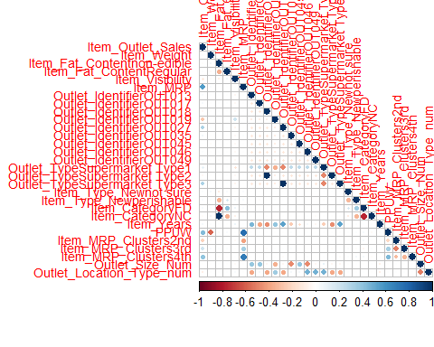

#Regression Model  
linear_reg_model = lm(Item_Outlet_Sales ~., data =train[,-c("Item_Identifier")])  
linear_reg_model

##   
## Call:  
## lm(formula = Item_Outlet_Sales ~ ., data = train[, -c("Item_Identifier")])  
##   
## Coefficients:  
## (Intercept) Item_Weight   
## 2181.357 -45.843   
## `Item_Fat_Contentnon-edible` Item_Fat_ContentRegular   
## -1.784 19.508   
## Item_Visibility Item_MRP   
## -10.864 985.536   
## Outlet_IdentifierOUT013 Outlet_IdentifierOUT017   
## 605.756 626.660   
## Outlet_IdentifierOUT018 Outlet_IdentifierOUT019   
## 509.250 4.126   
## Outlet_IdentifierOUT027 Outlet_IdentifierOUT035   
## 1050.623 640.765   
## Outlet_IdentifierOUT045 Outlet_IdentifierOUT046   
## 574.065 595.725   
## Outlet_IdentifierOUT049 `Outlet_TypeSupermarket Type1`   
## 625.962 NA   
## `Outlet_TypeSupermarket Type2` `Outlet_TypeSupermarket Type3`   
## NA NA   
## `Item_Type_Newnot sure` Item_Type_Newperishable   
## -1.012 6.861   
## Item_CategoryFD Item_CategoryNC   
## 7.884 NA   
## Item_Years PPUW   
## NA -74.728   
## Item_MRP_Clusters2nd Item_MRP_Clusters3rd   
## 27.393 55.944   
## Item_MRP_Clusters4th Outlet_Size_Num   
## 43.687 NA   
## Outlet_Location_Type_num   
## NA

# preparing dataframe for submission and writing it in a csv file   
submission$Item_Outlet_Sales = predict(linear_reg_model, test[,-c("Item_Identifier")])

## Warning in predict.lm(linear_reg_model, test[, -c("Item_Identifier")]):  
## prediction from a rank-deficient fit may be misleading

write.csv(submission, "Linear_Reg_submit.csv", row.names = F)