As there is no inbound connections allowed to the remote machines, we can use here Ansible which have push based architecture. Ansible is configuration management code which is use to manage the infrastructure automatically. It is infrastructure as code service. We need to follow below steps for installation and updation of services on target nodes.

1. Here we need to install ansible on remote machine.
2. Establish SSH connectivity between remote machine (ansible server) and target servers.
3. All target servers IP need to add in the inventory file.
4. Default location for the inventory file is /etc/ansible/hosts.

Ex.[appserverrs]

<ip address of the target machine>

1. Write down the playbook, which consist of set of tasks and each task is consist of modules.

Playbooks are writes in yaml file.

Ex:

---

- hosts: appservers

become_user: root

tasks:

- name: Install Nginx

apt: pkg=nginx

state=present

This example is for playbook which is used for installation of the nginx.

Run the playbook by using below command,

Ansible-playbook <playbook name>.yml

Once we run this command it will install the package on the target servers.

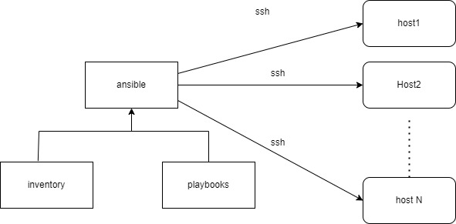

Disadvanatage

1. Cannot handle complex task
2. Its does not keep the track of dependendencies, its simply execute the sequence of task.