**1. In the below elements which of them are values or an expression? eg:- values can be**

**integer or string and expressions will be mathematical operators.**

*

‘hello’

-87.8

-

/

+

6

Ans 1:

* ----expression

'hello' ------value

-87.8 ------value

- --------------expression

/ -------------------expression

+ ----------------------expression

6 ---------------------value

**2. What is the difference between string and variable?**

Ans 2:

Variable is used to store the data , it can store int,float, boolean, string etc.

E.g. A= 4,

A = ‘Ineuron’

A = True

A =4.4

Whereas

String is a literal text string e.g. ‘Ineuron’

**3. Describe three different data types.**

Ans 3:

1. Numeric (represent the data which has numeric value.)
2. Integer (It contains positive or negative whole numbers (without fraction or decimal). )
3. Complex numbers (specified as *(real part) + (imaginary part)j*.)
4. Float (It is a real number with floating point representation. It is specified by a decimal point.)
5. Boolean (Data type with one of the two built-in values, True or False)
6. Set ( unordered collection of data type that is iterable, mutable and has no duplicate elements.)
7. Sequence Type (ordered collection of similar or different data types)
8. Strings ( A string is a collection of one or more characters put in a single quote, double-quote or triple quote.)
9. List ( just like the arrays,is an ordered collection of data.)
10. Tuple(also an ordered collection of Python objects. The only difference between tuple and list is that tuples are immutable)
11. Dictionary ( Dictionary holds key:value pair.)

**4. What is an expression made up of? What do all expressions do?**

Ans 4 :

Expression is a combination of variables, operations and values that returns some result after expression is evaluated.

E.g. a = b+c # b=2 , c=3

print(a) # a becomes 5

**5. This assignment statements, like spam = 10. What is the difference between an**

**expression and a statement?**

Ans 5:

> Expression is a combination of variables, operations and values that returns some result after expression is evaluated.

E.g. a = b+c # b=2 , c=3

print(a) # a becomes 5

> Statements represent an action e.g print statements, assignment statements.

E.g. print 'hello', x = 1, spam = 10.

**6. After running the following code, what does the variable bacon contain?**

**bacon = 22**

**bacon + 1**

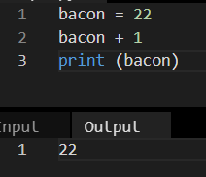

At line 1: bacon is assigned value 22

At line 2: + operator is used to add 1 to the current bacon value i.e. 22

At line 3: bacon value is printed which comes to be 22 as , at line 2 , after the operation was executed result value wasn’t assigned back to bacon variable.

**7. What should the values of the following two terms be?**

**‘spam’ +’spamspam’**

**‘spam’ * 3**

Ans 7 :

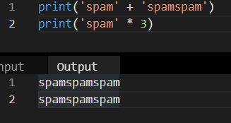

**8. Why is eggs a valid variable name while 100 is invalid?**

Ans 8:

Eggs is valid variable name because it follows all rules of variable declaration for python i.e.

* Contains only one word with no spaces,
* Uses only letters/numbers/underscore character (for this case letters)
* Does Not begin with a number

100 is invalid variable name because variable name can’t begin with a number.

**9. What three functions can be used to get the integer, floating-point number, or string**

**version of a value?**

Ans 9:

int(), float(), str() can be used to get the integer, floating-point number, or string

version of a value respectively.

**10. Why does this expression cause an error? How can you fix it?**

**‘I have eaten ’+ 99 +’ burritos’**

Ans 10:

+ operator is used to concatenate the multiple string values together,i.e. Concatenate str to str only

But in the given example ‘I have eaten ’+ 99 +’ burritos’ 99 is integer

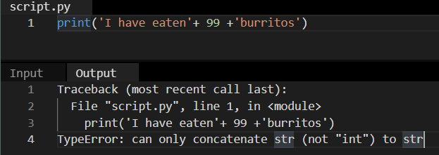

Hence it is giving error

If 99 is changed to string , this statement will work perfectly fine

