CUSTOMER CHURN PREDICTION
AND RETENTION ANALYSIS

A Machine Learning Based Data Science Project

Submitted By: Ankita Sahu
Course: B.Tech
Internship: Data Science Internship
Project: Week 6 – Integrated Project and Comprehensive Reporting

1. Executive Summary
Customer churn refers to customers discontinuing their services with a company. This project develops a Machine Learning based customer churn prediction system using telecommunication customer data. It includes data cleaning, exploratory data analysis, feature engineering, model training, evaluation, explainability and customer risk segmentation.

2. Problem Statement
Customer retention is important for business growth. Companies need to identify customers who are likely to leave their services. This project aims to analyze customer behaviour and predict churn using classification algorithms.

3. Project Objectives
- Understand customer demographics and service usage.
- Perform data cleaning and preprocessing.
- Analyze churn patterns using visualizations.
- Train multiple Machine Learning classification models.
- Compare models using evaluation metrics.
- Use SHAP for model explainability.
- Segment customers according to churn risk.
- Develop an interactive Streamlit application.

4. Dataset Description
The cleaned dataset contains 7043 rows and 20 columns.
The dataset includes customer information such as gender, tenure, contract type, internet service, monthly charges, total charges and churn status.
The target variable is Churn, which indicates whether a customer discontinued the service.

5. Data Cleaning and Preprocessing
- Converted TotalCharges into numeric format.
- Handled missing TotalCharges values using median imputation.
- Checked duplicate records.
- Removed the customerID column before model training.
- Converted the target variable into binary format.
- Applied one-hot encoding to categorical variables.
- Split data into training and testing sets using stratification.
- Applied StandardScaler for Logistic Regression.

6. Exploratory Data Analysis
Exploratory Data Analysis was performed to understand customer churn behaviour and identify important patterns in customer demographics, contracts and service usage.

Customer Churn Distribution
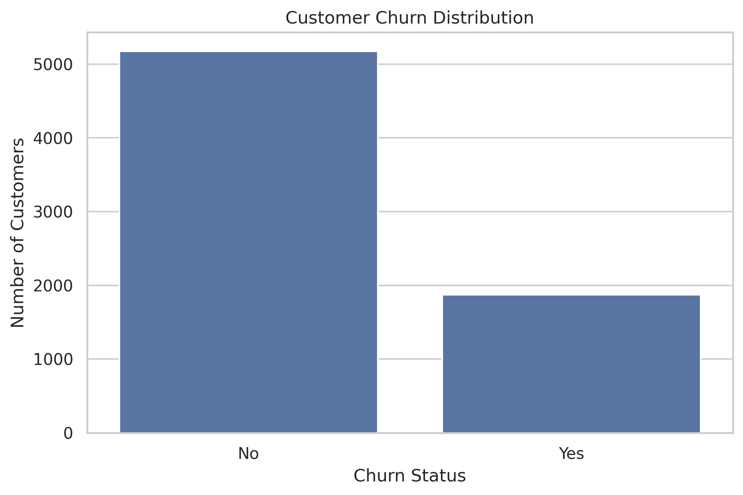

Contract Type vs Churn
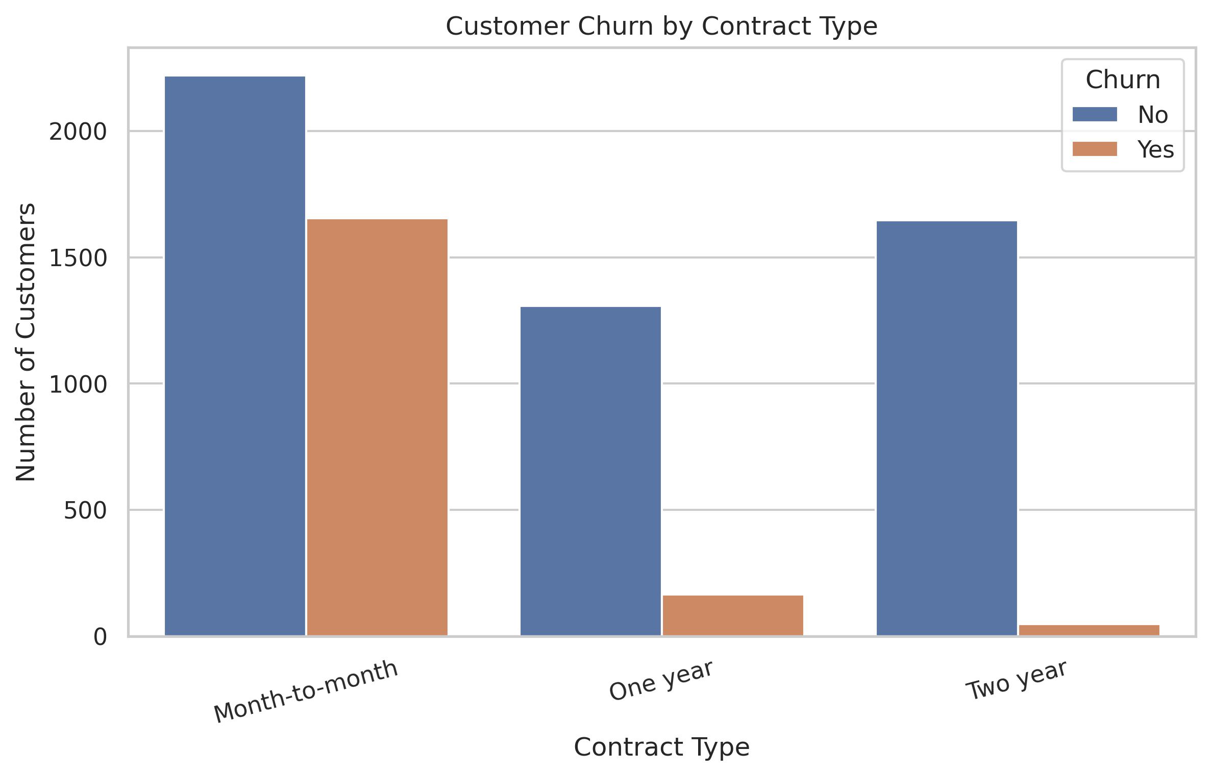

Customer Tenure vs Churn
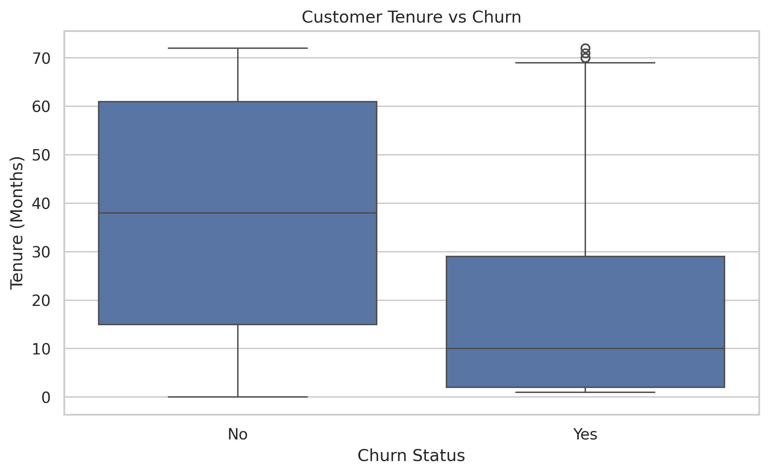

Monthly Charges vs Churn
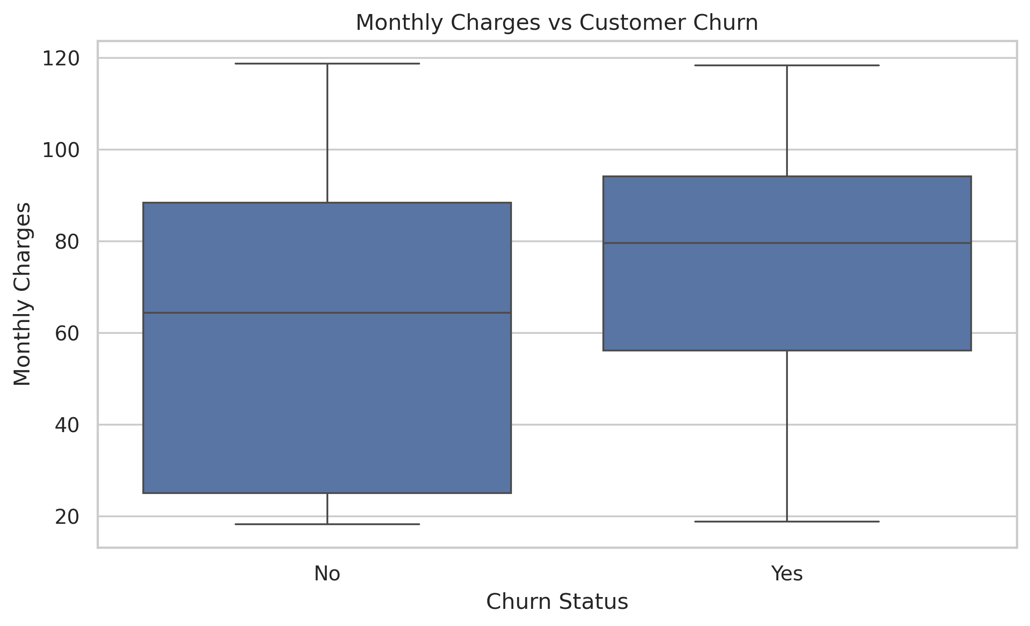

Payment Method vs Churn
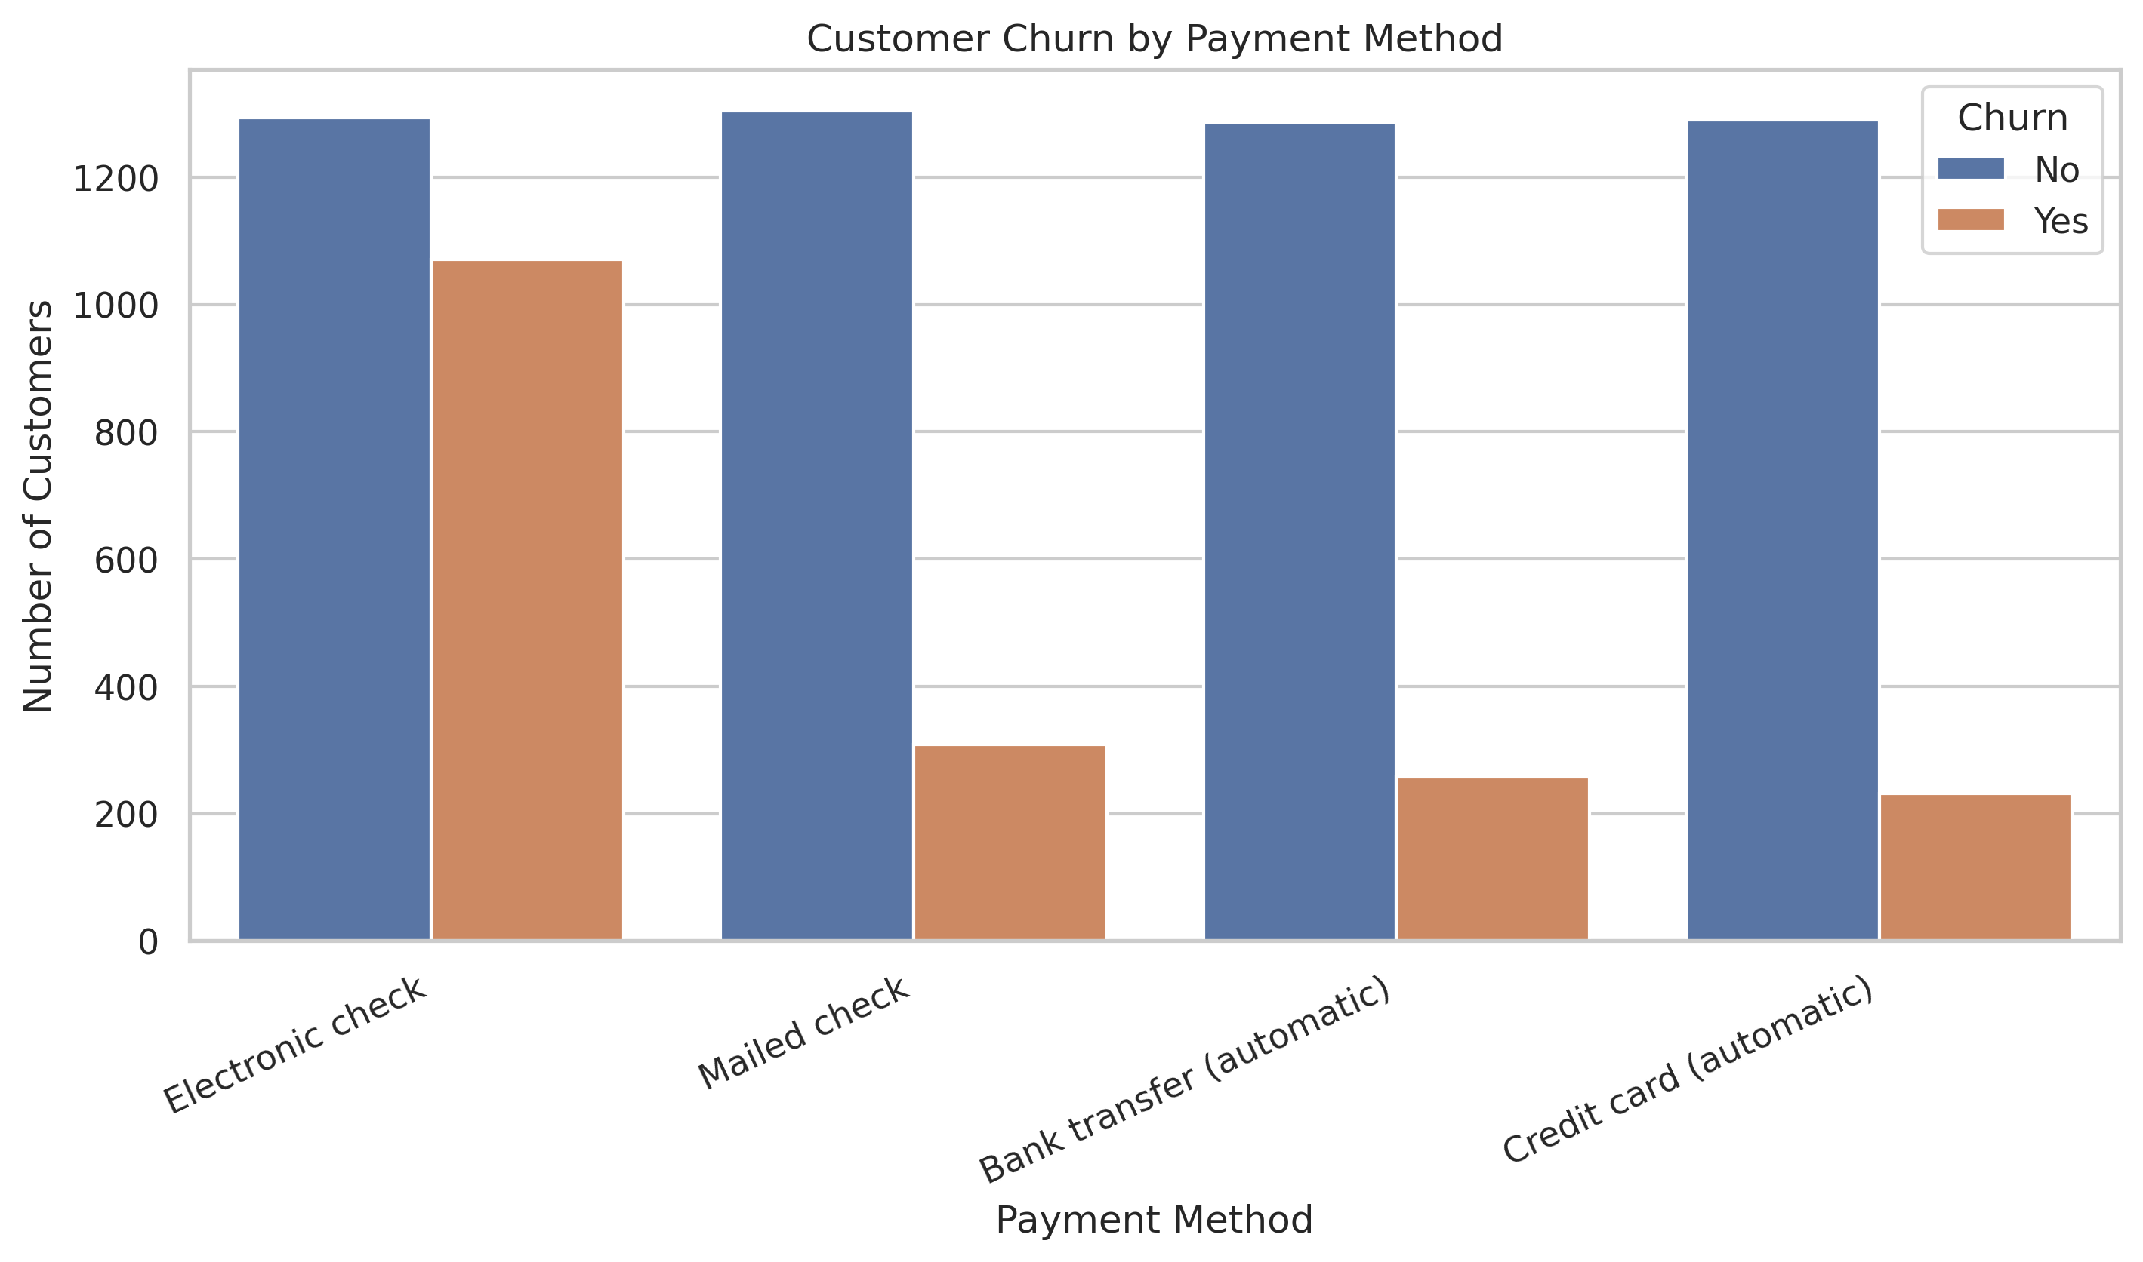

Internet Service vs Churn
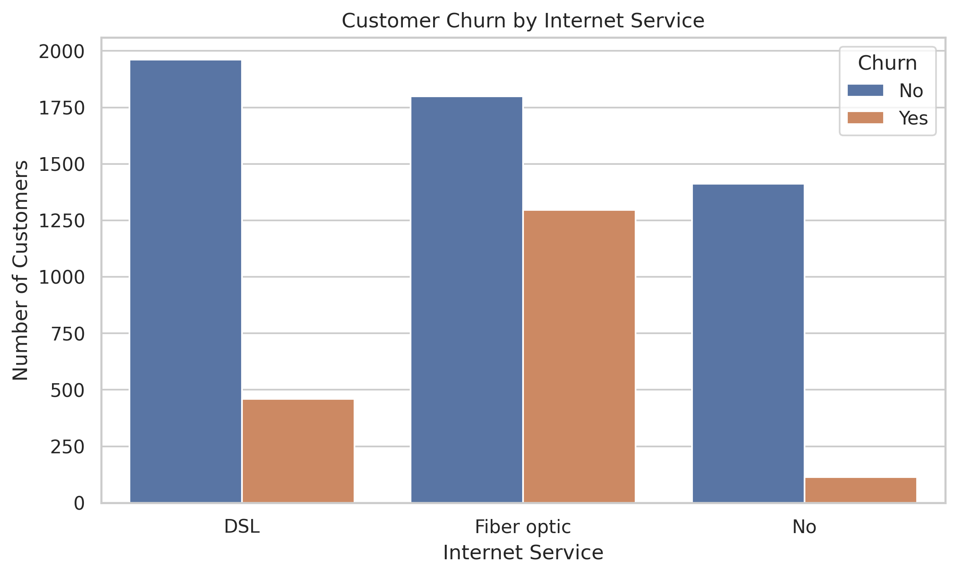

Correlation Heatmap
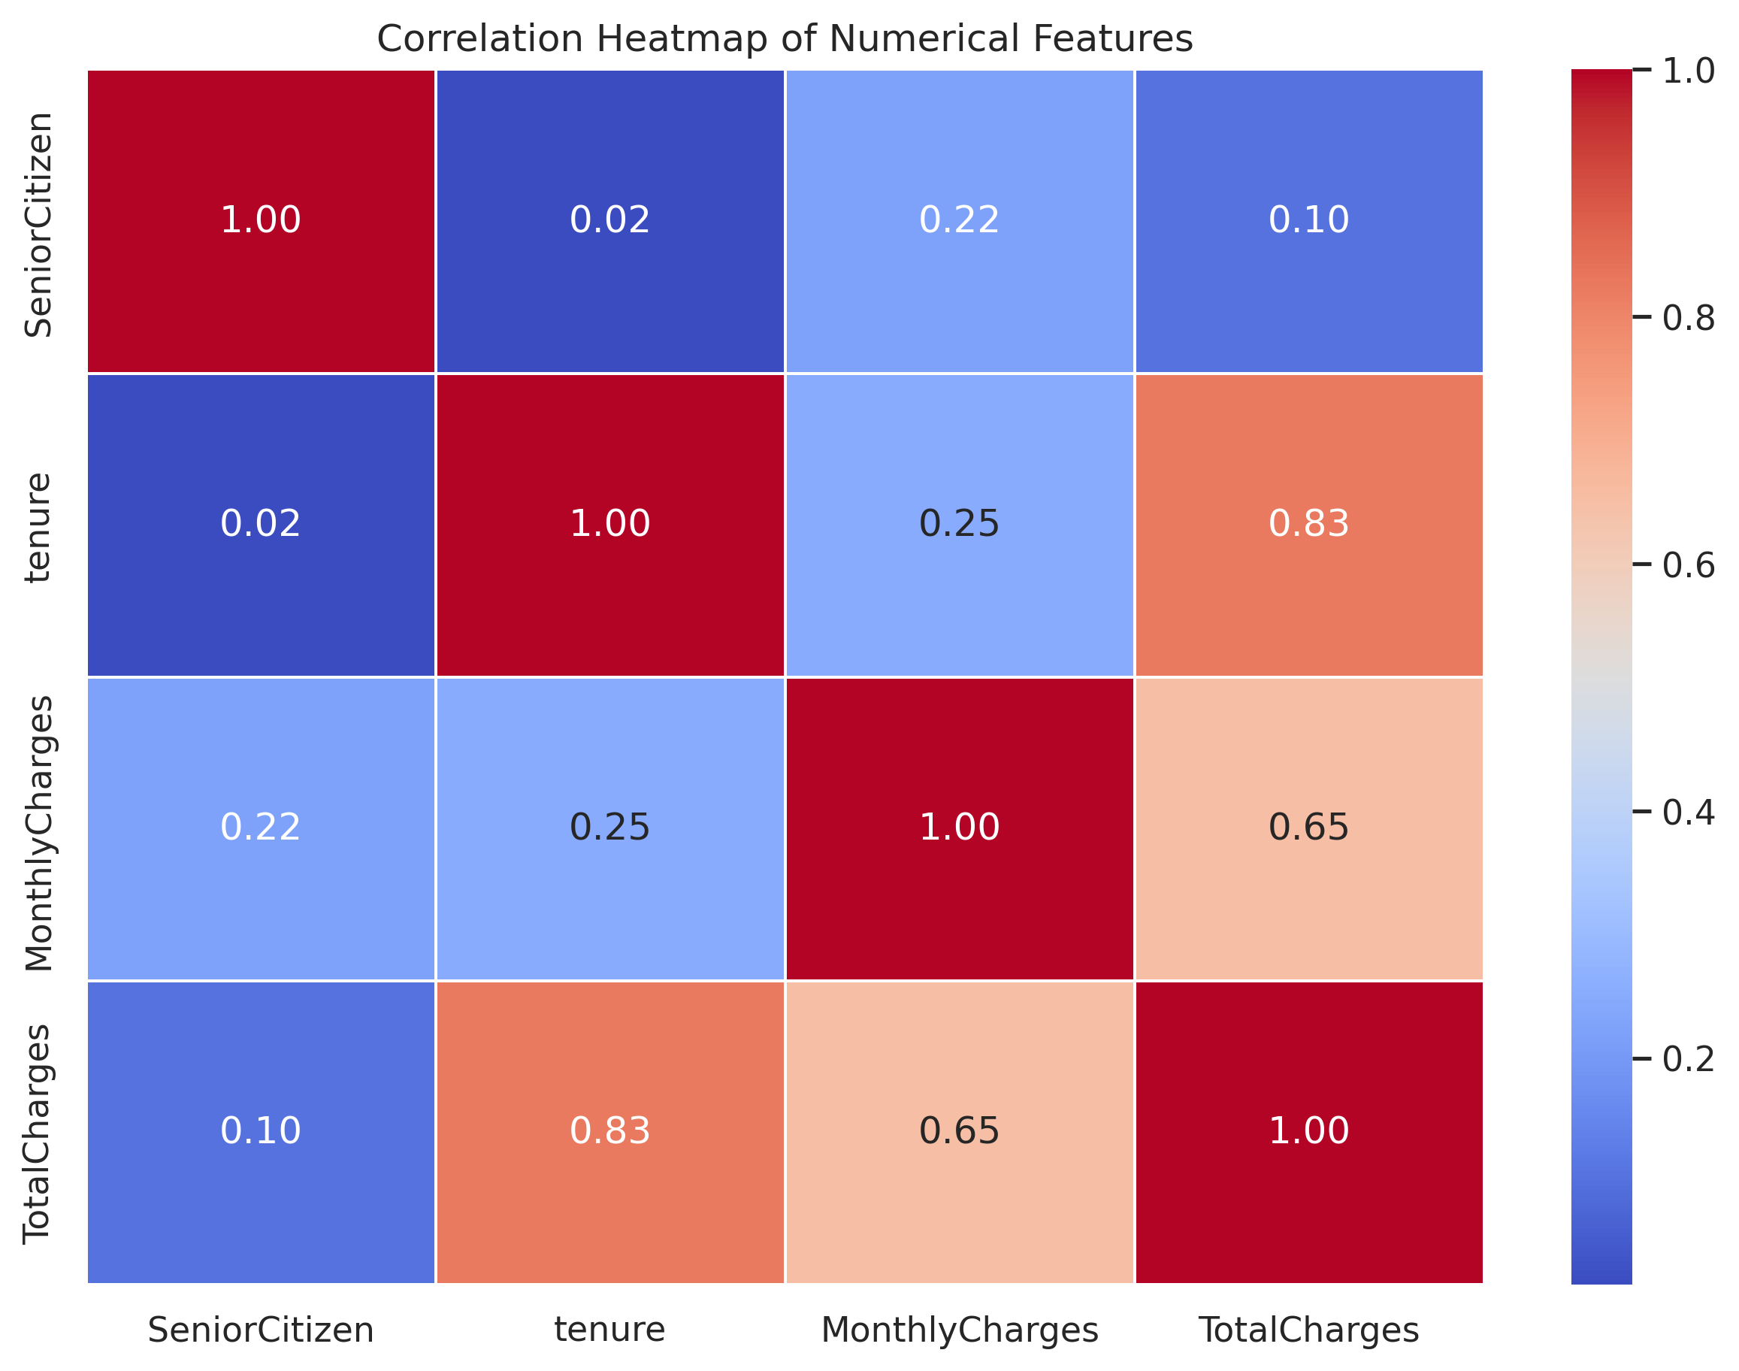

Gender vs Churn
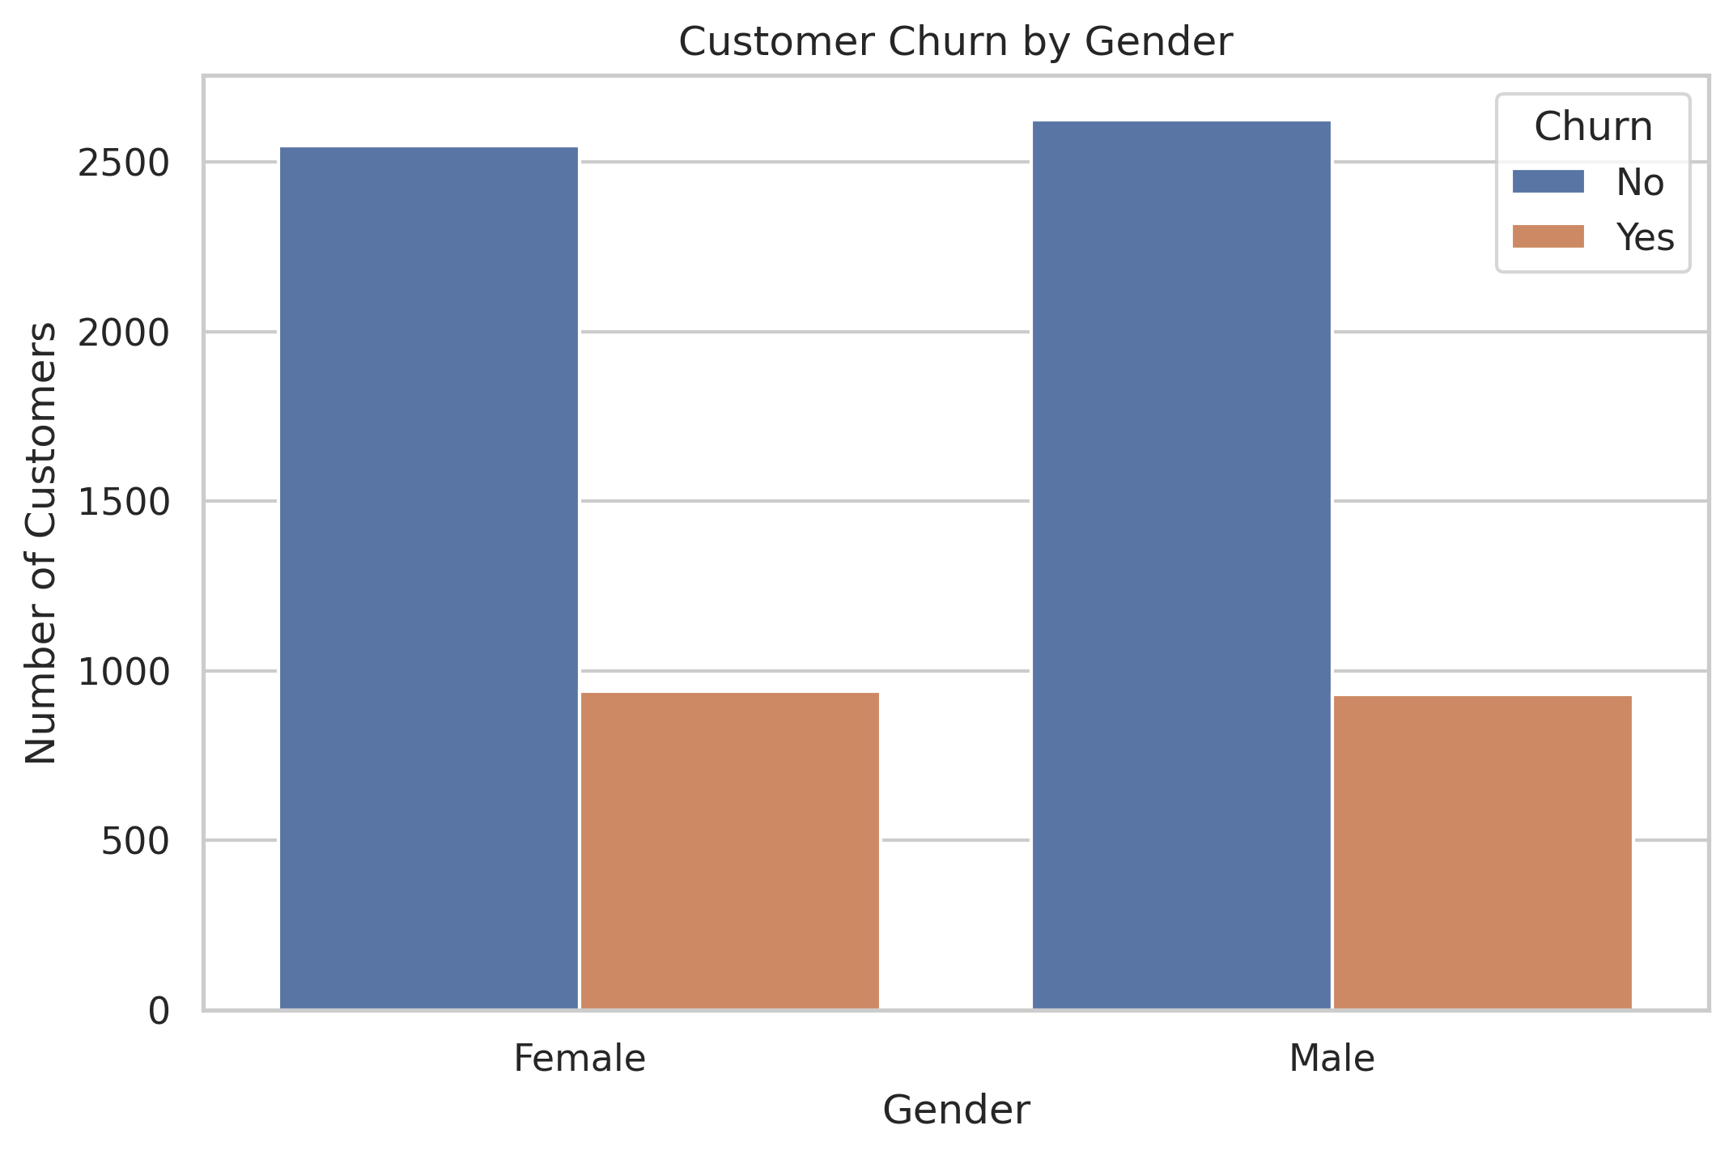

Senior Citizen vs Churn
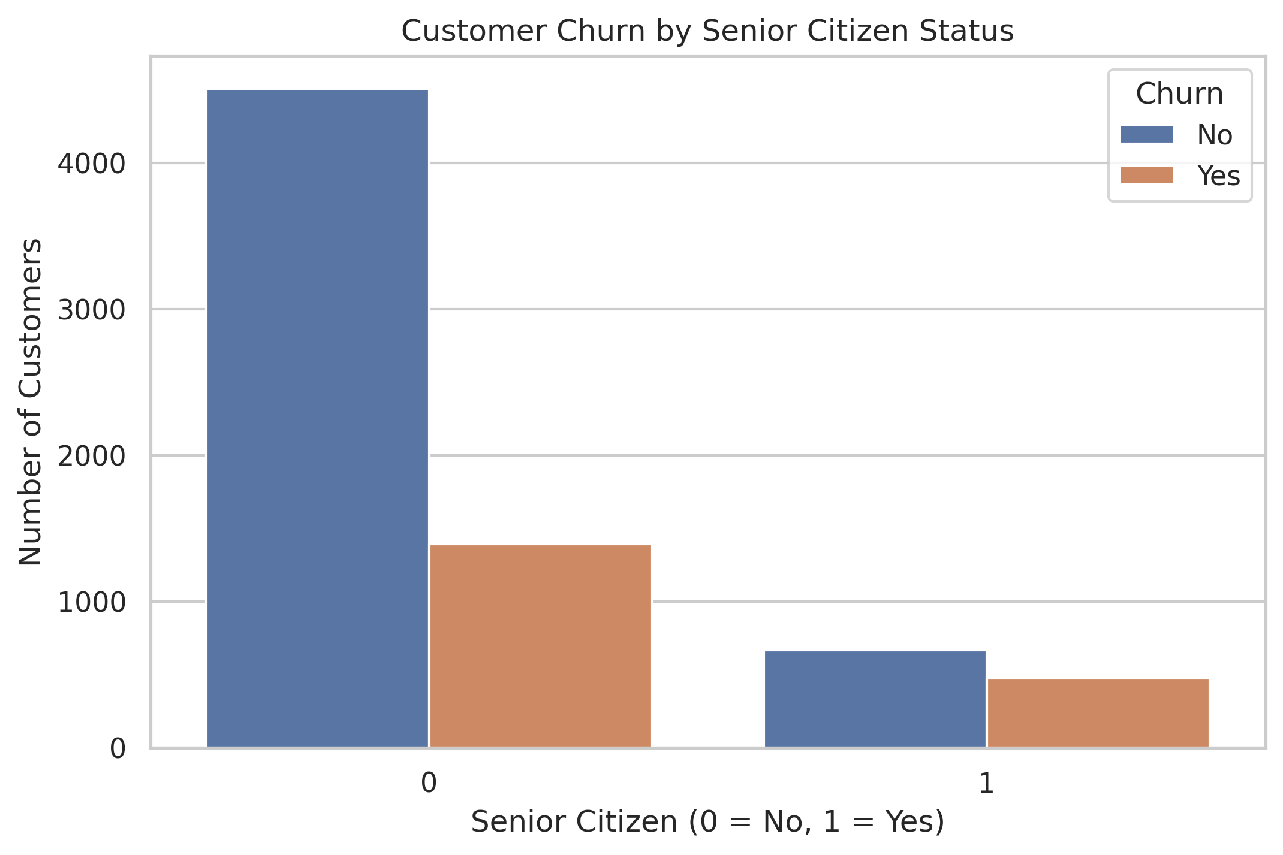

7. Machine Learning Methodology
Four classification approaches were evaluated: Logistic Regression, Decision Tree, Random Forest and Tuned Logistic Regression. The dataset was divided into training and testing subsets using an 80:20 split.

8. Model Performance Comparison
Model | Accuracy | Precision | Recall | F1-Score | ROC-AUC
Logistic Regression | 0.8070 | 0.6584 | 0.5668 | 0.6092 | 0.8416
Decision Tree | 0.7942 | 0.6296 | 0.5455 | 0.5845 | 0.8284
Random Forest | 0.8041 | 0.6667 | 0.5241 | 0.5868 | 0.8432
Tuned Logistic Regression | 0.8034 | 0.6520 | 0.5561 | 0.6003 | 0.8410
Logistic Regression achieved the highest accuracy (80.70%) and F1-score (0.6092). Random Forest achieved the highest ROC-AUC (0.8432). Logistic Regression was selected as the final model based on its overall accuracy and F1-score.

9. Model Evaluation Visualizations

Confusion Matrix
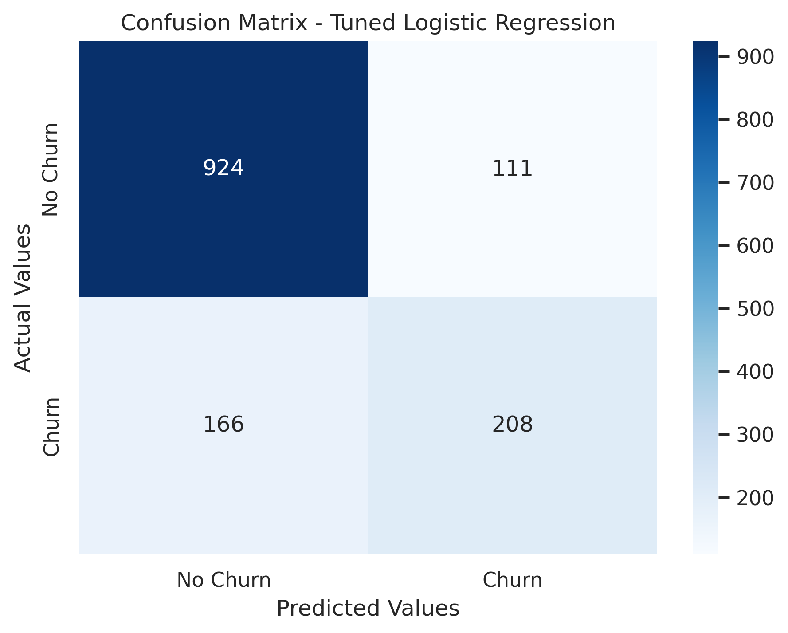

ROC Curve
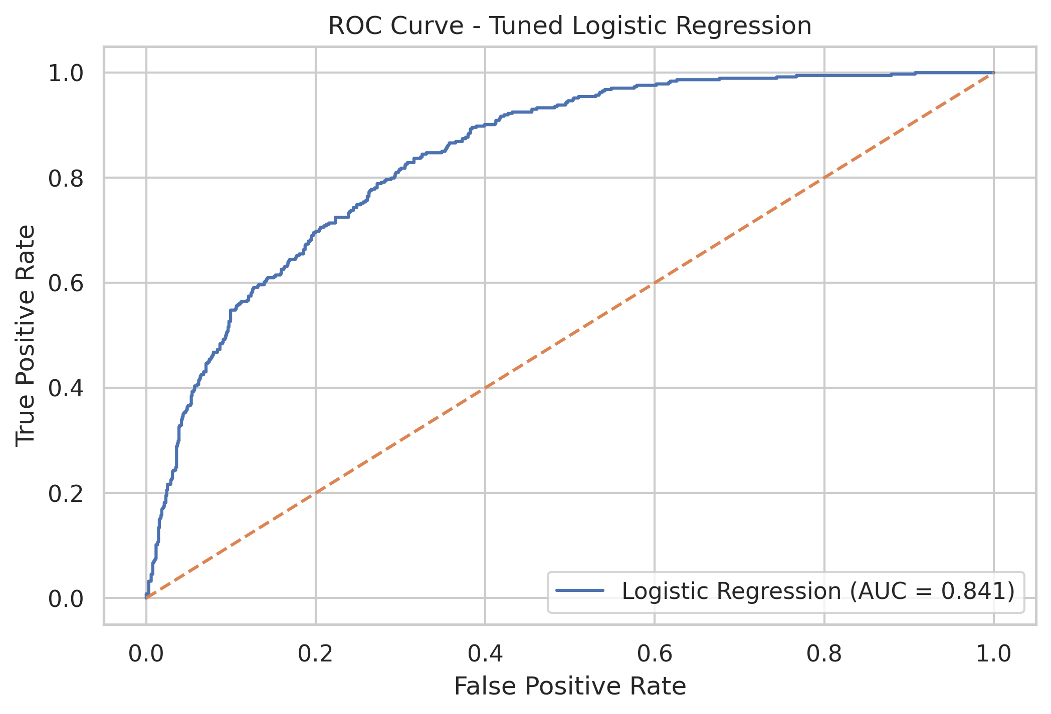

Precision-Recall Curve
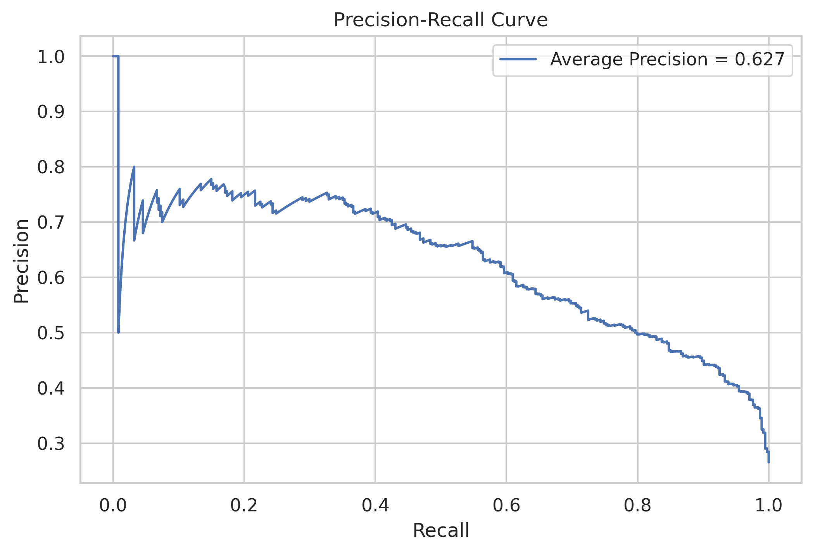

Feature Importance
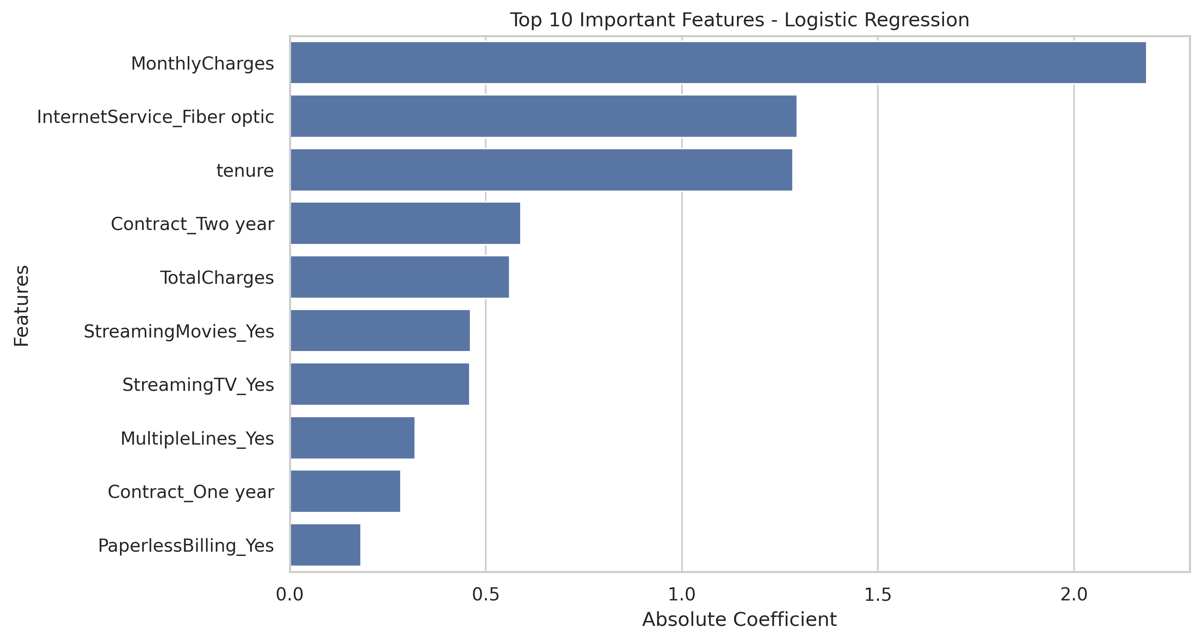

10. Model Explainability Using SHAP
SHAP (SHapley Additive exPlanations) was used to understand how input features influence the model predictions. The Beeswarm plot provides a global view of feature impact, while the Waterfall plot explains an individual prediction.

SHAP Beeswarm Plot
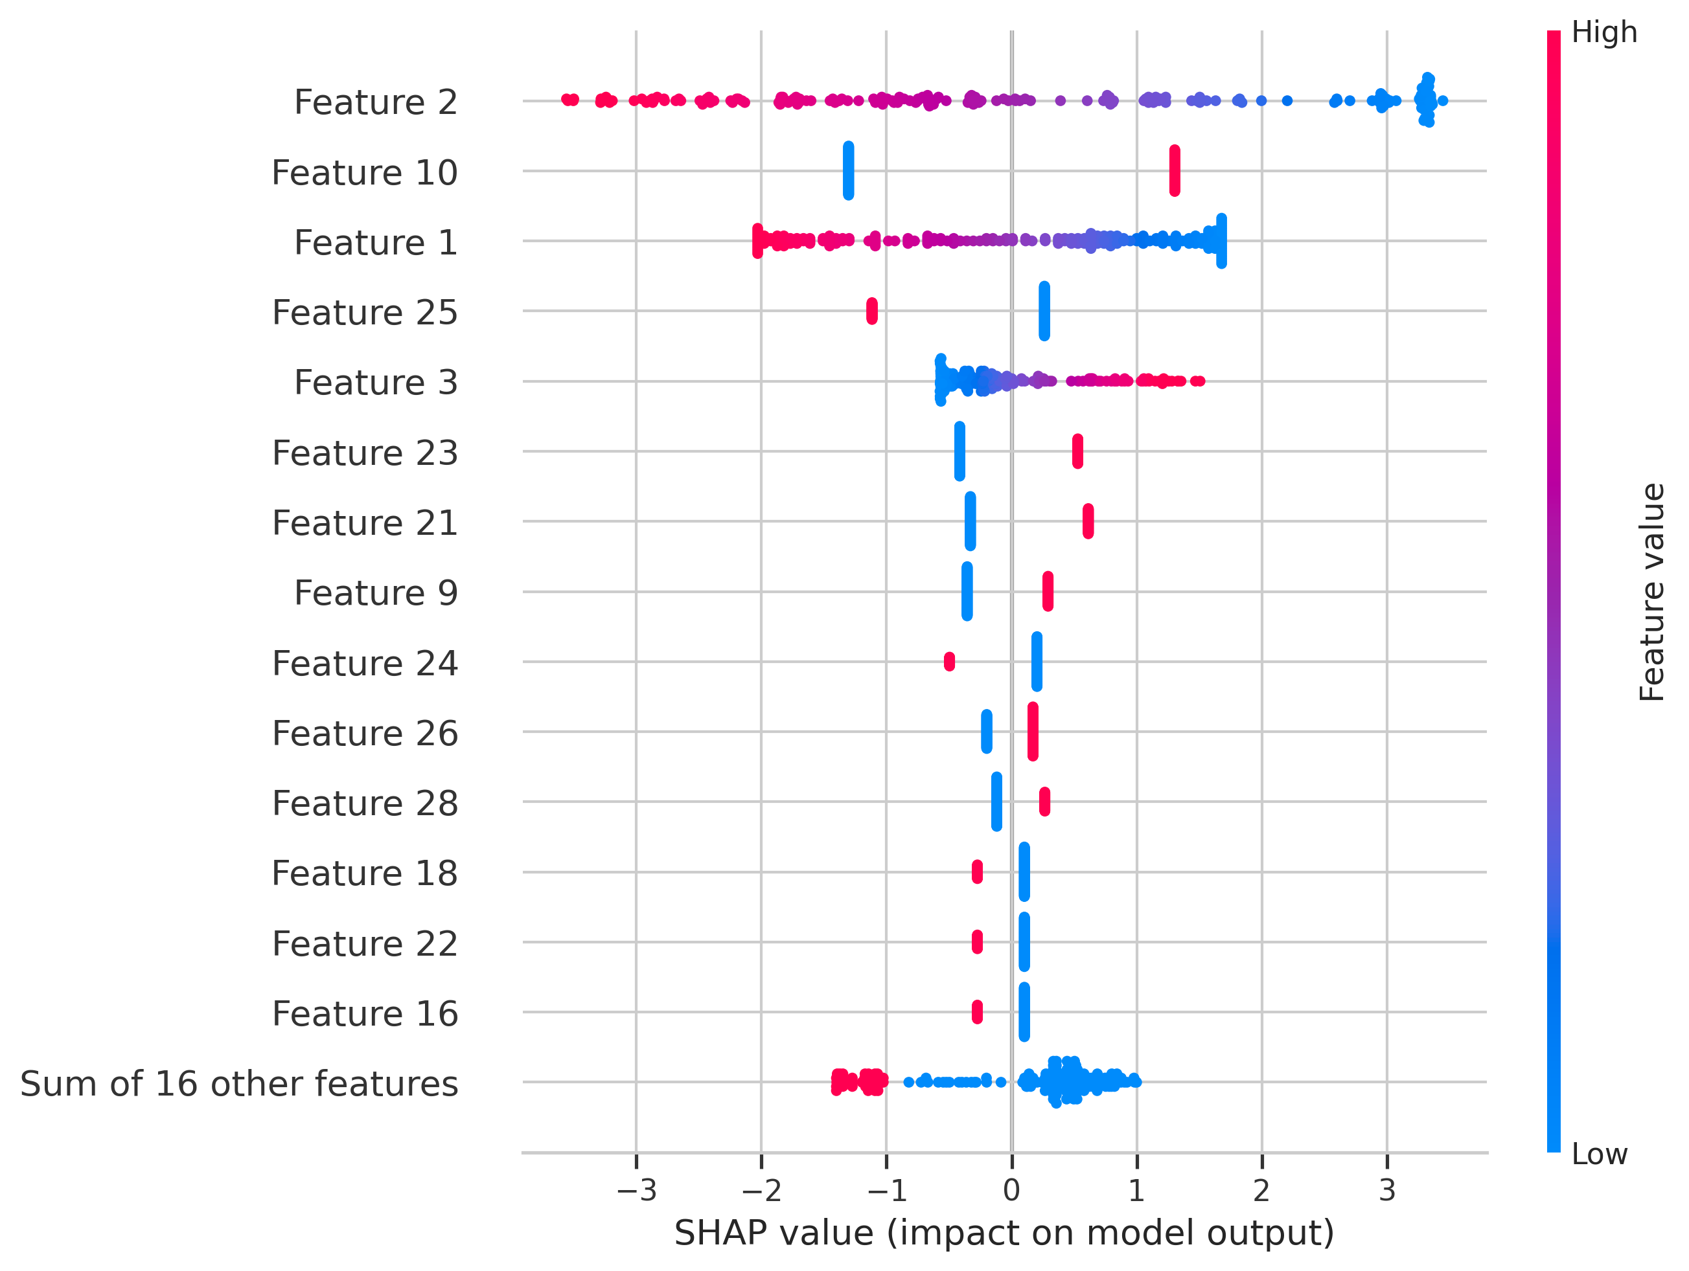

SHAP Waterfall Plot
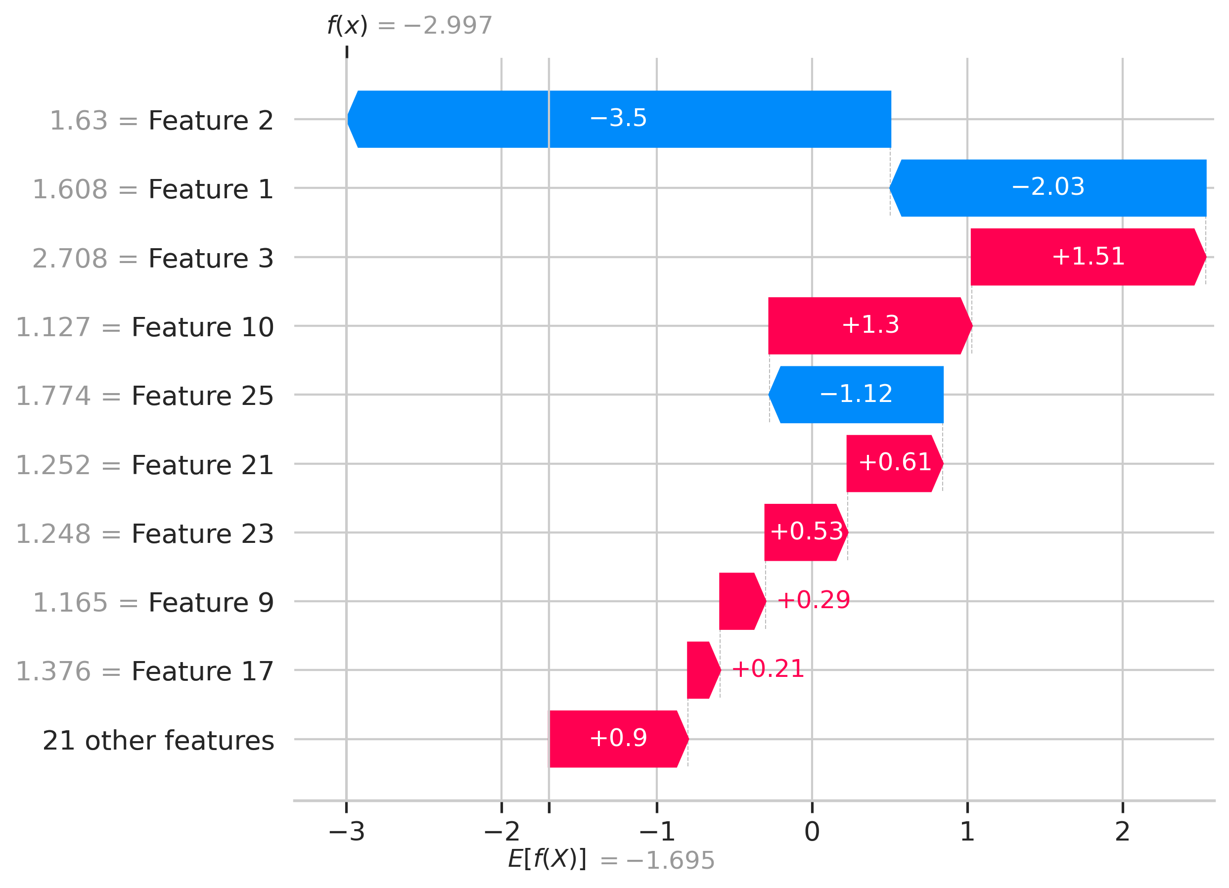

11. Customer Risk Segmentation
Customers were divided into three risk categories using predicted churn probabilities. High Risk customers have a probability of at least 0.70, Medium Risk customers have a probability from 0.40 to below 0.70, and Low Risk customers have a probability below 0.40. These are initial business-defined thresholds.

Customer Churn Insights Dashboard
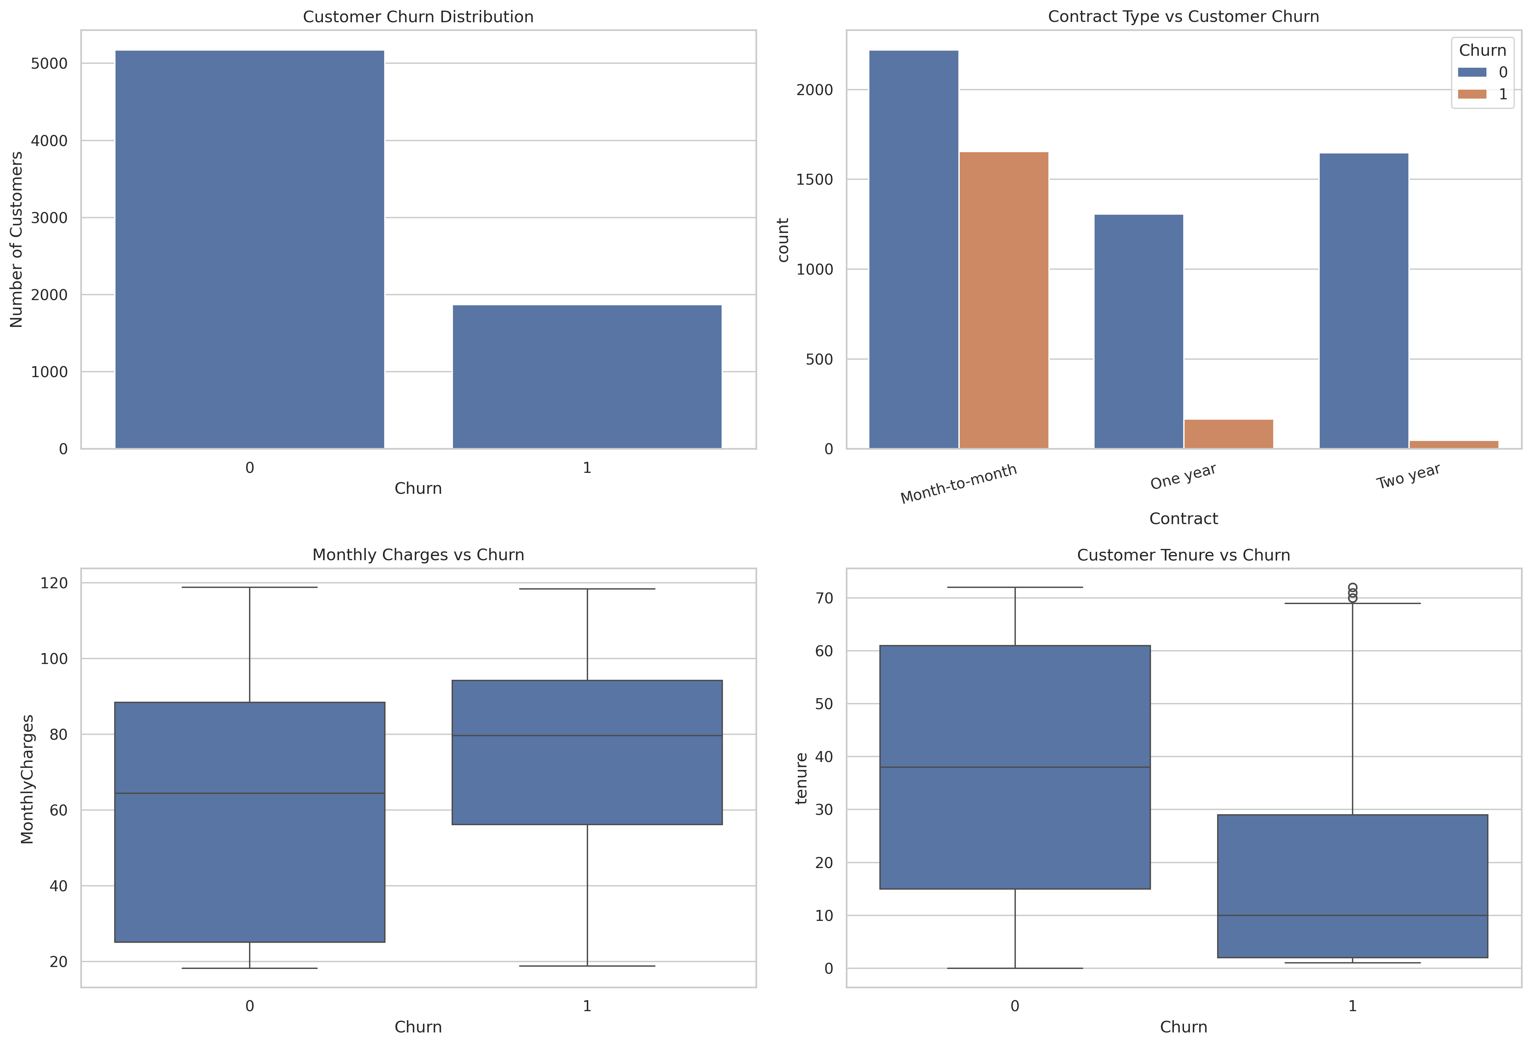

Customer Risk Analysis Dashboard
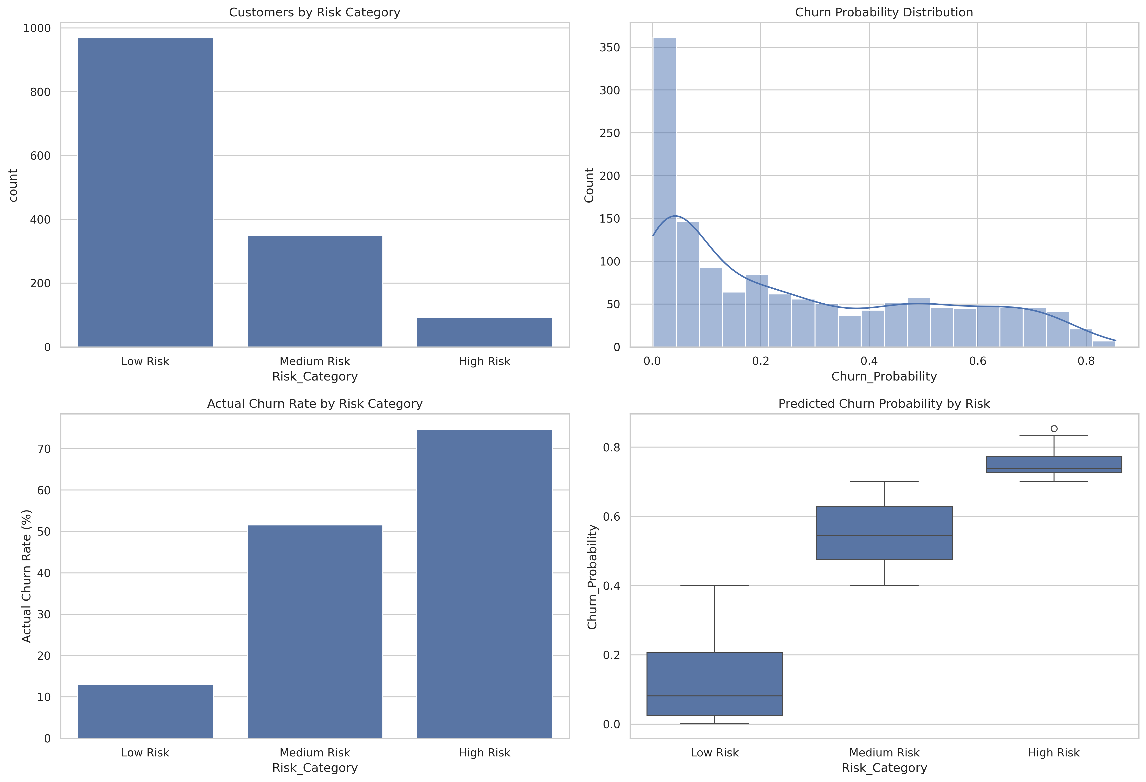

12. Business Recommendations
- Monitor customers with month-to-month contracts.
- Develop retention offers for customers with high predicted churn risk.
- Improve customer support and service satisfaction.
- Analyze payment methods and billing-related customer behaviour.
- Monitor new customers during their early tenure.
- Use model predictions as decision support, not as the sole basis for customer actions.

13. Project Limitations
The model is trained on a particular telecom dataset and may not generalize to every business. The recall of the selected Logistic Regression model is 56.68%, meaning some customers who actually churn may not be identified. Risk thresholds are initial business choices and require validation before real-world use.

14. Future Scope
- Deploy the Streamlit application on a cloud hosting platform.
- Evaluate additional classification algorithms.
- Tune the decision threshold based on business costs.
- Use larger and more recent customer datasets.
- Integrate real-time customer data and automated alerts.

15. Conclusion
This project demonstrates an end-to-end Machine Learning workflow for customer churn prediction. It combines data preprocessing, exploratory analysis, classification models, model evaluation, SHAP explainability and customer risk segmentation. The results provide a foundation for data-driven customer retention strategies.

