EXPLORATORY DATA ANALYSIS
Titanic Passenger Dataset
Week 2 — Data Science Internship Task

Objective
The objective of this report is to perform Exploratory Data Analysis (EDA) on the Titanic training dataset. The analysis uses descriptive statistics, missing-value checks, visualizations, correlation analysis, and a chi-square test to explore passenger characteristics and patterns associated with survival.

Dataset Overview
Item | Details
Dataset file | train.csv
Observations | 891 passengers
Columns | 12
Target variable | Survived (0 = did not survive; 1 = survived)
Variables examined | Sex, Pclass, Age, Fare, SibSp, Parch, Survived

1. Methodology
The dataset is loaded from train.csv using pandas. The analysis inspects the dataset shape and column information, checks missing values, and calculates descriptive statistics with df.describe(). Bar charts are used to compare survival counts and survival percentages by sex and passenger class. A histogram examines age distribution, a box plot examines fare spread and potential outliers, and a heatmap visualizes correlations among selected numerical variables. Finally, a chi-square test of independence assesses the association between sex and survival.

2. Data Quality and Descriptive Statistics
The notebook reports a dataset shape of 891 rows and 12 columns. The missing-value check uses df.isnull().sum() to count missing observations in each column. In this dataset, missing values are especially notable in Age and Cabin; Embarked also has a small number of missing values in the standard Titanic training data. These missing values should be acknowledged before modeling, and any imputation or row-removal decisions should be documented.
The df.describe() output summarizes numerical variables using count, mean, standard deviation, minimum, quartiles, and maximum. These statistics describe central tendency and dispersion. Categorical frequency counts and the printed survival counts provide additional context. The actual numeric summary table should be checked in the executed notebook when reviewing this report.

3. Visualization and Interpretation

3.1 Survival Counts
The bar chart of Survived compares passengers who did not survive (0) with those who survived (1). In the standard Titanic training dataset, more passengers did not survive than survived. This shows that the outcome classes are not evenly represented.
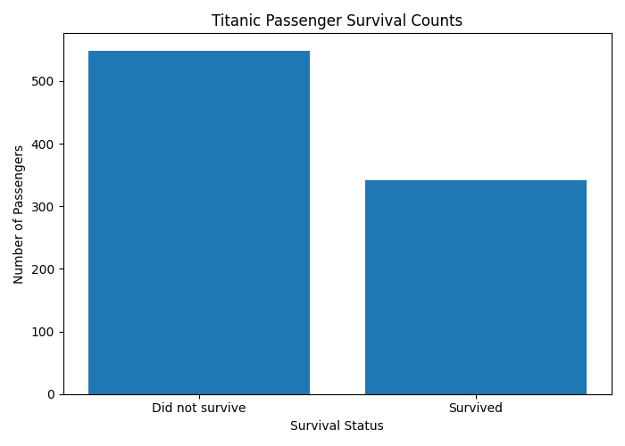

3.2 Survival Percentage by Gender
A normalized cross-tabulation calculates survival percentages separately for each sex. The chart shows a marked difference in observed survival percentages between female and male passengers, with females having a higher survival percentage in this dataset. This is an association in the observed data and does not establish causation.
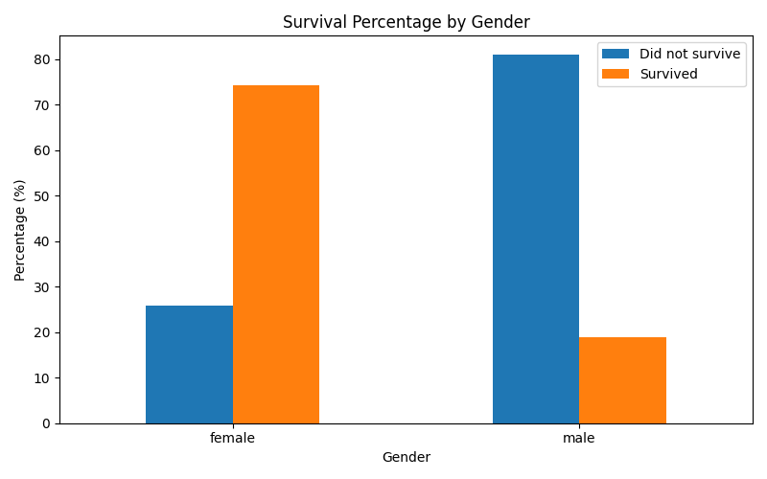

3.3 Survival Percentage by Passenger Class
The normalized cross-tabulation by Pclass compares survival percentages for first-, second-, and third-class passengers. The visualization helps assess whether survival outcomes differ by passenger class. In the standard Titanic dataset, first-class passengers generally had higher survival percentages than third-class passengers.
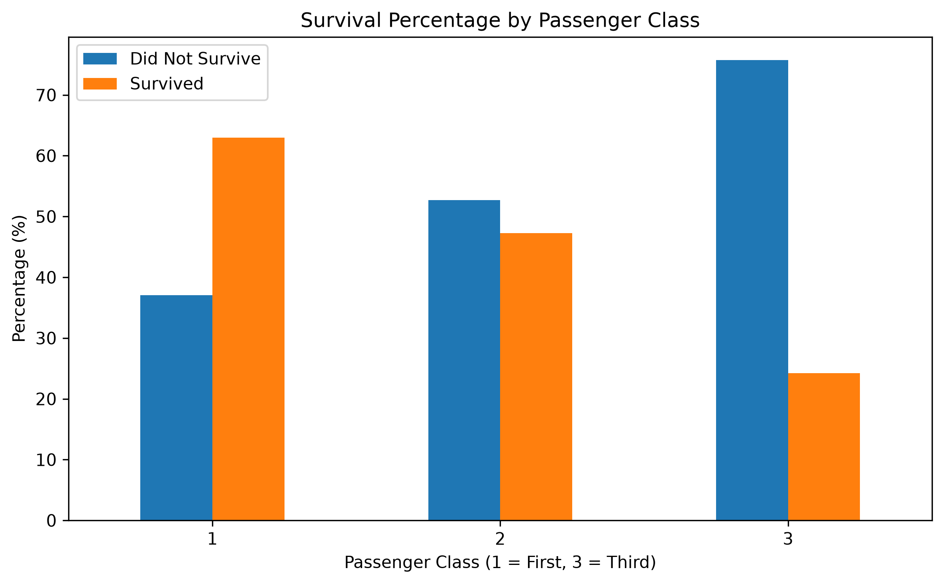

3.4 Age Distribution
The histogram plots recorded passenger ages after dropping missing Age values. It shows the distribution of ages among passengers with known ages and can reveal where observations are concentrated. Because missing ages are excluded, the chart does not represent every passenger.
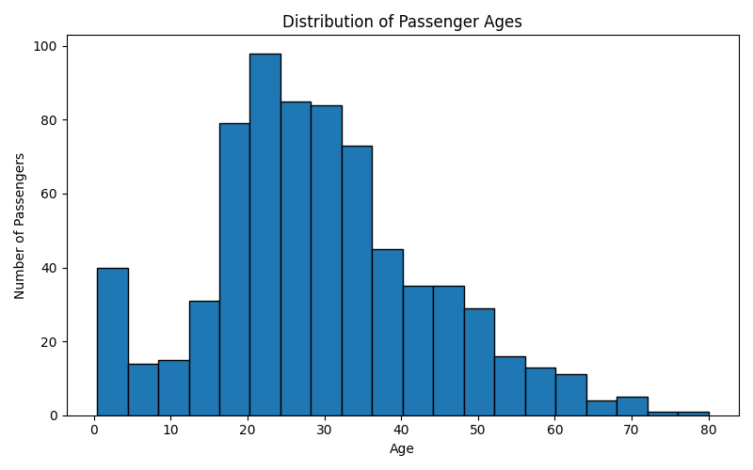

3.5 Fare Distribution and Potential Outliers
The box plot summarizes the distribution of Fare values after dropping missing entries. The median and spread show typical fare variation, while points beyond the whiskers can indicate potential outliers. A potential outlier is not automatically an error; it may reflect a genuinely high fare.
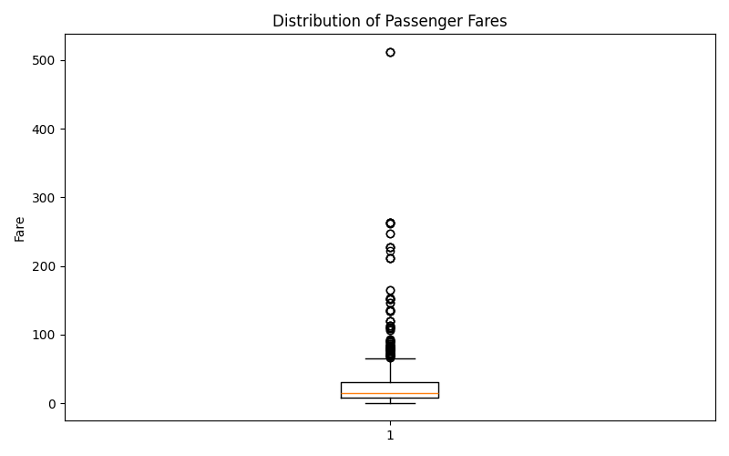

3.6 Correlation Heatmap
The heatmap displays pairwise correlations for Survived, Pclass, Age, SibSp, Parch, and Fare. Correlation values summarize the direction and strength of linear relationships. Pclass is an ordinal category, so its numeric coding should be interpreted carefully. Correlation does not imply causation.
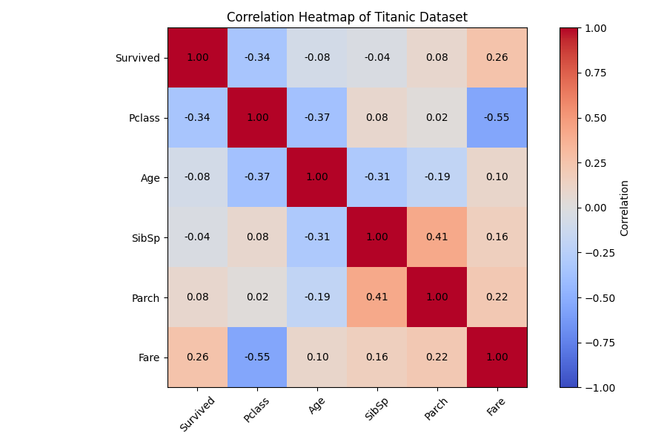

4. Hypothesis Testing: Sex and Survival
Research question: Is passenger sex statistically associated with survival?
Null hypothesis (H₀): Sex and survival are independent in the observed dataset.
Alternative hypothesis (H₁): Sex and survival are associated in the observed dataset.
The notebook creates a contingency table using pd.crosstab(df['Sex'], df['Survived']) and applies scipy.stats.chi2_contingency. The visible notebook output reports a chi-square statistic of 260.717 and a p-value printed as 0.0 after rounding to six decimal places. A rounded value of 0.0 does not mean the true p-value is exactly zero; it indicates that the p-value is smaller than the displayed precision (p < 0.000001).
At a significance level of 0.05, the null hypothesis is rejected. The observed data provide strong statistical evidence of an association between sex and survival. The test assumes independent observations and sufficiently large expected cell counts. Since this is observational data, the result does not prove that sex alone caused the survival difference.

5. Key Findings
- The training dataset contains 891 passengers and 12 columns.
- Missing values are present, particularly in Age and Cabin; the notebook's missing-value output should be reviewed for exact counts.
- The survival-count chart compares the number of survivors and non-survivors.
- Observed survival percentages differ by sex and passenger class.
- The age histogram describes ages for rows with recorded Age values.
- The fare box plot highlights fare spread and potential outliers.
- The correlation heatmap summarizes relationships among selected numerical variables.
- The chi-square test indicates a statistically significant association between sex and survival.

6. Limitations and Assumptions
- The analysis uses the provided Titanic training sample and may not represent all passengers.
- Missing values can affect summaries and visualizations; Age and Fare plots explicitly drop missing values.
- The chi-square test assumes independent observations and sufficiently large expected counts.
- Associations and correlations should not be interpreted as proof of causation.
- Exact descriptive statistics and missing-value counts should be checked against the final executed notebook before submission.

7. Conclusion
This EDA examined the Titanic dataset through data inspection, missing-value checks, descriptive statistics, visualizations, correlation analysis, and a chi-square test. The analysis highlights differences in observed survival by sex and passenger class, explores age and fare distributions, and identifies missing-data concerns. The hypothesis test provides strong evidence of an association between sex and survival. These findings establish a useful foundation for further data cleaning and predictive modeling.

Reproducibility and Submission Checklist
- Save the executed Jupyter notebook (.ipynb) with its code and outputs.
- Submit this report after verifying that its findings match the final notebook.
- Keep supporting plots and scripts available if requested by the internship.
- Include the dataset only if permitted by the internship submission rules.
Report note: This document was prepared from the code and notebook output provided in the conversation. Before submission, verify all descriptions against the final outputs from your own notebook.

