Alert For each loop:

Plan:

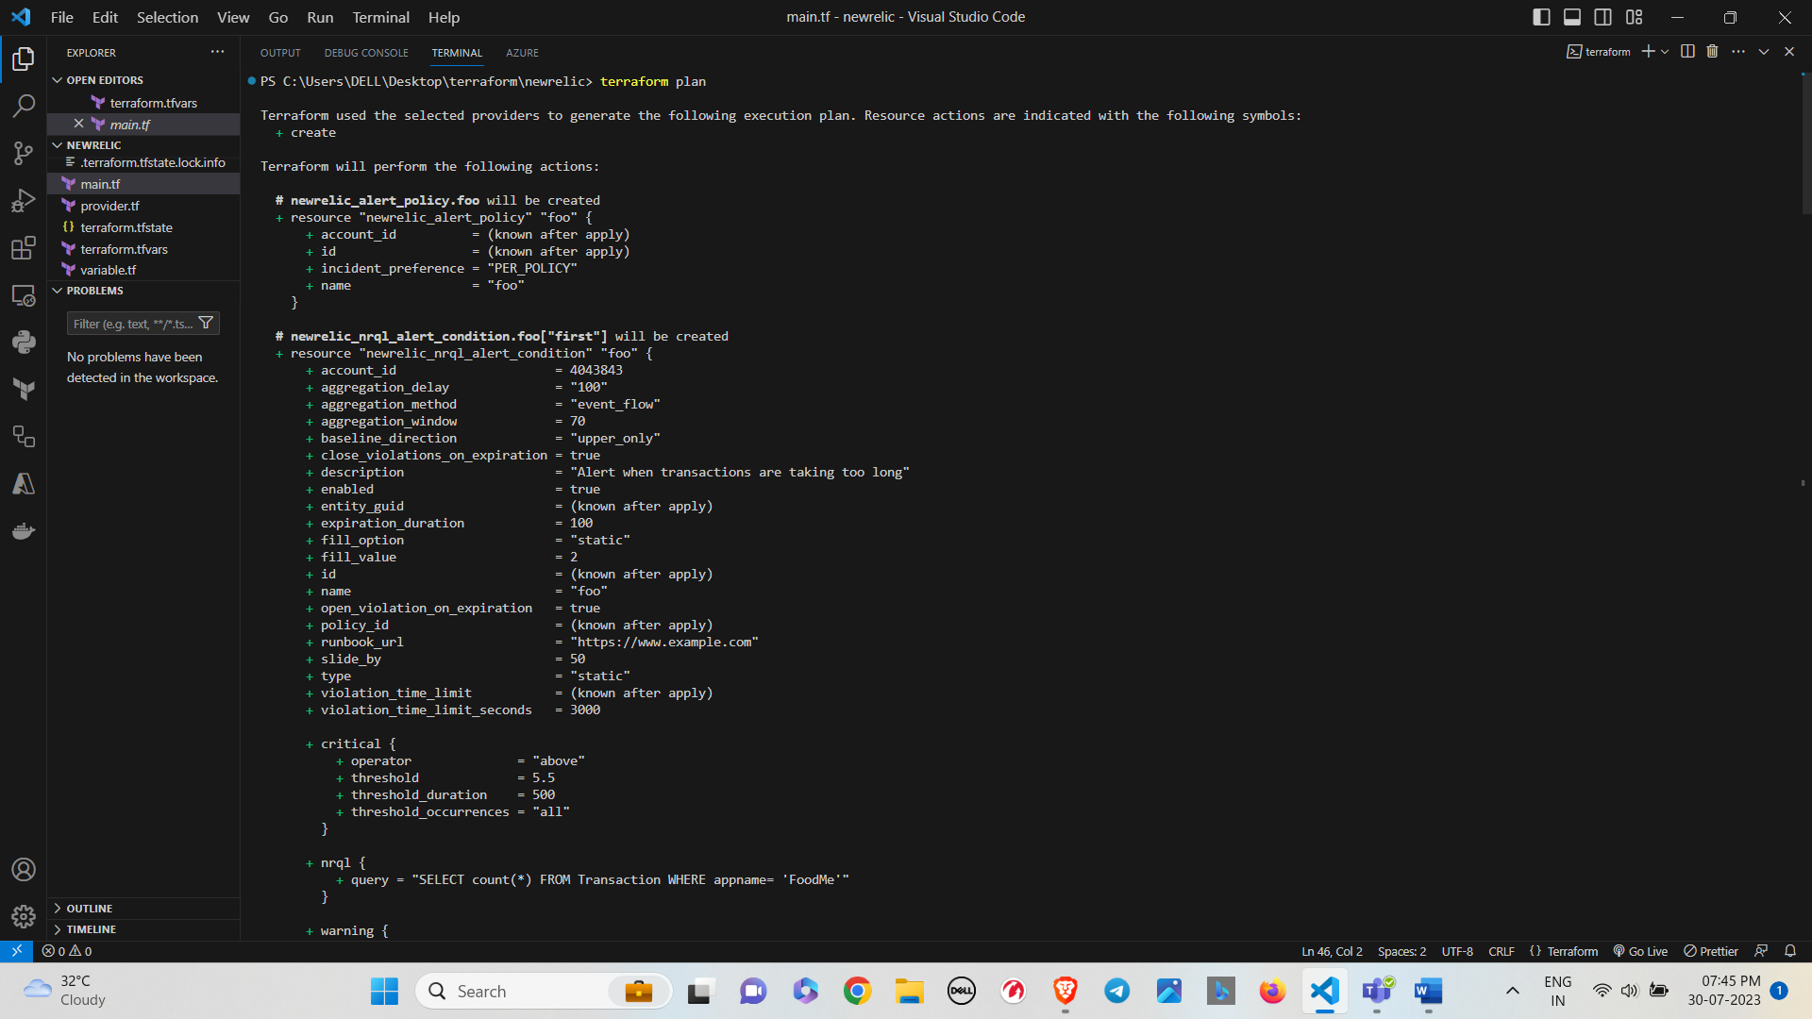

Apply:

Alert Count loop:

Plan:

Apply:

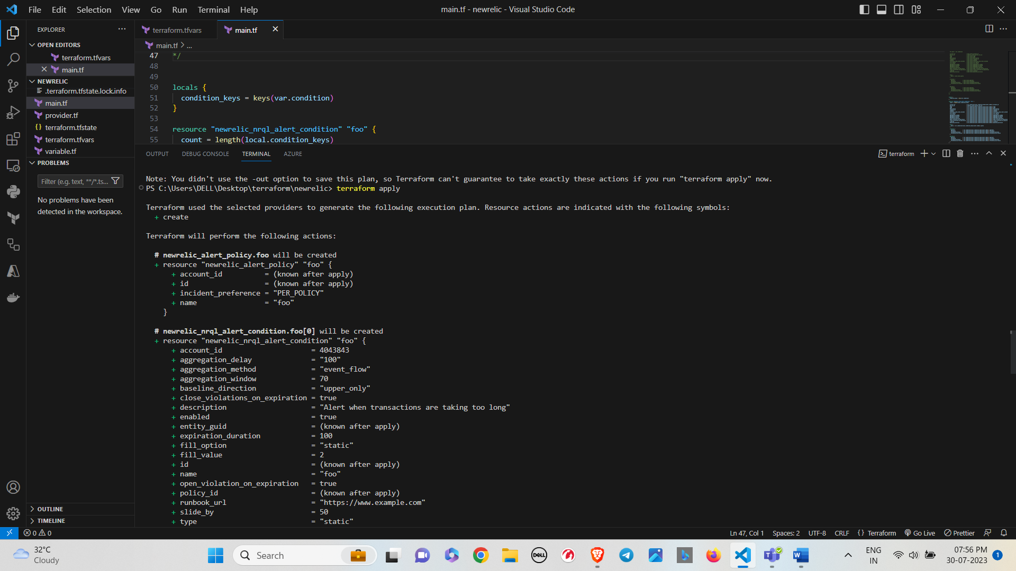

Dashboard

Plan :

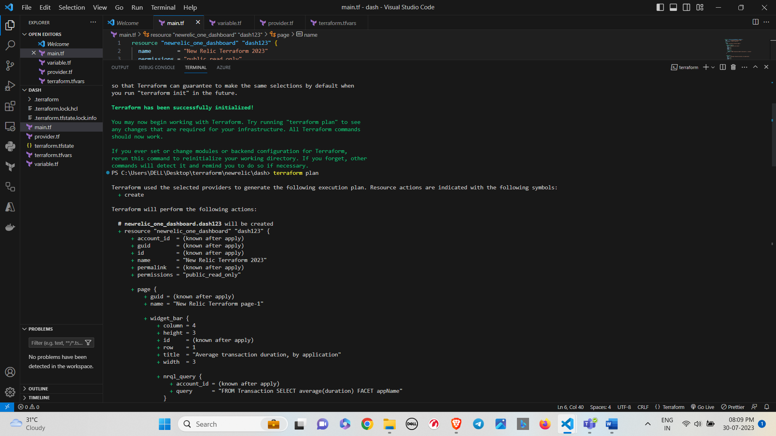

Apply:

