**Linked List**

Linked List can be defined as collection of objects called nodes that are randomly stored in the memory.

**An advantage of Linked Lists**

* Nodes can easily be removed or added from a linked list without reorganizing the entire data structure. This is one advantage it has over arrays.

**Disadvantages of Linked Lists**

* Search operations are slow in linked lists. Unlike arrays, random access of data elements is not allowed. Nodes are accessed sequentially starting from the first node.
* It uses more memory than arrays because of the storage of the pointers.

**Types of Linked Lists**

There are three types of linked lists:

* **Singly Linked Lists**: Each node contains only one pointer to the next node. This is what we have been talking about so far.
* **Doubly Linked Lists**: Each node contains two pointers, a pointer to the next node and a pointer to the previous node.

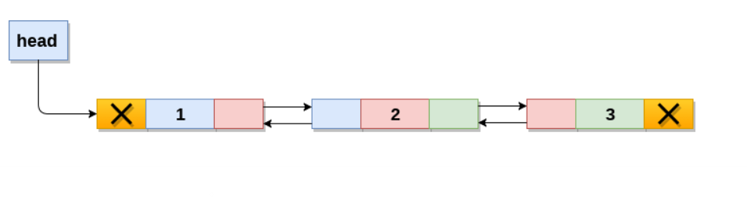

* **Circular Linked Lists**: Circular linked lists are a variation of a linked list in which the last node points to the first node or any other node before it, thereby forming a loop.

