Networking in JAVA

Client Server Architecture

**Client –**The client can be any computer that requests something from the server. For example– visiting any website we request the webpage from its domain. So here we act as a client.

**Server –**On the other hand, the Server is the computer that is designed to serve the requests to the client. For the same example as above, the client asks for the webpage then the server responds with the webpage to the client.

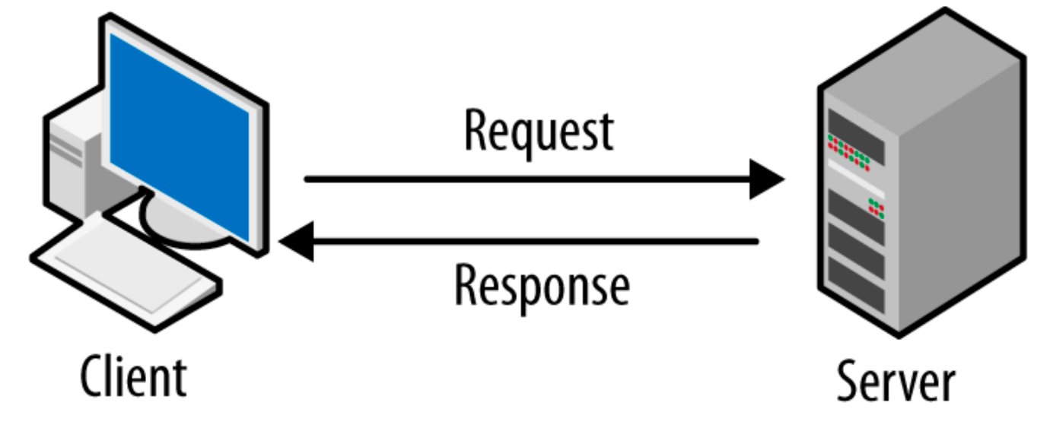

What is Client-Server Architecture?

The client-server architecture or model is an application network separating tasks between clients and servers that are either within the same system or need to communicate over a network. In order to access the service provided by the server, the server-client sends the request to another program, which runs a few programs that distribute work among the clients & share resources with them.

A client-server relationship corresponds to the request-response pattern and should adhere to a standard communications protocol that defines the language and rules used for the communications. The client-server communication adheres to the TCP protocol suite.

Client/server messages are exchanged via the TCP protocol until the connection is complete. TCP protocol determines how data should be distributed in packets that networks will deliver, transfers packets to and receives packets from networks, and manages flow control or retransmission of garbled and dropped packets.

The Internet Protocol is a connectionless protocol, which means that each packet traveling on the Internet is an independent piece of data, unconnected to any other packet.

What is Socket?

A socket is one endpoint of a two-way communication link between two programs running on the network. Java Socket programming is used for communication between the applications running on different JRE. Java Socket programming can be connection-oriented or connection-less. Socket and ServerSocket classes are used for connection-oriented socket programming and DatagramSocket and DatagramPacket classes are used for connection-less socket programming.

The client in socket programming must know two information:

* IP Address of Server, and
* Port number.

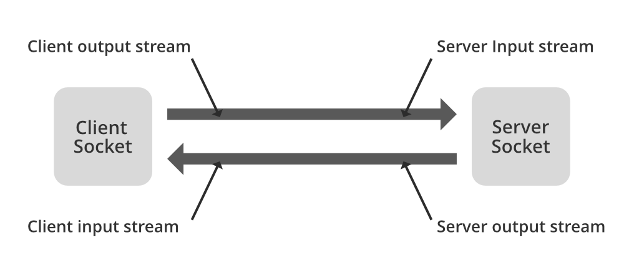

What is ServerSocket?

ServerSocket Class is used for providing system-independent implementation of the server-side of a client/server Socket Connection. The constructor for ServerSocket throws an exception if it can’t listen on the specified port (for example, the port is already being used).

* Waits for incoming client connection requests.
* Accepts connections and a socket is created.

