Department of Computer Science and Engineering
Software Architecture and Design Specification
Project: Pocket Packet Sniffer
Version: 1.0
Authors: Group 4 (Jackfruit Phase-1)
Ankita S (PES1UG24CS066) • Anusha Gupta (PES1UG24CS073)
Charan M (PES1UG24CS125) • Vaghasiya Akshar Arvindbhai (PES1UG25CS852)
Name | USN | SRN / PRN
Ankita S | PES1UG24CS066 | PES1202402282
Anusha Gupta | PES1UG24CS073 | PES1202402250
Charan M | PES1UG24CS125 | PES1202400244
Vaghasiya Akshar Arvindbhai | PES1UG25CS852 | PES1202503586

Date: 6 October 2026
Status: Draft

Revision History
Version | Date | Author | Change Summary
1.0 | 6 Oct 2026 | Group 4 | Initial draft: architecture, component diagram, 4 sequence diagrams, API design, security architecture.

Approvals
Role | Name | Signature/Date
Team Member | Ankita S (PES1UG24CS066)
Team Member | Anusha Gupta (PES1UG24CS073)
Team Member | Charan M (PES1UG24CS125)
Team Member | Vaghasiya Akshar Arvindbhai (PES1UG25CS852)
Course Coordinator

1. Introduction

1.1 Purpose
This document specifies the software architecture and detailed design of the Pocket Packet Sniffer v1.0. It describes the component structure, the chosen architecture pattern and its rationale, the dynamic behaviour of the system's four core flows (as UML sequence diagrams), the module interface (API) design, error-handling strategy, and the security architecture that realise the objectives and requirements defined in the SRS (v1.0). It is the Design-phase deliverable that developers use to implement each owned module consistently.

1.2 Scope
Covers the internal software architecture of Pocket Packet Sniffer v1.0: the layered component structure (Presentation → Controller → Service → Engine & Data); sequence diagrams for Live Capture start, Real-Time Summary refresh, Alert generation and Session Export; the in-process API design for the Capture, Summary, Alert and Session Store services; and the security architecture addressing the security requirements proposed in the Test Plan (SEC-01 to SEC-05). Excludes the internal design of Zeek itself, Raspberry Pi/ESP32 hardware and firmware design, and Future Scope items (multiple simultaneous interfaces, onboard display, remote dashboard), which are out of scope per the Synopsis and SRS.

1.3 Audience
Primary audience: the four Group 4 developers (Ankita S, Anusha Gupta, Charan M, Vaghasiya Akshar Arvindbhai), each implementing the module they own. Secondary audience: course faculty and evaluators assessing architectural soundness, modularity and requirements traceability; and any future maintainer extending the device (e.g., adding an onboard display or remote dashboard).

1.4 Definitions
Acronyms and terms used here follow SRS Appendix A. Additional architecture-specific terms:
- Controller: the thin layer that receives user actions from the Python UI and dispatches them to the corresponding Service.
- Service: a module containing the business logic for one owned feature, with no direct terminal/UI I/O (supports the Maintainability and Testability attributes of SRS Section 6.4).
- LogReader: the Zeek Integration component that tails Zeek's structured logs (conn.log, dns.log, http.log, notice.log) and yields parsed records.
- SessionStore: the Storage Layer component that owns the session index and the session files on local disk.
- STRIDE: Spoofing, Tampering, Repudiation, Information disclosure, Denial of service, Elevation of privilege — the threat-modelling categories used in Section 3.9.

2. Document Overview

2.1 How to use this document
Each developer should read Section 3 (Architecture) before writing any code for their module, to confirm which layer their functions belong in and which other components they call. Before implementing a specific flow, read the matching sequence diagram and API table in Sections 4.2–4.3. Testers should read Sections 3.9 and 4.4 when designing security and negative test cases for the Test Plan. Evaluators can use Section 3.8 (Traceability to Requirements) to check that every SRS requirement has an architectural home.

2.2 Related Documents
- Software Requirements Specification (SRS), Pocket Packet Sniffer, Version 1.0 — source of all REQ-x.y IDs referenced throughout this document.
- Software Test Plan (STP), Pocket Packet Sniffer, Version 1.0 (Draft) — source of NFR-01..05 and the proposed SEC-01..05 IDs; consumes this document's component/interface design for test-case design and the RTM.
- Group 4 — Pocket Packet Sniffer Synopsis / Project Proposal.

3. Architecture

3.1 Goals & Constraints
Goals: a modular, maintainable, independently-testable layered design in which each of the four owned features (Live Capture, Dashboard, Alerting, Session Storage/Export) can be implemented, unit-tested and reviewed in isolation using pre-recorded .pcap files (NFR-04); passive, local-only, secure-by-default behaviour; and a pipeline that keeps up with live traffic on a small LAN/lab segment with the dashboard refreshing at least every 2 seconds (NFR-01).
Constraints: packet analysis must be performed through Zeek rather than a custom parser; the control application and UI must be written in Python; raw captures must be stored in standard .pcap format; the target platform is Raspberry Pi-class Linux hardware with limited CPU, memory and storage; captured data stays on the device by default; one capture session per interface at a time (SRS Section 6.5); Agile, sprint-based delivery with Git/GitHub.

3.2 Stakeholders & Concerns
Stakeholder | Concerns
Students / TAs (end users) | Quick start of a capture, readable summary without Zeek/Wireshark expertise, trustworthy alerts, ability to keep and export sessions.
Junior network administrators | Low-effort first look at a segment; a device that does not disturb the network (passive operation) or crash on interface loss.
Course faculty / evaluators | Clean, modular design matching individual ownership; clear requirements-to-architecture-to-code traceability; demonstrable security validation.
Development team (Group 4) | Well-defined interfaces between the four owned modules so integration does not block anyone; unit testing without live network hardware.
Future maintainer | Ability to add an onboard display or remote dashboard without rewriting the Service and Storage layers (per Synopsis Future Scope).

3.3 Component (UML) Diagram
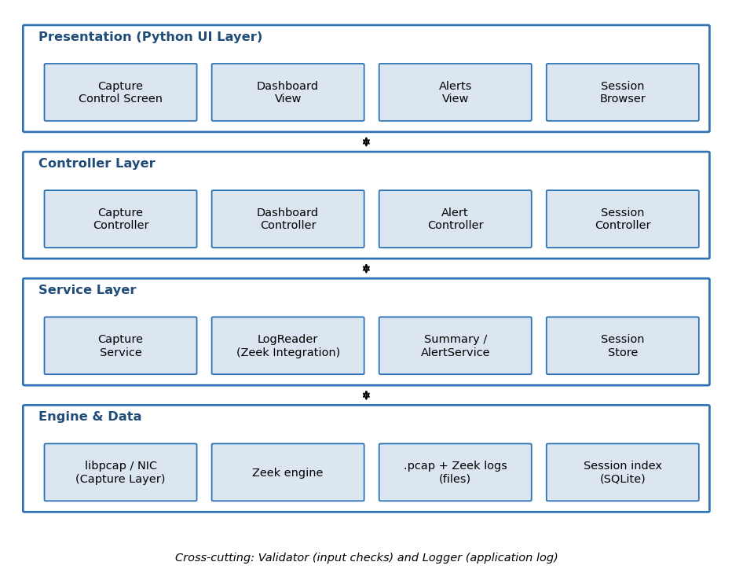
Figure 3.1 — Pocket Packet Sniffer High-Level Component Diagram (Layered Architecture)
Two cross-cutting components are shared by every Service and omitted above for clarity: Validator (interface, filter, duration and export-path checks) and Logger (application log). Both are detailed in Section 3.4.

3.4 Component Descriptions
Component | Responsibility | Owner
Python UI (Capture screen, Dashboard, Alerts view, Session browser) | Renders the terminal/dashboard screens, reads user input, displays results and errors (SRS 3.1). | Shared (UI/UX consistency)
CaptureController / CaptureService | Interface listing, start/stop, duration and filter control, .pcap writing, streaming to Zeek, graceful interface-disconnect handling (REQ-1.1..1.7). | Ankita S
LogReader (Zeek Integration) | Starts/feeds Zeek and tails its structured logs incrementally for the Summary and Alert services (REQ-1.5, REQ-2.1, REQ-3.2). | Ankita S / Anusha Gupta
DashboardController / SummaryService | Aggregates protocol breakdown, top talkers and connection counts and serves a refreshed summary (REQ-2.1..2.6). | Anusha Gupta
AlertController / AlertService | Enables/disables alerting, activates Zeek detection scripts, builds prioritised alert entries with timestamp, source and reason (REQ-3.1..3.5). | Charan M
SessionController / SessionStore | Maintains the local session index, session files, browsing, retention across reboots and export (REQ-4.1..4.5). | Vaghasiya Akshar Arvindbhai
Validator | Validates interface names, filters, durations and export paths before any use (SEC-03, SEC-05). | Shared
Logger | Writes the application log (errors, warnings, session events) without logging captured payload content. | Shared
Zeek engine / libpcap | External engines: packet acquisition and .pcap output; protocol parsing, structured logs and detection scripts. | External (not developed)
Local storage | Session directories holding .pcap files and Zeek logs, plus the session index (SQLite file) following SRS Appendix B fields. | Vaghasiya Akshar Arvindbhai

3.5 Chosen Architecture Pattern and Rationale
Pattern: layered architecture (Presentation → Controller → Service → Engine/Data) arranged along a linear data pipeline (Capture → Zeek analysis → Summary/Alerts → Storage/Export), with one-directional, adjacent-layer-only calls.
Rationale: the layers and pipeline stages map one-to-one onto the team's product-ownership split (Synopsis Section 6), so each member can implement, unit-test and demo their Controller+Service pair independently. Keeping UI code separate from Services satisfies the SRS Maintainability and Testability attributes and lets Services run against pre-recorded .pcap files and sample Zeek logs with Zeek and the network interface mocked. Treating Zeek as an external engine behind the LogReader confines all Zeek-specific parsing to one place. A distributed or microservice style was considered and rejected: the product is a single-device, single-user tool on constrained Raspberry Pi hardware, so extra processes or a message bus would add CPU/memory load and complexity with no benefit.

3.6 Technology Stack & Data Stores
Layer / Concern | Technology | Notes
Language | Python 3 | Control application and UI (SRS 2.5)
Packet capture | libpcap-based capture (e.g., tcpdump) run via argument-list subprocess | Writes standard .pcap; no shell string execution (SEC-03)
Analysis engine | Zeek (standard and extended scripts) | Produces conn.log, dns.log, http.log, notice.log
UI | Terminal-based Python interface (final choice per SRS 3.1) | Terminal or simple web/GUI dashboard allowed by SRS
Persistence | Session directories on local disk + SQLite session index | Fields per SRS Appendix B; local-only storage
Hardware | Raspberry Pi; optional ESP32 auxiliary component | Per Synopsis 3.3
Testing | pytest, pytest-cov, tcpreplay, nmap (lab traffic) | Per STP Section 6
Static analysis / CI | Bandit, SonarQube, Jenkins, Docker, GitHub | Per STP Section 6

3.7 Risks & Mitigations
Risk | Mitigation
Zeek is heavy for Raspberry Pi-class hardware and may drop packets under load | Single interface only; incremental log tailing; BPF filter support (REQ-1.4); replay-based performance test at 5 Mbps (NFR-02).
Interface disconnects or unplugs during capture | CaptureService monitors the capture process, finalises the partial .pcap, notifies the user within 5 seconds and returns to idle (REQ-1.7, NFR-03).
Command or path injection through filter, interface or export names | Validator allow-lists inputs; subprocesses use argument lists, never a shell; export names sanitised against path traversal (SEC-03, SEC-05).
Captured data exposure | Local-only storage, owner-only file permissions, no outbound transmission of captured data (SEC-01, SEC-02).
Alerts over-claim detection capability | Alerting restricted to Zeek-supported patterns; UI wording never presents the device as an IDS/SIEM (REQ-3.5).
Zeek unavailable or mismatched on the target OS | Sprint 0 spike to confirm installation; start-up check and clear fatal message (Section 4.4.3); tests use sample logs with Zeek mocked.

3.8 Traceability to Requirements
Architecture Component | Requirements Realised
CaptureController / CaptureService | REQ-1.1..1.7; NFR-03; SEC-03, SEC-04
LogReader (Zeek Integration) | REQ-1.5, REQ-2.1, REQ-3.2; NFR-04
DashboardController / SummaryService | REQ-2.1..2.6; NFR-01, NFR-02, NFR-05
AlertController / AlertService | REQ-3.1..3.5; SEC-04
SessionController / SessionStore | REQ-4.1..4.5; SEC-01, SEC-02, SEC-05
Validator / Logger | SEC-03, SEC-05; NFR-03

3.9 Security Architecture
Threats are analysed using STRIDE and mapped to the components responsible for mitigating each. The device is single-user with no login (SRS 6.3: access is controlled by physical/OS-level access), so the emphasis is on data confidentiality, input safety and passive operation.
STRIDE Category | Threat (Pocket Packet Sniffer-specific) | Mitigating Component(s) / Requirement
Spoofing | A crafted or replayed pcap/log is presented as genuine session data | Session records created only by SessionStore at capture end with generated Session ID; files stay in owner-only directories (SEC-02)
Tampering | Stored .pcap, Zeek logs or index altered by another OS user; malformed filter injected into the capture command | Owner-only permissions (SEC-02); Validator allow-list and argument-list subprocess (SEC-03)
Repudiation | Disputing when/on which interface a capture was made | Session index records interface, start/end timestamps and filter (SRS Appendix B); application log entries per session
Information Disclosure | Captured traffic leaks off the device or is read by other users; export written to an unintended path | No outbound transmission of captured data (SEC-01); owner-only files (SEC-02); sanitised export destination (SEC-05)
Denial of Service | Heavy traffic overwhelms the Pi; malformed input or interface loss crashes a session; active probing disrupts the segment | Single interface, filters, incremental log reading; graceful disconnect handling (REQ-1.7); passive-only operation (SEC-04)
Elevation of Privilege | Unsanitised input reaches a shell or Zeek with elevated capture privileges | Capture privileges limited to the capture subprocess; no shell execution; Validator checks before any call (SEC-03)

4. Design

4.1 Design Overview
The product is designed as four vertical, independently-ownable feature slices (Live Capture, Dashboard, Alerting, Session Storage/Export) sitting on a shared Zeek Integration and Storage foundation, each slice following the same Controller → Service shape described in Section 3. This section details the dynamic behaviour of the four core user-facing flows as UML sequence diagrams, followed by the module (API) interface design, the error-handling strategy, and the UX design.

4.2 UML Sequence Diagrams
Four sequence diagrams are provided — one per owned module — covering the highest-value flow in each (exceeding the minimum of two required).

4.2.1 Start Live Capture (Owner: Ankita S)
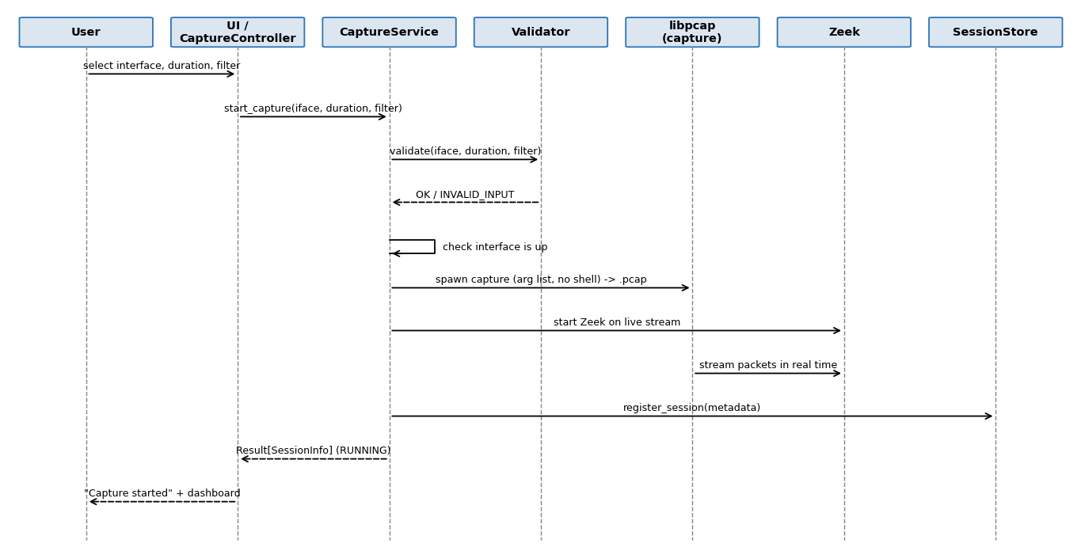
Figure 4.1 — Sequence Diagram: Start Live Capture (REQ-1.1..1.6)
CaptureService::start_capture() validates the interface, optional duration and optional filter through the Validator before anything is executed. The capture is launched with an argument list (no shell, SEC-03), writes the raw .pcap to the session directory and streams packets to Zeek in real time. The session is registered with SessionStore as RUNNING. Stopping (user request or duration elapsed) finalises the .pcap and Zeek logs and marks the session COMPLETED; an interface disconnect finalises the partial .pcap and returns Status::INTERFACE_DISCONNECTED (REQ-1.7).

4.2.2 Real-Time Summary Refresh (Owner: Anusha Gupta)
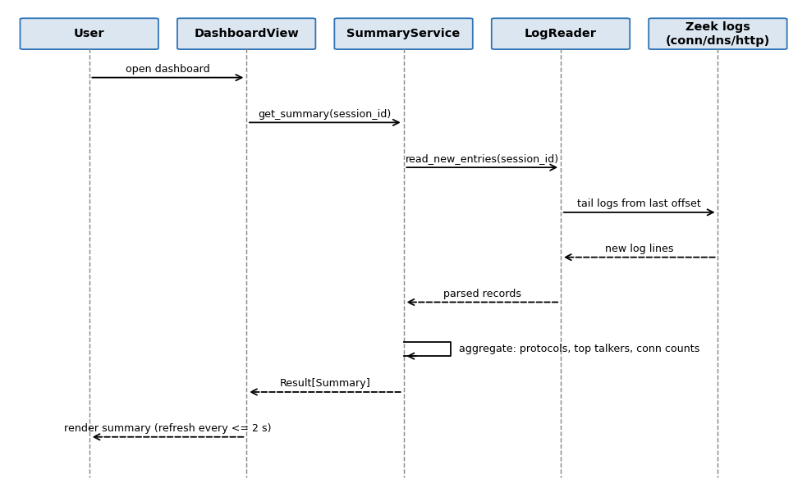
Figure 4.2 — Sequence Diagram: Real-Time Summary Refresh (REQ-2.1..2.6)
SummaryService does not re-read whole logs on each refresh: LogReader keeps a per-file offset and returns only new entries, which SummaryService merges into running counters (protocol breakdown, per-host byte/connection counts, total connections). The view refreshes at most every 2 seconds (NFR-01) and also works after the capture has ended, using the stored Zeek logs.

4.2.3 Alert Generation (Owner: Charan M)
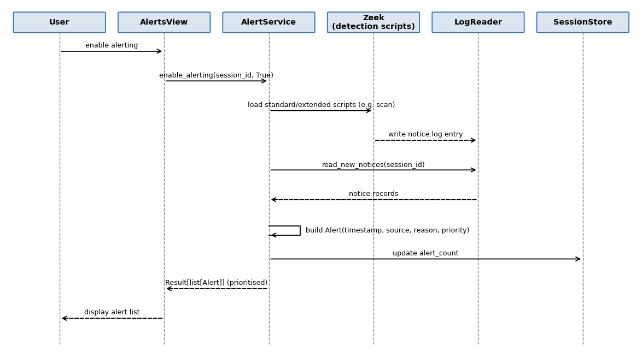
Figure 4.3 — Sequence Diagram: Alert Generation (REQ-3.1..3.5)
When alerting is enabled, Zeek runs with its standard/extended detection scripts (e.g., port-scan detection). AlertService reads Zeek's notice records through LogReader, converts each into an Alert with timestamp, source and reason, assigns a priority, sorts the list (highest priority first, then newest) and updates the session's alert count. Only patterns supported by Zeek or defined project-specific logic are reported (REQ-3.5).

4.2.4 Session Browse & Export (Owner: Vaghasiya Akshar Arvindbhai)
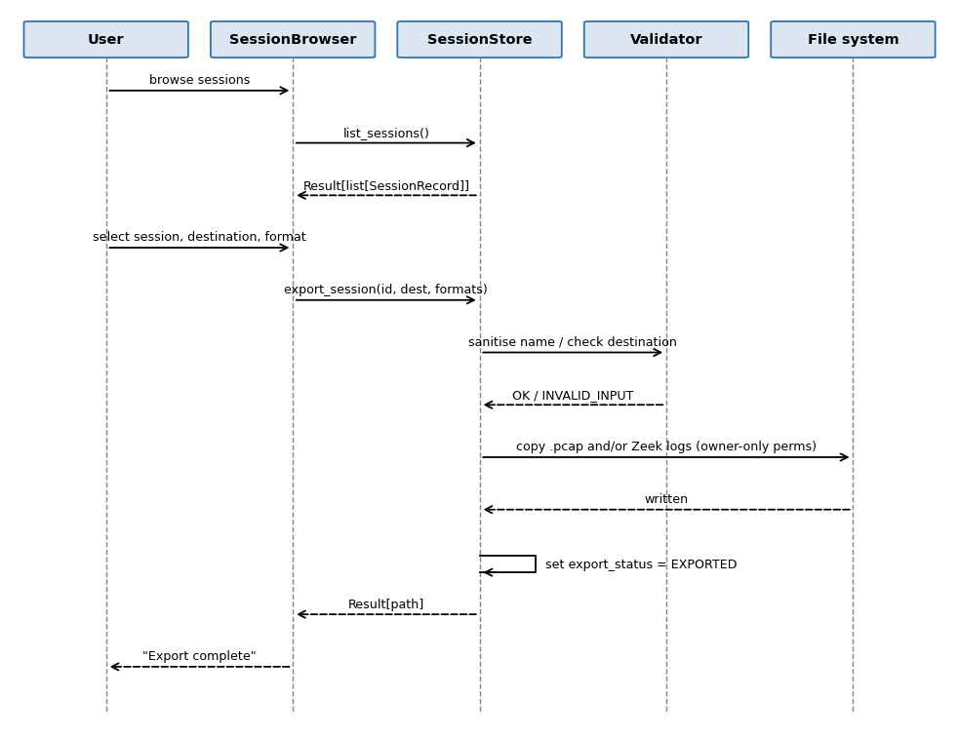
Figure 4.4 — Sequence Diagram: Session Browse & Export (REQ-4.1..4.5)
SessionStore reads the index to list sessions with date, duration and interface. On export, the session name and destination are sanitised against path traversal (SEC-05); the selected .pcap and/or Zeek logs are copied unmodified, so the exported .pcap stays Wireshark-compatible (REQ-4.5). Data persists across restarts and reboots because the index and files are on local disk (REQ-4.4).

4.3 API Design
The product is a single-process Python application with no mandatory network layer, so 'API' here means the in-process module interface (function signatures) between a Controller and its Service — not a REST/HTTP API. Interfaces are given for all four owned components (exceeding the minimum of two).

4.3.1 Shared Types (core/types.py)
Defined by Ankita S (Status/Result) and Vaghasiya Akshar Arvindbhai (SessionRecord) and adopted as the single canonical type set for every module, so all services return the same Status/Result shapes rather than each inventing its own error handling.
- class Status(Enum): OK, INVALID_INPUT, INTERFACE_UNAVAILABLE, INTERFACE_DISCONNECTED, ZEEK_ERROR, NOT_FOUND, PERMISSION_ERROR, IO_ERROR, INTERNAL_ERROR
- @dataclass Result[T]: status: Status, value: Optional[T], detail: str
- @dataclass SessionRecord: session_id, interface_name, start_ts, end_ts, duration_sec, filter_applied, pcap_path, zeek_log_path, alert_count, export_status — field lengths and mandatory flags per SRS Appendix B
- @dataclass Summary: protocol_breakdown: dict[str,int], top_talkers: list[(host, count)], connection_count: int, updated_at
- @dataclass Alert: timestamp, source, reason, priority (HIGH/MEDIUM/LOW)

4.3.2 Per-Component Interfaces
Component | Interface (signature) | Errors / Notes
CaptureService  (Ankita S) | list_interfaces() -> Result[list[str]]  start_capture(iface: str, duration: Optional[int], bpf_filter: Optional[str]) -> Result[SessionRecord]  stop_capture(session_id: str) -> Status | INVALID_INPUT, INTERFACE_UNAVAILABLE, INTERFACE_DISCONNECTED, ZEEK_ERROR. Only one active session per interface (SRS 6.5).
SummaryService  (Anusha Gupta) | get_summary(session_id: str) -> Result[Summary]  reset(session_id: str) -> Status | NOT_FOUND for unknown session; an empty summary is a valid OK result, not an error.
AlertService  (Charan M) | enable_alerting(session_id: str, enabled: bool) -> Status  get_alerts(session_id: str) -> Result[list[Alert]] | ZEEK_ERROR if scripts cannot be loaded; zero alerts is a valid OK result.
SessionStore  (Vaghasiya Akshar Arvindbhai) | register_session(rec: SessionRecord) -> Status  list_sessions() -> Result[list[SessionRecord]]  get_session(session_id: str) -> Result[SessionRecord]  export_session(session_id: str, dest: str, formats: set[str]) -> Result[str] | NOT_FOUND, INVALID_INPUT (unsafe name/path), PERMISSION_ERROR, IO_ERROR.

4.4 Error Handling, Logging & Monitoring
Lead: Ankita S (capture errors). Storage/log angle: Vaghasiya Akshar Arvindbhai.

4.4.1 Error-Handling Strategy
- Detect early: user-supplied values are validated by Validator before any subprocess, Zeek or file operation (SEC-03).
- Return, don't crash: errors travel upward as Status values (Section 4.3.1); each layer handles an error or passes it up unchanged.
- Translate once: only the UI turns a Status into text, in the form "ERROR: <area>: <message>."; internal details (stack traces, file paths) are logged but not shown.
- Fail safe: on any capture failure the partial .pcap is finalised and kept readable, and the session is marked with its final state (NFR-03).
- Never crash the device: after start-up, every error returns the user to the previous screen (SRS 6.2, 6.4).

4.4.2 Error Catalogue
Status | Raised by | User message (UI) | Log level
INVALID_INPUT | Validator | ERROR: input: <field> is not valid. | WARN
INTERFACE_UNAVAILABLE | CaptureService | ERROR: interface: <name> is not available. | WARN
INTERFACE_DISCONNECTED | CaptureService | WARNING: interface lost; capture stopped, partial capture saved. | WARN
ZEEK_ERROR | LogReader / AlertService | ERROR: analysis: Zeek could not be started. | ERROR
NOT_FOUND | SessionStore / Services | ERROR: session: not found. | INFO
PERMISSION_ERROR | SessionStore | ERROR: file: permission denied. | ERROR
IO_ERROR | SessionStore | ERROR: file: could not write <name>. | ERROR
INTERNAL_ERROR | Service boundary catch | ERROR: internal: unexpected error, see log. | ERROR

4.4.3 Start-up / Fatal Conditions
Condition at start-up | Action | Exit code
Zeek not found or not runnable | Print "FATAL: Zeek not available.", log, exit | 2
Session storage directory missing | Create it with owner-only permissions; continue | —
Session storage directory not writable | Print "FATAL: cannot write to session storage.", log, exit | 3
Session index missing or unreadable | Create a new index; if corrupt, keep the corrupt file, warn, rebuild from session directories | —
Log file cannot be opened | Warn and continue, logging to stderr only | —

4.4.4 Capture & Storage Recovery Rules
- A capture process that exits unexpectedly is detected by CaptureService, which finalises the .pcap and marks the session INTERRUPTED so it still appears in history and can be exported.
- Session index updates are written atomically (single SQLite transaction), so a power loss on battery-powered operation never leaves a half-written index entry (REQ-4.4).
- Each session has its own directory; partial files are never deleted automatically.
- Zeek logs are read incrementally; if a log rotates or is truncated, LogReader resets its offset and continues.

4.4.5 Logging & Monitoring
The product keeps an application log (written by Logger across all modules, for diagnosing failures) separate from the per-session artefacts (.pcap, Zeek logs) and index. Captured payload content is never written to the application log. Monitoring in this version is CI- and log-based rather than live: the Jenkins/GitHub build and test pass rate is the team's health signal, and the dashboard shows the live capture state to the user.

4.5 UX Design
The Python interface follows SRS Section 3.1: a capture control screen (interface list, start/stop, duration, filter), a live dashboard (protocol breakdown, top talkers, connection counts), an alerts view (timestamp, source, reason, priority) and a session browser with export. Wording and layout are kept simple so a user with no Zeek or Wireshark experience can start a capture and find the top talker within 5 minutes (NFR-05). Every screen shows a clear title and current capture state, invalid input re-prompts rather than crashing, and every operation returns to the previous screen on completion or cancellation. UI/UX consistency across the four views is a shared team responsibility (Synopsis Section 6).

4.6 Open Issues & Next Steps
- Confirm whether the ESP32 is required by the final hardware design and, if so, define its interface to the capture layer (SRS 2.4).
- Finalise the UI form (terminal vs. simple web/GUI dashboard) in Sprint 2/3; the Controller/Service split is designed to make this a Presentation-layer change only.
- Decide the alert priority mapping for each supported Zeek notice type (e.g., port scan).
- Agree the measurable NFR-01..05 and SEC-01..05 values proposed in the Test Plan and add them to the SRS so SRS, STP and this document stay consistent.
- Benchmark Zeek on the target Raspberry Pi in Sprint 0 to confirm the 5 Mbps replay target (NFR-02).
- Future enhancements (out of v1.0 scope): multiple simultaneous interfaces, onboard LCD, remote dashboard, trend analysis across stored sessions.

5. Appendices

5.1 Glossary
See SRS Appendix A for product-level terms (Zeek, .pcap, conn.log/dns.log/http.log, top talkers, port-scan behaviour, Raspberry Pi, ESP32). Architecture-specific terms are defined in Section 1.4 of this document (Controller, Service, LogReader, SessionStore, STRIDE).

5.2 References
- Software Requirements Specification (SRS), Pocket Packet Sniffer, Version 1.0, Group 4.
- Software Test Plan (STP), Pocket Packet Sniffer, Version 1.0 (Draft), Group 4.
- Group 4 — Pocket Packet Sniffer Synopsis / Project Proposal.
- Zeek Network Security Monitor documentation — https://zeek.org
- OMG Unified Modeling Language (UML) Specification, Version 2.5.1.

5.3 Tools
- Diagramming: diagrams in this document were generated programmatically in a UML sequence-diagram convention; Draw.io/PlantUML are acceptable alternatives for future revisions.
- pytest and pytest-cov (unit testing and coverage), Bandit and SonarQube (static analysis), Jenkins and GitHub (CI/CD and version control), tcpreplay and nmap (test traffic).

