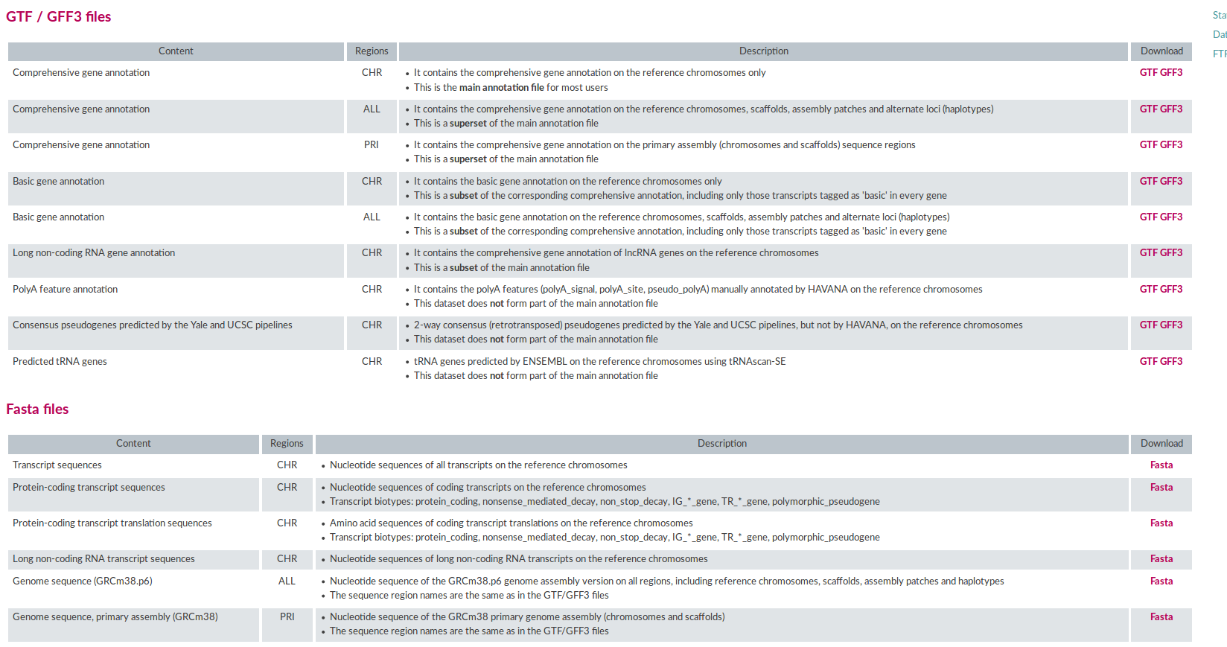

#They says mm10 and GRCm38 is same in possitions
#gencode, GRCm38, vM20

#Split genome: https://crashcourse.housegordon.org/split-fasta-files.html
csplit -s -z GRCm38.p6.genome.fa '/>/' '{*}'
for i in xx* ; do \
n=$(sed 's/>// ; s/ .*// ; 1q' "$i") ; \
mv "$i" "$n.fa" ; \
done
#I didnt use this genome. I used mm10 directly downloaded from UCSC chr files. This is more reliable . I believe GRCm38 = mm10. Since gencodes does not showed individual chromosomes fasta, I took this and created N-masked genome.
#grep chr because to remove empty lines
awk '{print "chr"$1"\t"$2"\t"$3"\t"$4"%"$5}' jf1v2_SnpallN.tsv > jf1v2_SnpallN.chr.tsv
python ~/tools_av/CrossMap-0.2.5/bin/CrossMap.py bed ./../../../jf1_ref/mm9ToMm10.over.chain.gz jf1v2_SnpallN.chr.tsv > jf1v2_SnpallN.chr._mm9ToMm10.chain
awk '{print $6"\t"$7"\t"$8"\t"$9}' jf1v2_SnpallN.chr._mm9ToMm10.chain | awk -F'%' '{print $0}' > jf1v2_SnpallN.chr.Mm10.txt
awk '{print $6"\t"$7"\t"$8"\t"$9}' jf1v2_SnpallN.chr._mm9ToMm10.chain | awk -F'%' '{print $1"\t"$2"\t"$3"\t"$4}' | grep chr | sed 's/chr//' > jf1v2_SnpallN.chr.Mm10.tsv

#New JF1_Ms strain SNPs obtained from Sanger Web
#https://www.biostars.org/p/370756/#370959
wget -q -O - "ftp://ftp-mouse.sanger.ac.uk/REL-1807-SNPs_Indels/mgp.v6.merged.norm.snp.indels.sfiltered.vcf.gz" | bcftools view --samples "JF1_MsJ" | bcftools query -i 'INFO/AC>0' -f '%CHROM %POS %REF %ALT\n' > JF1_Snp_Indel_Grcm38.txt

cat JF1_Snp_Indel_Grcm38.txt | wc -l
26645843

#Remove insertion-$4 and deletions-$3

awk 'length($3)<=1' JF1_Snp_Indel_Grcm38.txt | awk 'length($4)<=1' > JF1_Snp_Grcm38.txt
#length will not be less than 1. The pipe | symbol allows only single letter to be present in $3 and $4, making extraction of only SNP. In this file deletion has $3 > 1, $4 can be 1 or any other natural number. eg. $3 = CGCGC and $4 = CC or CCCC or C. On th other hand insertion has $4 > 1 , $3 any number.

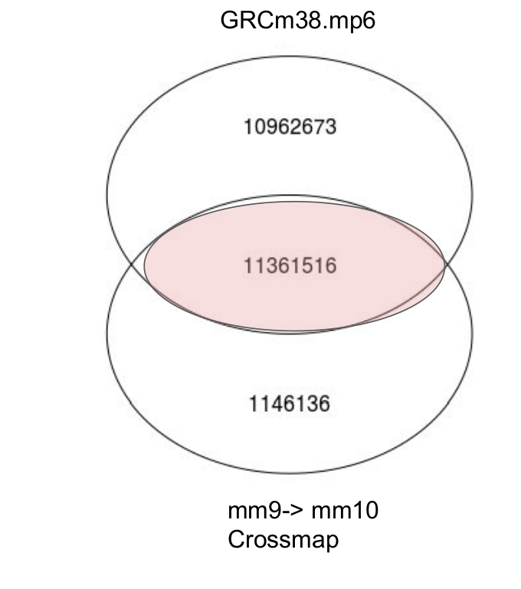
awk '{print $1"\t"$2"\t"$2"\t"$3"\t""N"}' JF1_Snp_Grcm38.txt > jf1v2_SnpallN-chr.GRCm38.tsv

awk '{print $1"\t"$2"\t"$2"\t"$3"\t"$4}' JF1_Snp_Grcm38.txt > jf1v2_Snp+chr.GRCm38.tsv

awk '{print NR"\t"$1"\t"$2"\t""1""\t"$3"/"$4}' JF1_Snp_Grcm38.txt > jf1v2_Snp-chr.GRCm38.Snpfile.txt

#Overlap SNPs between GRCm38 and mm10
awk '{print $1"%"$2"%"$3"%"$4}' JF1_Snp_Grcm38.txt > JF1_Snp_Grcm38.merged.txt
awk '{print $1"%"$2"%"$4"%"$5}' jf1v2_Snp.chr.Mm10.tsv > JF1_Snp_chr.mm10.merged.txt
fgrep -f JF1_Snp_Grcm38.merged.txt /home/ankitv/ref_av/gencodes/gencode_M20/N-masked-M20/JF1_Snp_chr.mm10.merged.txt -w
| awk -F'%' '{print $1"\t"$2"\t"$3"\t"$4}' > JF1_Snp_Grcm38.merged.overlapped.mm10.txt
cat JF1_Snp_Grcm38.merged.overlapped.mm10.txt | wc -l
11361516
#Overlap was also checked by R, as in venn

awk '{print $1"\t"$2"\t"$2"\t"$3"\t""N"}' JF1_Snp_Grcm38.merged.overlapped.mm10.txt > jf1v2_SnpallN-chr.GRCm38.mm10.tsv
awk '{print $1"\t"$2"\t"$2"\t"$3"\t"$4}' JF1_Snp_Grcm38.merged.overlapped.mm10.txt > jf1v2_Snp+chr.GRCm38.mm10.tsv
awk '{print NR"\t"$1"\t"$2"\t""1""\t"$3"/"$4}' JF1_Snp_Grcm38.merged.overlapped.mm10.txt > jf1v2_Snp-chr.GRCm38.mm10.Snpfile.txt
cat jf1v2_SnpallN-chr.GRCm38.mm10.tsv | wc -l
11361516

#Later on I also extracted indels as follows: Not used in analysis only for peak assessment
awk '{print $1"%"$2"%"$3"%"$4}' JF1_Snp_Indel_Grcm38.txt > JF1_Snp_Indel_Grcm38.merged.txt
fgrep -f JF1_Snp_Grcm38.merged.txt JF1_Snp_Indel_Grcm38.merged.txt -v | awk -F'%' '{print $1"\t"$2"\t"$3"\t"$4}' > JF1_Indel_Grcm38.txt

#As understood from /home/ankitv/ref_av/jf1_ref/jf1v2_Indel.bed , the end position of indels is the length of ref base minus 1, Indel will tell how many bases from reference is affected so only the position of bases in ref matters

awk '{print "chr"$1"\t"$2"\t"(length($3)+$2)-1"\t"$3"\t"$4}' JF1_Indel_Grcm38.txt > JF1_Indel_Grcm38.bed

#SNP positions uniqueness check
ankitv@ankitv-lab-riccio:/media/ankitv/Archivio1/MEA/test/mm10/bcftools$ awk '{print $1"%"$2}' JF1_Snp_Grcm38.txt | sort -k1,1 -u | wc -l
22324067
ankitv@ankitv-lab-riccio:/media/ankitv/Archivio1/MEA/test/mm10/bcftools$ cat JF1_Snp_Grcm38.txt | wc -l
22324067
#No duplicates found

#Marcos script:This script will read mm10 folder containing chromosome files (note chr*.fa has chr1,chr2,chr3…. in mm10 which will be removed later to make it 1,2,3….). Note: “chr” in fasta file of genome is removed by Marco’s python script while running and and only 1,2,3,4….. will be used to match with chromosme column (which is also 1,2,3,...) in SnpN file, tested by testchrname_genome_converter.py
cat marco.genome_converter.py
import glob

files_genoma = glob.glob("mm10/*.fa")
for file_cromosoma in files_genoma:
file_cromosoma = open( file_cromosoma ,'r')
file_cromosoma.close
sequenza_cromosoma = file_cromosoma.read().split()
nome_sequenza_cromosoma = sequenza_cromosoma[0][1:]
numero_cromosoma = nome_sequenza_cromosoma[3:]
del sequenza_cromosoma[0]
sequenza_cromosoma = bytearray(''.join(sequenza_cromosoma))

righe=[riga.rstrip().split('\t') for riga in open("jf1v2_SnpallN-chr.GRCm38.tsv",'r')]

conteggio=0
for riga in righe:
if riga[0]== numero_cromosoma:
sequenza_cromosoma[int(riga[1])-1]=riga[4]
conteggio=conteggio+1

print nome_sequenza_cromosoma +' SNPs number = '+str(conteggio)
conteggio=0

miofile = open(nome_sequenza_cromosoma+'.fasta','w')
miofile.write('>'+nome_sequenza_cromosoma+'\n'+sequenza_cromosoma)
miofile.close()

python marco.genome_converter.py
chr1 SNPs number = 1716476
chrY SNPs number = 7428
chr6 SNPs number = 1346368
chr13 SNPs number = 1048576
chr4 SNPs number = 1392032
chr19 SNPs number = 573221
chr7 SNPs number = 1311655
chr10 SNPs number = 1221605
chr12 SNPs number = 969949
chr16 SNPs number = 894369
chr11 SNPs number = 1037966
chr14 SNPs number = 941255
chr8 SNPs number = 766714
chr3 SNPs number = 1463437
chr5 SNPs number = 1400767
chr9 SNPs number = 1068088
chr2 SNPs number = 1493081
chrX SNPs number = 976973
chr18 SNPs number = 849269
chr15 SNPs number = 980956
chr17 SNPs number = 863563
chrM SNPs number = 0

#Overlap GRCm38.mm10
chr1 SNPs number = 869738
chrY SNPs number = 30
chr6 SNPs number = 674042
chr13 SNPs number = 552152
chr4 SNPs number = 660644
chr19 SNPs number = 311972
chr7 SNPs number = 620592
chr10 SNPs number = 623769
chr12 SNPs number = 489908
chr16 SNPs number = 478950
chr11 SNPs number = 563237
chr14 SNPs number = 489945
chr8 SNPs number = 404798
chr3 SNPs number = 740276
chr5 SNPs number = 738804
chr9 SNPs number = 567856
chr2 SNPs number = 812172
chrX SNPs number = 348326
chr18 SNPs number = 460741
chr15 SNPs number = 524067
chr17 SNPs number = 429497
chrM SNPs number = 0

#Check for total lines in new vcf file mp6
zcat mgp.v6.merged.norm.snp.indels.sfiltered.vcf.gz | wc -l
90311117 = ~ 90 million
#JF1 extracted SNPs by the above command may be specific.
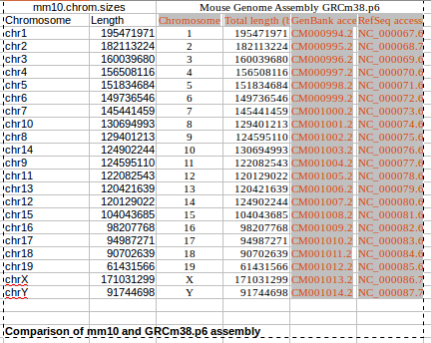

#Remove chr from all N-masked chromosme.fasta generated by previous script
sed -i '1d' chr1.fasta
sed -i '1d' chr2.fasta
sed -i '1d' chr3.fasta
sed -i '1d' chr4.fasta
sed -i '1d' chr5.fasta
sed -i '1d' chr6.fasta
sed -i '1d' chr7.fasta
sed -i '1d' chr8.fasta
sed -i '1d' chr9.fasta
sed -i '1d' chr10.fasta
sed -i '1d' chr11.fasta
sed -i '1d' chr12.fasta
sed -i '1d' chr13.fasta
sed -i '1d' chr14.fasta
sed -i '1d' chr15.fasta
sed -i '1d' chr16.fasta
sed -i '1d' chr17.fasta
sed -i '1d' chr18.fasta
sed -i '1d' chr19.fasta
sed -i '1d' chrX.fasta
sed -i '1d' chrY.fasta
sed -i '1d' chrM.fasta
sed '1s/^/>1 \n/' chr1.fasta > chr1.fa
sed '1s/^/>2 \n/' chr2.fasta > chr2.fa
sed '1s/^/>3 \n/' chr3.fasta > chr3.fa
sed '1s/^/>4 \n/' chr4.fasta > chr4.fa
sed '1s/^/>5 \n/' chr5.fasta > chr5.fa
sed '1s/^/>6 \n/' chr6.fasta > chr6.fa
sed '1s/^/>7 \n/' chr7.fasta > chr7.fa
sed '1s/^/>8 \n/' chr8.fasta > chr8.fa
sed '1s/^/>9 \n/' chr9.fasta > chr9.fa
sed '1s/^/>10 \n/' chr10.fasta > chr10.fa
sed '1s/^/>11 \n/' chr11.fasta > chr11.fa
sed '1s/^/>12 \n/' chr12.fasta > chr12.fa
sed '1s/^/>13 \n/' chr13.fasta > chr13.fa
sed '1s/^/>14 \n/' chr14.fasta > chr14.fa
sed '1s/^/>15 \n/' chr15.fasta > chr15.fa
sed '1s/^/>16 \n/' chr16.fasta > chr16.fa
sed '1s/^/>17 \n/' chr17.fasta > chr17.fa
sed '1s/^/>18 \n/' chr18.fasta > chr18.fa
sed '1s/^/>19 \n/' chr19.fasta > chr19.fa
sed '1s/^/>X \n/' chrX.fasta > chrX.fa
sed '1s/^/>Y \n/' chrY.fasta > chrY.fa
sed '1s/^/>M \n/' chrM.fasta > chrM.fa

#Check for recreated genome: see google slides

#*.fa are N-masked chromosomes, chr*.fa has >1, >2 and so on..
#Extract only chr (because it has extra scaffolds and assemblies). Create new gtf “chr symbol free”
grep chr gencode.vM20.chr_patch_hapl_scaff.annotation.gtf > gencode.vM20.chr_patch_hapl_scaff.annotation.chr.gtf
awk '{print $1}' gencode.vM20.chr_patch_hapl_scaff.annotation.chr.gtf > gencode.vM20.chr_patch_hapl_scaff.annotation.chr.col1
sed 's/chr//' gencode.vM20.chr_patch_hapl_scaff.annotation.chr.col1 > gencode.vM20.chr_patch_hapl_scaff.annotation.chr.col1-chr
paste gencode.vM20.chr_patch_hapl_scaff.annotation.chr.col1-chr gencode.vM20.chr_patch_hapl_scaff.annotation.chr.gtf | cut --complement -f 2 > gencode.vM20.chr_patch_hapl_scaff.annotation.chr.minuschr.gtf
#cp gencode.vM20.chr_patch_hapl_scaff.annotation.chr.minuschr.gtf gencode.vM20.chr_patch_hapl_scaff.annotation.chr.minuschrlike-.gtf (information added later)
#Indexing of mm10 N-masked genome
/home/ankitv/tools_av/STAR-2.5.4a/bin/Linux_x86_64_static/STAR --runThreadN 12 --runMode genomeGenerate --genomeDir ./ --genomeFastaFiles chr1.fa chr2.fa chr3.fa chr4.fa chr5.fa chr6.fa chr7.fa chr8.fa chr9.fa chr10.fa chr11.fa chr12.fa chr13.fa chr14.fa chr15.fa chr16.fa chr17.fa chr18.fa chr19.fa chrX.fa chrY.fa chrM.fa --sjdbGTFfile gencode.vM20.chr_patch_hapl_scaff.annotation.chr.minuschr.gtf --sjdbOverhang 124

Mar 22 01:15:23 ..... started STAR run
Mar 22 01:15:23 ... starting to generate Genome files
Mar 22 01:16:09 ... starting to sort Suffix Array. This may take a long time...
Mar 22 01:16:32 ... sorting Suffix Array chunks and saving them to disk...
Mar 22 01:35:57 ... loading chunks from disk, packing SA...
Mar 22 01:37:52 ... finished generating suffix array
Mar 22 01:37:52 ... generating Suffix Array index
Mar 22 01:41:58 ... completed Suffix Array index
Mar 22 01:41:58 ..... processing annotations GTF
Mar 22 01:42:13 ..... inserting junctions into the genome indices
Mar 22 01:46:10 ... writing Genome to disk ...
Mar 22 01:46:13 ... writing Suffix Array to disk ...
Mar 22 01:47:40 ... writing SAindex to disk
Mar 22 01:47:49 ..... finished successfully

#move chr*.fa from overlapped GRCm38-mm10 to current folder
mv ./../N-masked-JF1-Grcm38_overlapped/chr*.fa ./

#Indexing of mm10 N-masked genome for Time 0 and Bouchet data: For GRCm38_mm10
/home/ankitv/tools_av/STAR-2.5.4a/bin/Linux_x86_64_static/STAR --runThreadN 12 --runMode genomeGenerate --genomeDir ./ --genomeFastaFiles chr1.fa chr2.fa chr3.fa chr4.fa chr5.fa chr6.fa chr7.fa chr8.fa chr9.fa chr10.fa chr11.fa chr12.fa chr13.fa chr14.fa chr15.fa chr16.fa chr17.fa chr18.fa chr19.fa chrX.fa chrY.fa chrM.fa --sjdbGTFfile gencode.vM20.chr_patch_hapl_scaff.annotation.chr.minuschr.gtf --sjdbOverhang 49

#See commands in online sheet

#The full ondexes of STAR are in Cluster, removed from PC due to lack of space. So see ankitv@liiligridbio.na.iac.cnr.it cluster ref_av folder for indexes

