Hospital Data Management System
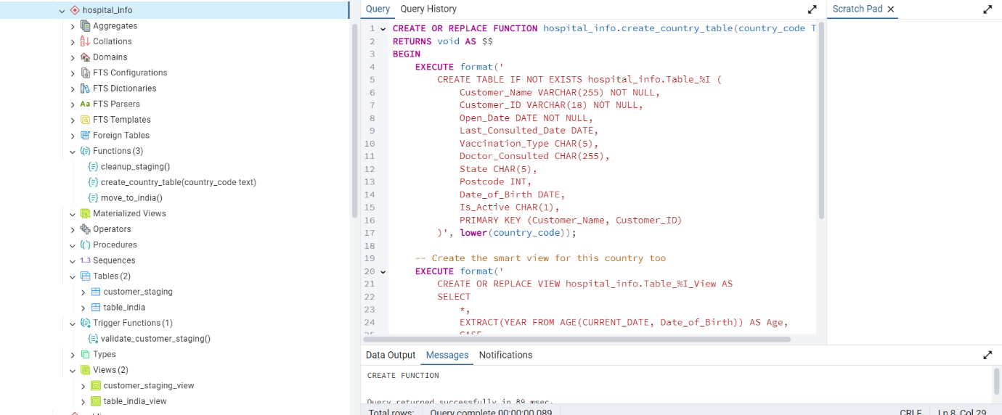

Introduction
This document provides step-by-step instructions for implementing a hospital data management system using PostgreSQL. The system is designed to handle patient records globally and distribute them into country-specific tables.

Setting Up the Database
First, we'll create a dedicated schema for our hospital system. This helps keep our hospital-related tables and functions organised separately from other database objects.
CREATE SCHEMA IF NOT EXISTS hospital_info;

Creating the Staging Table
The staging table is where we initially load all patient data. Consider it a temporary holding area before we sort patients into their respective country tables.

CREATE TABLE hospital_info.Customer_Staging (
Customer_Name VARCHAR(255) NOT NULL,
Customer_ID VARCHAR(18) NOT NULL,
Open_Date DATE NOT NULL,
Last_Consulted_Date DATE,
Vaccination_Type CHAR(5),
Doctor_Consulted CHAR(255),
State CHAR(5),
Country CHAR(5),
Postcode INT,
Date_of_Birth DATE,
Is_Active CHAR(1),
PRIMARY KEY (Customer_Name, Customer_ID)
);

Index creation
CREATE INDEX idx_country ON hospital_info.Customer_Staging(Country);
CREATE INDEX idx_consult_date ON hospital_info.Customer_Staging(Last_Consulted_Date);

Creating Smart Views
This view automatically calculates the patient's age, the days since their last visit, and whether they need a follow-up. It's like having a smart assistant that does these calculations for us whenever we look at the data.
CREATE OR REPLACE VIEW hospital_info.Customer_Staging_View AS
SELECT *, EXTRACT(YEAR FROM AGE(CURRENT_DATE, Date_of_Birth)) AS Age,
CASE
WHEN Last_Consulted_Date IS NOT NULL
THEN (CURRENT_DATE - Last_Consulted_Date)::INTEGER
ELSE NULL
END AS Days_Since_Last_Consulted,
CASE
WHEN Last_Consulted_Date IS NOT NULL AND
(CURRENT_DATE - Last_Consulted_Date)::INTEGER > 30
THEN 'Y'
ELSE 'N'
END AS Needs_Followup
FROM hospital_info.Customer_Staging;

Setting Up Country Tables
Let's create a table specifically for Indian patients. We'll follow the same pattern for other countries too.

CREATE TABLE hospital_info.Table_India (
Customer_Name VARCHAR(255) NOT NULL,
Customer_ID VARCHAR(18) NOT NULL,
Open_Date DATE NOT NULL,
Last_Consulted_Date DATE,
Vaccination_Type CHAR(5),
Doctor_Consulted CHAR(255),
State CHAR(5),
Postcode INT,
Date_of_Birth DATE,
Is_Active CHAR(1),
PRIMARY KEY (Customer_Name, Customer_ID)
);

View Creation
CREATE OR REPLACE VIEW hospital_info.Table_India_View AS
SELECT
*,
EXTRACT(YEAR FROM AGE(CURRENT_DATE, Date_of_Birth)) AS Age,
CASE
WHEN Last_Consulted_Date IS NOT NULL
THEN (CURRENT_DATE - Last_Consulted_Date)::INTEGER
ELSE NULL
END AS Days_Since_Last_Consulted,
CASE
WHEN Last_Consulted_Date IS NOT NULL AND
(CURRENT_DATE - Last_Consulted_Date)::INTEGER > 30
THEN 'Y'
ELSE 'N'
END AS Needs_Followup
FROM hospital_info.Table_India;

Data Quality Checks
This function acts like a security guard, ensuring that all new data meets our quality standards before it enters the system.

Function creation
CREATE OR REPLACE FUNCTION hospital_info.validate_customer_staging()
RETURNS TRIGGER AS $$
BEGIN
IF NEW.Customer_Name IS NULL OR TRIM(NEW.Customer_Name) = '' THEN
RAISE EXCEPTION 'Customer Name cannot be empty';
END IF;

IF NEW.Last_Consulted_Date IS NOT NULL AND NEW.Last_Consulted_Date < NEW.Open_Date THEN
RAISE EXCEPTION 'Last Consulted Date cannot be before Open Date';
END IF;
IF NEW.Is_Active IS NOT NULL AND NEW.Is_Active NOT IN ('A', 'I') THEN
RAISE EXCEPTION 'Is_Active must be either A or I';
END IF;
RETURN NEW;
END;
$$ LANGUAGE plpgsql;

Trigger Creation
CREATE TRIGGER validate_customer_staging_trigger
BEFORE INSERT OR UPDATE ON hospital_info.Customer_Staging
FOR EACH ROW EXECUTE FUNCTION hospital_info.validate_customer_staging();

Moving Data to Country Tables

This function handles moving Indian patients from staging to the India-specific table. If a patient exists, it updates their information with the most recent visit details.

CREATE OR REPLACE FUNCTION hospital_info.move_to_india()
RETURNS void AS $$
BEGIN
INSERT INTO hospital_info.Table_India (
Customer_Name, Customer_ID, Open_Date, Last_Consulted_Date,
Vaccination_Type, Doctor_Consulted, State, Postcode,
Date_of_Birth, Is_Active
)
SELECT
Customer_Name, Customer_ID, Open_Date, Last_Consulted_Date,
Vaccination_Type, Doctor_Consulted, State, Postcode,
Date_of_Birth, Is_Active
FROM hospital_info.Customer_Staging
WHERE Country = 'IND'
ON CONFLICT (Customer_Name, Customer_ID) DO UPDATE
SET
Last_Consulted_Date =
CASE
WHEN EXCLUDED.Last_Consulted_Date > hospital_info.Table_India.Last_Consulted_Date
THEN EXCLUDED.Last_Consulted_Date
ELSE hospital_info.Table_India.Last_Consulted_Date
END,
Vaccination_Type = EXCLUDED.Vaccination_Type,
Doctor_Consulted = EXCLUDED.Doctor_Consulted,
State = EXCLUDED.State,
Is_Active = EXCLUDED.Is_Active;
END;
$$ LANGUAGE plpgsql;

Cleanup Process

This function helps keep our staging table lean by removing old records. Think of it as regular housekeeping.

CREATE OR REPLACE FUNCTION hospital_info.cleanup_staging()
RETURNS void AS $$
BEGIN
DELETE FROM hospital_info.Customer_Staging
WHERE Last_Consulted_Date < CURRENT_DATE - INTERVAL '7 days';
END;
$$ LANGUAGE plpgsql;

Creating New Country Tables
This handy function lets us create tables for new countries as needed. It's like having a template we can use over and over.

CREATE OR REPLACE FUNCTION hospital_info.create_country_table(country_code TEXT)
RETURNS void AS $$
BEGIN
EXECUTE format('
CREATE TABLE IF NOT EXISTS hospital_info.Table_%I (
Customer_Name VARCHAR(255) NOT NULL,
Customer_ID VARCHAR(18) NOT NULL,
Open_Date DATE NOT NULL,
Last_Consulted_Date DATE,
Vaccination_Type CHAR(5),
Doctor_Consulted CHAR(255),
State CHAR(5),
Postcode INT,
Date_of_Birth DATE,
Is_Active CHAR(1),
PRIMARY KEY (Customer_Name, Customer_ID)
)', lower(country_code));

EXECUTE format('
CREATE OR REPLACE VIEW hospital_info.Table_%I_View AS
SELECT
*,
EXTRACT(YEAR FROM AGE(CURRENT_DATE, Date_of_Birth)) AS Age,
CASE
WHEN Last_Consulted_Date IS NOT NULL
THEN (CURRENT_DATE - Last_Consulted_Date)::INTEGER
ELSE NULL
END AS Days_Since_Last_Consulted,
CASE
WHEN Last_Consulted_Date IS NOT NULL AND
(CURRENT_DATE - Last_Consulted_Date)::INTEGER > 30
THEN ''Y''
ELSE ''N''
END AS Needs_Followup
FROM hospital_info.Table_%I', lower(country_code), lower(country_code));
END;
$$ LANGUAGE plpgsql;

Quick Start Guide

First-time setup:
- Set up your workspace
  - CREATE SCHEMA IF NOT EXISTS hospital_info;
- Run all the creation scripts above
- Create tables for additional countries
  - SELECT hospital_info.create_country_table('USA');
  - SELECT hospital_info.create_country_table('UK');
Daily tasks:
- Add new patients to the staging
  - INSERT INTO hospital_info.Customer_Staging VALUES (...);
- Move Indian patients to their table
  - SELECT hospital_info.move_to_india();
- Check on your patients
  - SELECT * FROM hospital_info.Customer_Staging_View;
  - SELECT * FROM hospital_info.Table_India_View;
Weekly maintenance:
- Clean up old staging records
  - SELECT hospital_info.cleanup_staging();

