|  |  |  |
| --- | --- | --- |
| **i cloud** | **Software Requirement Document** | |
|  | |  |

Contents

1 INTRODUCTION 2

1.1 Purpose 2

1.2 Scope of the product 3

1.3 Definitions, acronyms and abbreviations 3

1.4 References to other documents 3

1.5 Overview 3

2 OVERALL DESCRIPTION 3

2.1 Product Perspective 4

2.2 Product Features 4

2.3 User Characteristic 5

2.4 General Constraints 5

2.5 Assumptions and Dependencies 5

3 SPECIFIC REQUIREMENTS 6

3.1 External Interface Requirements 6

3.2 Functional Requirements 6

3.3 Behaviour Requirements 7

Use case: As text editor 8

3.4 Non-Functional Requirements 8

3.4.1 Performance requirements 8

3.4.2 Security requirements 8

4 Appendices 8

# INTRODUCTION

## Purpose

The Software Requirements Specification (SRS) will provide a detailed description of the requirements for the Portable Desktop using cloud computing. This SRS will allow for a complete understanding of what is to be expected of the portable desktop to be constructed. The clear understanding of the portable desktop and its’ functionality will allow for the correct software to be developed for the end user and will be used for the development of the future stages of the project. This SRS will provide the foundation for the project. From this SRS, the portable desktop can be designed, constructed, and finally tested.

This SRS will be used by the software engineers constructing the portable desktop. The software engineers will use the SRS to fully understand the expectations of this to construct the appropriate software. The end users will be able to use this SRS as a “test” to see if the software engineers will be constructing the system to their expectations. If it is not to their expectations the end users can specify how it is not to their liking and the software engineers will change the SRS to fit the end users’ needs.

## Scope of the product

The software product to be produced is portable desktop software which will provide services of desktop to the users remotely. The main purpose of portable desktop is to free the user from picking their laptops, pads every time as they will be provided with virtual desktop that is in the cloud and whenever they are required to login then just require login password and internet to access their desktop. The software will provide address book, media player, Bookmarks, upload facility, file manager and text editor.

## Definitions, acronyms and abbreviations

SRS - Software Requirements Specification

GUI - Graphical User Interface

CC - Cloud Computing

## References

[www.w3schools.com](http://www.w3schools.com)

www. php.net

## Overview

This SRS will provide the detailed description of the product and the specific requirements that are expected from the product to provide. The general description will describe the working, functioning and the user interfaces where as requirements specification will tell about the functional, non functional and domain requirements of the product.

# GENERAL DESCRIPTION

The general description about the project will help the users to understand the functionality of the product to be developed in more clear way. It provides base for specific requirements.

## Product Perspective

The context of product is to make the user to be free from carrying things with him in this digitalized world where the whole work is digitized these days. As SRS defines a system which is already developed other companies to make it our own style.

**-------Describe the context and origin of the product being specified in this SRS. For example, state whether this product is a follow-on member of a product family, a replacement for certain existing systems, or a new, self-contained product. If the SRS defines a component of a larger system, relate the requirements of the larger system to the functionality of this software and identify interfaces between the two. In this part, make sure to include a simple diagram that shows the major components of the overall system, subsystem interconnections, and external interface---------**

## Product Functions

* User account management

-Allow users to create new account and store their data in database.

-

-

* File Manager

-

-

-

* Contact Book

-Add contact of their friends i.e. their name, Email Id, contact number and their address.

-Search contact details of any person by their name

-Modify the contact of existing person

-User can delete the contact which no longer required

* Text Editor

-To make the text file.

-To edit the plain text files.

-Search option in the text editor to search for keyword

* Media Player

-To play audio and video files.

- user defined playlist

* Resource Bookmarking

-Add bookmark and tag name to locate to that page

-Delete the existing bookmarks.

-Rediret to bookmark on click.

* Storage Meter

-Tells how much space is used by the user and how much left in the cloud for it.

## User Characteristic

* End user has technical knowledge to how to operate operating system.
* End user do not used this kind of software in its history.

## General Constraints

-Minimum 512 MB RAM.

-Software in English language.

// write other ones please….??

**---------hardware limitations (timing requirements, memory requirements); interfaces to other applications; specific technologies, tools, and databases to be used; parallel operations; language requirements; communications protocols; security considerations---------------**

## Assumptions and Dependencies

* Users have good internet facility to use it.
* Software is stand alone application.
* Users upload restricted amount of data at a time.
* Software will use the resources of user’s computer.

# SPECIFIC REQUIREMENTS

This section contains all the software requirements at a level of detail, that when combined with the system context diagram, use cases, and use case descriptions, is sufficient to enable designers to design a system to satisfy those requirements, and testers to test that the system satisfies those requirements. The specific requirements are categorized to functional requirements, non-functional requirements and domain requirements.

## External Interface Requirements

**Software interface**

The software will interface with Mysql database and capable to run on any operating system.

**Graphical user interface**

How software interact with users

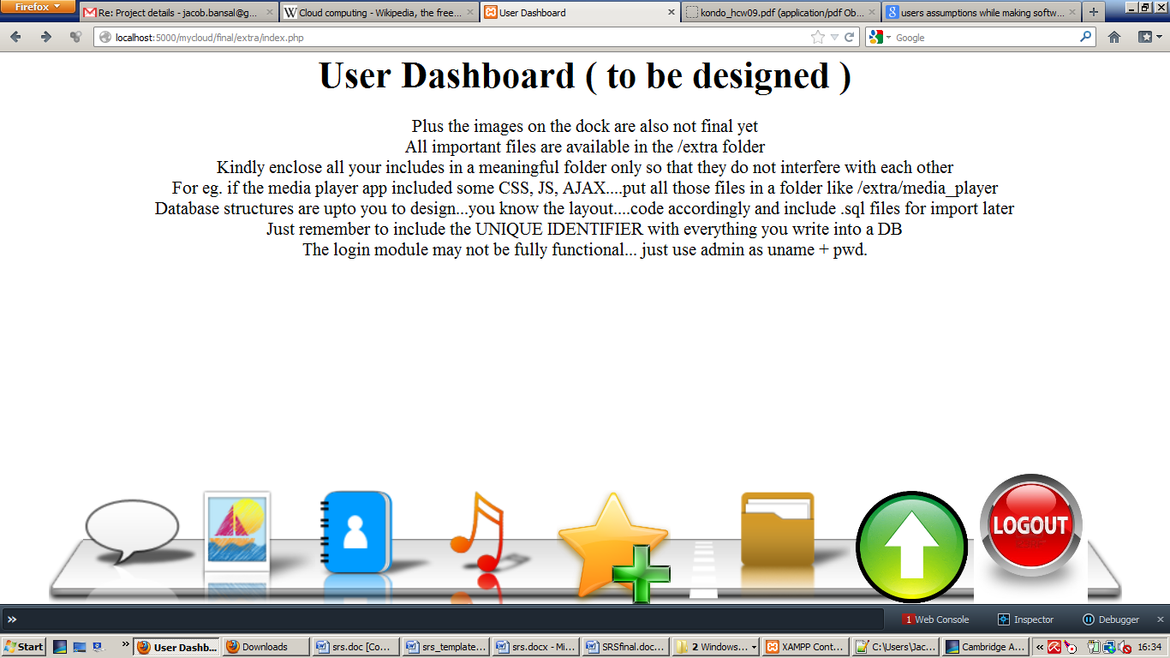

## Functional Requirements

// write details of each that how they are implemented….Each have to write what they have implemented and explanation of each functions we implement

* User account management

Brief description:-

Input:-

Output:-

* File Manager

Brief description:-

Input:-

Output:-

* Contact Book

Brief description:-

Input:-

Output:-

* Text Editor

Brief description:-

Input:-

Output:-

* Media Player

**Brief description:-** Cloud-O-Music is a audio/video player which uses the Jplayer API. Jplayer is a javascript and flash based music player through which we can run both audio and video files. Also we can generate playlist, add and remove audio/video files from playlist. Audio/video is streamed from particular URL where file is stored in user account. It supports numerous extensions such as m4v, ovg, wav, flv, rpmvg etc.

Input:- Media file (audio or video)

Output:- audio/video

* Resource Bookmarking

Brief description:-

Input:-

Output:-

* Storage Meter

Brief description:-

Input:-

Output:-

## Behaviour Requirements

**Use case: user login**

User

Validate username password

Username password

Brief Description:The user validates their username and password to login.

**Use case: Upload files**

User

Uploading files to cloud

Brief Description:Upload files to cloud from your computer

### Use case: As text editor

User

write plain text files

Brief Description:user can write new text files, view old files and also update it

**Use case: Contact book**

User

Add, view ,update or delete contact

Brief Description:user can write new contacts, view old and also update it.

## Non-Functional Requirements

### Performance requirements

* Software will start within 30 seconds.
* Portable

### Safety requirements

# Appendices

***-------------Data dictionary is used to track all the different variables, states and functional requirements that you described in your document. Make sure to include the complete list of all constants, state variables (and their possible states), inputs and outputs in a table. In the table, include the description of these items as well as all related operations and requirements--------***