MyCloud

A

Minor Project

Submitted to University Institute Of Engineering And Technology, Panjab University, Chandigarh



UNIVERSITY INSTITUTE OF ENGINEERING AND TECHNOLOGY

PANJAB UNIVERSITY

CHANDIGARH

**Submitted To: Submitted by:**

Prof. Dr. Sarbjeet Ankit Bhatnagar Jacob Bansal Harpreet Singh

ACKNOWLEDGEMENT

I wish to express my gratitude to individuals who have contributed their ideas, time and energy in this work

With profound sense of gratitude, I take it as highly esteemed privilege in expressing my sincere thanks to prof. Renu Vig, who gave me this opportunity to do my graduation in this premier institute.

I am earnestly indebted to our guide Prof. Sarvjeet, for the advice, trust and time he has provided to me. His knowledge and interest in cutting edge and the state of art research in both academia and research made him an invaluable source of guidance for the presented work. I am very grateful for the opportunity to work with him, to learn and to work on such an advanced topic which gave my bachelor’s degree great depth of research and understanding. Thanks to my parents for their support.

JACOB BANSAL HARPREET SINGH ANKIT BHATNAGAR

CERTIFICATE

This is to certify that the work, presented in the project entitled “icloud” University Institute of Engineering And Technology Panjab University, Chandigarh by Jacob Bansal, Ankit Bhatnagar, Harpreet Singh in partial fulfilment of the requirement for the award of degree of B.E.

This project work is a record of student’s own work carried out under my guidance and the matter embodied in the project have not been submitted to any university or institute for award of any other degree.

Project guide:

(Director UIET)

Dr. Renu Viz Assit.Prof.Dr.Sarvjeet

Panjab University UIET,Panjab University

Chandigarh Chandigarh

TABLE OF CONTENT

List of Tables

List of Figures

# Introduction

In today’s fast moving world, we are in constant need of data and information that affects us directly or otherwise. This prompted the requirement of a system that should serve this very purpose. It is not always feasible to carry your portable devices, let alone your entire personal desktop systems. Thus, it was necessary to construct a system that allows the users the freedom to access their important data and information whenever they required.

The **Portable Desktop Service on a Cloud** allows a user to carry his/her favourite resources wherever he/she might go and access them whenever the need arise. The main purpose of portable desktop is to free the user from picking their laptops, pads or any other portable devices every time as they will be provided with virtual desktop that is in the cloud and whenever they are required to login then just require login password and internet to access their desktop. The software will provide address book, media player, bookmarks, upload facility, file manager and text editor.

# Software Requirement Specification

## INTRODUCTION

### Purpose

## 

The **Portable Desktop Service on a Cloud** allows a user to carry his/her favourite resources wherever he/she might go and access them whenever the need arise. This SRS will allow for a complete understanding of what is to be expected of the portable desktop service and how it ought to be constructed. The clear understanding of the portable desktop and its functionality will allow for the correct software to be developed for the end user and will be used for the development of the future stages of the project. This SRS will provide the foundation for the project. From this SRS, the portable desktop can be designed, constructed, and finally tested.

This SRS will be used by the software engineers constructing the portable desktop. The software engineers will use the SRS to fully understand the expectations of this to construct the appropriate software. The end users will be able to use this SRS as a “test” to see if the software engineers will be constructing the system to their expectations. If it is not to their expectations the end users can specify how it is not to their liking and the software engineers will change the SRS to fit the end users’ needs.

### Scope of the product

The software product to be produced is a **portable desktop software which will provide services of desktop to the users remotely**. The main purpose of portable desktop is to free the user from picking their laptops, pads or any other portable devices every time as they will be provided with virtual desktop that is in the cloud and whenever they are required to login then just require login password and internet to access their desktop. The software will provide address book, media player, bookmarks, upload facility, file manager and text editor.

### Definitions, acronyms and abbreviations

SRS - Software Requirements Specification

GUI - Graphical User Interface

CC - Cloud Computing

### References

[www.w3schools.com](http://www.w3schools.com)

www. php.net

### Overview

This SRS will provide the detailed description of the product and the specific requirements that are expected from the product to provide. The general description will describe the working, functioning and the user interfaces where as requirements specification will tell about the functional, non functional and domain requirements of the product.

## GENERAL DESCRIPTION

The general description about the project will help the users to understand the functionality of the product to be developed in more clear way. It provides base for specific requirements.

### Product Perspective

The **context** of this product is to make the user free from carrying digital resources with him in this digitalized world where the whole work is digitized these days. The need of data and information is the order of the day and any service that eases that part of the user’s daily life would certainly be a breakthrough.

The **origin** of the this product is merely the idea around which it functions. In today’s fast moving world, we are in constant need of data and information that affects us directly or otherwise. This prompted the requirement of a system that should serve this very purpose. It is not always feasible to carry your portable devices, let alone your entire personal desktop systems. Thus, it was necessary to construct a system that allows the users the freedom to access their important data and information whenever they required.

The basic **requirements** of this system are minimal on the part of the user. The only thing they must have to access these is Internet connectivity and a system to access it. All the other things are managed by the System itself and user is indeed freed from all worries.

### Product Functions :

* User account management

- Allow users to create new account and store their data in a dedicated space on a service server / database.

- Allows users the freedom to store almost anything on the go, as the space hosted by the Server is completely their own.

- This is also provides security as far as the data of the user is concerned.

* File Manager

- Allows the handling of various files uploaded by the user, efficiently.

- Allows the system to directly access all the resources available to the User as and when required.

* Contact Book

-Add contact of their friends i.e. their name, Email Id, contact number and their address.

-Search contact details of any person by their name

-Modify the contact of existing person

-User can delete the contact which no longer required

* Text Editor

-To make the text files which can contain almost any type of formatting required.

- To edit the plain text file, which should function primarily as a basic note making service.

- Search option in the text editor to search for keyword

* Media Player

- To play audio and video files.

- Option to maintain user-defined playlists and thus provide customisation on the User’s part.

* Resource Bookmarking

- Add bookmark and tag name to locate to that page

- Delete the existing bookmarks.

- Redirect to bookmark on click.

* Storage Meter

-Tells how much space is used by the user and how much left in the cloud for it.

- Allows the system to decide whether a User has hauled all the space on the Server and is thus used to check a single User dominating all hosting on the Server.

### User Characteristic

* End user has technical knowledge to how to operate an operating system OR has used a desktop based system earlier.
* Graphical User Interface is provided which makes it easier for the User to operate the system.

### General Constraints

-Minimum 512 MB RAM.

-Software in English language.

### Assumptions and Dependencies

* Users have good internet facility to use it.
* Software is a standalone application, given that the User has access to an Internet-enabled browser.
* Users must upload only restricted amount of data at a time.
* Software will use the resources of user’s computer.

## SPECIFIC REQUIREMENTS

This section contains all the software requirements of the Portable Desktop Service Software at a level of detail, that when combined with the system context diagram, use cases, and use case descriptions, should be sufficient to efficiently design the system. The specific requirements are further categorized to functional requirements, non-functional requirements and domain requirements.

### External Interface Requirements

**Software interface**

The software will interface with MySQL database and capable to run on any operating system.

### Functional Requirements :

* User account management

Brief description:- The user account management system forms the basis of the entire platform. This is a core component in the functioning of the service as it enables user to interact with the system and in turn with the resources uploaded by them at anytime.

Input :- The input to the user account management system is a pair of user credentials that are namely as his/her username and password.

Output:- The output of the user account management system is a **global unique identifier ( GUID )** which is then used throughout the system as the principal method to distinguish a user from one another. All transactions within the system and its dependencies are carried out with respect to this GUID.

* File Manager

Brief description :- The File Manager forms yet another part of the System that is very important for the functioning of the System itself. It forms the basic platform on which the entire data exchange services function. This is a core part of the System that is responsible for efficiently handling of all major data transactions in the System.

The File Manager follows a strict order of file structuring throughout the system which is as follows :

**< Login >**

**< GUID >**

**< resources > / < GUID > / < internal folder structure >**

**/ < media >**

**/ < bookmarks >**

**/ < docs >**

**/ < images >**

**/ < miscellaneous >**

Input :- The input to the File Manager are through the File Upload Mechanism. **The File Upload mechanism delivers the uploaded file through an HTTP/HTML header format, handled in PHP and is then stored on the hosting server.**

Output :- The output of the File Manager is a well crafted tree-like structure that enabled the System to act upon the data uploaded into the System effectively. This tree like structure of all files is further assisted by database entries which are directly interacted with the Services provided in the System.

* Contact Book

Brief description:- The contact book is a user utility that helps him/herto store important contacts within the MyCloud environment. This helps the user to access all his/her contacts as and when required.

Input:- The input to the contact book is the set of values defined in the Contact form as presented to the user. The user enters the required information and updates his/her contact book.

Output:- The output of the contact book is the already stored contact details of all entries, entered by the User.

* Text Editor

**Brief description:-** The Text Editor is another utility that helps the User to create and edit simple text files that can be further used by him/her as and when required. These text files can be saved as whatever type the user specifies and then directly downloaded to the System where the user accesses it.

**Input:-** The input to the system is the text / information that the User desires to use and create a text file with. The User is presented with an editable text region that can be used to create the text file as and when required.

**Output:-** The output of this system is the text files that the user created or edited using the specified system.

* Media Player

**Brief description:-** Cloud-O-Music is a audio/video player which uses the Jplayer API. Jplayer is a javascript and flash based music player through which we can run both audio and video files. Also we can generate playlist, add and remove audio/video files from playlist. Audio/video is streamed from particular URL where file is stored in user account. It supports numerous extensions such as m4v, ovg, wav, flv, rpmvg etc.

**Input:-** Media file (audio or video)

**Output:-** Audio / Video being played or viewed using the System itself.

* Resource Bookmarking

**Brief description:-** Resource bookmarking is yet another utility that helps the user to tag or bookmark important resources on the Web for future references. The user can tag a specific url by a specific tag name that the System stores and renders to the User as and when required.

**Input:-** A set of URLs and their desired tag names.

**Output:-** Complete listing of all the URLs by their tag names and them acting as direct hotlinks.

* Storage Meter

**Brief description:-** Storage Meter is a utility that helps the User to keep a track of the amount of storage that the User uses on the Cloud using the System. Since the Cloud is a value payable service, the user can then be charged for the storage if and when the System goes commercial.

**Input:-** No as such input is required to this utility. The System itself maintains a central logic to compute all storage sizes.

**Output:-** The amount of storage used by the User at the current point of time.

### Non-Functional Requirements

### Performance requirements

* Software will start within 5-10 seconds.
* Portable

### Safety requirements

# Appendices

***-------------Data dictionary is used to track all the different variables, states and functional requirements that you described in your document. Make sure to include the complete list of all constants, state variables (and their possible states), inputs and outputs in a table. In the table, include the description of these items as well as all related operations and requirements--------***

# DESIGN DOCUMENTS

## USE CASE DIAGRAM

**Use case: user login**

User

Validate username password in user

Username password

Brief Description:The user validates their username and password to login.

**Use case: File Uploader**

User

Uploading files to *cloud*

Brief Description:Upload files to cloud from your computer and stored in server.

**Use case: Contact book**

User

Add, view ,update or delete contact

Brief Description:user can write new contacts, view old and also update it.

### Use case: As text editor

User

To create edit the text files

Brief Description:user can write new text files, view old files and also update it

### Use case: Media Player

User

To paly audio/video sons

Brief Description: User play the audio/video files through the player.

### Use case: Resource Bookmarking

User

To bookmark the important document

Brief Description:user can tag or bookmark important links.

## ER Diagrams

* docs table

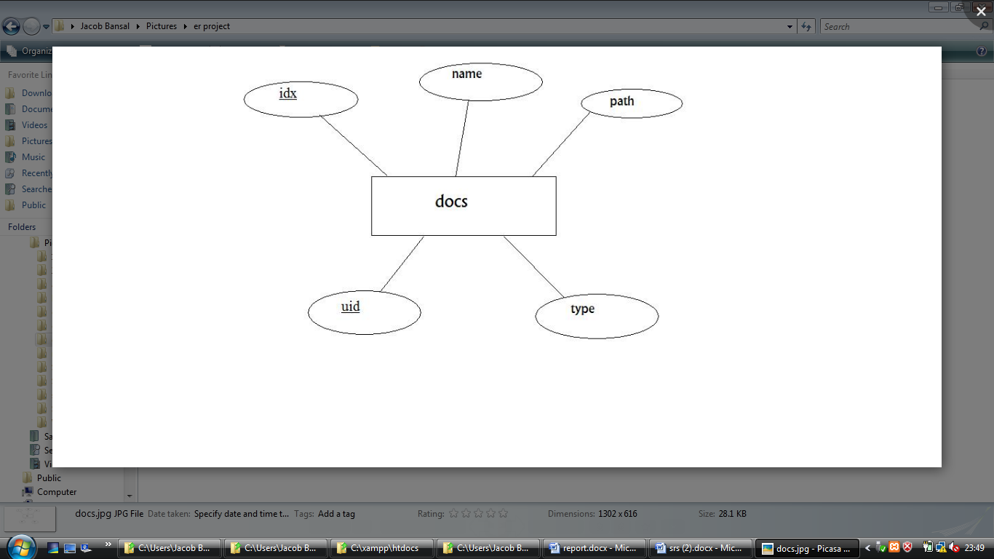

* images table

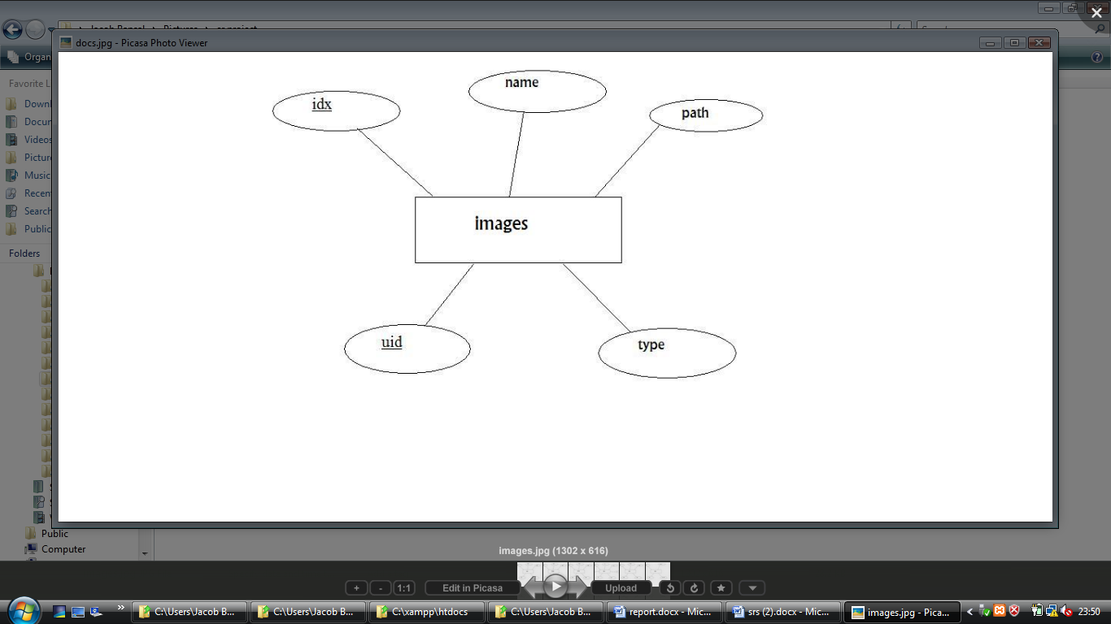

* media table

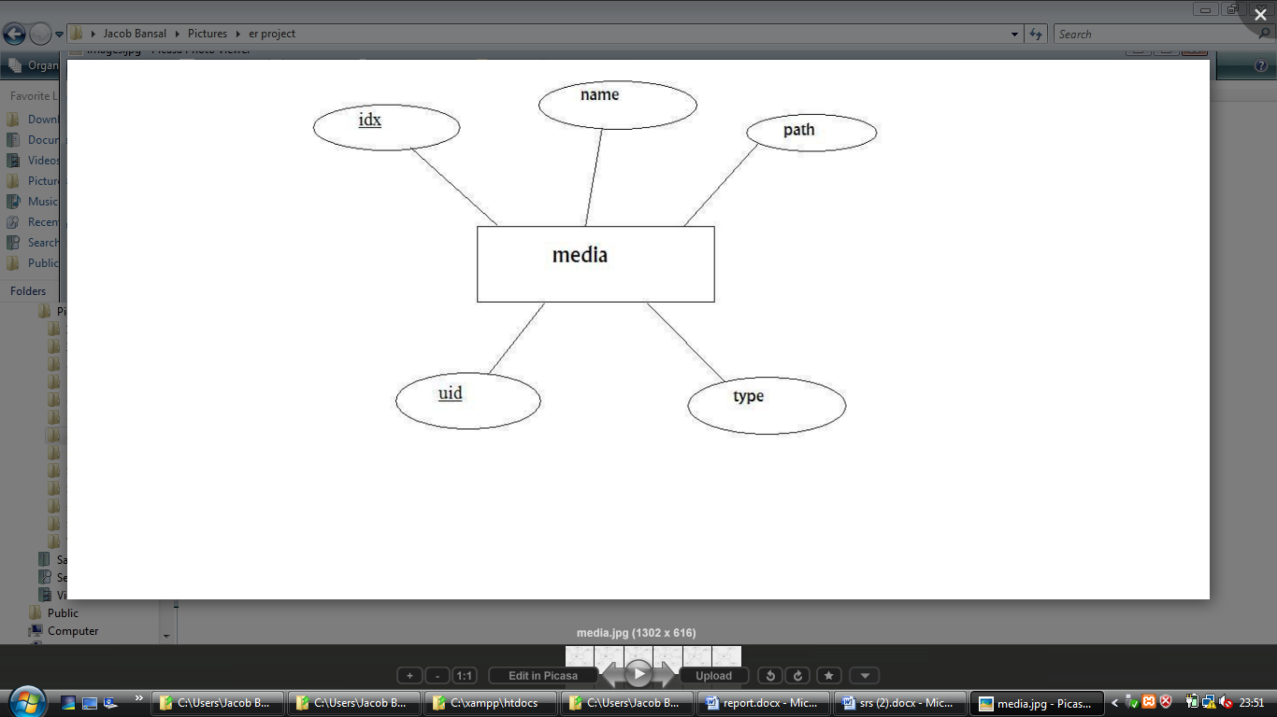

* members table

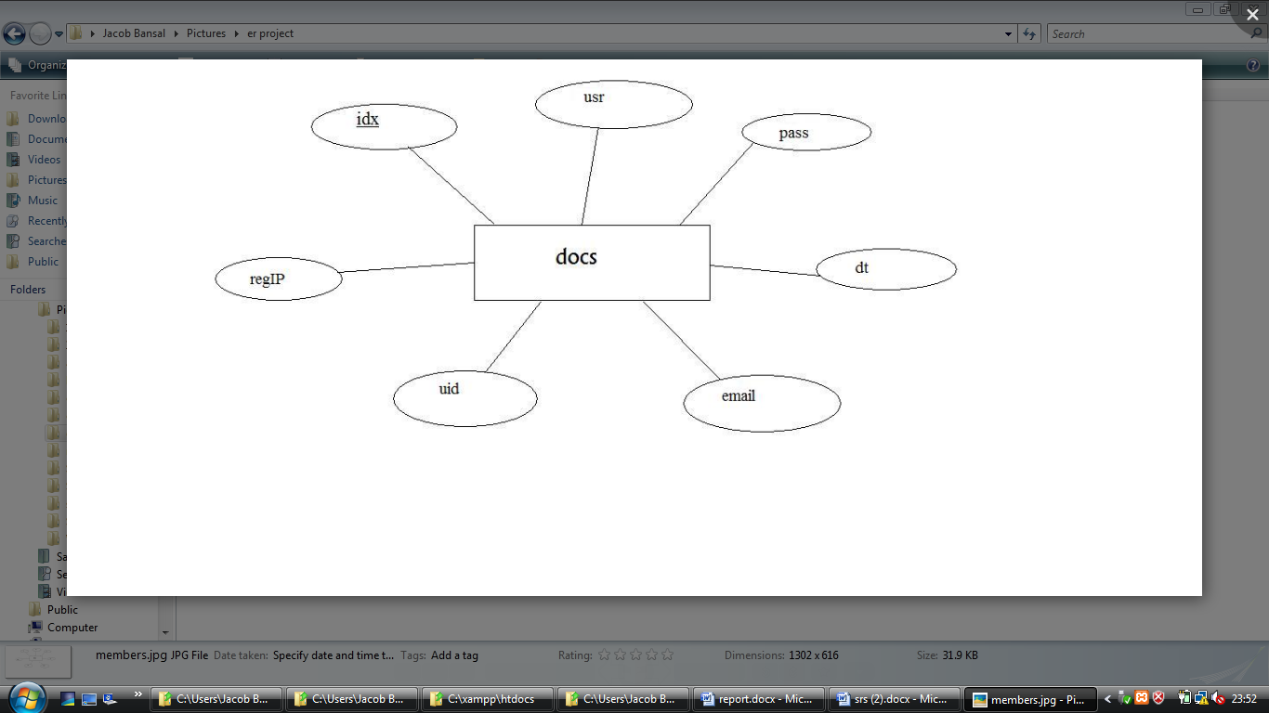

* misc table

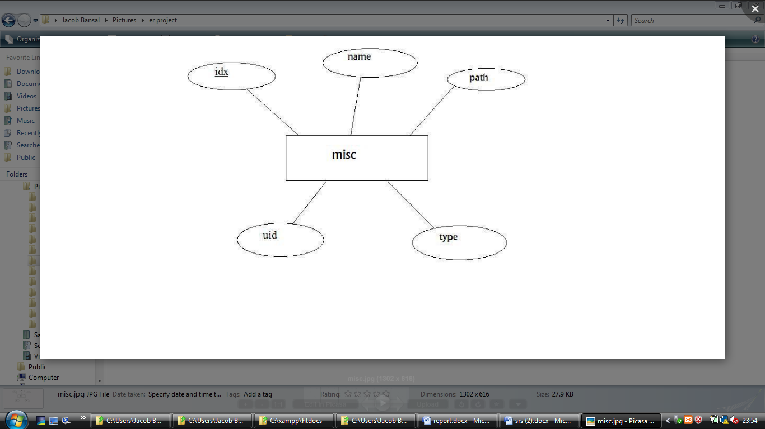

* url table

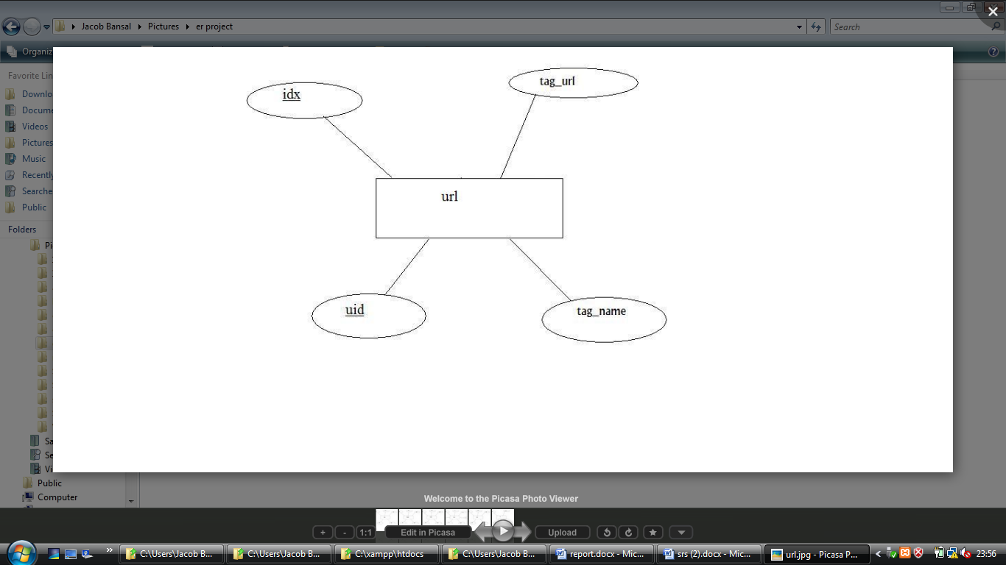

# Pseudo code

# Results and Discussion

# Appendices

# Biblography