**Domino – One Place for Data Science Work**

Domino, a Platform-as-a-Service for data analysis, to equip a larger group of users with functionality that has typically been inaccessible to people without engineering abilities and/or a massive amount of time to set up infrastructure and plumbing.

Although Domino is language agnostic, it has particularly deep integration with R, including integration with RStudio and first-class support for packages from CRAN and other repositories.

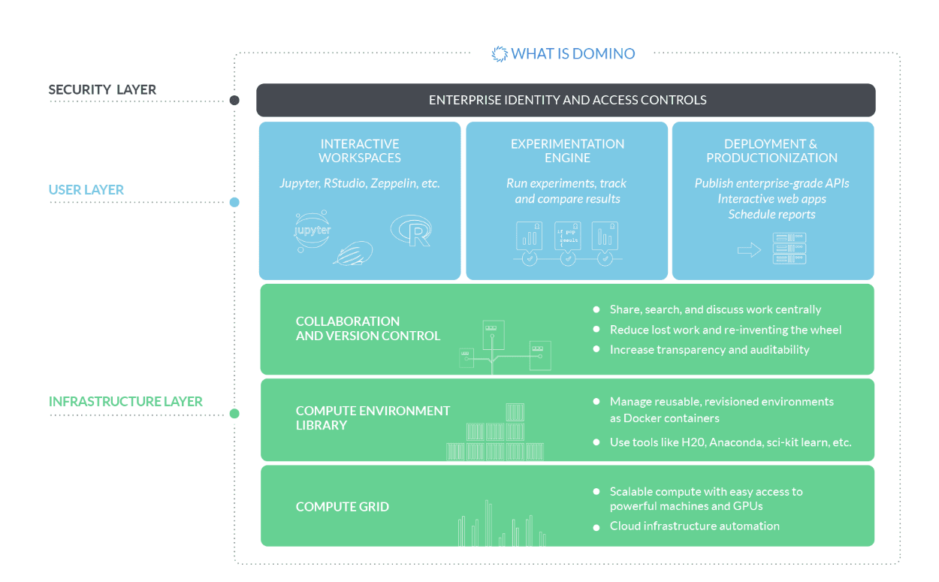

Domino address three core areas of functionality:

(1) It lets you run your R code (or Python, Julia, Matlab, and more) in the cloud without any setup or configuration. Domino handles AMI and package management, job distribution and secure data transfer. It allows you to change your hardware with one-click, or to distribute your analysis across multiple machines.

(2) It automatically keeps a revisioned history of your project — code, data, and results — so you can browse and reproduce past work. Unlike traditional source control, Domino tracks large data files, and creates a first-class association between your results artifacts (e.g., charts) and the code/data that produced them.

(3) It facilitates collaboration so you can easily share results and co-author analyses.

**Domino and Docker**

While Docker focus on how engineers use Docker to ship their software, Domino use Docker in their product itself, to allow data scientists to easily control what sort of environment (packages, libraries, etc.) to use when they work. In other words, Domino expose Docker as a user-facing feature (in addition to using it internally as a DevOps tool).

**Working with Domino (Demo)**

1. Sign Up for Domino Trial Account (for 15 day)
2. Here you can create a new Project. Also, if you want to work on the existing project (share on git hub)

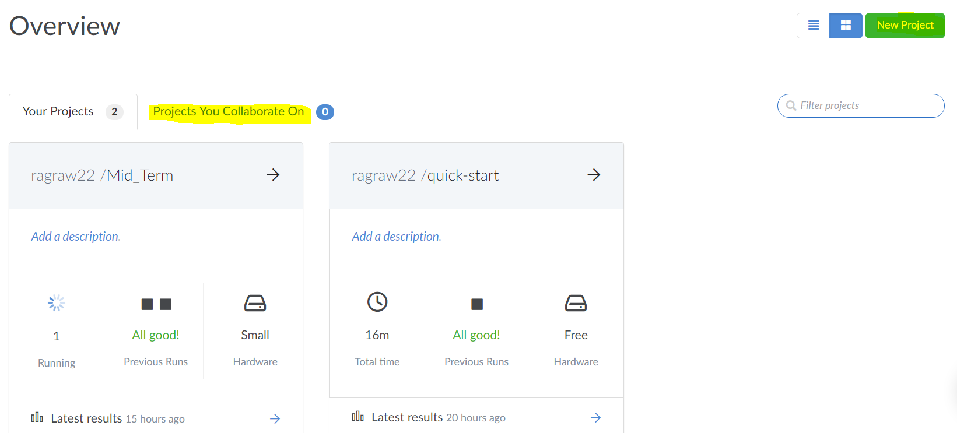

1. Select the language /environment and Launch the notebook.

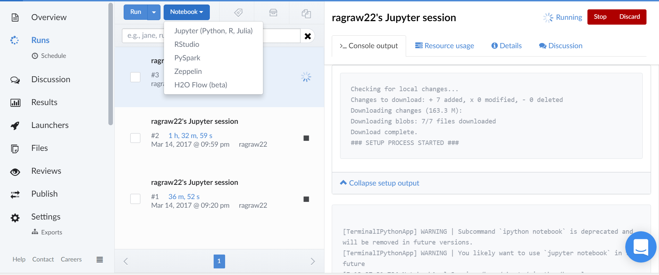

1. In Demo, we will be working on the Python Notebook and the working of Logistic Regression and Random Forest Algorithm.
2. Load the Loan Data into a pandas data frame.
3. Clean the data and create the train data and test variable.

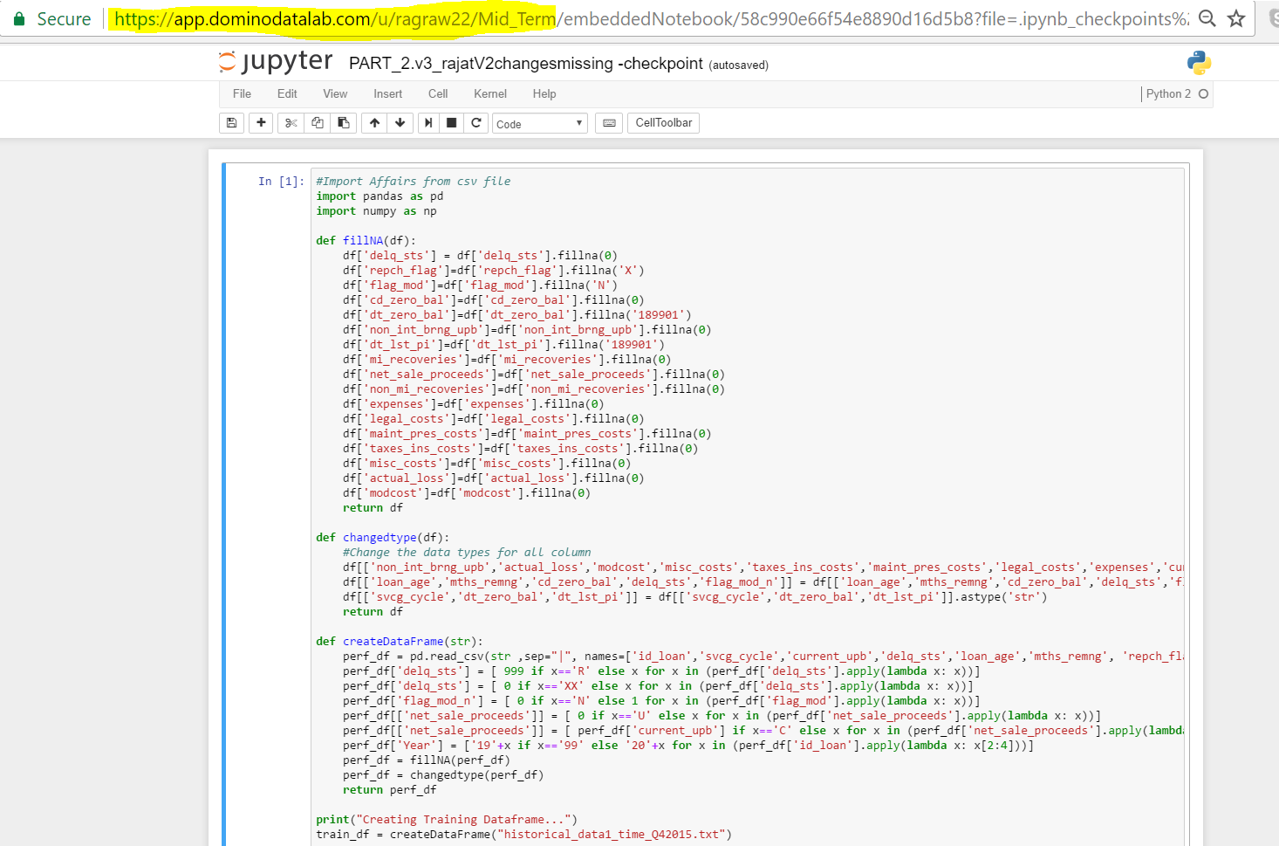

1. Check the accuracy and create the classification report.

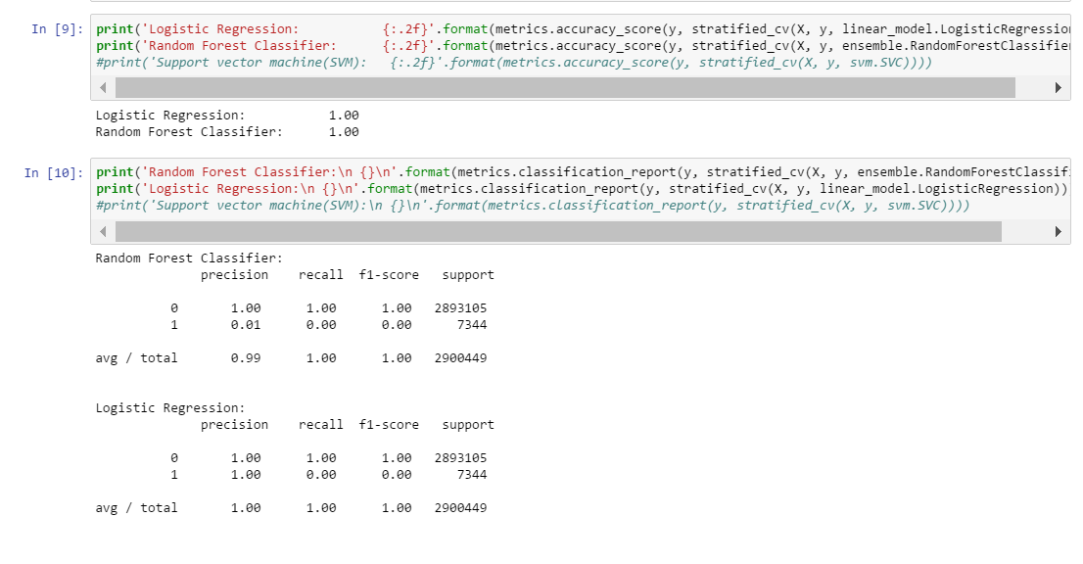

1. Create the Confusion Matrix

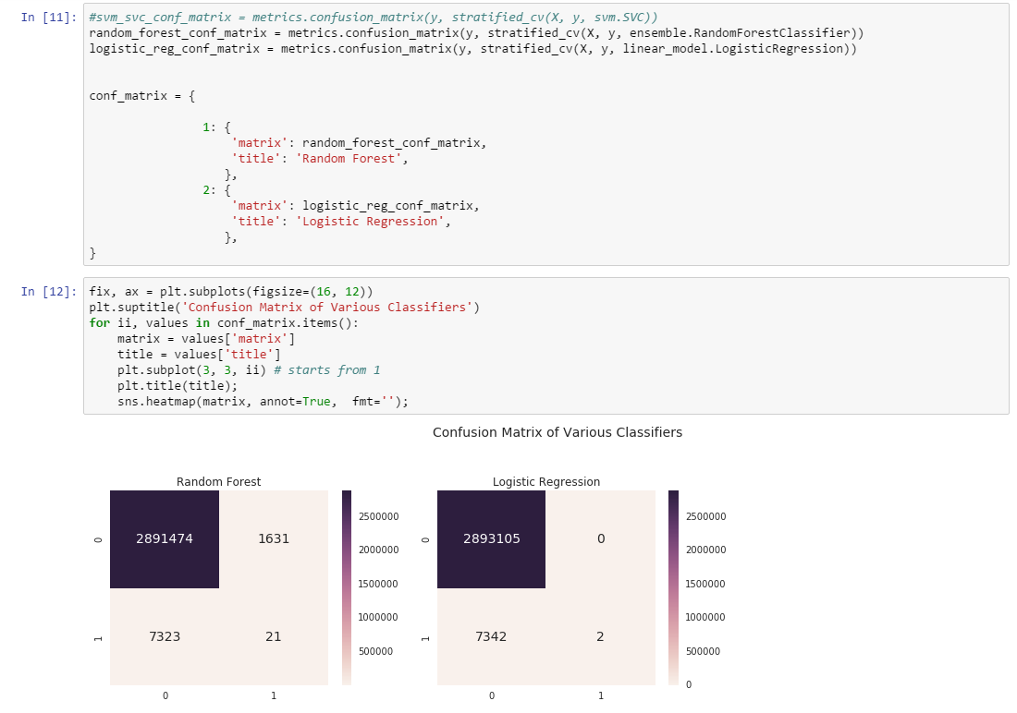

1. Check the result and Resource usage.

