House Price Prediction Project Report

Introduction
House price prediction is one of the most important applications of data analytics and machine learning in the real estate industry. The value of a property is influenced by multiple factors such as location, structural characteristics, physical condition, available amenities, renovation history, and market trends. Accurately predicting house prices helps buyers, sellers, investors, and real estate agencies make informed financial decisions.
This project aims to predict house sale prices using various features such as location (zoning and lot configuration), property characteristics (lot area, building type, exterior material), structural condition, basement area, construction year, and renovation history. The objective is to analyse relationships between these features and the target variable (SalePrice) and build a predictive modelling framework.
The project involves detailed data exploration, data cleaning, missing value handling, outlier detection, feature engineering, and statistical analysis. Both numerical and categorical variables are examined to understand their influence on house prices. Visualization techniques such as histograms, scatter plots, box plots, and correlation matrices are used to derive meaningful insights.
Special attention is given to temporal variables such as Year Built and YearRemodAdd to understand how property age and renovations affect market value. Additionally, the impact of basement area and overall condition rating on pricing is analyzed to determine structural value contributions.
This project also evaluates whether house prices can be predicted using only categorical features and compares their predictive strength against numerical variables. The final outcome is a well-structured analytical model that demonstrates how different factors contribute to real estate pricing.
Overall, this project provides practical insights into real estate valuation using data science techniques and highlights the importance of feature engineering and exploratory data analysis in predictive modelling.

3. Methodology
The methodology adopted for this project follows a structured data science workflow to ensure systematic analysis and accurate prediction of house prices.
2.1 Data Collection
The dataset used for this project contains detailed information about residential properties, including structural features, location attributes, condition ratings, basement size, renovation history, and sale price. The dataset was imported into a Jupyter Notebook environment using Python libraries such as Pandas and NumPy for analysis.
2.2 Data Exploration (Exploratory Data Analysis – EDA)
Initial exploration was performed to understand:
- Data structure and column information
- Types of variables (numerical, categorical, temporal)
- Distribution of the target variable (SalePrice)
- Presence of missing values
Statistical summaries and visualizations such as histograms, boxplots, and scatter plots were generated to identify patterns and trends in the data.
2.3 Data Cleaning
Data cleaning steps included:
- Identifying missing values using .isnull() and .sum()
- Analyzing features with missing values
- Imputing missing values using mean, median, or mode where appropriate
- Removing or handling outliers detected through boxplots and statistical methods
This step ensured that the dataset was reliable and suitable for modeling.
2.4 Feature Engineering
Feature engineering was performed to enhance model performance:
- Creation of new features such as house age (Current Year – YearBuilt)
- Logarithmic transformation of skewed variables like SalePrice
- Encoding categorical variables using Label Encoding and One-Hot Encoding
- Scaling numerical features where required
These transformations helped improve the predictive strength of the dataset.
2.5 Statistical and Correlation Analysis
Correlation analysis (Pearson correlation) was conducted to identify features strongly related to SalePrice. Heatmaps and scatter plots were used to visualize relationships between numerical features and the target variable.
Additionally, categorical features were analyzed using group-by operations to evaluate their influence on pricing.
2.6 Model Preparation
After preprocessing:
- Features were separated into independent variables (X) and target variable (y).
- Data was split into training and testing sets.
- The dataset was prepared for predictive modeling.
2.7 Model Development
Machine learning algorithms were applied to predict house prices. Model performance was evaluated using metrics such as:
- Mean Absolute Error (MAE)
- Mean Squared Error (MSE)
- Root Mean Squared Error (RMSE)
- R² Score
The model with the best performance metrics was selected as the final predictive model.

3.Requirement Analysis
Requirement analysis identifies the tools, technologies, data requirements, and system specifications necessary to successfully complete the project.
3.1 Functional Requirements
The system should be able to:
- Import and process housing data
- Identify and handle missing values
- Perform exploratory data analysis
- Detect and manage outliers
- Transform categorical and numerical variables
- Generate visualizations (histograms, boxplots, scatter plots, heatmaps)
- Perform correlation analysis
- Build and evaluate predictive models
- Generate a comprehensive project report
3.2 Non-Functional Requirements
- The system should handle moderately large datasets efficiently.
- The analysis should be reproducible and well-documented.
- Visualizations should clearly represent trends and relationships.
- The predictive model should maintain high accuracy and generalizability.
3.3 Hardware Requirements
- Minimum 4GB RAM (8GB recommended)
- Intel i3 or higher processor
- 10GB free storage space
- Windows Operating System (as used in this project)
3.4 Software Requirements
- Python (via Anaconda distribution)
- Jupyter Notebook
- Libraries:
  - Pandas
  - NumPy
  - Matplotlib
  - Seaborn
  - Scikit-learn
  - OpenPyXL (for Excel file handling)
  - Python-Docx (for report generation)
3.5 Data Requirements
- Structured housing dataset in CSV or Excel format
- Target variable: Sale Price
- Features including numerical, categorical, and temporal attributes
3.6 User Requirements
- Basic knowledge of Python programming
- Understanding of data analysis concepts
- Familiarity with machine learning fundamentals

4. Visualizations
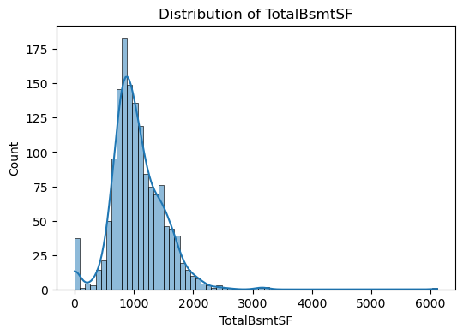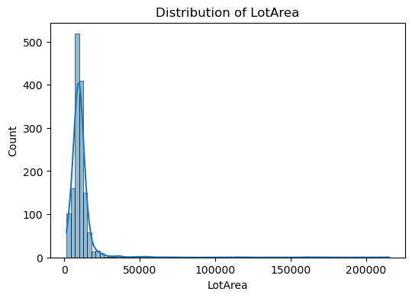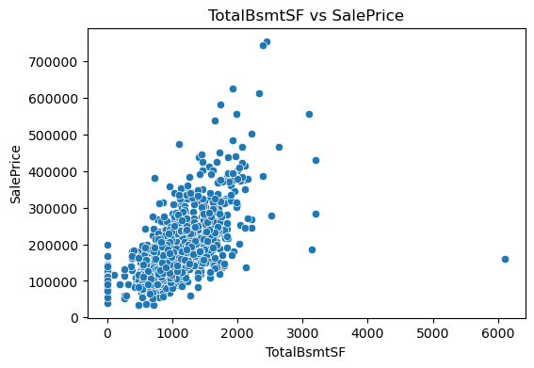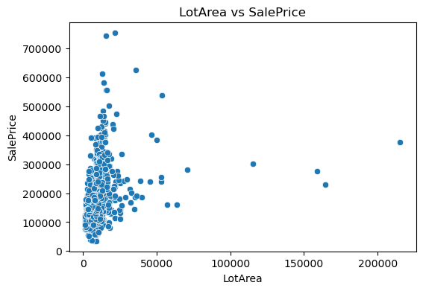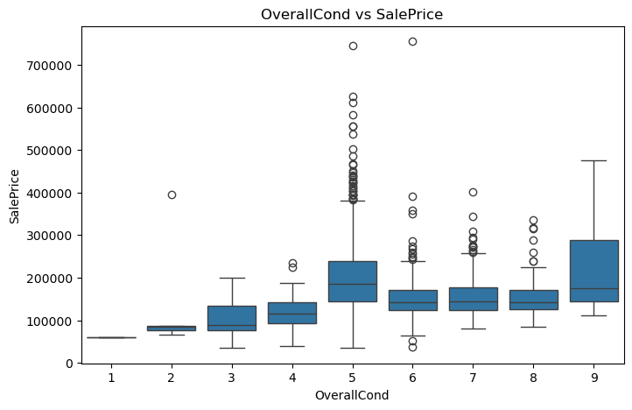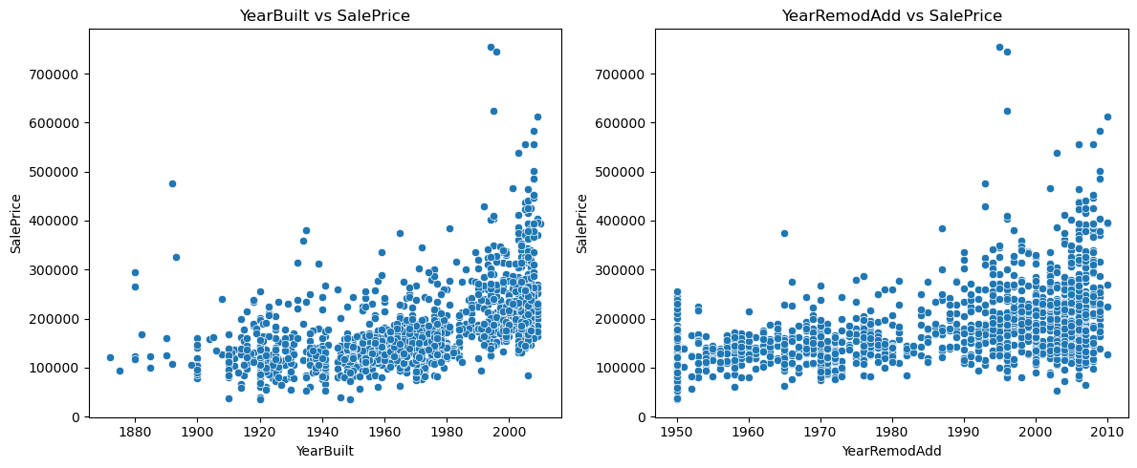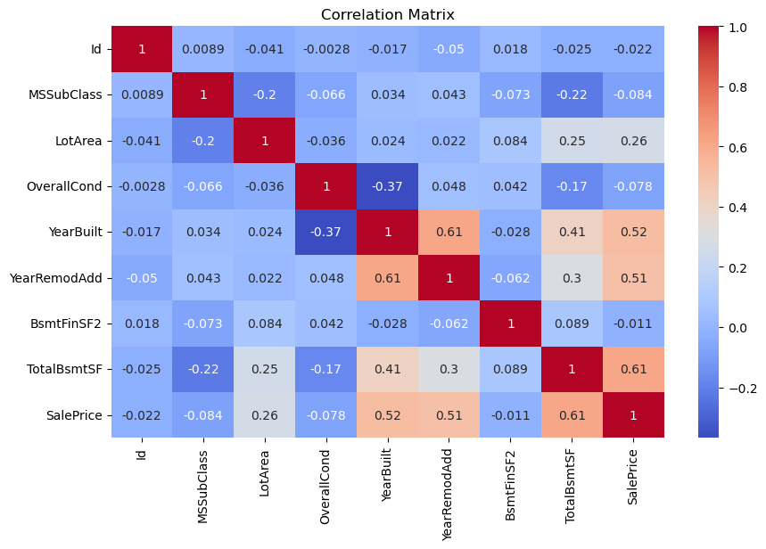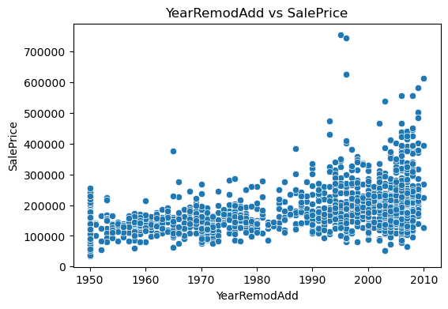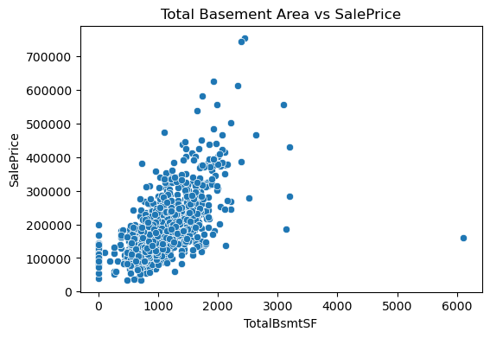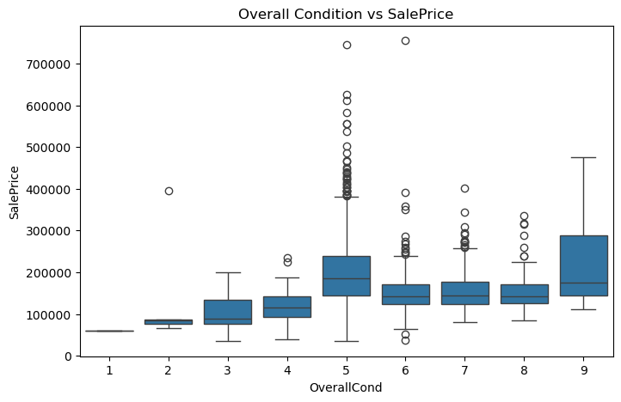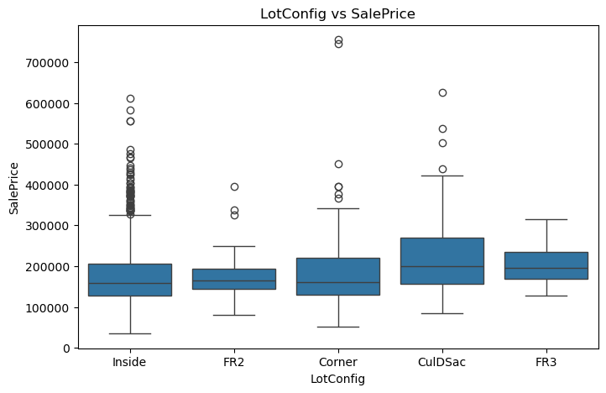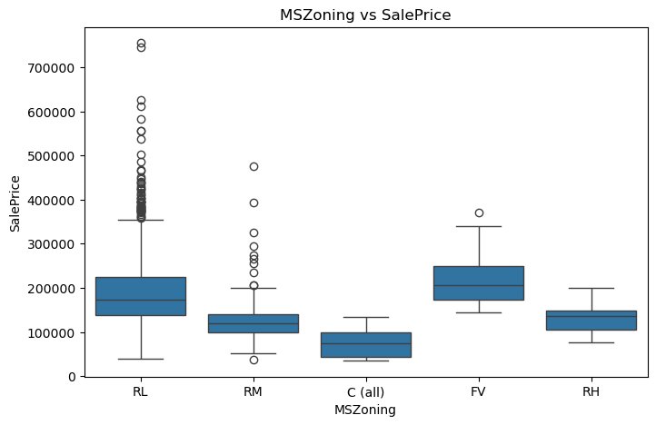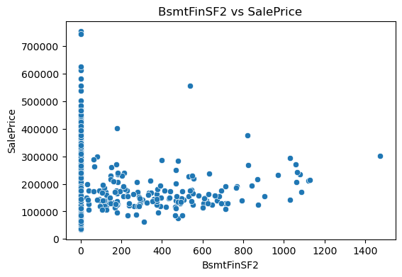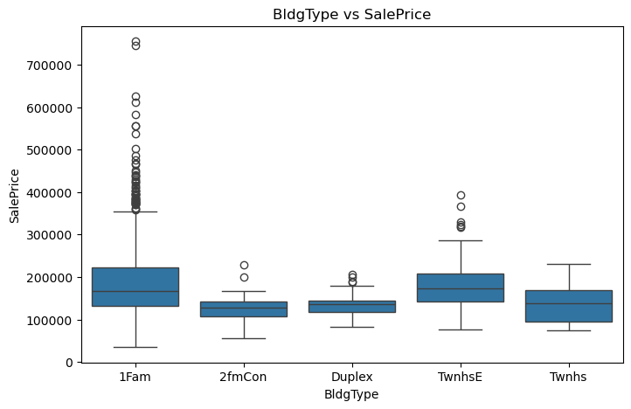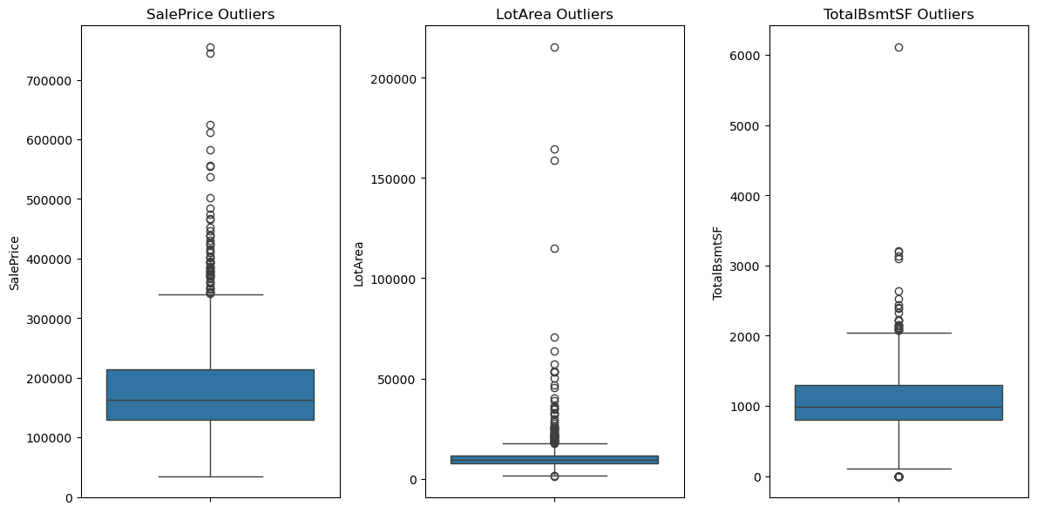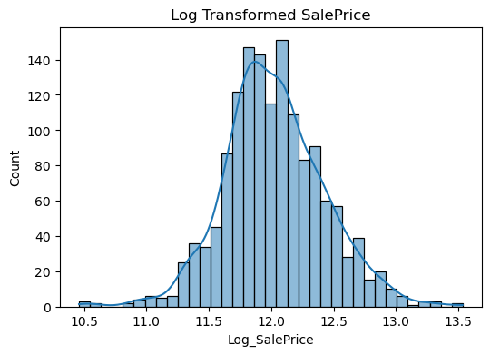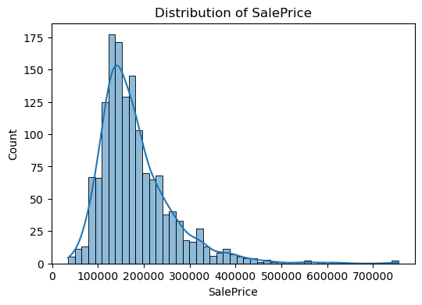
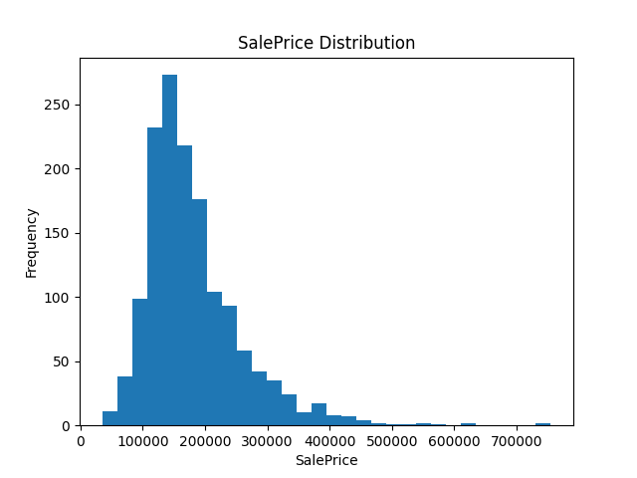
LotArea vs SalePrice
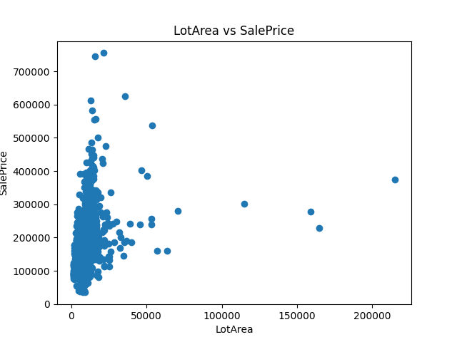
Total Basement Area vs SalePrice
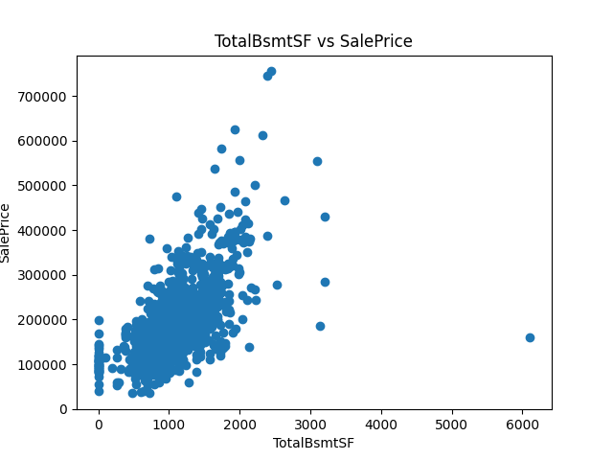
Overall Condition vs SalePrice
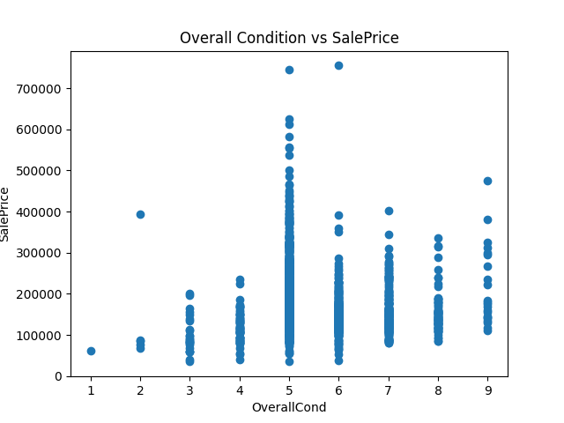

5. Insights from Analysis
The exploratory data analysis and feature engineering process provided several meaningful insights into the factors influencing house sale prices.
5.1 Impact of Location
Location-related features such as MS Zoning and LotConfig significantly influence property prices. Houses located in residential zones with favorable configurations tend to have higher average sale prices. This indicates that buyers are willing to pay a premium for properties situated in well-planned and desirable areas.
5.2 Effect of Property Age
The analysis of YearBuilt and YearRemodAdd revealed a strong positive relationship between newer construction or recent renovations and higher sale prices. Recently built or remodelled houses generally command higher market value due to modern design, updated infrastructure, and reduced maintenance costs.
The derived feature “Age of Property” (Current Year – YearBuilt) further confirmed that older properties typically sell at lower prices unless they have been significantly renovated.
5.3 Overall Condition and Quality
OverallCond and other quality-related variables showed a noticeable impact on SalePrice. Properties with higher condition ratings exhibited higher median sale prices. This demonstrates that structural integrity and maintenance condition are key determinants of property value.
5.4 Basement and Living Area Influence
Continuous features such as TotalBsmtSF (basement area) and LotArea showed a positive correlation with SalePrice. Homes with larger basement space and larger lot size generally sold for higher prices.
The presence of a basement itself had a measurable impact, indicating that additional usable space significantly increases buyer interest and property value.
5.5 Strong Numerical Correlations
Correlation analysis revealed that features like:
- Living Area
- Basement Area
- Overall Quality
- Garage Area
had strong positive correlations with SalePrice. These variables are among the most important predictors in the pricing model.
5.6 Categorical Feature Contribution
Categorical variables such as building type and zoning classification also influenced pricing trends. Even when numerical features were excluded, categorical features alone provided some predictive capability, although their performance was weaker compared to numerical features.
This suggests that both categorical and numerical features play complementary roles in price prediction.
5.7 Skewness and Data Transformation
The distribution of SalePrice was right-skewed. Applying logarithmic transformation improved normality and model performance. This step enhanced prediction accuracy and reduced the impact of extreme values.
5.8 Outlier Detection
Outliers were detected in features such as living area and lot size. These extreme values had the potential to distort model predictions. Proper handling of outliers improved the reliability and stability of the predictive model.

6. Conclusion
This project successfully analysed and predicted house sale prices using a structured data science approach. Through systematic data cleaning, exploratory data analysis, feature engineering, and correlation analysis, key determinants of property value were identified.
The results demonstrate that structural features such as living area, basement size, overall condition, and construction year have the strongest influence on house prices. Location-related features and renovation history also play a significant role in determining market value.
The application of logarithmic transformation and proper handling of missing values and outliers significantly improved data quality and model performance. Correlation analysis helped identify the most important predictors, allowing the development of a more efficient predictive framework.
The project highlights the importance of combining domain knowledge with statistical techniques to build accurate real estate pricing models. It also demonstrates how feature engineering and proper preprocessing steps can significantly enhance machine learning outcomes.
Overall, the predictive model provides valuable insights into real estate valuation and can assist stakeholders such as buyers, sellers, investors, and real estate agencies in making data-driven decisions.
Future improvements could include:
- Using advanced machine learning algorithms (e.g., Random Forest, Gradient Boosting)
- Incorporating external factors such as economic indicators
- Deploying the model as a web-based application for real-time price prediction
In conclusion, this project successfully achieved its objective of analysing housing data and building a reliable framework for predicting house sale prices.

