Final Project [Naïve Bayes Classifier]

Ankit Chaudhary (ac957)

Harshvardhan Sawal (hs655)

**Approach:** We have implemented Naïve Bayes Classifier using Gaussian.

As Gaussian is probabilistic in nature so we have converted Categorical data into Binary data (Numeric Data).

**APIs Used:**

**pandas:** used to read dataset

**matplotlib.pyplot:** used to create graphs

**sklearn: a.)** model_selection: used to split dataset into test and train data

**b.)** metrics: used to create confusion matrix and finding accuracy score

**c.)** naïve_bayes: used to implement GaussianNB

Outputs:

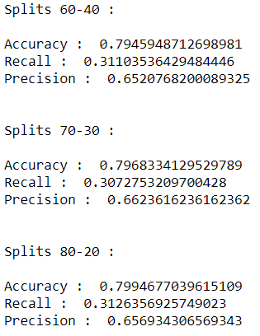

  1. Y- axis: precision, x axis: hold out split

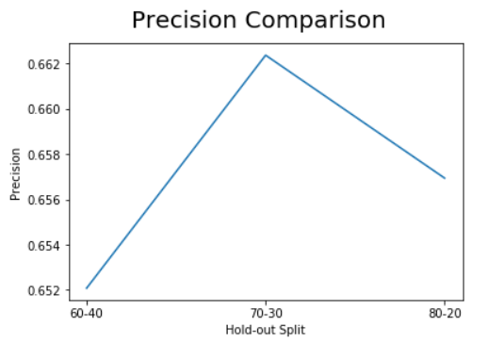

  2. Y- axis: recall, x axis: hold out split

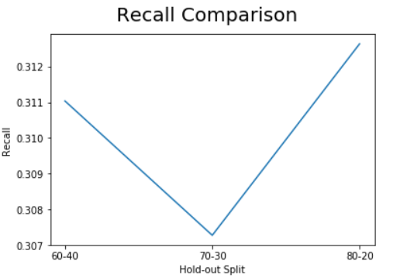

  3. Y- axis: accuracy, x axis: hold out split

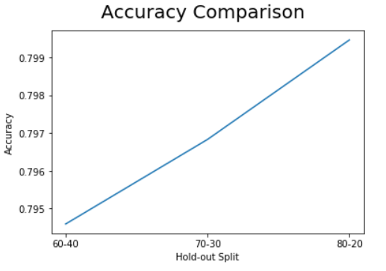

Refrences:

1. <https://scikit-learn.org/stable/modules/generated/sklearn.naive_bayes.GaussianNB.html>
2. <https://scikit-learn.org/stable/modules/generated/sklearn.model_selection.train_test_split.html>
3. <https://scikit-learn.org/stable/modules/generated/sklearn.metrics.confusion_matrix.html>
4. <https://scikit-learn.org/stable/modules/generated/sklearn.metrics.accuracy_score.html>