Dreamcatchers- An Event Management Website

Scrum Board

1. Sprint 1: -

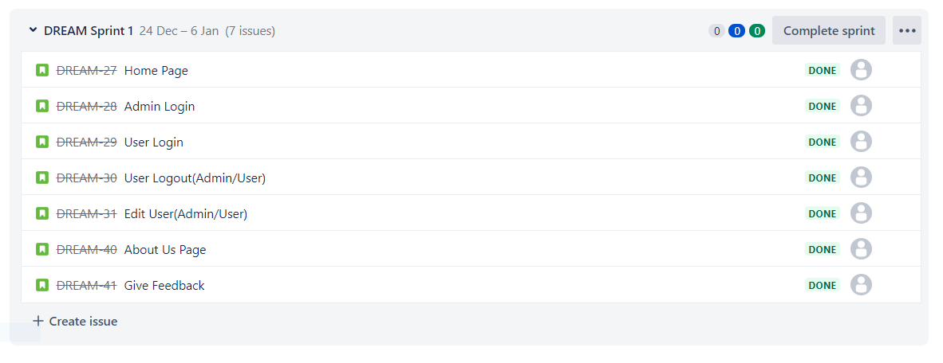

1. Sprint 2 And Sprint 3: -

